  - Communications

The purpose of this section of the report is to give an overview of the communication system. This section will examine and discuss the types of communication devices needed to complete the mission. The rover will use an parabolic dish reflector antenna (PDRA) to send and receive signals. This antenna will allow the rover to stay in contact with the LRO and the penetrators. The penetrators and the single site box (SSB) will have an omnidirectional antennas that will be used to send data to the rover. This data will then be sent to Earth via LRO.
After researching many different antenna designs, a parabolic dish reflector antenna was chosen, based on its relative ease of design, analysis, and implementation. The critical factor for a dish is efficiency, since uniform illumination is not possible. Thus spillover, illumination, and feed blockage losses will have to be considered in order to maximize overall efficiency. Figure X was used to determine the parameters needed to maximize efficiency.

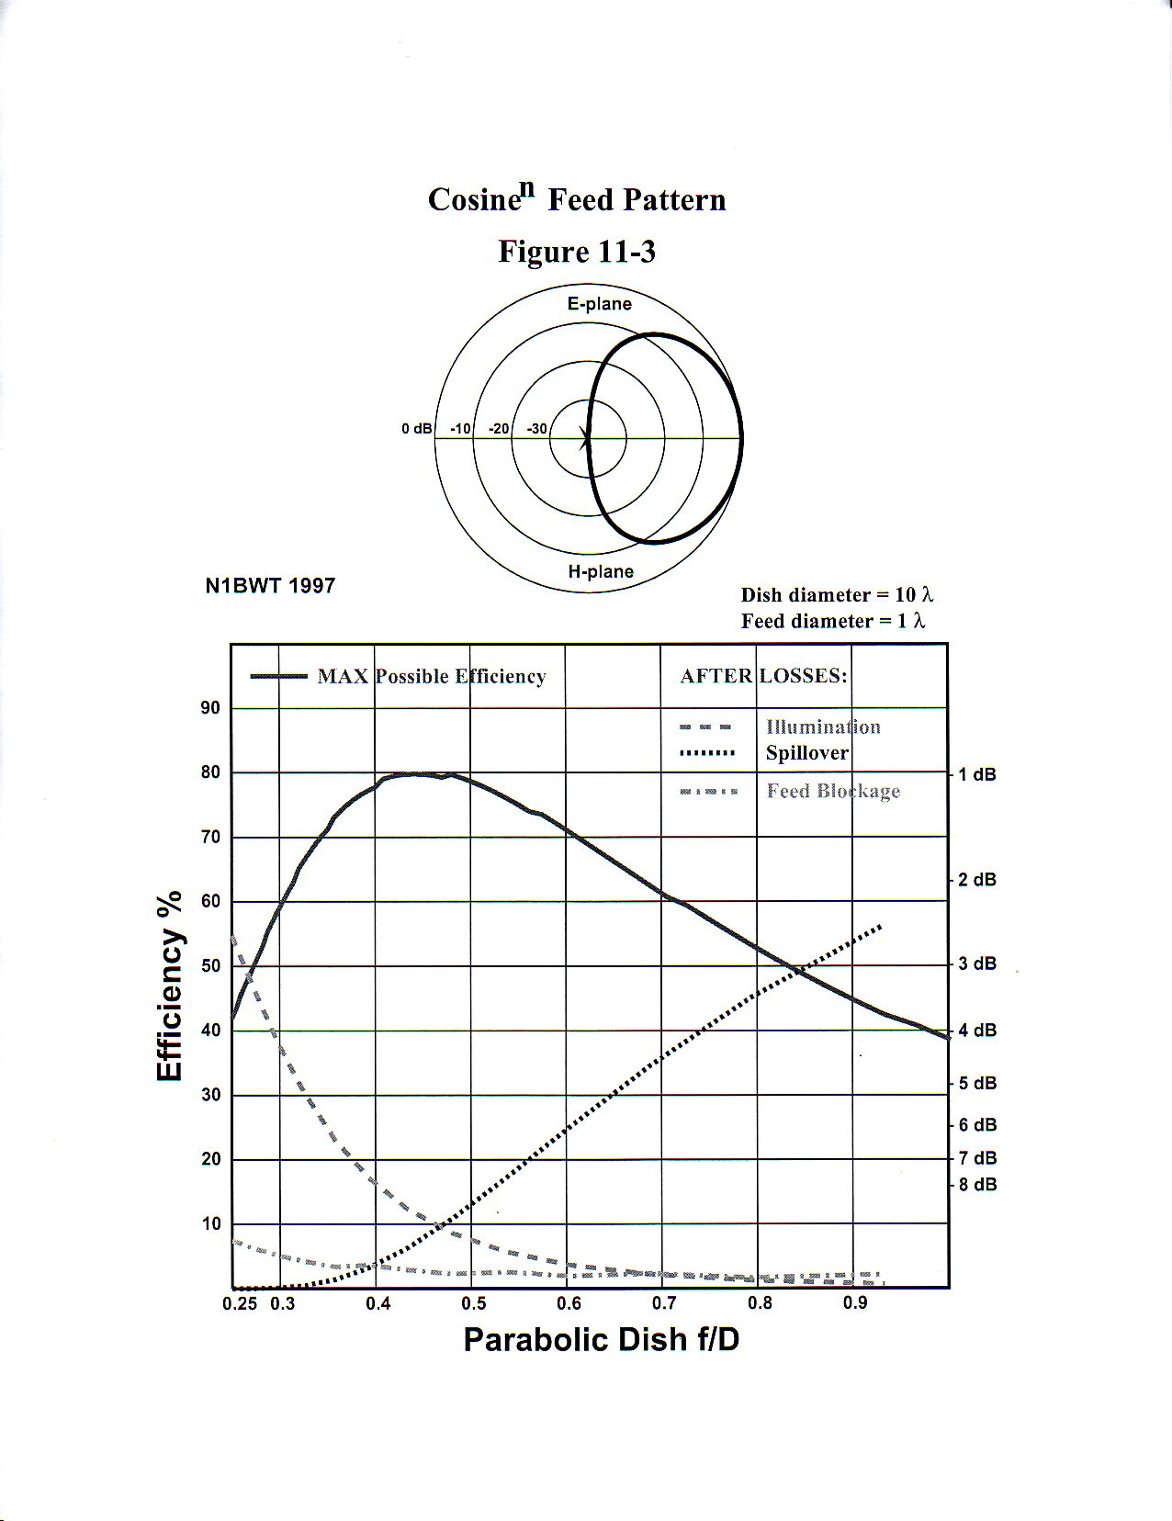

Figure: X

Analyzing the above figure, the maximum possible efficiency for a reflector with a diameter of ten wavelengths and a feed diameter of one wavelength is 80%, with a corresponding focal length to diameter ratio of 0.45. At 8 GHz, the free space wavelength was calculated to be 0.0375 meters, so the dish diameter will be 0.375 meters and feed diameter will be 0.0375 meters. Thus, the required focal length will be 0.16875 meters, which gives the placement of the feed antenna. The required symmetrical cosine^{n} (n is an integer) radiation pattern for the feed antenna can be very closely approximated with a step-less, dual-mode conical horn antenna, which will require a circular waveguide input. With this information, the maximum directive gain (or directivity) can be calculated. Assuming both the transmitting and receiving antennas have exactly the same dimensions, the directivity for both will be 789.587, which in decibels is equal to 28.974. With this information and the perilune distance of 100 km, The Friis transmission equation (FTE) can be used to determine the power received by the receiving antenna, given the transmitted power, which is 4.8 Watts (due to the 80% antenna efficiency). Using this equation (assuming the reflectors are circular), the maximum received power was calculated to be 2.13 Watts (taking into count the 80% efficiency of the receiving antenna). A picture of PDRA can be seen in Figure X.

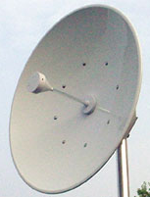

Figure: X Parabolic Dish Reflector Antenna (PDRA)

The transmitter needs to be space qualified, which means the system must be radiation-hardened to protect it from high-energy background cosmic radiation that would otherwise severely damage the electronics. The transmitter selected was the T-712 high data rate X-band transmitter manufactured by L3 Communications. This transmitter is specifically designed for the rover and orbiter applications. Table X lists the specifications for the T-712.

Table: X Description of Transmitter
Frequency Range | X-band, 8.0-8.5 GHz
Frequency Source | DRO phase-locked to TCXO
Modulation | SQPSK
Data Rate | 5 Mbps to 150 Mbps
Input Power | 66 Watts primary power
RF Output Power | 6 Watts
Operating Voltage | 22 to 38 Vdc
Inputs | I-channel data (AC-Coupled PECL), Q-channel data (AC-Coupled PECL), Reference clock (AC-Coupled PECL), Unit on command (pulsed), Unit off command (pulsed)
Outputs | Reference clock (AC-Coupled PECL), RF output power telemetry, Unit temperature telemetry, Secondary voltage telemetry
Weight | 8 lbs (3.63 kg)
Radiation Hardening | 20 krad total dose

Since the antenna has a high directive gain, it will need to be pointed as close to the LRO as possible to obtain a successful transmission. Thus, a gimble system will be needed to point the antenna at the LRO as well as a method to determine the relay satellite’s current position. The conical scanning technique is a commonly used technique in RADAR applications. This technique involves re-positioning the beam slightly off-center from the midline of the antenna, then rotating it at a constant rate. By observing the peaks in the received signal, the direction that the antenna needs to be pointed can be determined. Two versions of this method are available, a rotated feed and a nutated feed. With a rotated feed, the feed is set slightly off the focal point, and then is rotated around the focal point. The other method is involved is called a nutated feed, in which the feed is fixed and the reflector is rotated around the focal point. The primary difference between the two is polarization change. With a rotated feed, a polarization change will occur while with a fixed feed, no polarization will occur. More analysis is required to determine which method is best for this particular application. In addition, a proper beacon signal for the relay satellite will need to be selected whose auto-correlation pattern will be easily distinguishable from the received background noise.

Each of the penetrators uses a miniaturized radio transmitter and receiver system weighing less than 50 grams. The area that this transmitter and receiver occupy is a little more than 64${\text{cm}}^{2}$, and consumes less 2 watts in transmit mode. The antenna on the penetrators will be an omnidirectional antenna. The communication bandwidth will be S-band. This S-band system operates in the S-band portion of the RF spectrum of 1,700 to 2,300 MHz. The subsystem is the S-band Phase Modulation System (PMS), and it is used to transmit information to the rover. This transmitter is tuned to 2,250.0 MHz. The parabolic dish reflector antenna on the rover is used to downlink data from the 15 different penetrators one at a time. The transmission rate of the penetrators is 8 KB per second. Each penetrator will have 300 MB of data to be sent to the rover. The time that it will take each penetrator to finish its data transmission was calculated to be 625 minutes. So the rover will have to remain in place for approximately 6.5 day after landing. A figure of an omnidirectional can be seen in Figure X.

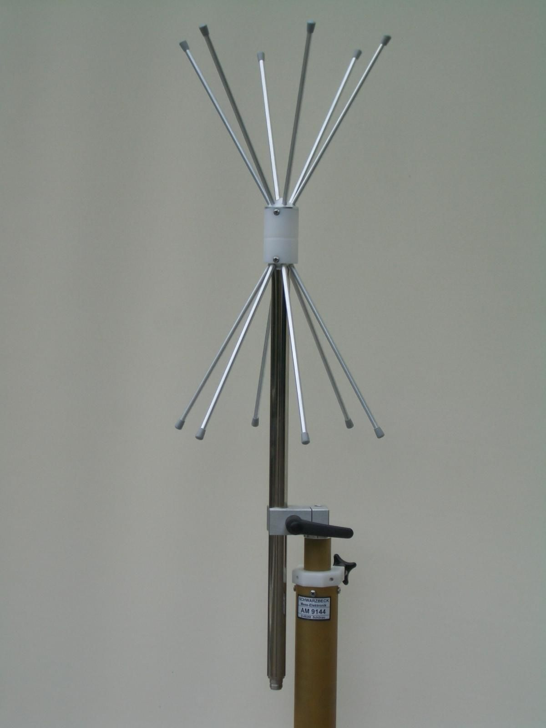
Figure: X Omnidirectional Antenna

The communication system on board the Single Site Box (SSB) will be similar to that used on the penetrators. It will have an omnidirectional antenna with a miniaturized radio transmitter. It will also be using S-band communication bandwidth. This S- band system will operate in the RF spectrum of 1,700 to 2,300 MHz. The subsystem of the antenna system is the S-band Phase Modulation System (PMS), and it is used to transmit information found by the SSI to the rover. The transmission rate of the SSB is the same as the penetrators. The only difference is that the amount of data being stored is 1 GB which will be gather and stored over the course of the year.

The LRO will be in a high elliptical orbit over the south pole of the Moon. This orbit will allow 8.456 minutes of accessibility in each 12-hour period. Calculation for the LRO line of sight can be seen in appendix I. Since the rover will have an available communication link of 8.456 minutes every 12 hours and is also required to take data and high-resolution images of the moon. This data will have to be stored on the rover while the LRO is unavailable. Additionally, control and other operational memory will have to be stored for operation of the rover. The plan is to use non-volatile flash memory for the rover’s data storage needs. This type of memory was chosen over others, such as hard drives, because of the lack of moving parts. The designers have concluded that approximately 10 gigabytes of flash memory should be sufficient to handle the needs of the rover and have allocated 6 gigabytes of this memory for storage of images and other scientific data. The remaining 4 gigabytes will be used for operational needs. This will be a redundant system storing operation memory in two locations in case of data corruption.

The communication is the most important portion of the project. If no communication can be made then the mission is a failure. Using the PDRA and the T-712 transmitter along with the omnidirectional antennas on board the penetrators and the SSB will make the system to be less vulnerable to failure and will ensure that data gathered will be sent back to earth complete.

