2.8 Payload

The payload or science for the Cyclops will be similar to that of the Viking. One part of the payload that will be reused is the Gas Chromatograph Mass Spectrometer the second is the surface sampler assembly. The portion that is being added is the use of penetrators, Miniature Thermal Emission Spectrometer (Mini-TES) and a single site box. The following sections will discuss each of these in greater detail.
The Gas Chromatograph Mass Spectrometer (GCMS) is used on the rover to perform atmospheric and organic analysis of the lunar surface. This analysis is important to know the organic content of the moon. These methods will be done through gas chromatographic and mass spectral methods. This system will be capable of analyzing compounds between 0.1 ppm and 2500 ppm by weight of the samples. One function of the GCMS will use an instrument to analyze the atmosphere by opening an inlet valve for a period of time to allow the moons atmosphere to equilibrate in GCMS. A second function of the GCMS is to perform molecular analyses. This is done by a PDA that will deliver ground samples of moon surface material to the GCMS. A portion of the sample will then be loaded into an oven inside the LPA for further analysis. The GCMS will consist of two major assemblies. The first major assembly being a sensor subset that will house a hydrogen supply assembly (HSA), a loading and pyrolyzing assembly (LPA), a gas chromatograph assembly (GCA), an atmospheric filter assembly, and mass spectrometer assembly (MSA). The HSA portion of the first assembly will consist of a hydrogen tank containing $H_{2}$ at pressure of approximately 5.2 MPa, a one-shot valve, a pressure transducer, and two high-pressure valves. The hydrogen is used for the LPA to provide pressurant for the pyrolyzed sample. The GCA serves to control and separate the flow of the vapor products of the sample of interest as it travels from the pyrolysis oven to the MSA. One major assembly that will be used is the instrument data assembly (IDA), which initiates and controls the GCMS sequences in response to commands, and will digitize both engineering and mass spectral data and then transmits the data to the data acquisition system. The mass of the GCMS is 6 kg and the dimensions are 10cm x 10cm x 8cm. This system mentioned above can be seen in Figure X.

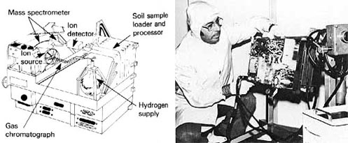
Figure: X Gas Chromatograph Mass Spectrometer (GCMS)

The surface sampler assembly (SSA) has a primary purpose to acquire process and distribute samples from the moon’s surface to the GCMS. It secondary functions are to include physical properties, magnetic properties, and meteorology investigations. The main components of the SSA include the SSAA, GCMS PDA, and the SSCA. The SSAA consists of a controlled 3-axis 3-m furlable tube boom and collector head capable of acquiring surface samples at any location within 12.1$m^{2}$ area in front of the rover. This collector head and boom can be seen in Figure X. The GCMS PDA will receive $\text{2000}−μm$particle size samples from the SSAA then grinds them down even smaller to $\text{300}−μm$particle size then delivers the sample to the GCMS for testing. The SSCA will consist of the electronics necessary to provide control functions and data acquisition for the SSAA.

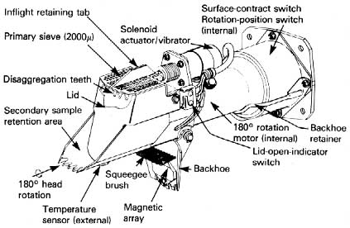

Figure: X Surface Sampler Assembly (SSA)

There will be fifteen penetrators fired into the Shackeltons crater; this will be the mission’s main source of data acquisition in the permanent dark regions. These penetrators similar to those of Deep Space 2 (DS2) will have a total mass of 3.572 kg each and will consist of threes parts the aftbody, forbody and a launch mechanism. The aftbody is a short cylinder 100mm high and 136mm in diameter, which will contain the primary batteries, pressure sensors, atmospheric accelerometer, and communications equipment, including a 130mm omnidirectional antenna. The aftbody is designed to remain above the surface after impact to provide radio communications to rover. The forebody, or penetrator, is a long thin cylinder 100mm long and 37.54mm diameter with a mass of .67 kg. One set of thermal properties equipment, including a temperature sensor, are housed near the front of the cylinder. Above this at the center of the cylinder is the drill motor surrounded by the electronics and microcontroller. Above the drill motor is the drill apparatus, soil sample chamber, and the heating and ice and water vapor detection equipment. At the top of the penetrator is a 3-axis impact accelerometer. The forebody fits in the aftbody in its stowed position and is designed to separate on impact with the surface. It has a rounded front end in order to penetrate into the ground. Both of these parts of the probe are designed to withstand extreme decelerations. The power uses two lighium-thionyl chloride batteries providing 600 milliamp-hours. The probe confuration can be seen in Figure 1 below. The last part of the probe is the ejection system which consists of mechanism that will catapult the probe away from the rover. The penetrator will then procede to freefall to the bottom of the crater at a velocity of approximately 151.5 m/s and penetrate to a depth of .096 m. The transmission rate for each probe is 8 KB per second. The probes are designed to survive an impact of up to 180 m/s. Calculations for these can be seen in appendix H-2, H-3, H-4.
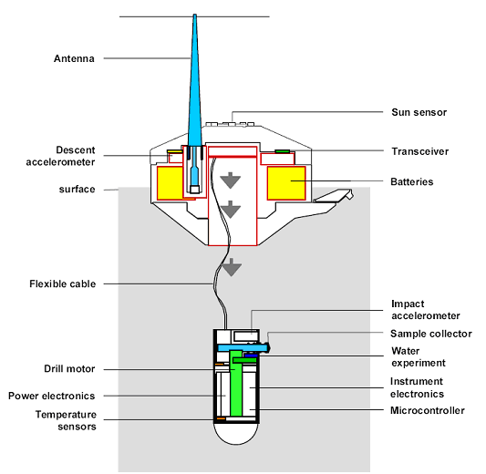
Figure: X Deep Space 2 Probe

The Miniature Thermal Emission Spectrometer (Mini-TES) will be mounted on the rover. The Mini-TES has a main objective to provide measurements of minerals and thermo physical properties on the moon. It does this by colleting high resolution infrared spectra over the wavelengths where distinctive vibrational spectral bands are best observed. The Mini-TES covers the spectral range 5-29$μm$ with a spectral sample interval of 9.99${\text{cm}}^{−1}$. The telescope is approximately 6.5 cm in diameter and is used to feed a flat-plate moving mirror mounted on a voice-coil motor assembly. The overall Mini-TES envelope is 23.5 x 16.3 x 15.5 cm and has a mass of 2.4 kg. The parameters and description for the Mini- TES that the group has chosen can be seen in Table X.

Table: X
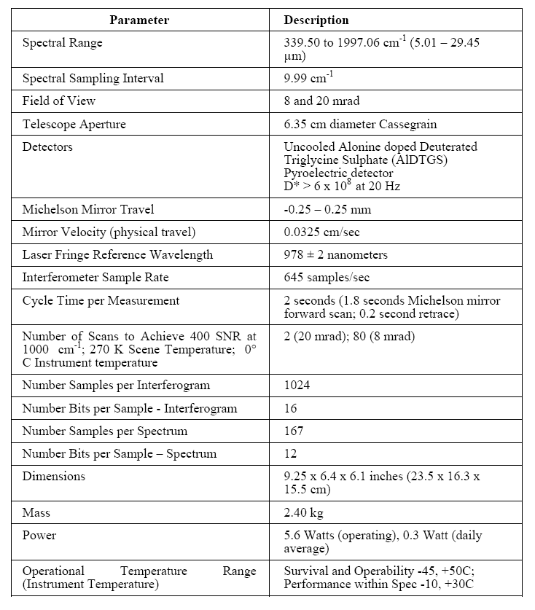

The last part of the science is the Single Site Box (SSB), which will be used to determine lighting conditions every 2 hours over the course of one year, micrometeorite flux, and assess electrostatic dust levitation and its correlation with lighting conditions. The SSB will house a Surface Stereo Imager (SSI). This instrument simulates the human eye with a two optical lens system that will give three-dimensional views. It will also simulate the resolution of human eyesight using a charged-coupled device that produces high density 1024 x 1024 pixel images. The SSI will exceed the capabilities of the human eye by using optical and infrared filters, allowing multispectral imaging at 12 wavelengths of geological interest and atmospheric interest. This SSI will also be used to estimate the optical properties of the moon’s atmosphere around the drop off site. Using narrow-band imaging of the Sun, the imager will estimate density of atmospheric dust, optical depth of airborne aerosols, and abundance of atmospheric water vapor. The power for SSB will be provided by a solar panel. The overall mass of the SSB will be approximately 10 kg. The data transmission rate is 8 KB per second. A picture of the SSI can be seen in Figure X.

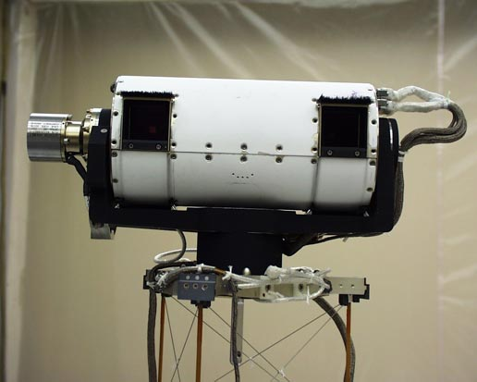
Figure: X

The payload is extremely important to the success of this mission. The payload for the Cyclops will utilize off the shelf technology, except for the penetrator launch system. The overall weight of the payload for the Cyclops will be approximately 120 kg. These systems working in parallel ensure that the mission goals will be completed on time.

