Competition Sensitive Document Attached

Team 02F
IPT 2008 White Paper
The Attached Document is Competition Sensitive until May 2, 2008

If you find this document unattended put it in a secure place and notify

Dr. Robert A. Frederick, Jr.
IPT Project Director
Office: 256-824-7203
Cell: 256-503-4909
frederic@eng.uah.edu
Alternate Concepts White Paper

IPT 02F

The University of Alabama in Huntsville
Team Leader  Structures  Power  Systems Engineering  GN&C  Thermal  Payload / Communications  Operations | Matt Isbell, isbellm@email.uah.edu  Matthew Pinkston, mmjpink@hotmail.com  Robert Baltz, baltzr@email.uah.edu  Tyler Smith, smitht5@email.uah.edu  Kevin Dean, kwd0001@email.uah.edu  Joseph Woodall, joseph.woodall@charter.net  Thomas Talty, talty@uah.edu  Chris Brunton, bruntonc@email.uah.edu  Audra Ribordy, audra342@yahoo.com
Southern University
Mobility | Chase Nelson, cnelson0053@gmail.com  Eddie Miller, eddie.miller212@gmail.com
ESTACA
Sample Return | Kim Nguyen, kim.nguyen98@gmail.com  Vincent Tolomio, vincent.tolomio@gmail.com

Submitted By:

Team Frankenstein
February 21, 2008

Submitted To:
Dr. P.J. Benfield and Dr. Matthew Turner
Department of Mechanical and Aerospace Engineering
The University of Alabama in Huntsville
pj.benfield@uah.edu
matt.turner@uah.edu
Abstract
For the Spring 2008 Integrated Product Team competition, Team Frankenstein will be competing in the design of a Lunar Exploration Transportation System. This system must have the ability to land on the moon at a polar location and also have mobility while on the moon. For a single site, the lunar lander must determine lighting conditions every two hours over the course of a year, determine micrometeorite flux, and assess electrostatic dust levitation and its correlation with lighting conditions. The lander system must also achieve the mobility goals by collecting independent measurement of 15 samples in permanent dark and 5 samples in lighted terrain, determine the composition, geotechnical properties and volatile content of the regolith, and relay all information back to earth. For the second phase of this competition, Team Frankenstein developed two alternatives to the given baseline design, the Viking lander. Each design consists of a lander and rover combination. The first is a land-on-wheels concept that consists of the lander and rover as one vehicle. The second concept is a traditional lander that will deploy a rover on the lunar surface. Each design was thoroughly assessed based on the specifications of the Concept Description Document. After both designs were assessed and ranked, one design was chosen and will be carried into the third phase.
Team Frankenstein’s first option is Cyclops. This design encompasses the land-on- wheels concept. Cyclops will land and travel on the lunar surface to accomplish our Concept Description Document requirements. The lander will have a hexagonal structure with six wheels, and penetrators. This option has been selected by Team Frankenstein to carry into the third phase of the project. This option was chosen due to its lighter weight, ease of design, and ease of mobility just to name a few.
The second option is Medusa. This design has a lander that will deploy a rover on the surface to complete the Concept Description Document requirements. The lander will have a hexagonal structure with four landing legs, and penetrators.
The main reason for selecting Cyclops is because of the score of the evaluation matrix. Cyclopes had a better score in areas such as ease of design, achieving scientific objectives, and lighter weight. This design is the better choice at this time to carry into the third phase of the project.

Technical Description

1.0 Overview of Phase 2
For Phase 2, the individual Integrated Product Teams have worked independently to produce two alternative configurations to a baseline design. The deliverables for Phase 2 are a white paper and an oral presentation. The white paper compares the baseline concept, the Viking Lander, with two alternative concepts. This white paper summarizes a strategy for selecting alternative systems, qualitative and quantitative information to evaluate each idea, and a logical rationale for down selecting one concept from among the three presented.

1.1 Specification Summary
For a successful mission, there are certain requirements that must be achieved. For this mission, the lander and rover must be able to retrieve the samples from the moon’s surface as required by the Concept Description Document and relay it back to Earth. The lander will land at a polar location with the capability to land at other lunar locations. After reaching the Moon, the lander has to be able to determine lighting conditions every two hours over the course of a year, determine micrometeorite flux, and assess electrostatic dust levitation and its correlation with lighting conditions for a single site. The lander must also achieve the mobility goals, be able to determine the composition, geotechnical properties and volatile content of the regolith, relay all information back to Earth by the end of our mission end (one year), and meet the landing mass for the chosen Atlas V-401 EPF shroud configuration. These requirements are the foundation for designing the lander. The lander must meet each requirement and each lander system is directly affected by the requirements and moon environment.

1.2 Team Frankenstein Approach to Phase 2
Upon completing Phase 1, the baseline review, Team Frankenstein began to function as a team and each individual became responsible for their own discipline. The harsh environment and mobility on the moon caused the most concern. The harsh environment presents an issue because of the little information known about the moon. The requirements to achieve surface objectives in the permanently dark sites are also an issue due to the temperature ranging from +107 to -223 degrees Celsius. Mobility was non-existent on our baseline lander. The Concept Description Document for the Lunar Exploration Transportation System, however, does require mobility.
The group reviewed the baseline review presentation to attain detailed information about the customer’s specific requirements. From the customer’s requirements, each discipline began investigating the possible solutions to meet the given Concept Description Document requirements. Team members in each discipline presented their design ideas to the team. The team began revising these possibilities. After deliberation, Team Frankenstein created two design concepts. The team evaluated the concepts based on the weighted values for desired criteria and chose the winning concept.
Figure 1 shows the outline of the design process used for Phase 2. The Concept Description Document requirements were evaluated and given to the project manager. The manager then forwarded them on to the systems engineer and finally to the individual disciplines. After each discipline presented their own alternatives, a systems evaluation was completed and changes were made as necessary. This process was repeated until the final concepts were developed. Our results were then submitted to the project office for a final evaluation before being presented to the customer.
Results
System Simulation
CDD/Customer
Project Office
Systems Engineer
Thermal
Power
GN&C
Operations
Payloads
Structures
Mobility
Sample Return

Figure 1 – Outline of the Design Methodology

2.0 Description of Concepts
Team Frankenstein has narrowed its concepts of designing a lunar lander to two different configurations. After research and application of engineering principles, the configurations were chosen based on the attributes of payload, propulsion, structure, electronics, communications, power, control system, and thermal system as well as how they affected each other. The first configuration was a single rover landing on wheels and the second configuration was a lander with a single rover. The Viking Lander was used as the baseline configuration for the project. Table 1 summarizes the final configurations of the baseline and the two alternative concepts.
Cyclops, the single rover landing on wheels, was the first concept based on its advantages of mass conservation and a reduced amount of ground support. Cyclops’ attributes will consist of the payload, propulsion, structure, electronics, communications, power, control system, and thermal system. The Cyclops will be able to discharge fifteen penetrators on descent with all fifteen in permanent dark terrain. With the Cyclops the time between sample data gathering and transmission will be minimal, because no rover will need to return data back to a stationary lander. The Cyclops will require less travel time and power in extreme cold than a single rover having to retrieve data and return it back to a stationary lander. Less weight will also be a key factor in the Cyclops concept because a rover will not be part of the payload.
Medusa, a lander with a single rover, was the second concept based on its advantage of proven off the shelf technology. Medusa’s attributes will consist of the payload, propulsion, structure, electronics, communications, power, control system, and thermal system. Medusa will be able to discharge fifteen penetrators on descent with all fifteen in permanent dark terrain. The rover that detaches from Medusa is capable of more maneuverability because of its smaller size and lighter weight. The lander being in a permanent position reduces the risk of failure to its subsystems, because a mobile lander could cause damage to its components. More travel time is required for the rover to recover the samples, but a rover gives a better probability of mission completion and data return. For example, if an impact is greater than calculated and the lander is compromised, the rover would still be able to complete the mission.

Table 1– BOOST Matrix for LETS

 |  | Baseline | Alternative Concepts
 |  | 02-BL | 02F-ALT1 | 03F-ALT2
CONFIGURATION | STATE | Viking | Cyclops | Medusa
CATEGORY
1. Mobility | [Land on Wheels] | Other | Land on Wheels | Single Lander w/rover
1. Mobility | [Single Lander w/rover] | Other | Land on Wheels | Single Lander w/rover
1. Mobility | [Other] | Other | Land on Wheels | Single Lander w/rover
2. Propulsion | [MR-80B ] | RCS and TDS Engines | MR-80B | MR-80B
2. Propulsion | [RCS and TDS Engines] | RCS and TDS Engines | MR-80B | MR-80B
2. Propulsion | {Other} | RCS and TDS Engines | MR-80B | MR-80B
3. Structures | [Six Legs/Wheels] | Three Legs | Six Legs/Wheels | Four Legs
3. Structures | [Four Legs] | Three Legs | Six Legs/Wheels | Four Legs
3. Structures | [Three Legs] | Three Legs | Six Legs/Wheels | Four Legs
3. Structures | [Other] | Three Legs | Six Legs/Wheels | Four Legs
4. Thermal | [Multi-Layer Insulation] | Thermal Switches | Multi-Layer Insulation | Multi-Layer Insulation
4. Thermal | [Thermal Switches] | Thermal Switches | Multi-Layer Insulation | Multi-Layer Insulation
4. Thermal | [other] | Thermal Switches | Multi-Layer Insulation | Multi-Layer Insulation
5. Guidance | [GCSC] | GSCS | Autonomous | Autonomous
5. Guidance | [Autonomous] | GSCS | Autonomous | Autonomous
5. Guidance | [Other] | GSCS | Autonomous | Autonomous
6. Communications | [Telemetry] |  | Telemetry | Telemetry
6. Communications | [S-Band DCS] |  | Telemetry | Telemetry
6. Communications | [Other] | S-Band DCS | Telemetry | Telemetry
7. Control | [Radar Altimeter] | Radar Altimeter | Radar Altimeter | Radar Altimeter
7. Control | [Other] | Radar Altimeter | Radar Altimeter | Radar Altimeter
8. Power | [Batteries and RTG] | Batteries and RTG | Batteries and RTG | Batteries and RTG
8. Power | [Solar] | Batteries and RTG | Batteries and RTG | Batteries and RTG
8. Power | [Other] | Batteries and RTG | Batteries and RTG | Batteries and RTG

2.1 Baseline Concept: “Viking Lander 1” [02-BL]
The baseline design, Viking Lander shown in Figure 2, was a NASA program to put a lander on Mars. The objective of the Viking mission was to take direct measurements from the Martian surface and to enhance knowledge of the planet’s biological, chemical, and environmental existence. The Viking mission was separated into many phases: cruise, orbital, separation, entry, and landing. During the cruise phase, the Viking orbiter provided all communications and navigation control. The orbital phase provided information for the Viking’s possible landing sites. The separation, entry, and landing phases occurred when the parachute was deployed, the aeroshell cap separated from the lander, and the legs of the lander were deployed.
The Viking Lander design consisted of structures and mechanisms, thermal control, communications, guidance and control, power, propulsion, pyrotechnics, telemetry and data handling, and science subsystems. The venting assembly, deployment mechanism for the high gain antenna, landing legs, the lander body structure, aero-decelerator made up of an aeroshell and parachute, as well as a bioshield made up the structures and mechanisms subsystems. The thermal control subsystem provided all components and structures with an acceptable temperature environment of -133 to 27 degrees Celsius. The communication subsystem had the capability to support radio science experiments and receiving transmitted commands from Earth. The guidance and control subsystem interfaced with other lander subsystems and utilized the flight software to perform guidance, steering, control of the lander from separation to landing, command processing and sequencing for all mission phases, and computation of lander orientation. The power subsystem provided switching for various electrical loads, sensors for detecting unsafe operating conditions, and was a power source for the lander. The reaction control system and terminal descent system made up the monopropellant propulsion subsystem. The reaction control system consisted of four three-engine clusters and two fuel tanks to provide impulse energy for deorbit and altitude control through entry. Three engines, four roll engines, and two fuel tanks for controlling velocity on descent made up the terminal descent system. The pyrotechnics devices that made up the pyrotechnic subsystem controlled all functions on the lander by responding to the commands from the aerospace ground equipment, the Viking orbiter, or the guidance, control, and sequencing computer. The telemetry and data handling subsystem controlled, processed, and modulated all of the VLC data during the mission. The biology, gas chromatograph and mass spectrometer, lander camera system, meteorology, seismometer, surface sampler assembly, x-ray fluorescence spectrometer, and magnetic properties included the instruments that made up the science subsystem.
Even though the Viking mission cost the U.S. Government roughly $1 billion dollars, the data and information recovered from the Viking Lander furthered our interest in space and exploration. The Viking Lander was successful on many levels throughout the mission including the extended life and durability of the lander which created a baseline for other concepts.

2.2 Alternative 1 Concept: “Cyclops” [02F – ALT1]
Cyclops, the single rover landing on wheels shown in Figure 3, was the first design for the lunar exploration transportation system. This concept is based on its advantages of being light weight and requiring less ground support. Some of the subsystems of the Cyclops include the payload, structure, electronics, communications, power, altitude control, thermal, and propulsion. With these systems the Cyclops will provide the flexibility to conduct systematic tasks at different locations on the lunar surface.
The payload of the Cyclops will need access to the lunar environment. It will house the propulsion subsystem, communication hardware, altitude control sensors and thrusters, computers, batteries, radar altimeter, penetrators, and thermal control parts. Six legs will be used to provide more maneuverability and stability for the structures portion of the Cyclops. The electronics and communications systems will be working together with the computers onboard to provide the Cyclops with telemetry to send back to Earth. The primary objective of the power subsystem is to provide power to all onboard subsystems, which include the electronics, communications, computers, and the altitude control system. This will be achieved through the use of lithium ion batteries as well as a radioisotope thermoelectric generator. The altitude control system will be designed for twelve MR-106 monopropellant thrusters. The thrusters will be used for stability of the Cyclops while in descent. The radar altimeter will also be part of the altitude control system which will measure the distance between the Cyclops and the ground below it. The thermal portion of the design will provide insulation to the Cyclops with temperatures ranging from 107 degrees Celsius to -223 degrees Celsius. The thermal subsystem on the Cyclops will also consist of a multi-layer insulation used to reduce dust build up and thermal radiation as well as prevent extremely cold temperature damage. The propulsion system will have two MR-80B monopropellant liquid rocket engines.
On the Cyclops’ descent to the Moon, the penetrators will be spread across the surface of the moon in fifteen permanent dark by means of an independent propulsion system within the penetrators. These penetrators will be separated by a distance of at least 500 meters from each other. In descent the Cyclops will also provide guidance, navigation, and control beginning at five kilometers above the surface of the moon. The impact of the Cyclops on the surface of the moon will be dampened by the suspension of the six wheels. Once the motion of the Cyclops has ceased, a sample box will be dropped off to determine lighting conditions every two hours over the course of one year, assess electrostatic dust levitation, and determine micrometeorite flux. The Cyclops will then be able to begin its mission of collecting samples in the lighted sites.

2.3 Alternative 2 Concept: “Medusa” [02F – ALT2]
Medusa, a lander with a single rover shown in Figure 4, was the second design for the lunar exploration transportation system. This concept is based on its advantage of proven off the shelf technology. Some of the subsystems of Medusa include the payload, structure, electronics, communications, power, altitude control, thermal, and propulsion. With these systems Medusa will provide the flexibility to conduct systematic tasks at different locations on the lunar surface.
The payload of Medusa will need access to the lunar environment. It will house the propulsion subsystem, communication hardware, altitude control sensors and thrusters, computers, batteries, radar altimeter, penetrators, rover, and thermal control parts. Four legs will be used to provide stability on landing for the structures portion of Medusa. The electronics and communications systems will be working together with the computers onboard to provide Medusa with telemetry to send back to Earth from the rover’s findings. The primary objective of the power subsystem is to provide power to all onboard systems which include the electronics, communications, computers, and the altitude control system. This will be achieved through the use of lithium ion batteries as well as a radioisotope thermoelectric generator. The altitude control system will be designed for twelve MR-106 monopropellant thrusters. The thrusters will be used for stability of Medusa while in descent. The radar altimeter will also be part of the altitude control system which will measure the distance between Medusa and the ground below it. The thermal portion of the design will provide insulation to Medusa as well as its rover with temperatures ranging from 107 degrees Celsius to -223 degrees Celsius. The thermal subsystem on Medusa and its rover will also consist of a multi-layer insulation used to reduce dust build up and thermal radiation as well as prevent extremely cold temperature damage. The propulsion system will have two MR-80B monopropellant liquid rocket engines.
On Medusa’s descent to the moon, the penetrators will be spread across the surface of the moon in fifteen permanent dark sites by means of an independent propulsion system within the penetrators. Calculations will ensure that the penetrators will meet the minimum distance requirement of 500 meters apart. In descent Medusa will also provide guidance, navigation, and control beginning at five kilometers above the surface of the moon. Once Medusa has landed on the surface of the moon, a rover will be unloaded to retrieve samples of the moon’s surface. Medusa will remain stationary to determine lighting conditions every two hours over the course of one year, assess electrostatic dust levitation, analyze samples from rover, and determine micrometeorite flux.

3.0 Selection of Final Concept

The following categories were used in the final selection of the concept. They are as listed: landed mass, trip survival, operational limitations, scientific objectives, communications, landing site objectives, launch survival, technology readiness level, power, thermal, and mobility. The user defined objectives are ease of designing and ease of completing scientific objectives. Table 3 is a Concept Selection Matrix. It gives weight to each of the CDD attributes. The team then decides if the attributes is not met, partially met, or met in the design. If the CDD attribute has been deemed mission critical by the project office, it is given a weight of 5. It the CDD attribute is deemed not to be mission critical, but still critical; then it is given a weight of 4. If the attribute is deemed to be important, then it is given a weight of 3. If the attribute is deemed to be not very important to the success of the mission, it is given a weight of 2. If the attribute is not at all important to the success of the mission, it is given a weight of 1. If the attribute can be ignored, it is given a weight of 0.

The CDD for this design has several mission critical attributes. They are: trip survival, operational limitations, scientific objectives, communications, launch survival, power, and mobility. The lander must first survive launch if the mission is going to proceed. Then it must be able to survive the trip to the moon and still function. The lander must be able to power its self and move around the lunar surface. The lander must be able to complete all its scientific objectives and communicate the results back to mission control. The lander must also survive the operational limitations; survive for one year, on the lunar surface. If any of those attributes of the mission is not met, the mission is deemed to be a failure. There are no attributes to the mission that were deemed critical but not mission critical. There is no attribute with a weight of 4. There are several important attributes to the CDD. They are landed mass, landing site objectives, ease of designing and ease of completing scientific objectives. The landing mass of the lander is important; however there are always ways to cut back on mass, so it is not a main component of the design. The landing site objectives, land on a 12° slope, can also be handled easily. Ease of designing and completing the scientific objectives are the user defined attributes and can be met without too much difficulty. There is one attribute that was deemed not very important to the success of the mission, but still important. That attribute is that all components must be TRL9. The mission can be completed without using TRL9 equipment.
The two concepts that were considered were Medusa, and Cyclops as mentioned above. Out of these two concepts, it was decided to develop The Cyclops, because it is believed that a wheel mounted lander will operate more effectively and more efficiently. The Cyclops will have a more flexible design allowing it to be used at various lunar locations. It is also believed that a wheel mounted lander will operate with more operational ease making it more likely that the mission objectives will be achieved. If the Cyclops lander were to fail during the mission, the scientific portion could still be accomplished with the penetrators that were deployed from the lander during lunar decent. They could relay their data to the LRO and then back to mission control. With the ease of design and ease of accomplishing the scientific objectives being key elements in the design, the wheel mounted lander, Cyclops, is the design of choice.

4.0 Phase 3 Plan

4.1 Key Issues to Address
Technology readiness will be one of the main issues to be tackled. A TRL of 9 is one of the figures of merit. TRL which stands for Technology Readiness Level, is used as a FOM to discourage new technology from being implemented into the design. This however, does not limit the use of new technology. Another key issue to address, is the use of penetrators, this technology is a great match to the requirements that must be met. However the concept has never been used in mid flight on a lander or for the combination of tasks set out. Figures of Merit (FOM) will be used for deciding base concept designs. The FOM’s will be used in place of cost analysis. Keeping the “mission low cost” is definitely a priority, but the team is most concerned with functionality and reliability of the lander. With this in mind TRL 9 will be less of a priority, and the team will focus on intuitive and leading edge ideas and designs to overcome the objectives. Although funding will be based on politics and “preferred customers”, it is wished that the funding was based on research and knowledge of the project.

4.2 Planned Tasks for ESTACA and Southern University
ESTACA is our partner from France that is involved with this project. ESTACA is responsible for the Sample Return Vehicle or SRV. Southern University from Baton Rouge, Louisiana is in charge of the Rover to be used in the lander. Since a rover will not be used, Southern University is focusing on making the lander mobile to meet objectives.

4.3 Phase 3 Schedule
Each subsystem must develop a unique design that best fits the requirements for the chosen concept. There, however, will most likely be compromises on each design of the subsystem in yielding a beneficial product as far as the whole design goes. Pugh’s concept matrix was implemented in deciding the final design. With the final design decided, the team will now be focusing on executing final subsystem designs. The following steps in the process will be: Dividing up subsystems within the team, deciding on final subsystem designs, integrating designs to one complete lander, applying GN&C and Con-ops to the final product.

5.0 Illustrations

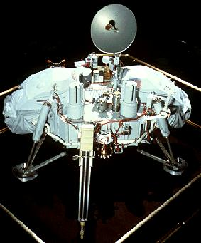

Figure 2 – Baseline: “Viking Lander” [02-BL]

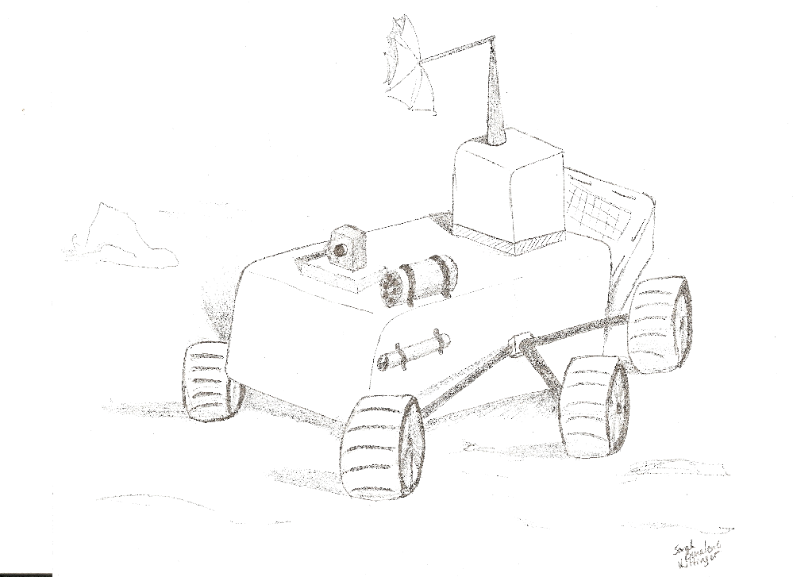

Figure 3 - Alternative 1 Concept : “Cyclops” [02F – ALT1]
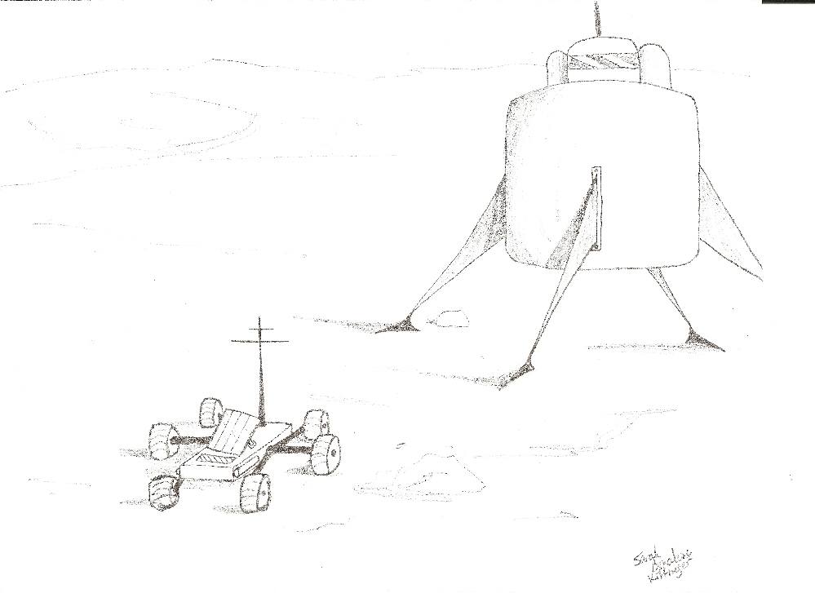
Figure 4 – Alternative 2 Concept: “Medusa” [02F – ALT2]

Table 2 – Engineering Summary

 |  | 02-BL | 02F-ALT1 | 02F-ALT2
NAME | Units | Viking | Cyclops | Medusa
GN&C | kg | 25 | 35.5 | 35.5
Structures | kg | 399 | 265 | 315
Power | kg | 60 | 45 | 45
Thermal | kg | 25 | 45 | 45
Payload | kg | 91 | 95 | 60
Sample Return | kg | N/A | 300 | 200
Mobility | kg | N/A | N/A | 232.3
Total | kg | 600 | 785.5 | 932.8
Table 3 - Concept Evaluation Matrix
Scoring Legend | NA  Not Analyzed  0 | Does Not Meet  0 | Partially Meets  5 | Meets  10

CDD Attribute | Score  Wt. | Baseline | Concept 1 | Concept 2 | CDD Requirement
CDD Attribute | Score  Wt. | Viking Lander | Cyclops | Medusa
Weight | 3 | 0 | 10 | 5 | Landed mass 932.8kg
Trip Survival | 5 | 10 | 10 | 10 | Survive Lunar Cruise up to 28 days
Operational Limitations | 5 | 10 | 10 | 10 | Operate for at least 1 yr
Scientific Objectives | 5 | 0 | 10 | 5 | Sample lunar surfaces
Communications | 5 | 5 | 5 | 5 | Send and Receive communication from Earth
Landing Site Objectives | 3 | 0 | 5 | 5 | Land on 12° slope, and within 100m of site
Launch Survival | 5 | 10 | 10 | 10 | Survive launch g loads (3g’s)
Technological Readiness Level 9 | 2 | 10 | 5 | 10 | Should be TRL 9
Power | 5 | 10 | NA  0 | NA  0 | Store power when in the dark
Thermal | 2 | 5 | NA  0 | NA  0 | Survive Temperature swings
Mobility | 5 | 0 | 10 | 10 | Must be mobile
USER SUPPLIED
Ease of Designing | 3 |  | 10 | 5 | User Selected
Ease of completing Scientific Objectives | 3 |  | 10 | 10 | User Selected
Total Score | 48 |  | 39 | 36.5

6.0 References

1) Holmberg, N.A., Faust, R.P., Holt, M.H., “Viking 75’ Spacecraft Design and Test Summery,” NASA Reference Publication, 1027, November, 1980.
2) Ingoldby, R.N., “Guidance and Control System Design of the Viking Planetary Lander,” AIAA Journal, Vol.1, No.3, 1978, pp.189-196.
3) Lawrence, G.F., Scofield, W.T., “Automated Lunar Landing Missions Using the Viking Spacecraft,” AIAA Paper, pp. 71-822, July 1971.
4) Bauer, D.E., Collicott, H.E., “Spacecraft Thermal Control, Design, and Operations,” AIAA Journal, Vol.1, No.3, 1982, pp. 311-345.

