    - Dimensional Properties
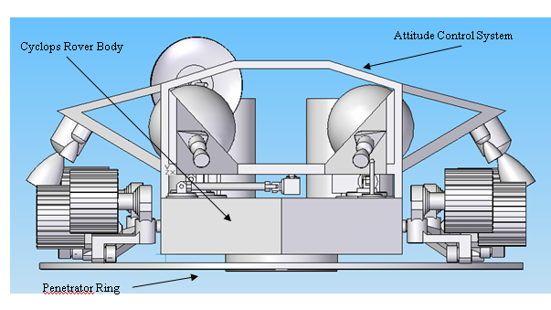
Figure X
This figure shows a front view of Cyclops with the attitude control system and penetrator ring attached.

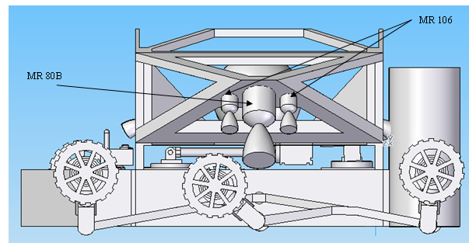

Figure X
In this figure, Cyclops is attached to the attitude control system and has its wheels folded up for transport

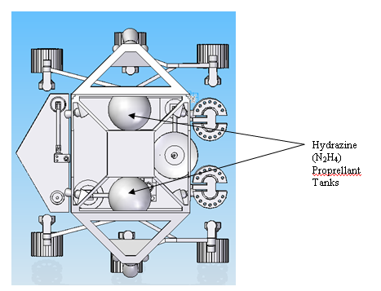
Figure X
A top view of Cyclops attached to the attitude control system

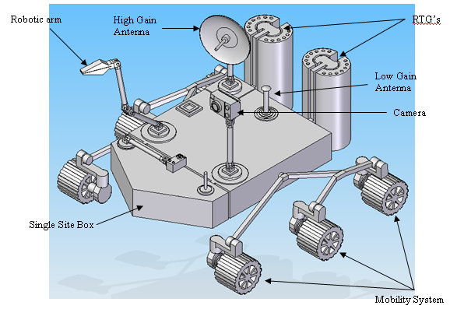

Figure X
An isometric view of Cyclops after it has detached from the attitude control system and begun to rove

