    - Dimensional Properties
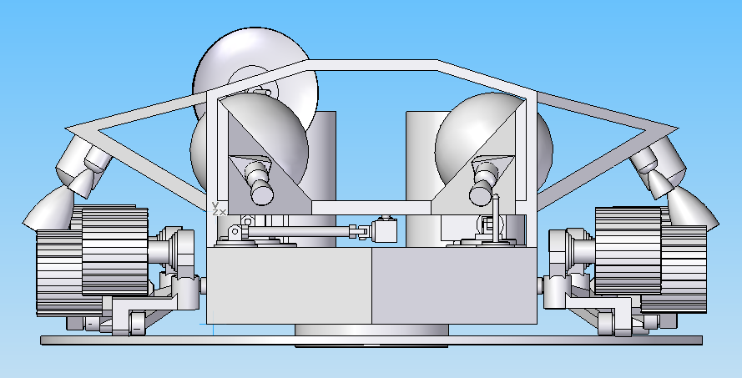

Figure X
This figure shows a front view of Cyclops with the attitude control system and penetrator ring attached.
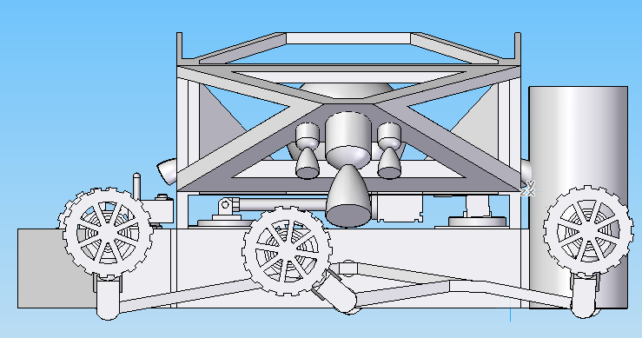

Figure X
In this figure, Cyclops is attached to the attitude control system and has its wheels folded up for transport
Penetrator Ring
MR 80B
Attitude Control System
Cyclops Rover Body
MR 106
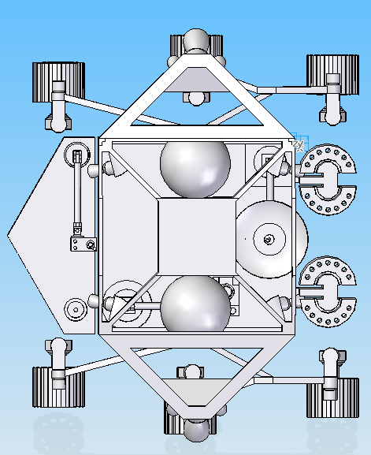

Figure X
A top view of Cyclops attached to the attitude control system
Hydrazine (N₂H₄) Proprellant Tanks
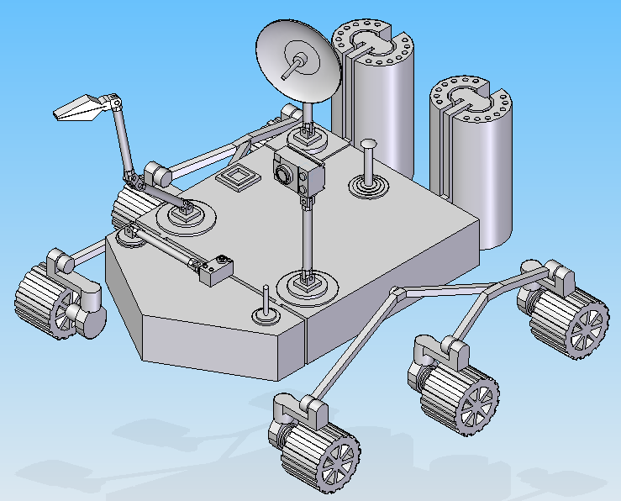

Figure X
An isometric view of Cyclops after it has detached from the attitude control system and begun to rove
RTG’s
Robotic arm
Mobility System
Camera
Low Gain Antenna
High Gain Antenna
Single Site Box

