Lunar Cruise

Cyclops will be able to handle the temperatures seen in the lunar cruise environment. The minimum and maximum temperatures seen in lunar cruise are less than those minimum and maximum temperatures seen on the surface of the moon. Since Cyclops is able to handle the temperatures seen on the surface of the moon, it will also be able to handle those seen in lunar cruise. Charged particle flux is seen from three different sources. These sources are 1) solar wind, 2) solar cosmic rays, and 3) galactic cosmic rays and are detailed in the image below. The effects of the radiation on the lunar lander/rover are a concern; however, the flux rate of each type of charged particle is relatively low. Meteoroids and micrometeroids are also a concern. The likelihood of micrometeroids impacting the lunar lander/rover is low.

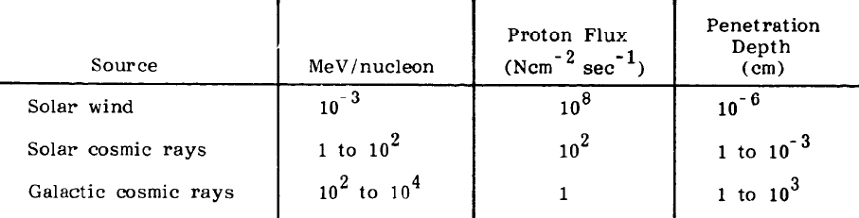

Interface

The Cyclops can interface with the Atlas V 401 using any of the different interface adapters available. The possible interface options available, as outlined in the Atlas Launch System Mission Planner's Guide, Rev 10a, January 2007, CLSB-0409-1109, are shown in the figure below.
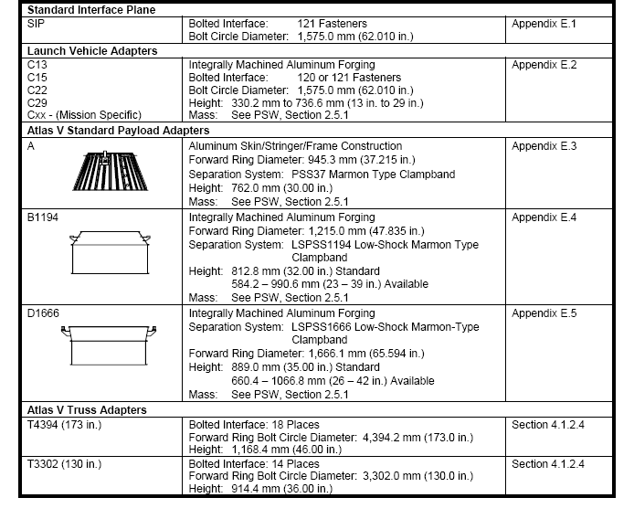

NASA Technical Memorandum 82478, Space and Planetary Environment Criteria Guidelines for Use in Space Vehicle Development, Volume 1
Atlas Launch System Mission Planner's Guide, Rev 10a, January 2007, CLSB-0409-1109

