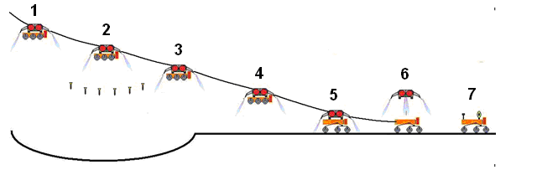

Figure X – Cyclops Decent and Penetrator Deployment in Shackleton Crater
1) Attached to the attitude control system, Cyclops starts descent, 2) Penetrators are released, 3-4) Cyclops continues descent, 5) Cyclops lands, 6) Attitude control system detaches from Cyclops, and 7) Cyclops begins to rove.

