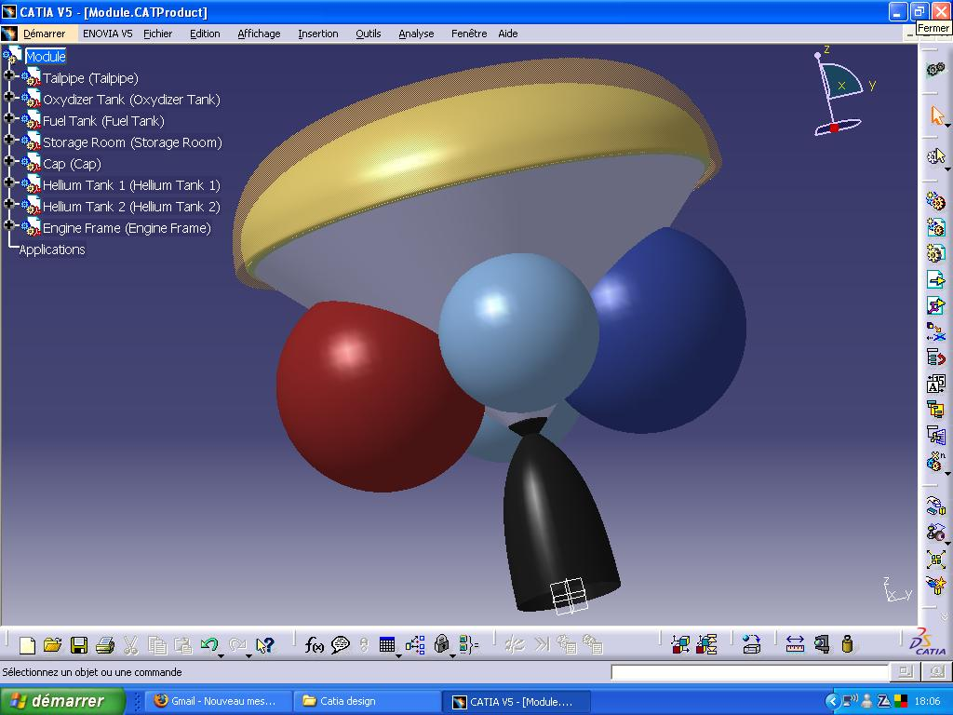
The above is a CAD model of the SRV that is used with the lunar lander.

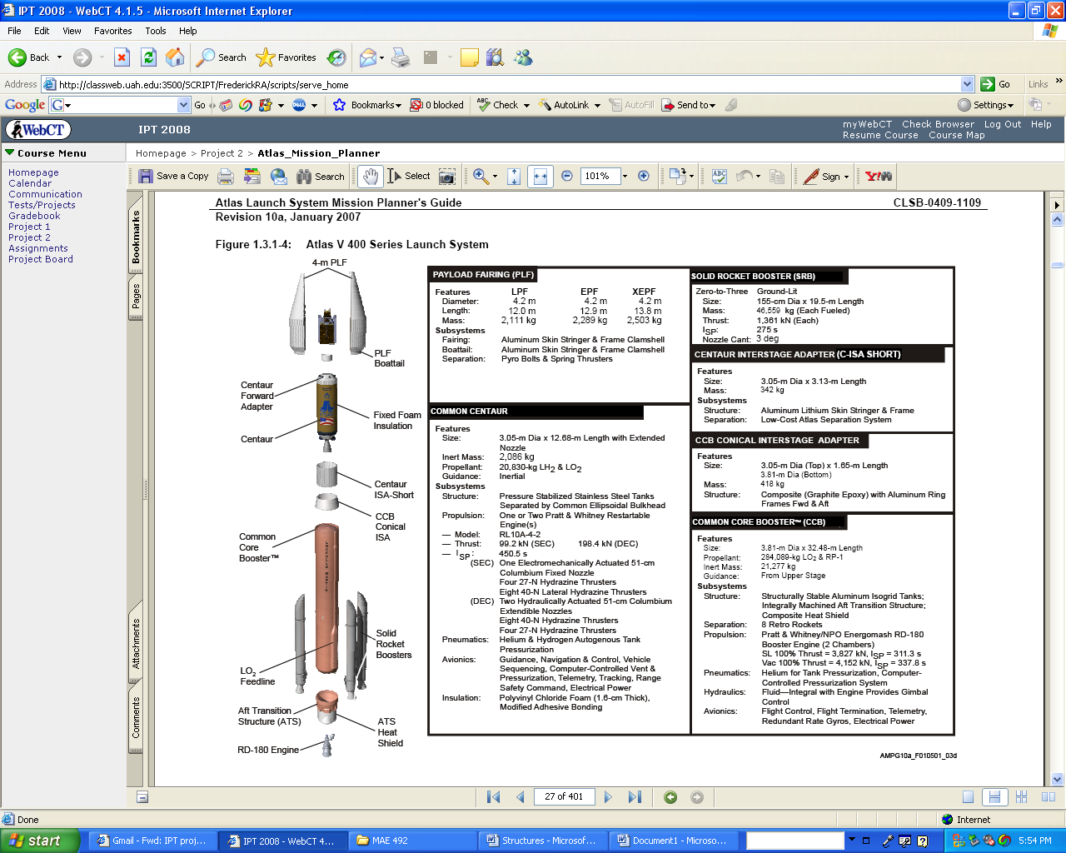
The above diagram shows the Atlas V 400 Series Launch System that is used to launch the lander. The payload fairing information was especially useful in designing the lunar lander for launch.
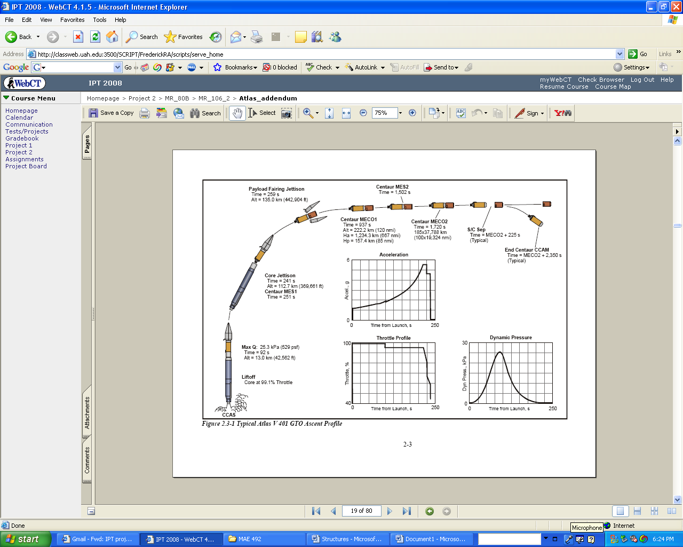
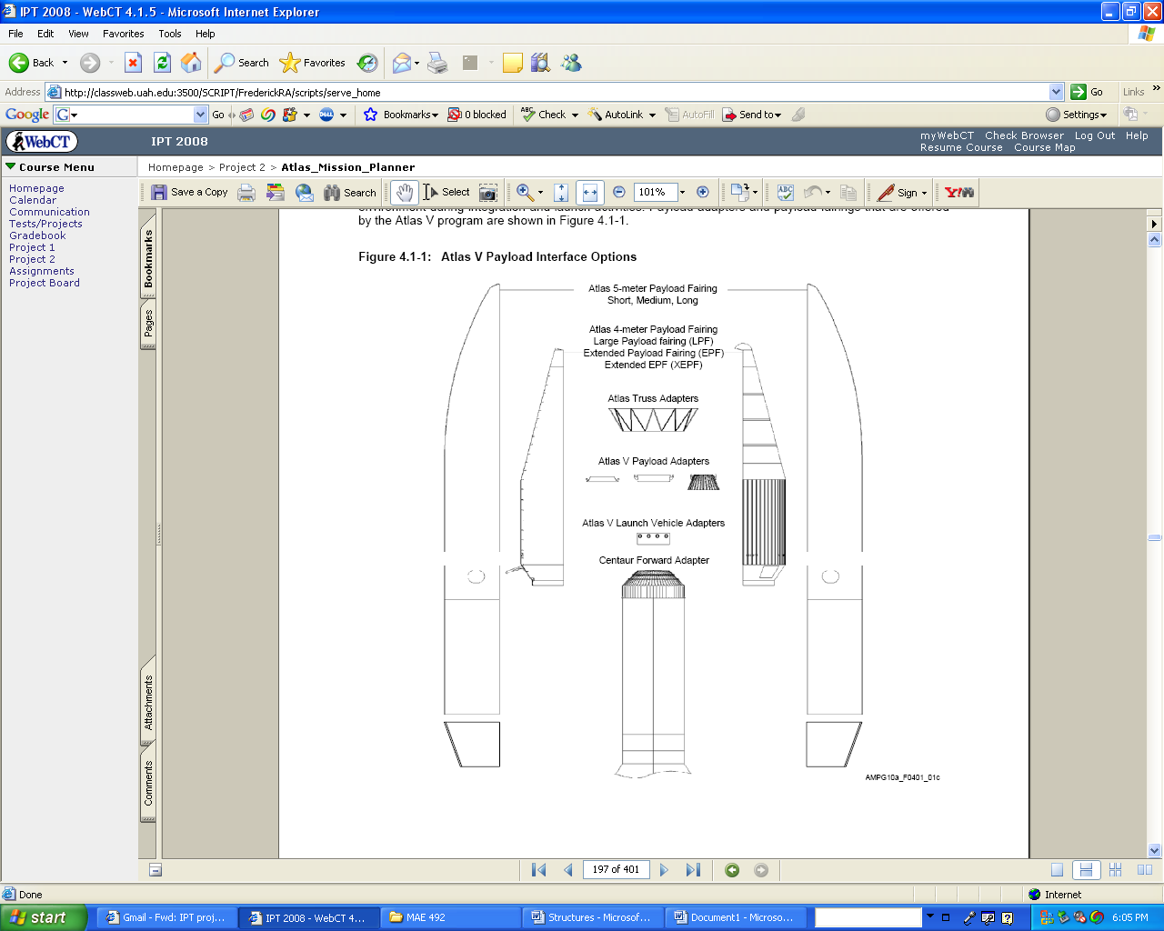
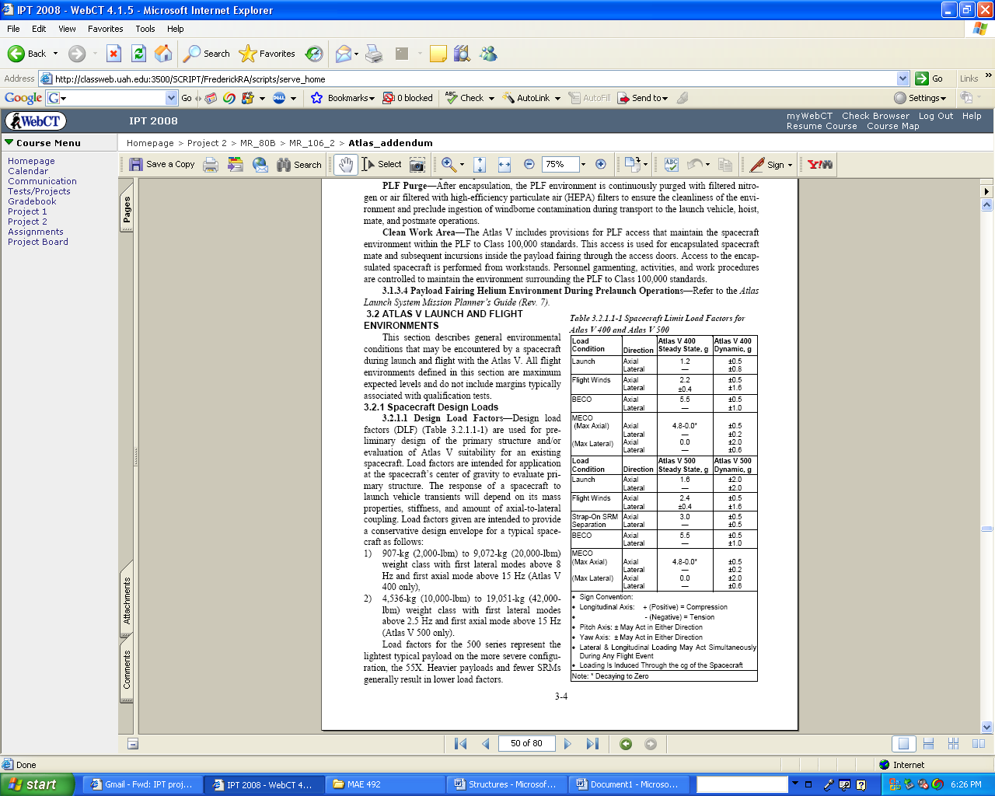

These calculations show the force acting on each wheel of the lander at launch.
The force at launch will be the greatest amount of force seen by the structure.
Free Body Diagram
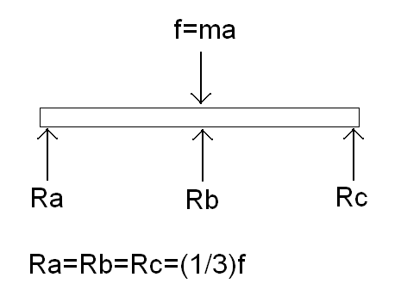
Total weight of lander
Max acceleration seen at launch
Total force acting on lander
Force acting on each side of the lander rocker bogey during launch
Force acting on each wheel during launch
Maximum force each wheel can handle
Since f2 is less than fmax, the structure will be able to handle the maximum force seen at launch

These calculations show that the lander is capable of landing on a 12 degree slope.
The calculations are done on the worst case scenario for the lander.
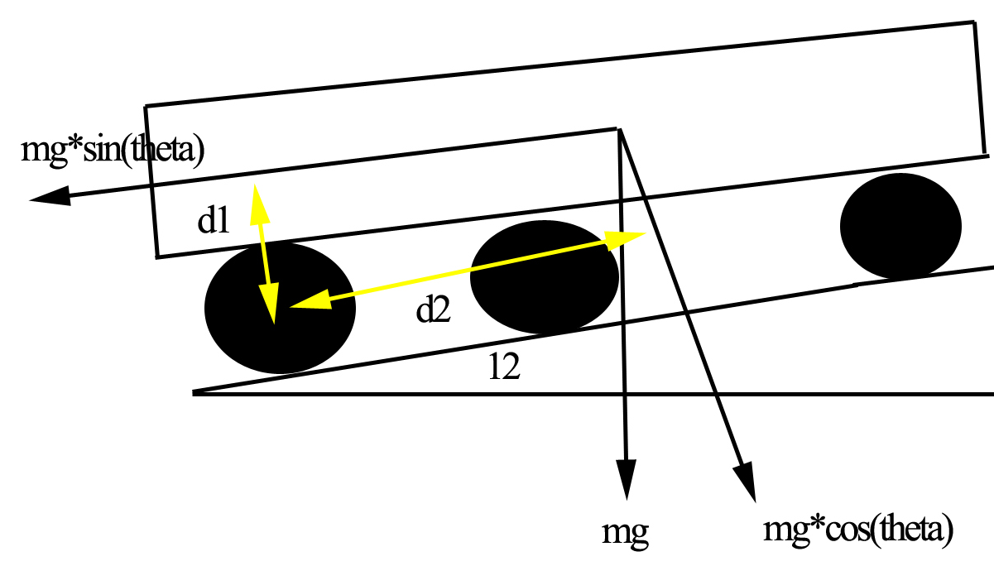
Since the magnitude of T1 is less than the magnitude of T2, the lander will safely land on a 12 degree angle.
Aluminum 6061 T6

Density | 2.7 g/cc | 0.0975 lb/in³ | AA; Typical
Mechanical Properties

Hardness, Brinell | 95 | 95 | AA; Typical; 500 g load; 10 mm ball
Hardness, Knoop | 120 | 120 | Converted from Brinell Hardness Value
Hardness, Rockwell A | 40 | 40 | Converted from Brinell Hardness Value
Hardness, Rockwell B | 60 | 60 | Converted from Brinell Hardness Value
Hardness, Vickers | 107 | 107 | Converted from Brinell Hardness Value
Ultimate Tensile Strength | 310 MPa | 45000 psi | AA; Typical
Tensile Yield Strength | 276 MPa | 40000 psi | AA; Typical
Elongation at Break | 12 % | 12 % | AA; Typical; 1/16 in. (1.6 mm) Thickness
Elongation at Break | 17 % | 17 % | AA; Typical; 1/2 in. (12.7 mm) Diameter
Modulus of Elasticity | 68.9 GPa | 10000 ksi | AA; Typical; Average of tension and compression. Compression modulus is about 2% greater than tensile modulus.
Notched Tensile Strength | 324 MPa | 47000 psi | 2.5 cm width x 0.16 cm thick side-notched specimen, K_{t} = 17.
Ultimate Bearing Strength | 607 MPa | 88000 psi | Edge distance/pin diameter = 2.0
Bearing Yield Strength | 386 MPa | 56000 psi | Edge distance/pin diameter = 2.0
Poisson's Ratio | 0.33 | 0.33 | Estimated from trends in similar Al alloys.
Fatigue Strength | 96.5 MPa | 14000 psi | AA; 500,000,000 cycles completely reversed stress; RR Moore machine/specimen
Fracture Toughness | 29 MPa-m½ | 26.4 ksi-in½ | K_{IC}; TL orientation.
Machinability | 50 % | 50 % | 0-100 Scale of Aluminum Alloys
Shear Modulus | 26 GPa | 3770 ksi | Estimated from similar Al alloys.
Shear Strength | 207 MPa | 30000 psi | AA; Typical
Electrical Properties

Electrical Resistivity | 3.99e-006 ohm-cm | 3.99e-006 ohm-cm | AA; Typical at 68°F
Thermal Properties

CTE, linear 68°F | 23.6 µm/m-°C | 13.1 µin/in-°F | AA; Typical; Average over 68-212°F range.
CTE, linear 250°C | 25.2 µm/m-°C | 14 µin/in-°F | Estimated from trends in similar Al alloys. 20-300°C.
Specific Heat Capacity | 0.896 J/g-°C | 0.214 BTU/lb-°F
Thermal Conductivity | 167 W/m-K | 1160 BTU-in/hr-ft²-°F | AA; Typical at 77°F
Melting Point | 582 - 652 °C | 1080 - 1205 °F | AA; Typical range based on typical composition for wrought products 1/4 inch thickness or greater; Eutectic melting can be completely eliminated by homogenization.
Solidus | 582 °C | 1080 °F | AA; Typical
Liquidus | 652 °C | 1205 °F | AA; Typical
Processing Properties

Solution Temperature | 529 °C | 985 °F
Aging Temperature | 160 °C | 320 °F | Rolled or drawn products; hold at temperature for 18 hr
Aging Temperature | 177 °C | 350 °F | Extrusions or forgings; hold at temperature for 8 hr

Carbon Fiber Material Properties

Physical Properties | Metric | English | Comments
Density | 1.81 g/cc | 0.0654 lb/in³
Mechanical Properties | Metric | English | Comments
Tensile Strength, Ultimate | 3800 MPa | 551000 psi | Tow Tensile Test
Modulus of Elasticity | 228 GPa | 33100 ksi | In Tension; Tow Tensile Test
Electrical Properties | Metric | English | Comments
Electrical Resistivity | 0.00155 ohm-cm | 0.00155 ohm-cm
Material Components Properties | Metric | English | Comments
Carbon, C | 95.0 % | 95.0 %

