  - The Solution

    - Concept Overview

The concept proposed by team Frankenstein is one of reliability and mission success. The Cyclops is designed to be a fail proof multi-mission lander/rover that not only meets but exceeds the mission parameters of the LETS requirements. The Cyclops’ added reliability allows for possible malfunction during its mission but not total mission failure. During the first stage of the Cyclops’ mission, penetrators are deployed prior to landing. If any of the penetrators fail, the Cyclops will have the ability to acquire any of the missing/needed samples due to its mobility and multi-mission ability. The Cyclops offers not only a high percentage in initial mission success, but reliability in redundancy for mission objectives.

- Figures of Merit. The following Figures of Merit (FOM) will be used to evaluate the LETS design concepts.

  - Number of surface objectives accomplished (as outlined below)
  - Percentage of mass allocated to payload
  - Ratio of objectives (SMD to ESMD) validation (2 to 1 being the goal)
  - Efficiency of getting data in stakeholders hands vs. capability of mission
  - Percentage of mass allocated to power system
  - Ratio of off-the-shelf hardware to new development hardware

    - Dimensional Properties

CAD drawings will be in the next draft of the Final Report and will reflect the following MSL design.

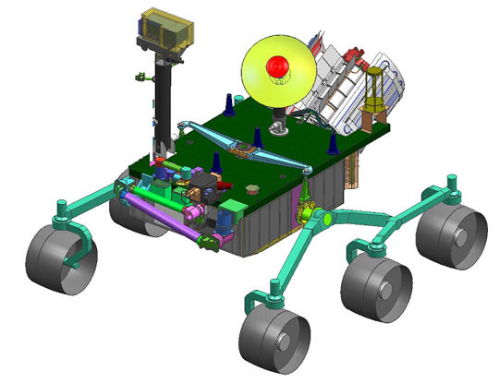
Figure x
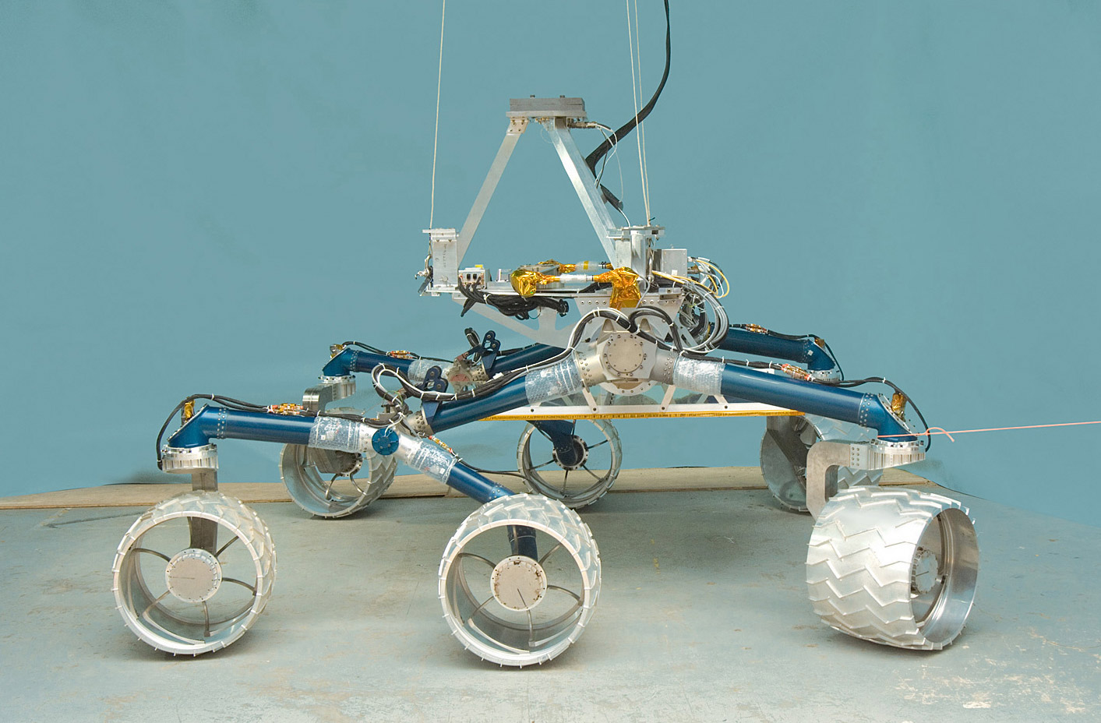
Figure x

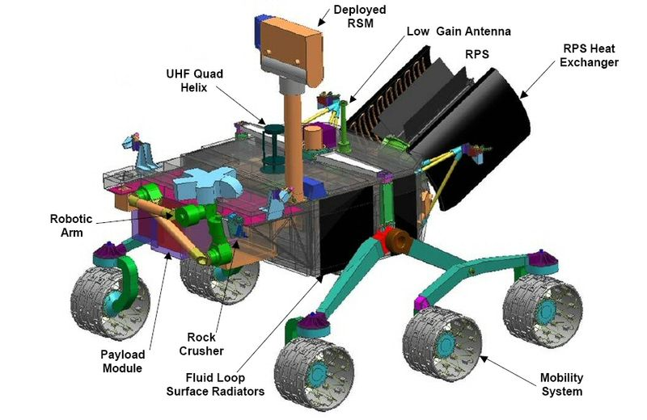
Figure x

    - Operations Scenarios

While in lunar orbit/descent the Cyclops will deploy fifteen penetrators from a launch ring positioned between the rover and the attitude control system. The penetrators once released, will utilize their kinetic energy in order to impact the lunar surface at targeted dark sites and relay data back to the Cyclops rover once the rover has landed. The attitude control system will then carry the Cyclops out of the dark region where it will land and separate from the attitude control system and the penetrator launch ring. This process is shown in Figure X below. Once landed, the Cyclops will rove to a suitable site in order to deploy our single site observation device with the attached sample return vehicle. The Cyclops will then begin its data acquisition from the dark site penetrators and acquiring lighted samples outside the dark region. If any of the launched penetrators fail to operate successfully, the Cyclops rover will then proceed to said dark sites and acquire the lunar samples itself. All data acquired will either be stored for direct transmission to earth or relayed through the LRO if necessary. The single site observation device that was deployed upon lunar landing of the Cyclops will acquire the lighting conditions, micrometeorite flux, and assess the electro static dust conditions. In addition to the recorded data, a sample return vehicle will be integrated with the single site observation device in order to return actual raw material to earth for further study.

1
2
3
4
5
6
7
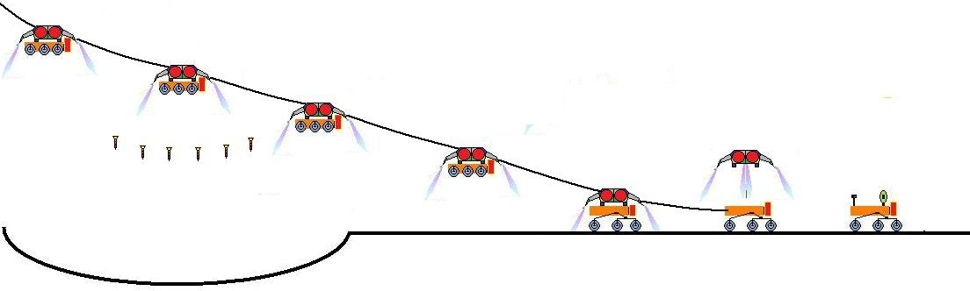
Figure X – Cyclops Decent and Penetrator Deployment in Shackleton Crater
1) Attached to the attitude control system, Cyclops starts descent, 2) Penetrators are released, 3-4) Cyclops continues descent, 5) Cyclops lands, 6) Attitude control system detaches from Cyclops, and 7) Cyclops begins to rove.

  - The Performance

Final Concept Evaluation

CDD Requirement | Requirement | Assessment | Remark
Landed Mass | 932.8 kg | Exceeds | Actually 810 kg
Survive Lunar Cruise | 28 days | Exceeds | Capable of surviving lunar cruise exceeding 28 days
Operational Period | 1 year | Exceeds | TRL 9 materials will remain functional beyond 1 year
Sample Lunar Surface | 15 dark | Exceeds | Mobility allows roving to as many sites as is needed
Communication | Send and Receive (real time) | Exceeds | Capable of sending data at 150 Mbps
Landing Parameters | 12º slope Within 100 m. | Exceeds | Six wheel rocker bogey system allows landing on slopes greater than 12 degrees
Survive Launch of 6 G's | 6 G's | Exceeds | Cyclops structure will handle g-loads exceeding 6 g’s
Technology Requirements | TRL9 | Meets | Materials used are TRL 9
Power Requirements | Store Power in Dark Conditions | Exceeds | RTG can provide the power needed during dark conditions
Thermal Conditions | Survive Temperature Changes | Exceeds | Materials used will withstand temperatures exceeding the 50K to 380K range
Sample Return Vehicle | Sample Return (Goal) | Exceeds | Exceeds the sample return expectations
Mobile | Roving/Real-Time Mobility | Exceeds | 6 wheel rocker bogey allows roving in real-time

