  - Dimensional Properties
Attitude Control System
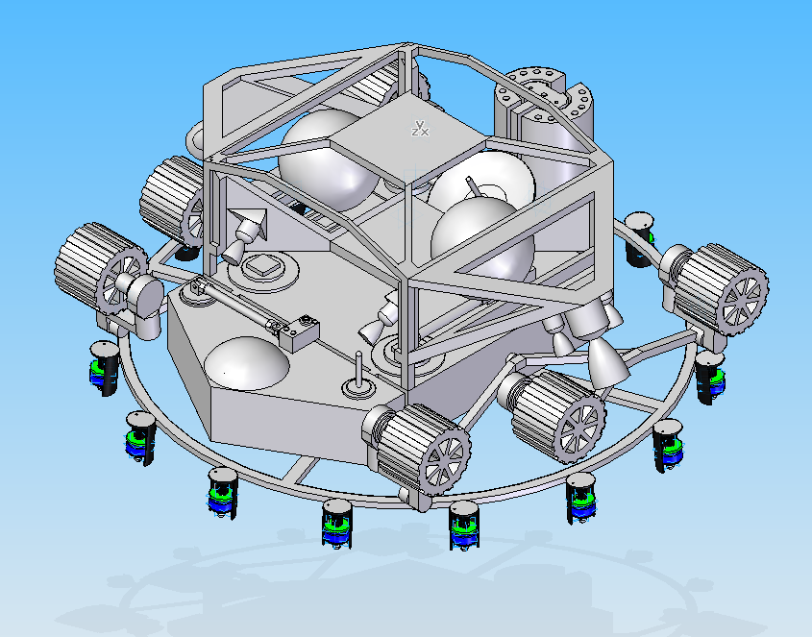
SRV
Penetrator
Penetrator Ring
Wheel
Figure 1 (Transport and Descent Configuration) ISO

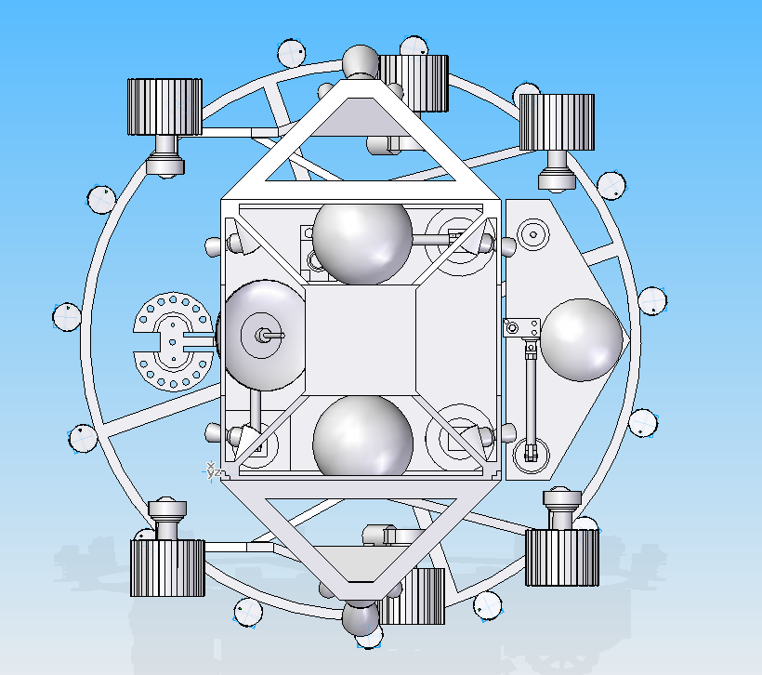
Hydrazine Tank
RTG
Figure 2 (Transport and Descent Configuration) Top
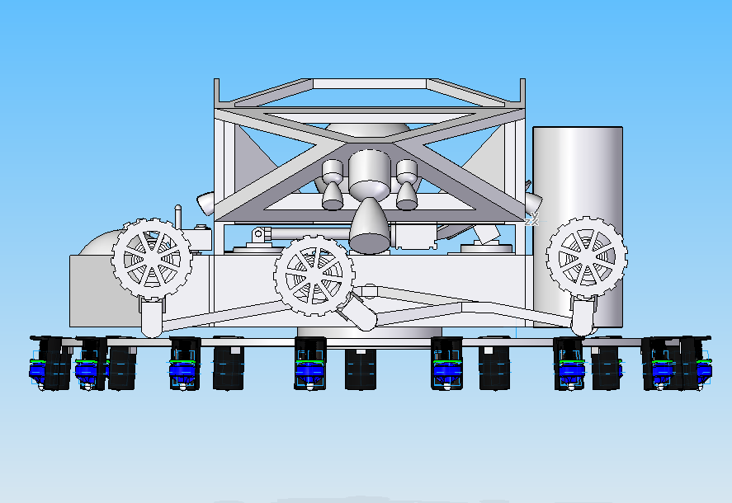
MR 80B
MR 106
Figure 3 (Transport and Descent Configuration) Side

The transport and descent configuration consist of the rover in stowed position, the attitude control system, and the penetrator ring platform with its attached penetrators. In this configuration it will be stowed in the Atlas V 4-mLPF. After separation from the Atlas, the attitude control system will navigate to the desired target zone and deploy the penetrators and jettison the ring.

System Specifications (Auxiliary Systems)
- Penetrator Ring Platform
  - Outer Diameter- 125.586 in.
  - Inner Diameter124.586 in.
  - Mounting ring- 13 in. Outer Diameter (11.5 in. Inner Diameter)
  - Aluminum Construction (6061 T6)

- Attitude Control
  - Main thrusters- MR 80B
  - Attitude Control Thrusters- MR 106
  - Hydrazine Tank x 2- 21.652 Outer Diameter
  - Aluminum Frame (6061 T6)- (112.83in. Max Width)
(60.793 Max Length) (34.597 Max height)

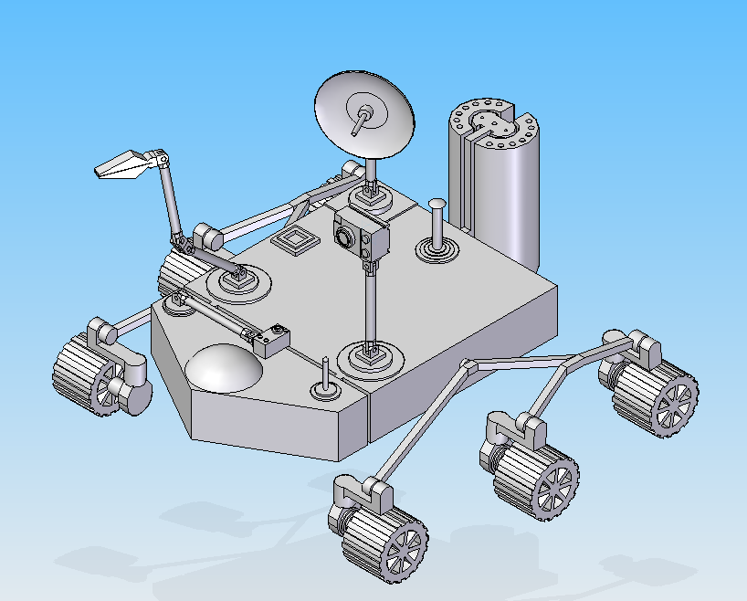
High Gain Antenna
Camera
Scoop Arm
Low Gain Antenna
Small Low Gain Antenna
Figure 4 (Deployed Configuration) ISO

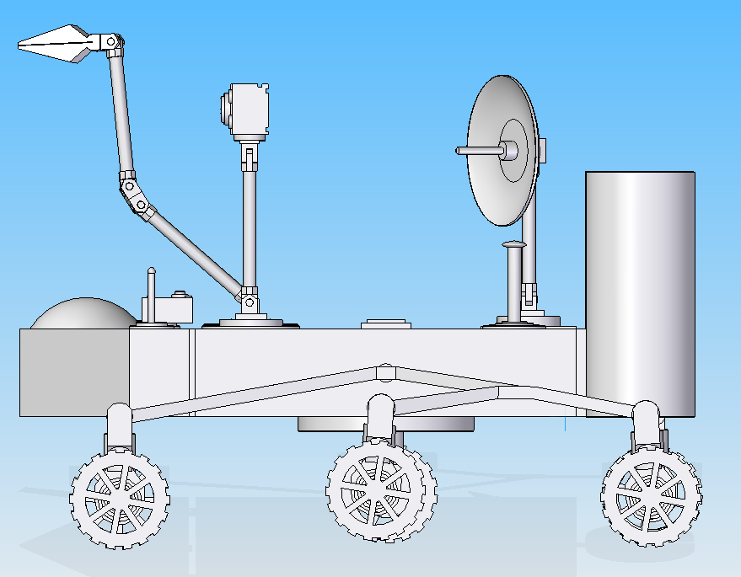
Figure 5 (Deployed Configuration) Side

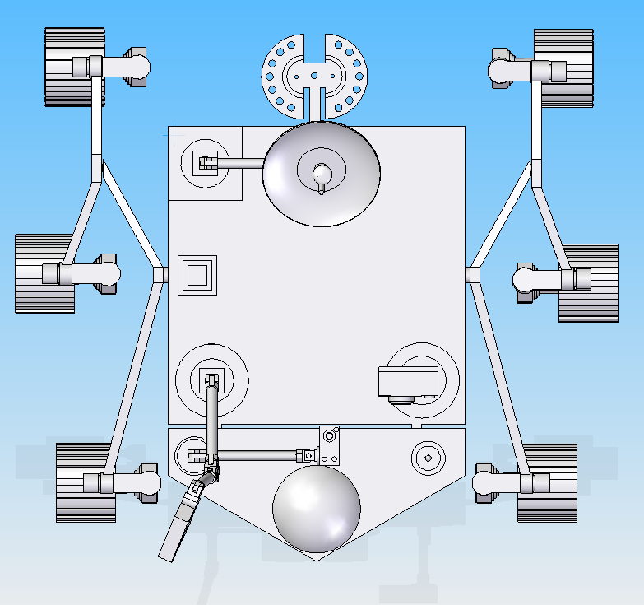
Single Site Box
Figure 6 (Deployed Configuration) Top

Once soft landing has occurred, the attitude control system will detach and use the remainder of its fuel to safely crash land away from the rover. In this configuration the rover can begin to acquire data from the landed penetrators and begin to take samples itself using the scoop arm and depositing said samples into starboard side deposit bay. In addition, once a suitable site is found, the single site box can be deployed along with its attached sample return vehicle.

System Specifications (Main)
- Rocker Bogie Wheel x 6
  - 13 in. Outer Diameter (Aluminum Construction-6061 T6)

- Single Site Box
  - Max Width-60.793 in.
  - Max Length-27.09 in.
  - Max Height- 14 in.

- Sample Return Vehicle
  - Max Diameter- 9 in.
  - Max Height- 13 in.
- Camera
  - Dimensions- 12 x 8 x 6

- Main Chassis
  - Dimensions- 60.793 x 60.793 x 14 in.
  - Aluminum Frame
  - Carbon composite exterior
  - MLI Insulation

- Rocker Bogie Suspension
  - Aluminum construction (6061 T6)
  - Maxon EC 60 Brushless DC motor (60mm) x 6

- Scoop Arm
  - Max Reach- 68in.

