Explosive Bolts are used to firmly attach mating items and then allow remote separation on command.  CAD Explosive Bolts come in two general types: fragmenting and non-fragmenting. The former, while more compact and economical, can produce a small amount of fragmentation and do liberate the products of combustion of the pyro/explosive material used. Non-fragmenting bolts separate cleanly without fragmentation and contain all products of combustion. CAD's Undersea-capable bolts are typically of the non-fragmenting type.  CAD Explosive Bolts are manufactured using a wide range of materials, which can be selected to maximize strength and corrosion resistance and/or minimize weight or electrical conductivity.  As with our other pyrotechnically powered devices, a small amount of electrical energy can liberate a large amount of chemical energy and translate this to a large amount of mechanical work. |  | 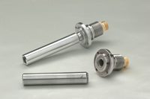

Applications:
- On-Command separation of stages/sections on aerospace vehicles.
- Release of payload and/or stores on air vehicles.
- Release of payload, malfunctioning manipulator arms, ballast plates, etc. on undersea vehicles (Manned or Remotely Operated).
Performance:
- Tensile strengths from 300 to 85,000 lbs-Force.
- Materials cut: Fiber Optics; Stainless Steel Wire Rope; Armored Composite Tether; Steel, Stainless Steel, Titanium, etc. Structural Members.
- Operating Temperatures of -65° F. to 420° F. (-54° C. to 215° C.)
- Undersea Applications rated to 15,000 PSI.
- Materials: Stainless Steel, Inconel, Plated Carbon Steel and Plastic.

Representative Part Numbers and Characteristics
Part Number | Thread | Type | Tensile Strength | Material | Figure (Typical)
056003 | 1/2-20 | Fragmenting | 5,000 lbf | 4130 Steel, Cadmium Plated | Figure 1
056038 | 10-32 | Non-Fragmenting | 1,400 lbf | 300 Series Stainless Steel | Figure 2
056222 | 3/8-24 | Non-Fragmenting | 6,000 lbf | 18-8 Stainless Steel | Figure 3
057018 | 7/8-14 | Fragmenting | 80,250 lbf | Inconel  718 | Figure 4
9090020 | 3/4-16 | Non-Fragmenting Undersea | 18,000 lbf | Stainless Steel | Figure 5
9090038 | M20-2.5 (Metric) | Non-Fragmenting Undersea | 15,000 lbf | 17-4PH Stainless Steel | Figure 6
Representative Outlines

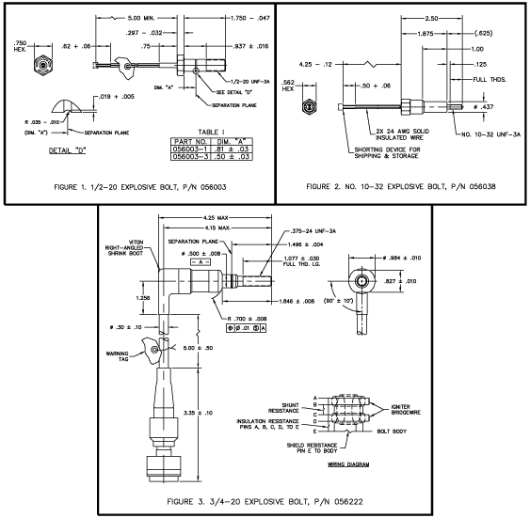
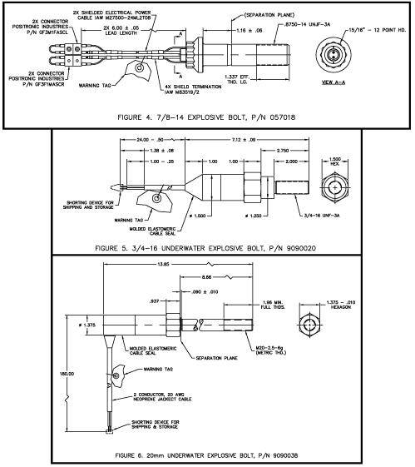

Copyright © 2004, Cartridge Actuated Devices, Inc.

Pyrotechnic fastener

From Wikipedia, the free encyclopedia
(Redirected from Explosive bolt)
Jump to: navigation, search
This article needs additional citations for verification.
Please help improve this article by adding reliable references. Unsourced material may be challenged and removed. (April 2008)
A pyrotechnic fastener (also called an explosive bolt, or pyro, within context) is a fastener, usually a nut or bolt, that incorporates a pyrotechnic charge that can be initiated by a remote command^{[citation needed]}. Explosive charges embedded within the bolts are typically activated by an electric current, and the charge instantly breaks the bolt into two or three pieces^{[citation needed]}. The bolt is typically scored around its circumference at the point(s) where the severance should occur^{[citation needed]}. Upon detonation a select part of the fastener rapidly disassembles without producing any shrapnel or fragments, freeing the mated units from each other. They are often used in space applications to ensure separation between rocket stages, since they are lighter and far more reliable than mechanical latches^{[citation needed]}.
Often the term "explosive bolt" is used to refer to pyrotechnic fasteners in general. For example it is often stated that the Space Shuttle is held to the launch pad with explosive bolts but it is actually the large "frangible nuts" that each contain two pyrotechnic charges that split the nut into two pieces.
For the safety and reliability reasons, exploding bridgewire detonators and slapper detonators are frequently used in aerospace technology in place of classical blasting caps^{[citation needed]}.
More recent developments have utilized pulsed laser diodes to detonate initiators through fiber-optic cables which subsequently fire the main charge.
Gas generators are close cousins of pyrotechnic fasteners^{[citation needed]}. They are used to generate large amounts of gas, eg. for turbopumps, to inflate balloons especially airbags, to eject parachutes, and for other such applications^{[citation needed]}.

[edit] Compositions used
Various pyrotechnic compositions can be used, depending on the desired burn rate and required amount of energy and volume of gas produced^{[citation needed]}. Some materials, eg. RDX, sublimate in vacuum, which limits their usefulness in aerospace applications^{[citation needed]}. Composition with the character of bipropellants and flash powders are often used^{[citation needed]}.

[edit] Standard pyrotechnic mixtures used by NASA
- Manganese/barium chromate/lead chromate: time delay mix, used for sequencing. Gasless burning.
- RDX/nitrocellulose: gas generator, unsuitable for deep space missions, burn rate dependent on pressure.
- Boron/potassium nitrate: gas generator and rocket motor igniter, thermally stable, stable in vacuum, burn rate independent of pressure.
- Zirconium/potassium perchlorate: NASA standard initiator (NSI). Rapid pressure rise, little gas but emits hot particles, thermally stable, vacuum stable, long shelf life. Sensitive to static electricity.
- Lead azide: used in detonators. Sensitive to impact, friction, and static electricity. Thermally and vacuum stable, if dextrin not used for desensitizing. Long shelf life.
- Hexanitrostilbene: used in detonators, linear shaped charges, and bulk explosives. Insensitive to stimuli other than explosion. Thermally stable. Vacuum stable. Detonates at 22,000 ft/s.

[edit] External links
- Article detailing the use of explosive bolts by NASA
- Explosive bolts being used to power rescue cutting equipment
- [1]
Retrieved from "http://en.wikipedia.org/wiki/Pyrotechnic_fastener"
Categories: Fasteners | Pyrotechnics
Hidden categories: Articles needing additional references from April 2008 | All articles with unsourced statements | Articles with unsourced statements since April 2008

