Final Proposal:
Advanced Tactical Missile
(ATM)

IPT 3

Submitted By:
Warbird Concepts, Inc.


July 31, 2026

Submitted To:
Michael P.J. Benfield
Lecturer
Technology Hall N231
Department of Mechanical and Aerospace Engineering
University of Alabama in Huntsville
Huntsville, AL 35899
pj_benfield@msn.com
Class Web Page: http://www.eb.uah.ed

Executive Summary

The need for higher technology, precision weapons that will be easily integrated into today’s armed forces has led to the development of the TIGER (Tube-Launched, INS/GPS Enhanced Rocket). The TIGER is an Advanced Tactical Missile (ATM) that is capable of being fired from the current M261 launcher found on such diverse platforms as HMMWVs and Apaches. Its similarity to the existing missile allows for easy integration into current system since the TIGER not only uses the same launcher but also the same warhead, storage containers, and much more. These similarities, however, do not interfere with the TIGER’s capabilities. Its guidance package provides increased accuracy and its modern propellant greatly extends its range, placing troops using it farther out of harms way. The relatively low cost as well as the ease of manufacturing due to the TIGER’s use of existing guidance components and standard materials make the TIGER an excellent choice to add to the arsenal of the future.

CDD Compliance List

The list shows the location in the CDD provided by the customer of every specification and the number of the page where that specification is dealt with in this proposal.
Specifications | CCD Location | Proposal Location
Operational between 61.0 m (200 ft) below MSL and 6,096.0 m (20,000 ft) above MSL | 2.2.1.1.1 | 2.8
Minimum Range of 8 km (4.97 mi) when fired from Helicopter | 2.2.1.2.1 | 2.3.4.2
Minimum Range of 4 km (2.5 mi) when fired from Ground | 2.2.1.2.1 | 2.3.4.2
Maximum Platform Error of 19 milliradians | 2.2.1.2.2 | 2.3.4.2
Operational under Maximum Crosswind of 7.7 m/s (15 knots) | 2.2.1.2.3 | 2.3.4.2
Deliver M261 Warhead to Wall in Space | 2.2.1.2.4 | 2.3.4.2
Minimum Launcher Exit Velocity of 43 m/s (141 fps) | 2.2.1.2.5 | 2.3.3
Minimum Smoke Signature | 2.2.1.2.6 | 2.4.1.2
Motor Cannot Produce Damaging Ejecta | 2.2.1.2.7 | 2.8
Use one of two propellants given | 2.2.1.3 | 2.4.1.2
Capable of being loaded in arctic gear | 2.2.2.1 | 2.8
Compatible with the M261 Launcher | 2.2.2.2 | 2.8
Compatible with the M261 Launcher Interfaces | 2.2.2.2.1 | 2.8
Minimal Longitudinal Force Greater than 13.5 times the Maximum System Weight | 2.2.2.2.2 | 2.3.1
Modified Fusing System for M261 MPSM Warhead | 2.2.2.3 | Appendix I
Submunition Deployment Velocity 603 m/s(1978 fps) | 2.2.2.3.3 | Appendix I
Safe and Arm device | 2.2.2.3.2 | Appendix I
Submunition Deployment to occur at Wall in Space | 2.2.2.3.1 | Appendix I
Maximum Acceleration of 79 g | 2.2.2.3.2 | 2.3.3
Maximum System Weight of 297 kg(654.6 lbs), ObjectiveWeight of 267.9 kg (590.0 lbs) | 2.2.3.1 | 2.2
Maximum System Length of 202.4 cm (79.7 in), Objective Length of 182.1 cm (71.7 in) | 2.2.3.2 | 2.2
Maximum Outer Diameter of 70 mm (2.794 in) | 2.2.3.3 | 2.2
Minimum Service Life of 10 years, Objective of 25 years | 2.2.4.1 | 2.8
Maximum Unit Production Cost of $15,000/unit on 10,000 units w/ Objective Cost of $10,000/unit | 2.2.4.2 | 2.6.2
Stowable Temperature Range from -53.8ºC (-65ºF) to 73.9ºC (165ºF) | 2.2.5.1 | 2.8
Operational Temperature Range from -45.5ºC (-50ºF) to 65.5ºC (150ºF) | 2.2.5.1 | 2.8
Operational During or After Constant 100% Humidity | 2.2.5.2 | 2.8
Minimum Hazard Classification of 1.1 with Objective of 1.3 | 2.2.6.1 | 2.8
Satisfying IM Compliance Requirements | 2.2.6.2 | 2.8
Flight Fail Safe | 2.2.6.3 | Appendix I
Minimum Ballistic Trajectory of 3.5 km (2.17 mi) |  | 2.3.4.2.1
Objective Ballistic Trajectory of 5 km(3.11 mi) |  | 2.3.4.2.1
Design for Manufacturability | 2.2.7.1 | 2.6
Manufacturing Plan | 2.2.7.2 | 2.6
Test Plan | 2.2.8 | 2.7
All Components of System shall be Unclassified | 2.2.9 | N/A
Documentation | 2.2.10 | N/A

Table of Contents
CDD Compliance List iv
List of Figures vii
List of Tables vii
Common Nomenclature and Acronyms ix
Team Specific Nomenclature and Acronyms x
IPT 3: Feasibility of Advanced Tactical Missile (ATM) 12
1.0 ATM – Advanced Tactical Missile 12
1.1 The Need 12
1.2 The Requirements 12
1.3 The Solution 13
1.3.1 Concept Overview 13
1.3.2 Dimensional Properties 14
1.3.3 Operations Scenario 15
1.4 The Performance 16
1.5 The Implementation 17
2.0 Technical Description of Methods Used 17
2.1 Project Office 17
2.2 Systems Engineering 18
2.3 Aerodynamics / Trajectory 20
2.3.1 Aerodynamics Methods and Assumptions 20
2.3.2 Results and Discussion 21
2.3.3 Trajectory Approach 24
2.3.4 Working with AP02 24
2.3.5 Final Conclusions 31
2.4 Propulsion 32
2.4.1 Propellant Design 32
2.5 Structures 37
2.5.1 Guidance Module Casing 37
2.5.2 Avionics / Guidance System 39
2.5.3 Propulsion Module Casing 39
2.5.4 Nozzle 42
2.5.5 Weight / Center of Gravity Analysis 46
2.6 Manufacturing 46
2.6.1 Propulsion 47
2.6.2 Nozzle 49
2.6.3 Guidance 49
2.6.4 Plant Location 49
2.6.5 Missile Cost 49
2.6.6 Final Assembly 50
2.7 Testing 50
2.8 Platform Integration 51
3.0 Company Capabilities Error! Bookmark not defined.
3.1 Company Overview Error! Bookmark not defined.
3.2 Personnel Description Error! Bookmark not defined.
4.0 Summary and Conclusions Error! Bookmark not defined.
5.0 Additional Recommendations Error! Bookmark not defined.
5.1 Propulsion Error! Bookmark not defined.
5.2 Nozzle Error! Bookmark not defined.
5.3 Motor Casing Error! Bookmark not defined.
5.4 Guidance System Error! Bookmark not defined.
References Error! Bookmark not defined.
Appendix A Concept Requirements Document Error! Bookmark not defined.
Appendix B Electronic Files Index Error! Bookmark not defined.
Appendix C Project Office Error! Bookmark not defined.
Appendix D Systems Engineering Error! Bookmark not defined.
Appendix E Aerodynamics / Trajectory Error! Bookmark not defined.
Appendix F Propulsion Error! Bookmark not defined.
Appendix G Structures Error! Bookmark not defined.
Appendix H Testing Error! Bookmark not defined.
Appendix I Guidance System Error! Bookmark not defined.

List of Figures
Figure 1: Artist Drawing 14
Figure 2: 3D Drawing Highlighting Key Features 14
Figure 3: Three-View Drawing 15
Figure 4: Operations Scenario 15
Figure 5: Information Flow Chart 19
Figure 6: Cross Sectional Drawing of the Missile 19
Figure 7: LVX Drawing of Aerodynamic Configuration 21
Figure 8: Drag Coefficient Versus Mach Number 22
Figure 9: Trim Normal Force 22
Figure 10: Trim Drag 23
Figure 11: Maneuverability – g’s Available for Pitch Maneuver 23
Figure 12: Maneuverability – Radius of Turn Maneuver 23
Figure 13: Failsafe Ballistic Trajectory - Ground Mission 25
Figure 14: Failsafe Ballistic Trajectory - Helicopter Mission 26
Figure 15: Line of Sight Ground Mission Range to Wall in Space 26
Figure 16: Dead On Ground Mission Velocity to wall in space 26
Figure 17: Dead On Helicopter Range to wall in space 27
Figure 18: Dead On Helicopter Velocity to wall in space 27
Figure 19: Ground Range with crosswind and platform error to wall in space 28
Figure 20: Ground Velocity with crosswind and platform error to wall in space …………..28
Figure 21: Crosswind and Platform Error Recovery for Ground Mission 28
Figure 22: Helicopter Range to wall in space with crosswind and platform error 29
Figure 23: Helicopter Velocities to wall in space with crosswind and platform Error 29
Figure 24: Crosswind and Platform Recovery Graph for Helicopter Mission 30
Figure 25: Maximum Lift/Drag Graph for Helicopter Mission 30
Figure 26: Maximum Lift/Drag Graph for Ground Mission 31
Figure 27: Maximum Achievable Helicopter Range 31
Figure 28: Maximum Achievable Ground Range 31
Figure 29: Grain Lengthwise Cross-Section 35
Figure 30: Grain Cross-Section at Slot Region 35
Figure 31: Thrust Versus Time with Temperature Effects 36
Figure 32: Pressure Versus Time 36
Figure 33: Burn Area Versus Web Distance 37
Figure 34: Guidance Case 38
Figure 35: Motor Case 39
Figure 36: Motor Bulkhead 40
Figure 37: Motor Case Metal Insert 40
Figure 38: Nozzle Aerodynamic Profile Used in APO2TM 44
Figure 39: Fin Closure 44
Figure 40: Original and Improved Nozzle Design 45
Figure 41: Original and Improved Fin Design 45
Figure 42: Propellant Mandrel 48
Figure 43: Proposed Design with Incorporated Revisions Error! Bookmark not defined.

List of Tables

Table 1: Final Concept Evaluation 16
Table 2: Summary of Technical Parameters Calculations 20
Table 3: Vehicle Weight Statement 20
Table 4: Propellant Properties 34
Table 5: Final Grain Parameters 35
Table 6: Test Matrix for the ATM 50

Common Nomenclature and Acronyms

Term | Definition
AHS |  | American Helicopter Society
AIAA |  | American Institute of Aeronautics and Astronautics
AMCOM |  | US Army Aviation and Missile Command
ATM |  | Advanced Tactical Missile
CDD |  | Concept Description Document
CPE |  | Computer Engineering
CG |  | Center of Gravity
Cm |  | centimeters
DATCOM |  | Data Communication
DoF |  | Degrees of Freedom
EE |  | Electrical Engineering
ESTACA |  | Ecole Supericure des Techniques Aéronautiques et de Construction Automobile
Ft |  | feet
Fps |  | feet per second
G |  | Gravity Units
GPS |  | Global Positioning System
HE |  | High Explosive
HERO |  | Hazards of Electromagnetic Radiation to Ordinance
I/O |  | Input/Output Document
IM |  | Insensitive Munitions
In |  | inch
INS |  | Inertial Navigation System
IPT |  | Integrated Product Team
K |  | one thousand
KCAS |  | Knots Calibrated Air Speed
Lbs |  | pounds
M |  | meter
m/s |  | meters per second
MAE |  | Mechanical and Aerospace Engineering
Mi |  | miles
MIL-STD |  | Military Standard
min |  | minimum
max |  | maximum
mil |  | milliradians
MPSM |  | Multipurpose Sub-munition
MSL |  | Mean Sea Level
N |  | Newtons
NA |  | Not Applicable
Ns |  | Newton seconds
Pa |  | Pascals
Psi |  | Pounds per square inch
UAH |  | University of Alabama in Huntsville
Vel |  | Velocity

Team Specific Nomenclature and Acronyms

Word or symbol | Comments
a | max acceleration or burning rate law coefficient
A* | nozzle throat area
A_{b,i} | initial burning surface area
ADAMS | CAD modeling program
AEROLAB | Rocket Drag and Stability Calculator – Version 1.2.1
A₀ | burn rate coefficient at T_{ref}
AP02 | Aeroprediction Code, 2002
c | maximum distance from the centroidal axis
C* | characteristic velocity
C₁ | cost of first missile produced
CAD | Computer Aided Design
CATIA | CAD modeling program
CD or C_{D} | coefficient of drag
Cf | thrust coefficient
C.G. or CG | center of gravity
CM | moment coefficient
CN | normal force
C_{n} | cost of the n^{th} missile
C_{N,TRIM} | trim normal force
d | diameter
D | drag
DATCOM | Missile DATCOM – Aerodynamics, Stability, and Control Calculation, 1997
DES-STAR | Design Star Propellant Grain Design Program
DoD | Department of Defense
d_{prop} | propellant diameter
FOPD | First Order Preliminary Design Program
F₀ | initial thrust
F_{max} | maximum thrust
g | gravity
GRAINS2 | Propellant Grain Design Program
h | convective heat transfer coefficient
HC | hazard classification
HMMWV | High Mobility Multi-purpose Wheeled Vehicle (also known as HUMVEE)
I | moment of inertia
IMU | inertia measurement unit
I_{sp} | specific impulse
I_{t} | total impulse
J_{o} | polar moment of inertia
k | Thermal conductivity
L | total length or learning curve
L/D | lift over drag
LAUNCH 2 | Rocket Trajectory Calculation Code version 2.01A
LVX | Launch Vehicle eXpert System, Launch Vehicle Aerodynamics Module – Version 4.0S
M | maximum bending couple moment
M_{i} | initial mass
M_{prop} | mass of propellant
MS | Microsoft
n | burning rate law exponent or number of missiles
N(g’s) | number of g’s
p | internal pressure of the casing
P | pressure
P_{a} | atmospheric pressure
Pi | initial position (lat,long,alt)
P_{max} | max pressure allowed
q | dynamic pressure
q” | heat transfer per unit area or heat flux
R | range
R_{turn} | radius of turn
r | radius of the casing or burn rate
r_{inner} | inside casing radius
r_{outer} | outside casing radius
S | section modulus of the casing
S_{ref} | reference area
SST | stainless steel
t | thickness of the casing
T | ambient temperature
T_{ref} | reference temperature
V_{prop} | propulsion volume
W_{L} | weight of missile in pounds
x | material thickness
α | angle of attack
γ | launch angle or specific heat ratio of combustion products
ρ_{p} | density of propellant
σ_{hoop} | hoop stress
σ_{longitudinal} | longitudinal stress
σ_{p} | propellant temperature sensitivity

IPT 3: Feasibility of Advanced Tactical Missile (ATM)

ATM – Advanced Tactical Missile

The Need
As each day passes technology continues to rapidly advance deeper into areas that were once thought impossible. This is clearly evident as competitors of all disciplines struggle day to day to provide the latest and most efficient product in their market. However, no industry is as heavily affected by the race for technological supremacy as the military. Likewise, it could be said that no other industry has been as influential and determined in the advancement of our way of life. Because of this determination, the military has achieved a status of power and precision that cannot be known by any other country. By implementing long-range guidance aided weaponry, the military has drastically reduced many of the grim aspects found in modern warfare. These highly precise weapons systems not only reduce the number of military casualties, but also ensure that innocent civilians are kept out of harms way. As the possibility of war presents itself each day, it becomes increasingly important to continue to produce and refine weapons of this nature.

While much of the focus on today’s military centers around precision guided bombs and missiles, not all of it’s arsenal is as advanced. One of the most commonly used rocket systems, the HYDRA-70, is based on technology from the Korean War time period. Despite being constructed using decades old ideas, the HYDRA is still implemented on platforms such as the Apache and HMMWV. While some critics feel that the HYDRA-70 system is outdated and simply needs to be replaced, others see opportunity and promise in the long-standing program.

In order to improve over the existing design, AMCOM is pursuing the development of the Advanced Tactical Missile (ATM) to replace the HYDRA-70. With extensive experience, AMCOM has consistently been an active leader in the field of missile development. With a variety of testing facilities readily available, AMCOM is perhaps the most sensible customer to lead the development of the ATM. As a commonly used weapon in today’s military, it is of utmost importance that the HYDRA-70 be upgraded to maintain its feasibility and success in today’s battlefield.

The Requirements
The ATM is a 2.75-inch GPS guided “fire and forget” weapon. It consists of a rocket motor, GPS guidance system, and a modified M261 MPSM warhead. The most important aspect of the re-designed ATM is compatibility with current 2.75-inch storage, transportation, and launch containers. It must be designed to mount to rotary and fixed wing aircraft and ground launch platforms, such as the M261 launcher currently in use on a variety of military platforms.

Compatibility requirements include size and weight restraints. The length must be no more than 202.4 cm (79.7 in.) with an objective length of 182.1 cm (71.7 in.) and a maximum outer diameter of 70 mm (2.794 in.) to ensure proper fit into the launch tube. Due to loading restrictions on aerial platforms, the total amount of weight that can be added to a 19-round M261 launcher is 297 kg (654.6 lbs) with an objective weight of 267.9 kg (590.0 lbs). This equates to 15.6 kg (34.4 lbs) per missile for a fully loaded launcher.

There are several enhancements that will be added to the 2.75-inch missile to make it more flexible and desirable. The range will be increased to at least 4 km (2.5 miles) when launched from a ground platform at a 20° inclination, and at least 8 km (4.97 miles) when launched from an aerial platform at a 15° inclination. This will allow troops to remain at an added distance from the fire zone. In case of guidance failure, the ATM must be capable of achieving a ballistic trajectory with a threshold range of 3.5 km, with an objective range of 5 km. The smoke signature and objective hazard must remain at a minimal (1.1), also to ensure troop safety.

The missile will contain an INS/GPS aid to guide the ATM. The guidance system will be capable of overcoming as much as a 19-milliradian error from the launch platform with a maximum crosswind of 7.7 m/s (15 knots). The exit velocity of the missile from the launch platform should not exceed 43 m/s (141 fps) with a maximum acceleration of 79 g. The impact velocity at a point in space should not exceed 603 m/s (1978 fps). The missile should be able to operate effectively in numerous weather conditions ranging from -45°C (-50°F) to 65.5°C (150°F) with 100% humidity.

Another important concern is cost of the ATM. It must be manufactured at a cost not to exceed $15K, with an objective cost of $10K per unit. A quantity of 10,000 units per year must be manufactured to include warhead. It must be designed for ease in manufacturing with a minimum 10-year service life with a design goal of a 25-year service life. These requirements laid the framework for the team to begin the design process. A detailed description of these requirements can be found in the Concept Description Document (CDD) located in Appendix A.

The Solution

Concept Overview
The solution proposed by Warbird Concepts, the TIGER, is a astonishing blend of technical harmony from all engineering disciplines based on the winning design of the Hawkeye from Spring 2003. The TIGER was designed to meet the needs of the Army by providing a cost-effective advanced tactical missile for launch in aerial and land-based scenarios. The missile is guided through control of the canards by the avionics subsystem. The TIGER is an extremely versatile weapon, capable of being deployed from the arctic, desert, and all climates in between. In addition, the missile can be stored for up to 10 years with no ill effects. Tail fins remain a straight, spring-loaded design to eliminate any rotating about the missile’s axis caused by the curved fins of the Hydra-70. The TIGER is now a formidable weapon because of the design enhancing-engineering of Warbird Concepts.

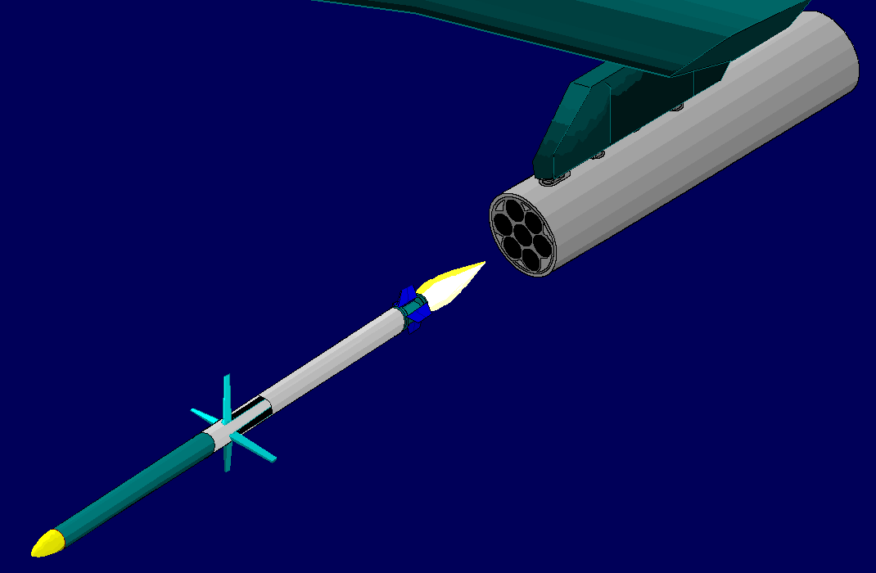
Figure 1: Artist Drawing

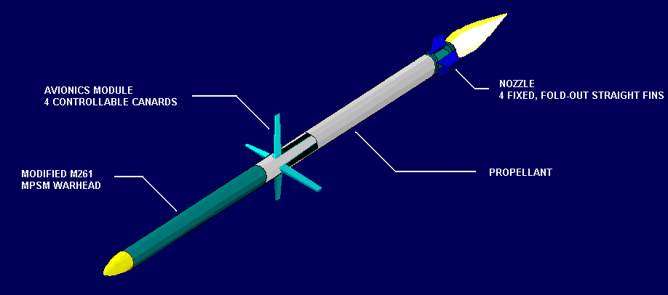
Figure 2: 3D Drawing Highlighting Key Features

Dimensional Properties

Figure 3 shows a three-view drawing of the TIGER:
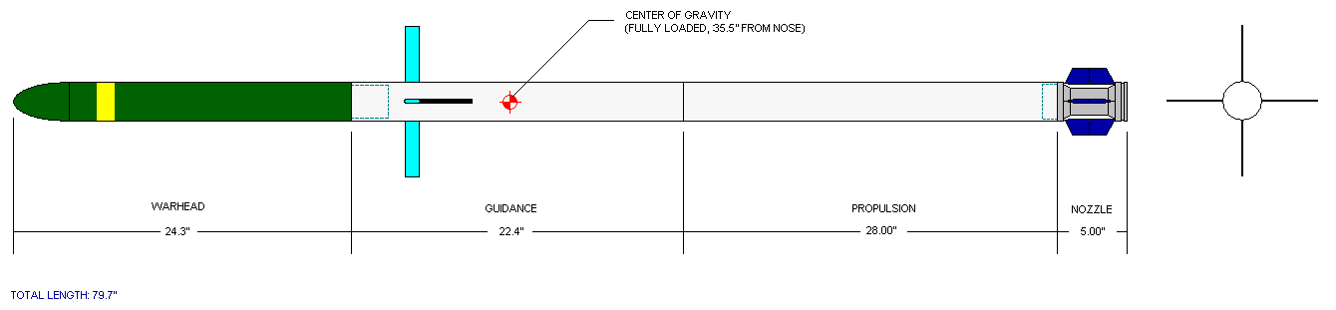
Figure 3: Three-View Drawing

Operations Scenario
The possible operations scenarios for the TIGER are outlined in Figure 4 below. In accordance with the CDD, TIGER meets all scenario requirements.

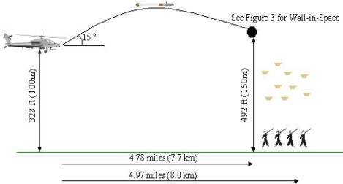 | 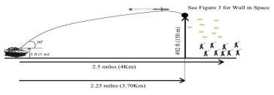
Figure 4: Operations Scenario

In preparation for a mission, the TIGER, or rather multiple TIGERs, are loaded into the M261 launcher. The loading procedure is very similar to that of the Hydra-70 rocket. Depending on aircraft or HMMWV loading, up to nineteen TIGER missiles can be carried in each launcher. This enables the aircraft or HMMWV to engage multiple targets as well as strike hardened targets with multiple munitions as delivered by the TIGER. After the fire sequence is initiated, commands are downloaded through cables to the avionics section of the missile. A targeting and ranging system on the launcher determines the exact location in space of the proposed target. GPS systems within the missile and on the launcher communicate through the umbilical to coordinate attack information. Once the missile has received this information, it can operate in “fire and forget” mode. When the operator selects a target, the igniter is set off through a command from the launch rig. When the propellant ignites, the TIGER is thrust forward, out of the launcher. As it deploys, first the canards, then the tail fins spring into place from their folded positions. Very little smoke signature is required in order to conceal the location of the missile’s launch. As the missile closes in on its target, the onboard GPS system blends its data with IMU data to correct position, velocity, and attitude state estimates. Servomotors receive commands from the avionics module in order to guide the missile towards its intended target. When the GPS system indicates the missile has reached the “wall in space” it has been targeting, the warhead is deployed. Multiple warhead designs are available, making the TIGER suited for striking a diverse list of targets. Upon detonation of the warhead, the TIGER has completed its mission.

The Performance
Table 1 summarizes the performance characteristics of the TIGER. These claims are substantiated in section 2.
Table 1: Final Concept Evaluation
CDD Requirement | Requirement | Assessment | Remark
Helicopter Mission | Min. Range of  8 km (4.97 mi.) | Exceeds | 10 km (6.21 mi)
Ground Mission | Min. Range of  4 km (2.5 mi.) | Exceeds | 10.25 km (6.37 mi)
Platform Error | Max. 19 mils. | Meets | Based on trajectory simulation
Crosswind | Max. 7.7 m/s (15 knots) | Meets | Based on trajectory simulation
Launcher exit Vel. | Min. 43 m/s (141 fps) | Exceeds | 44.64 m/s (146.46 ft/s)
Smoke Signature | Minimum Smoke | Meets | Minimum smoke
M261 Launcher | Compatible | Meets | Compatible
M261MPSM Warhead | Modified | Meets | Compatible with modified warhead
Acceleration | Max. 79g | Meets | 75.4 g
Velocity at wall in space | Max. 603 m/s (1978 fps) | Meets | 205.86 m/s (675.40 ft/s)
System Weight | Max.653.6 lbs (297 kg) | Meets | 592.971 lbs (268.97 kg) for 19 missiles
System Length | Max. 202.4 cm. (79.7 in) | Meets | 202.4 cm (79.7 in)
Unit Production Cost | Max. $15K/unit  10,000 units | Meets | $14,393.64
Temperature | Operation Conditions  -45.5°C(-50°F)- 65.5°C (150°F) | Meets
Hazards Classification | Min. 1.1  Objective 1.3 | Meets

The Implementation
The implementation of the TIGER can be subdivided into three basic areas: preparation, production, and deployment. These three topics will be discussed below.

In order to prepare the TIGER for use, a few issues must be addressed. First, the software that operates the guidance system must be chosen and verified. Next, the missile must be built and any unforeseen difficulties addressed that result from actual production. After possible redesign of elements that infringe upon production, the missile must be tested in the field under actual firing conditions. When the TIGER passes prototype production and testing, it will be ready for mass production.

Production will be a very straightforward process once preparation is complete. No new technology or production methods need be created to successfully produce the TIGER. All components are commercially available, or can be produced via conventional methods.

Because of the pre-existing Hydra-70 rocket, deployment of the TIGER will also be a diminutive task. TIGER fits into all Hydra-70 shipping containers. Once M261 launchers are modified to accommodate GPS units, as specified, there will be no compatibility issues with the launcher. Storage and life cycle issues are also identical between the Hydra-70 rocket and TIGER advanced tactical missile.

Technical Description of Methods Used

Project Office
Designing an ATM was a multi-step process. Each individual design group was constantly communicating in order to maintain overall compatibility. Despite having numerous major objectives to meet for the new ATM, the heart of the design process was centered about the propulsion and structures discipline. As a team all individuals felt that this area should be of the utmost importance. Once a propellant grain was designed and selected, the head of trajectory was responsible for ensuring that the missile would be capable of satisfying the requirements set forth in the CDD. Communication between these two departments was critical, being that if something were changed in the propulsion aspect, all data would have to be reanalyzed by trajectory to once again ensure compliance. Likewise, the head of structures was required to ensure that a casing could be constructed to house the propellant, comply with the requirements, and not alter the trajectory of the missile. All of this data would then in turn be passed to the system engineer, manufacturing, and testing disciplines to determine whether or not the current design remained feasible to manufacture and test. Throughout the design process problems were incurred and the design was refined in order to remain compliant. Further details concerning team operations can be viewed in Appendix C. Also, a depiction of information transfer between disciplines can be seen in Appendix C.

Throughout the design process there were no major design threatening problems. Multiple grain designs and casing materials were obtained giving the design team a variety of choices. However, the most critical decisions came in picking the most effective design. This demonstrated the many trade-offs often found in designing a product such as this. The following sections provide a detailed description of the final design and its performance. Also presented are the previously mentioned trade-offs and how they affected the team’s choice for the final design.

Systems Engineering
Adjusting the design of Team Three’s concept from Spring 2003 revolved around meeting the requirements of the customer as outlined in the CDD. The goal of TIGER Concepts was to make Team Three’s design feasible not only for use in the field, but actual production as well. The team began by choosing disciplines for each team member according to that member’s perceived intellectual strengths. Once disciplines were assigned, each team member set out to learn about the requirements in the CDD that directly affected his/her discipline. Each team member was also tasked with reading the text of Team Three’s final report from Spring 2003. Countless hours were spent with mentors and colleagues understanding the requirements set before us, and what it would take to meet those requirements.

Armed with information, the team then set out to achieve our goal. After learning to use the various software programs that are necessary for propellant and aerodynamic testing, iterating the data began. The team functioned in a manner very like the flow chart shown in Figure 5 below. Many ideas flowed back and forth between team members about improving the design. The team met twice a week for at least two hours to discuss and implement design changes. In addition, many team members spent considerable time outside of the designated meetings working on the design and its associated parameters. The Project Office ensured that everyone was focused on meeting the requirements of the CDD while disciplines communicated data back and forth to optimize the missile’s design (designated the “TIGER”).
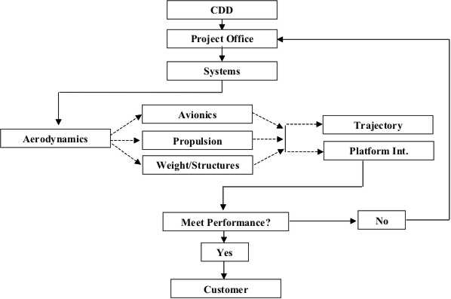
Figure 5: Information Flow Chart
Having a baseline concept to start with, Warbird Concepts never had to develop and choose between multiple concepts. Most time was spent tweaking grain and propellant design as well as nozzle parameters. A cross-sectional drawing of the missile is shown below in Figure 6. The nozzle section is the right center of the figure. Spring-loaded fins deploy upon launch of the missile. These fins provide stability and lifting surfaces for the missile. The propellant is located to the left of the nozzle. Propellant grain profile was optimized to give the best results in meeting the CDD. The case of the missile is made of a graphite-epoxy in order to abandon the aluminum case of the Hydra-70. The avionics section is located to the left of the propellant. This portion contains the guidance system and associated circuitry. The canards that guide the path of the missile during flight are further left of the guidance system. The canards are controlled by servomotors, which are fed information from the guidance system. At the far left is the warhead. Delivery of the warhead to the target is the main objective of the TIGER advanced tactical missile.

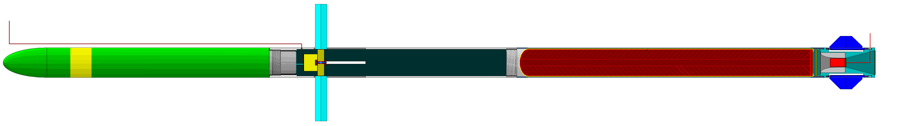
Figure 6: Cross Sectional Drawing of the Missile
Table 2 and Table 3 contain a breakdown of some of the key characteristics of the TIGER.

Table 2: Summary of Technical Parameters Calculations
Parameter | Properties
Gross Mass, lb (kg) | 14.156 kg (31.209 lbs)
Propellant Mass, lb (kg) | 2.999 kg (6.612 lbs)
Missile Length, in. (cm) | 2024.38 mm (79.7 in.)
Maximum Drag Coefficient | 3.0 (trim condition, at Mach=1.5, and canard deflection of 20°)
Propellant I_{sp}, sec | 215.5 sec
Total Impulse, lbf-sec (N-sec) | 6339 N-sec (1425 lbf-sec)
Case Thickness, in (cm) | 1.5875 mm (0.0625 in.)
Max Pressure, psi (MPa) | 14.72 Mpa (2134.482 psi)
Table 3: Vehicle Weight Statement
Parameter | Value | Value | Value
Warhead Mass Total |  | 13.600 lbs
Guidance Module
Guidance Casing | 2.210 lbs
Battery | 2.000 lbs
IMU | 0.800 lbs
Canards (4) | 0.240 lbs
Other Guidance Components | 2.230 lbs
Guidance Module Total |  | 7.480 lbs
Motor Assembly
Motor Case | 0.842 lbs
Propellant (initially) | 6.612 lbs
Nozzle Assembly | 1.265 lbs
Tail Fins (4) | 0.291 lbs
Other | 1.119 lbs
Motor Assembly Total |  | 10.129 lbs
Missile Net Takeoff Weight |  |  | 31.209 lbs

A weight statement in kg can be found in Appendix D.

Aerodynamics / Trajectory

Aerodynamics Methods and Assumptions
The purpose of the aerodynamic analysis was to determine the geometry of the missile that would meet the given requirements. This particular task was covered by the winning team of the previous semester. It was recommended by the instructor, Mr. Benfield, to focus on trajectory rather than aerodynamics so that a complete study could be completed by one person in the available time frame. The aerodynamic design is the same as the previous semester. The calculations and conclusions of the previous semester have been included for reference. The geometry was determined by trying to maximize lift and minimize drag while leaving room for maneuvering throughout the flight. Several computer codes were utilized to determine the aerodynamic characteristics of the missile. As a first-order analysis, AEROLAB was used to determine minimum drag coefficients. Once the basic design was chosen, Missile DATCOM was used to obtain a wider range of aerodynamic data, including drag, lift, and moment coefficients, trim data, hinge moments, center of pressure, and pressure distributions. This data was used for the analysis of the trade studies that determined the geometry of the missile. A supporting program, LVX, was used to visually determine the geometry inputs for DATCOM. Finally, AP02 was used in the analysis of the final design to compliment the DATCOM results and to provide the geometry and aerodynamic data for the trajectory simulations, as well as for the analysis of the aerodynamic bending and buckling stresses within the casings. The input and output files used in DATCOM, LVX, and AP02 can be found in Appendix E.

One important calculation for the maneuverability of the missile is the number of g’s available for pitch maneuvers. Equation 1 below is used to determine the available g’s. Values less than zero indicate that the missile does not meet lift-over-weight requirements for level flight, and values greater than zero indicate available maneuverability.
Equation 1 $n(g's)=\frac{q⋅S_{\text{ref}}⋅C_{N,\text{TRIM}}}{M_{i}⋅g}−1$
Another important calculation for the maneuverability of the missile in the lateral plane is the radius of turn calculation, as shown below in Equation 2. This equation gives the distance required for the missile to turn based on the lifting force, weight, and velocity of the missile.
Equation 2 $R_{\text{turn}}=\frac{M_{i}⋅{\text{Vel}}^{2}}{q⋅S_{\text{ref}}⋅C_{N,\text{TRIM}}}$

Figure 7: LVX Drawing of Aerodynamic Configuration

Results and Discussion
Figure 8 below shows the drag calculated by AP02 as a function of Mach number for both the original configuration and the added drag geometry. Figure 9 below shows the trim normal force at the minimum and maximum Mach numbers, based on the trajectory analysis. Figure 10 below shows the trim drag. Both plots show points at which the missile is flying at trim conditions, and they represent expected trends for lift and drag data Figure 11 below shows the pitch maneuverability of the missile. The design is maneuverable at Mach 0.5 and above, which is acceptable for the trajectory being flown. Figure 12 below shows the lateral maneuverability through one of the trajectory simulations for the design. Its calculated radius of turn at each point in the trajectory allows it to turn towards the targeted wall-in-space.

Figure 8: Drag Coefficient Versus Mach Number

Figure 9: Trim Normal Force
Figure 10: Trim Drag

Figure 11: Maneuverability – g’s Available for Pitch Maneuver

Figure 12: Maneuverability – Radius of Turn Maneuver

Trajectory Approach
There were two codes available for trajectory analysis. LAUNCH 2, a 2 DoF (degree of freedom) program was only used for checking velocities out of the tube. The actual trajectory analysis was completed by using AP02

LAUNCH is a 2 dimensional trajectory tool that was used for the early analysis of the missile. It takes inputs of rocket and grad data to determine trajectory outputs. Launch was used for checking velocities out of the tube and for calculating purely ballistic flight trajectory. It should be noted that it does not take into account lift or any type of guidance system.

LAUNCH Outputs for Exit Velocity and Max Acceleration
Condition | Exit Velocity | Max Acceleration
Hot Temperature | 51.81 m/s (170 fps) | 75.4g
Operating Temperature | 51.01 m/s (167.4 fps) | 65g
Cold Temperature | 44.64 m/s (146.5 fps) | 50.5g

The trajectory analysis in AP02 was the most advanced code available for the team to use. AP02 is a true 3 DOF program that maps the missile’s trajectories using different scenarios such as ballistic ranges, maximum lift-over-drag ranges, moving target-seeker ranges, and point in space ranges. The code also allowed the user to compensate for platform error and crosswinds.

Working with AP02
Once the basic missile configuration is setup in AP02, the only things that will change are the inputs which, in turn, change the outputs.

Inputs
There are six inputs for AP02 and are described below.
- Weights and CG setup. This can either be constant during the missile flight, or it can be input as a file to indicate the weight change as the propellant burns and the CG moves toward the nose of the missile. There are ten data points available to describe the weight and the CG profile data for the missile.
- Guidance setup. This determines what type of flight path will be used. The choices are a pure ballistic trajectory, proportional navigation, explicit, user defined and max lift/drag. These will be further elaborated on in the outputs sections as per which was chosen for each CDD requirement.
- Thrust profile. The thrust profile is mapped out using twenty data points. The nozzle exit area is also entered at this point, with care being taken that it is entered in the appropriate units (which can be found at the bottom of the AP02 screen.)
- Control setup. Here, the control surface is chosen as either the canard or tail, and the maximum deflection that the user will allow the control surfaces to deflect is entered. Also, there is the option for instantaneous response of the control surfaces, or to have first order lag, and the structural g limit is entered.
- Initial launch conditions setup. The most important items here are the initial altitude, elevation angle, and the azimuth angle, which is used to set up the platform error of 19 milli-radians.
- Trajectory analysis options. At this point the user defines the time step for the program to run, whether the simulation requires a rotating or non-rotating earth model, and if all, most, or just the critical points will be written to the output file.

Outputs

Ballistic Output
The ballistic outputs show the range of the missile if the guidance system fails for any reason. The results ensure that the minimum failsafe range requirement is met by the proposed design. The requirement for the ballistic range is 3.5 km with an objective range of 5 km. The overall worst-case scenario is an air launch cold condition case with a failsafe ballistic range of 3.95 km (12,967 ft). The minimum failsafe requirements are met for all flight scenarios as seen in Figure 13: Failsafe Ballistic Trajectory - Ground Mission and Figure 14.

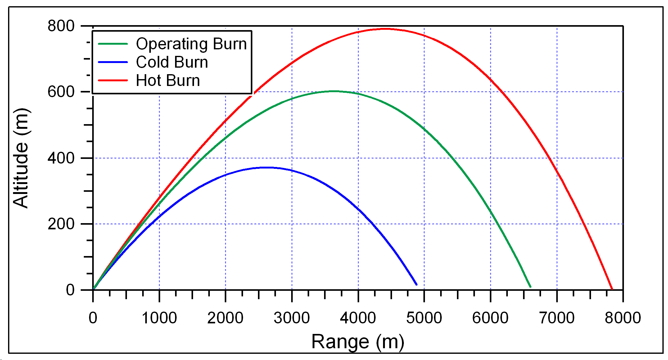
Figure 13: Failsafe Ballistic Trajectory - Ground Mission
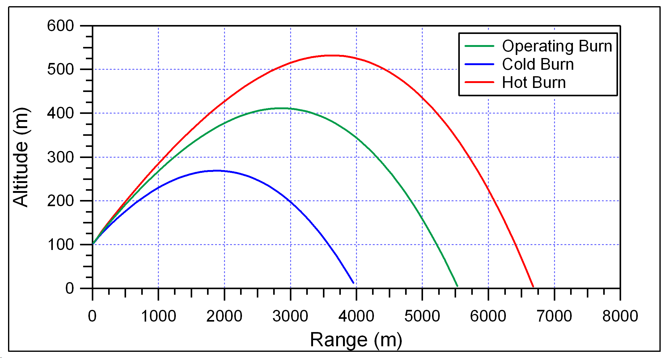
Figure 14: Failsafe Ballistic Trajectory - Helicopter Mission

Line of Sight Output
This set of outputs used a proportional guidance system to guide the missile to the wall in space. For these basic guidance runs, platform error and crosswinds were ignored to determine if the missile could be guided to the wall in space. In essence, the missile followed a purely line of sight trajectory to its target.

For the ground mission, a launch angle of 20° was used and the target was placed 3.7 km (12,139.07 ft) downrange at an altitude of 150 m (492 ft). The altitude and range of the missile for this configuration can be seen in Figure 15. The missile reached a maximum velocity of 462 m/s (1516 ft/s) for the operating temperature scenario as seen in Figure 16.
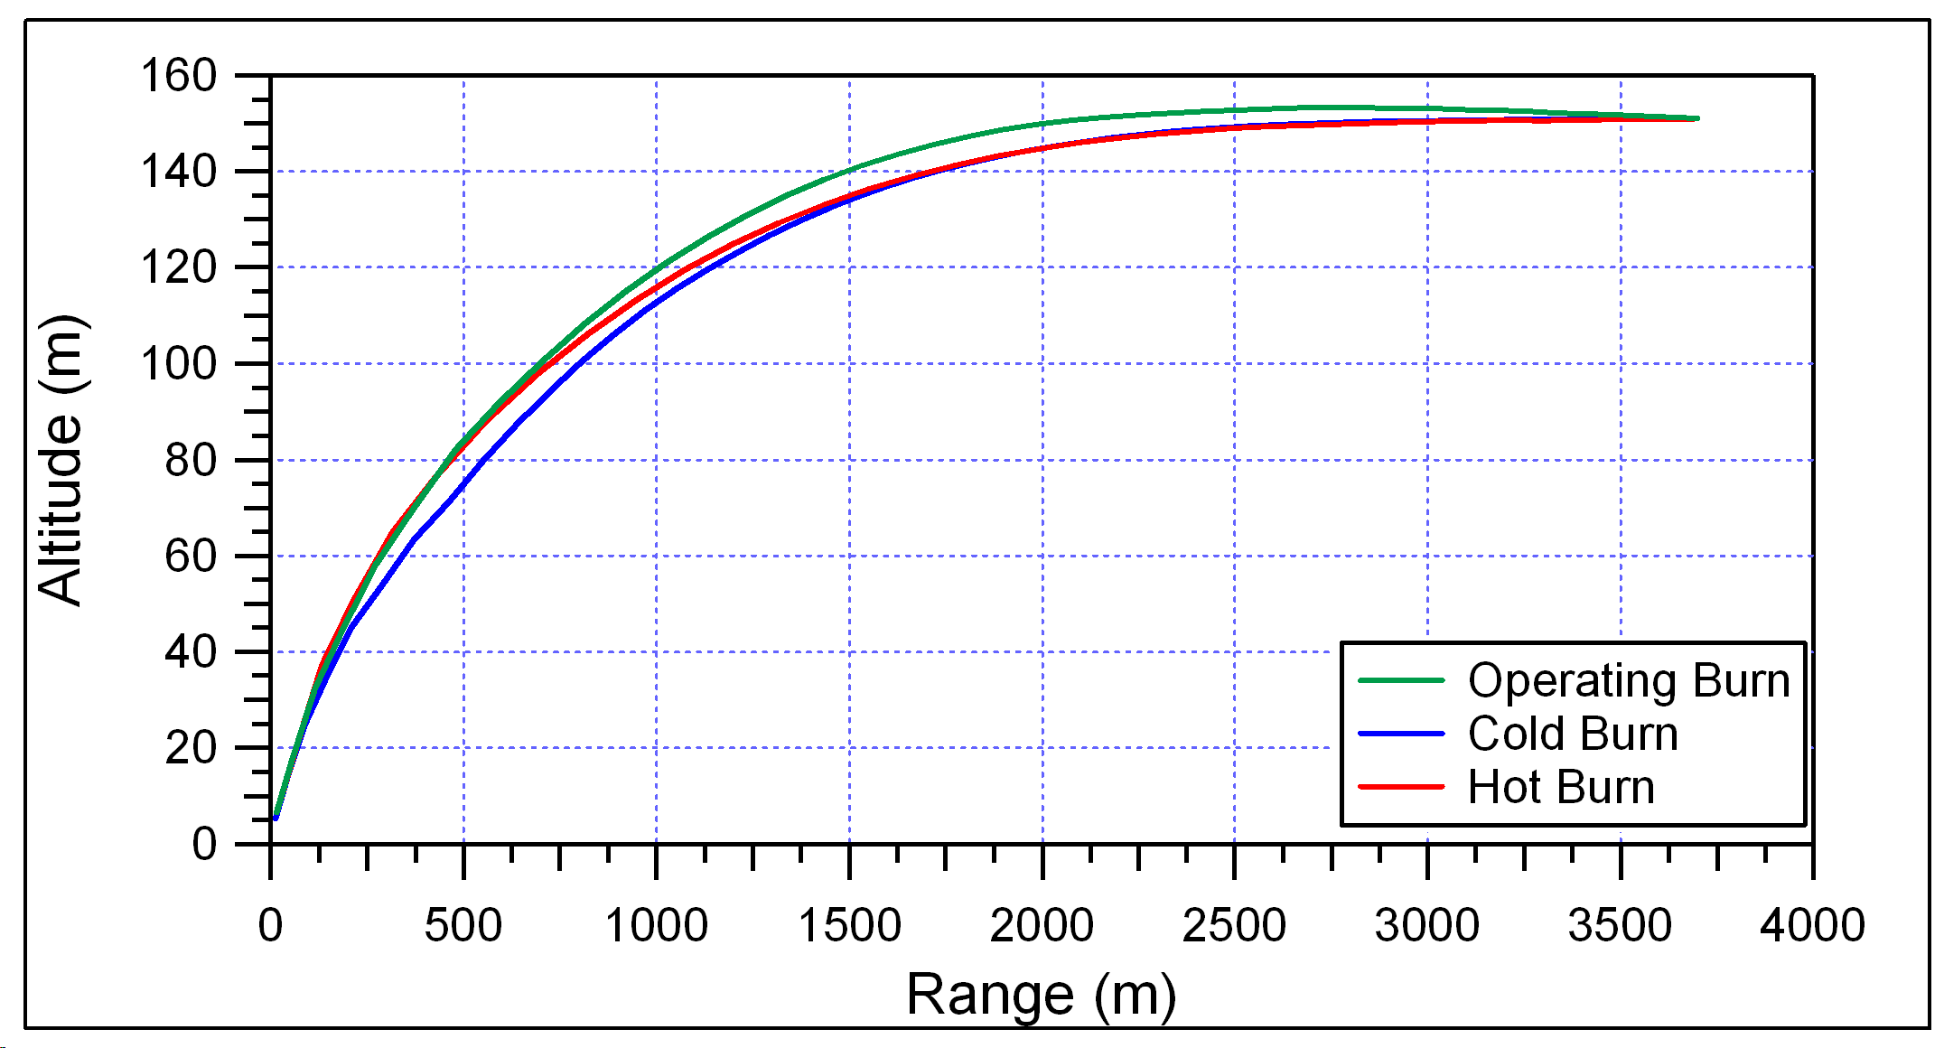
Figure 15: Line of Sight Ground Mission Range to Wall in Space
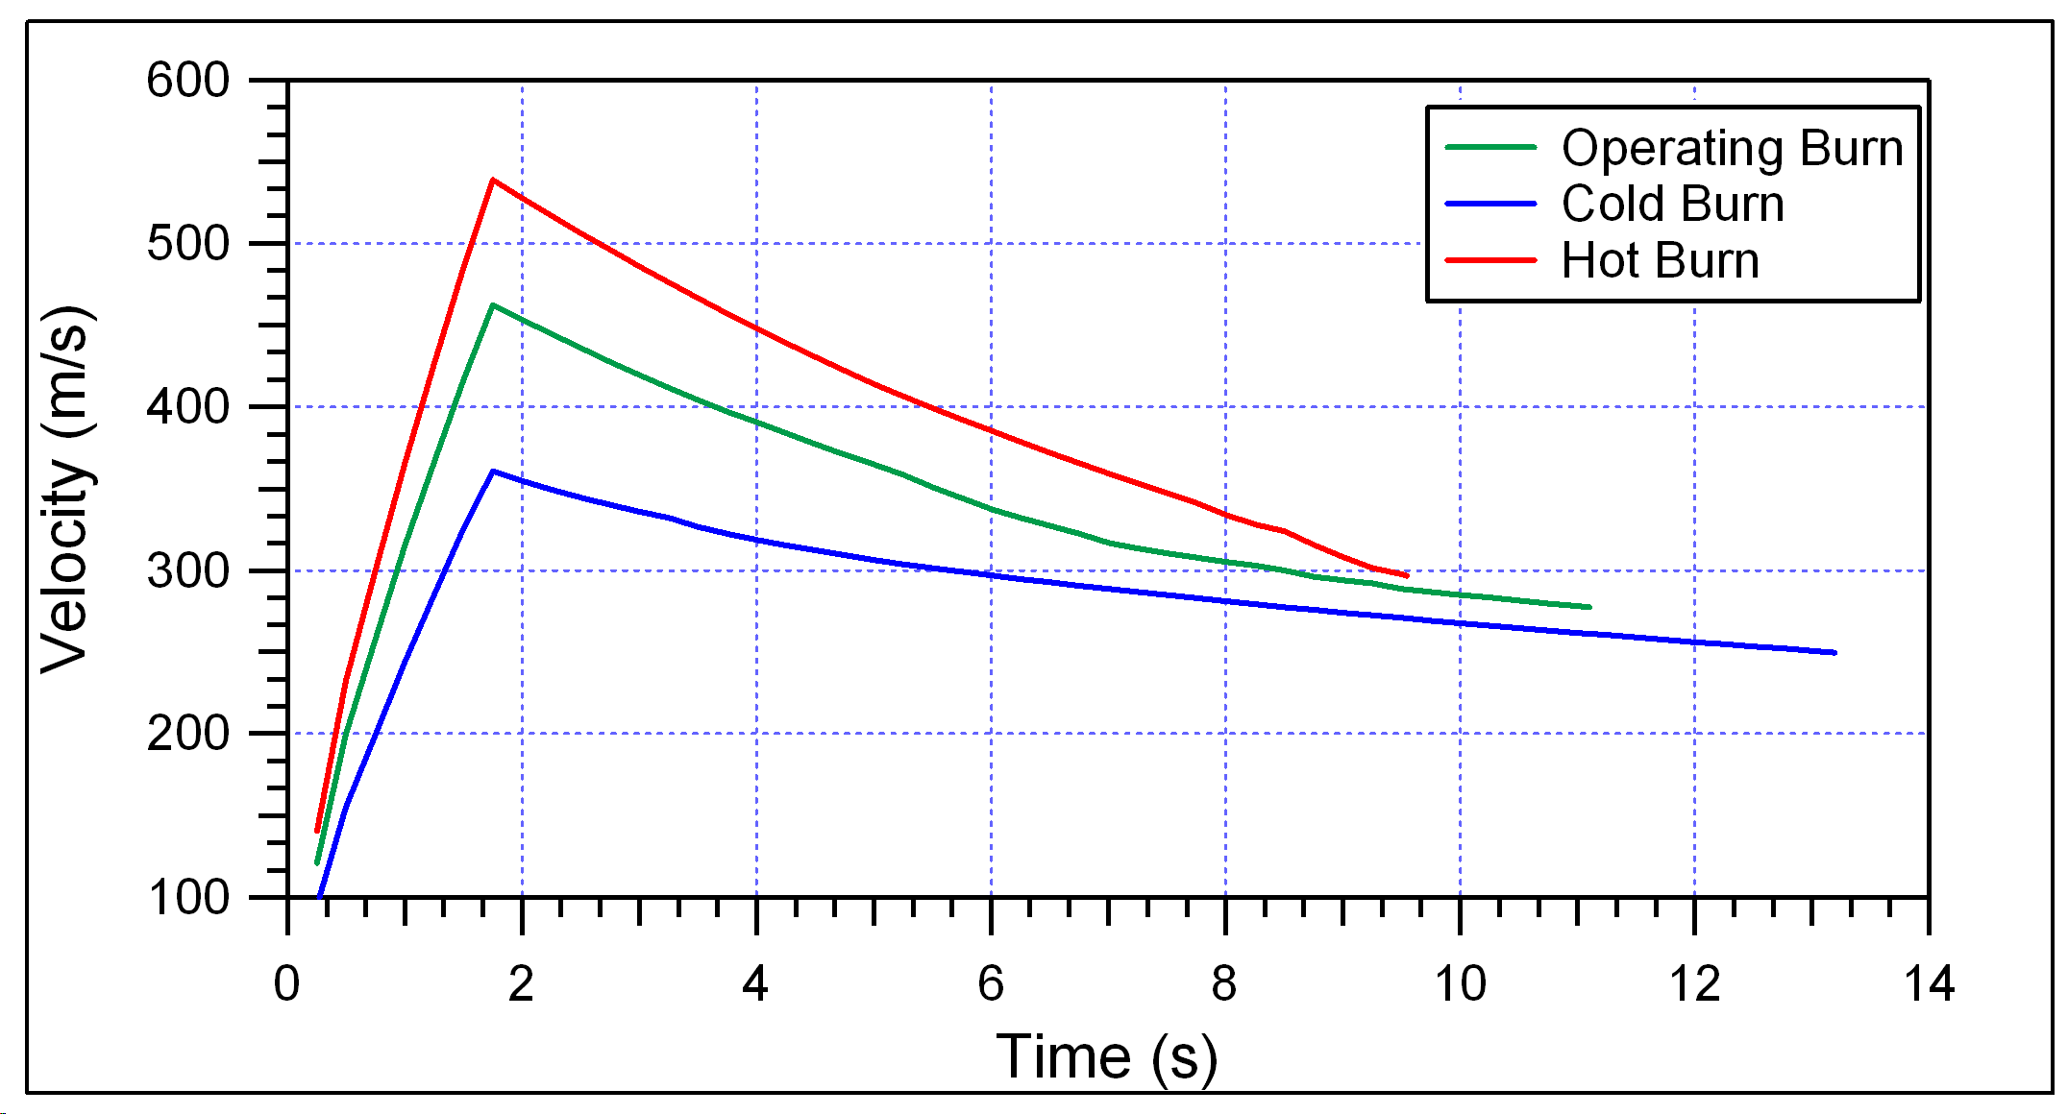
Figure 16: Dead On Ground Mission Velocity to wall in space
The target for the helicopter mission was set at 7.7 km (25,262.39 ft) downrange and at an altitude of 150 m (392 ft). The altitude and range of the missile for this configuration can be seen in Figure 17. The missile reached a maximum velocity of 460 m/s (1510 ft/s) for the operating temperature scenario as seen in Figure 18.

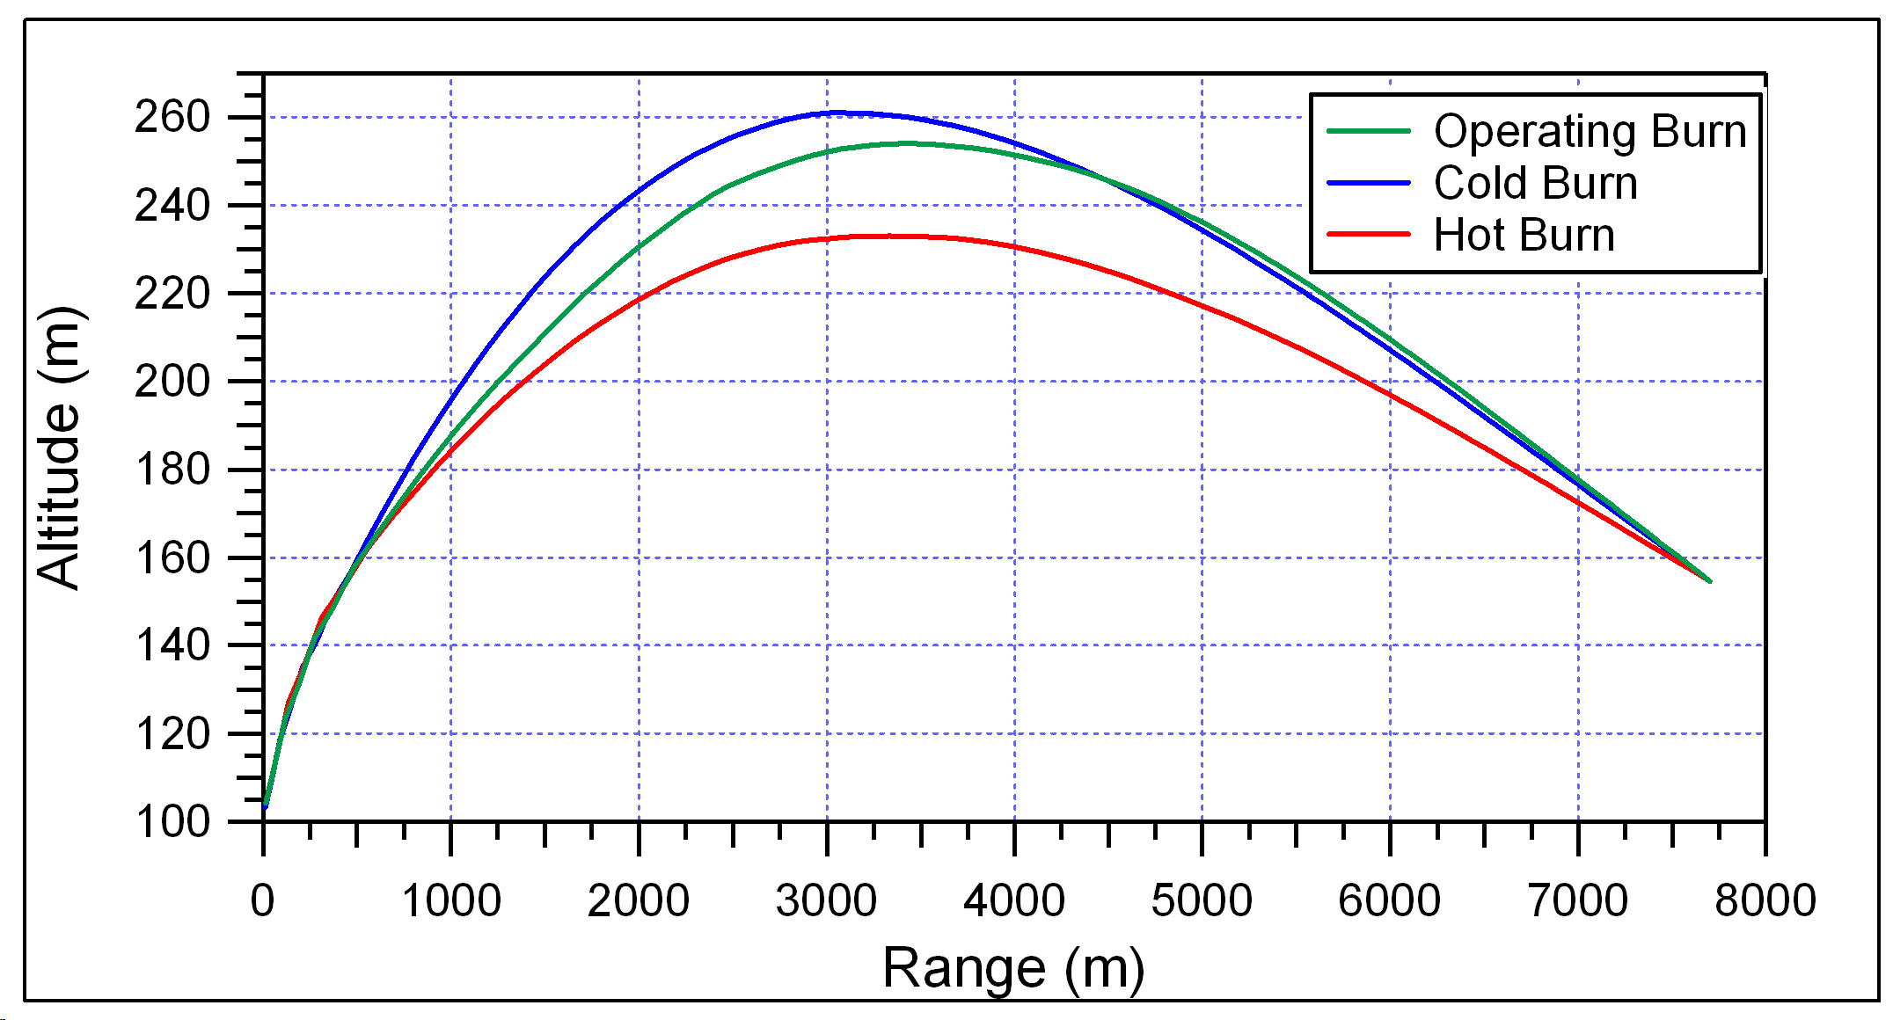
Figure 17: Dead On Helicopter Range to wall in space
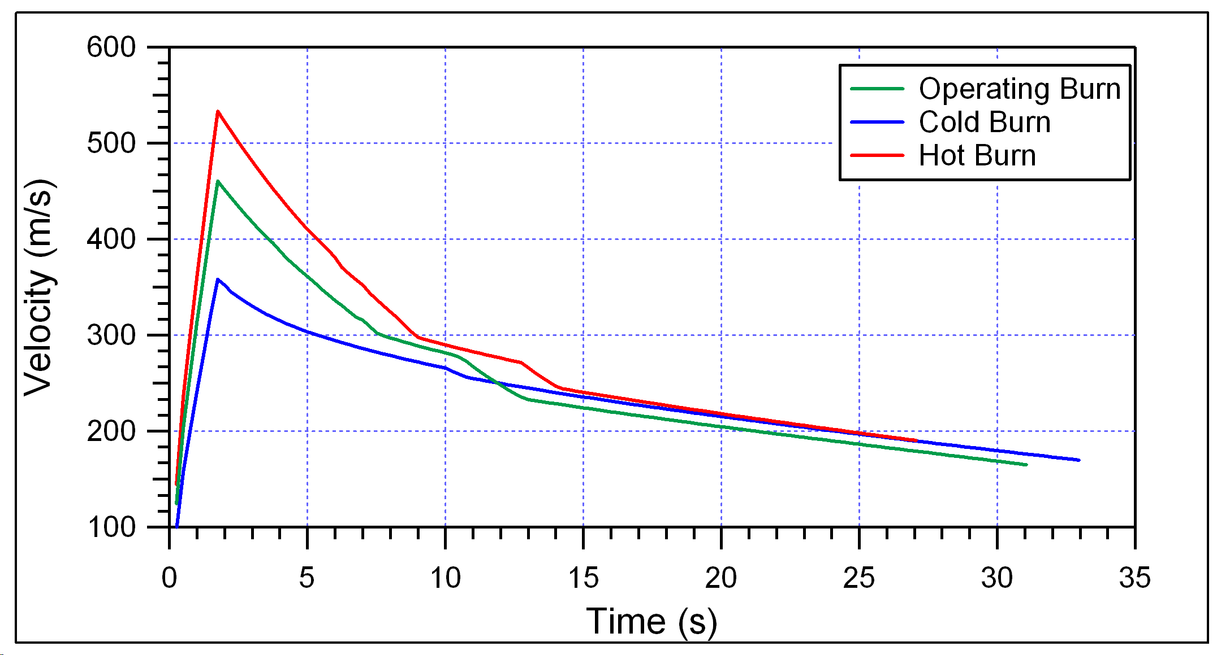
Figure 18: Dead On Helicopter Velocity to wall in space

Guided Launch with Crosswinds and Platform Error
This data is the next step after the line of sight runs. It incorporates inherent platform error and crosswind conditions into the flight of the missile. This is a more realistic evaluation for the performance as compared to the previous runs. AP02 does not have an option for adding crosswinds to the trajectory so it was “tricked” into simulating the crosswinds. A constant velocity target profile was used with the 15 knot (7.7 m/s) used as the velocity. The target position was then subtracted from the missile position so that the actual movement of the missile could be acquired with the crosswinds taken into account. The platform error of 19 milli-radians (1.089 degrees) was taken into account by entering the error into the azimuth angle for the launch. The first of these runs was the ground mission. Figure 19 shows that the missile still achieves the wall in space requirement and Figure 20 shows that the velocity at the wall in space is less than the required velocity of 603 m/s (1978 ft/s) for all ground scenarios. Figure 21 shows the recovery made by the missile to overcome the crosswind scenario. It is interesting to note that the guidance system overcorrects the trajectory but it is well within the wall in space requirements.
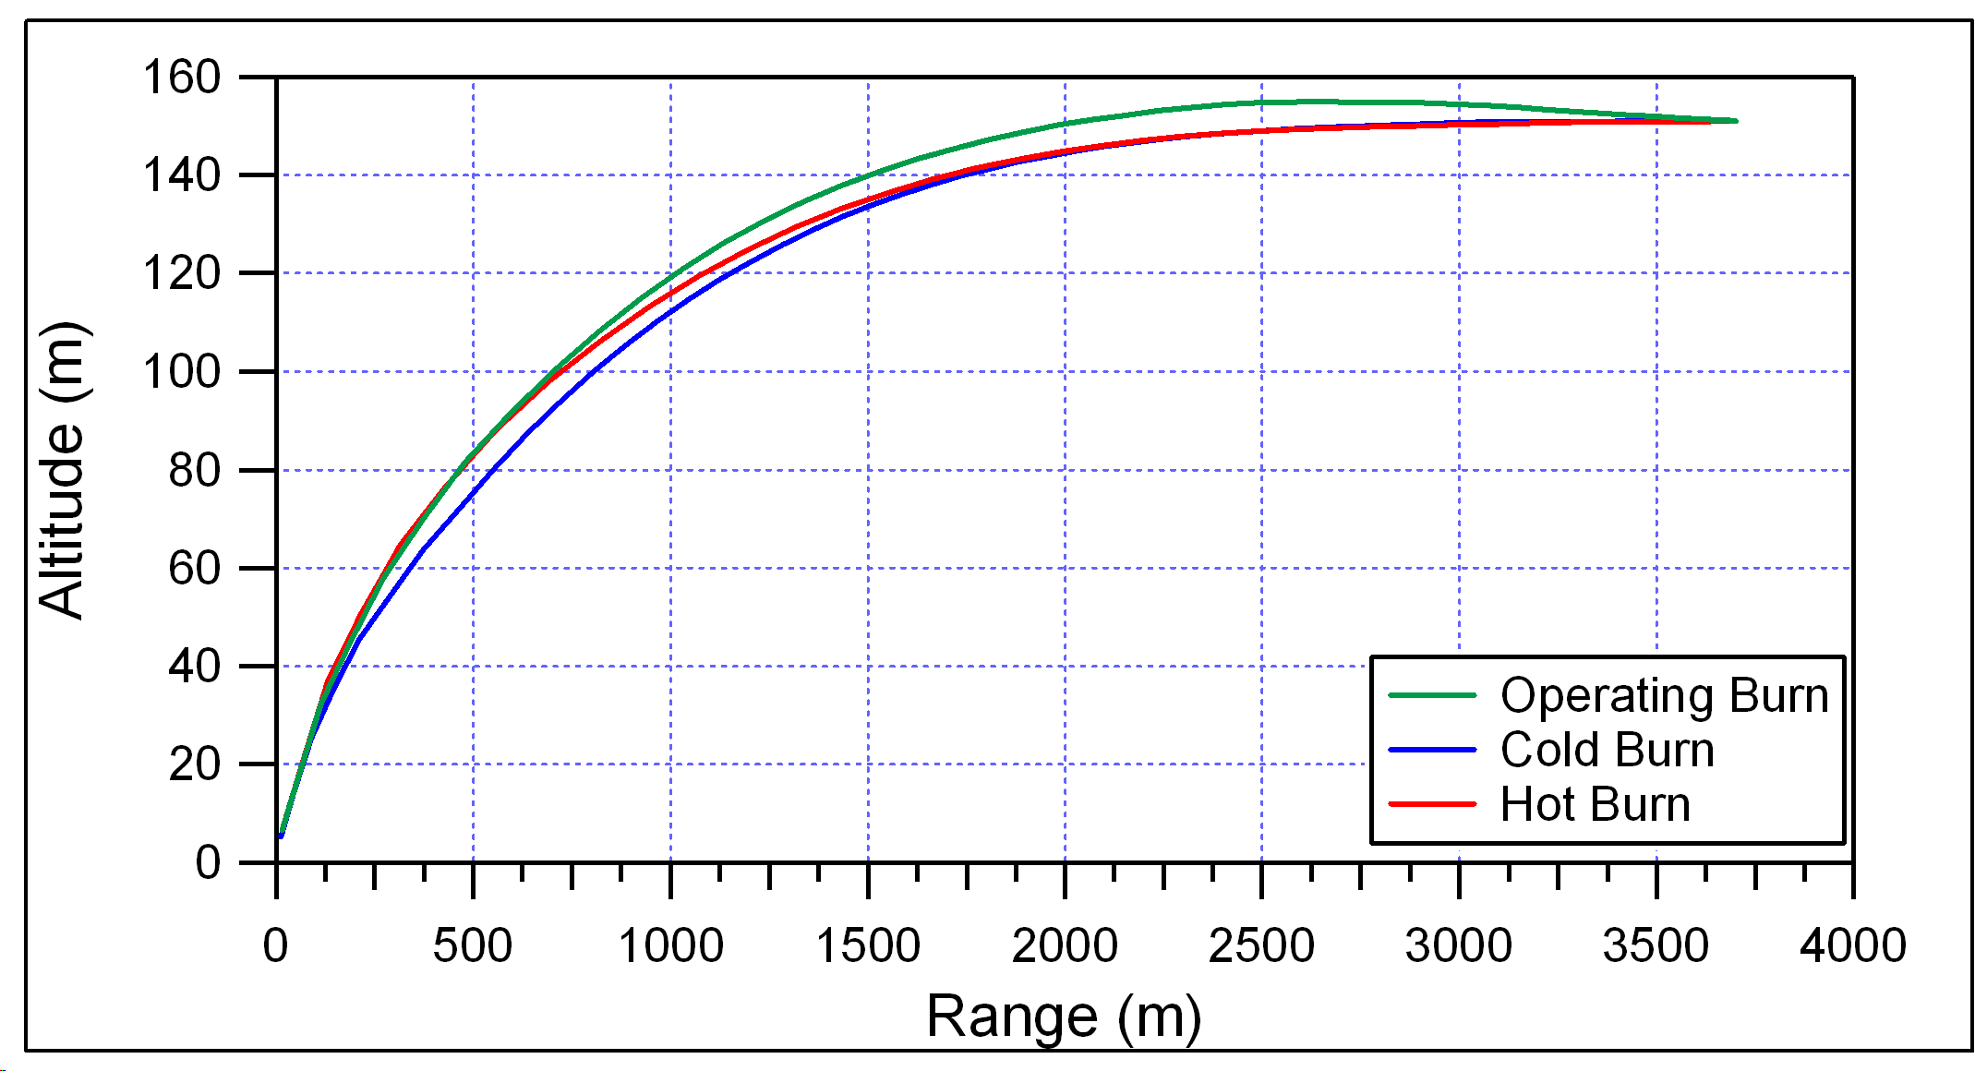
Figure 19: Ground Range with crosswind and platform error to wall in space
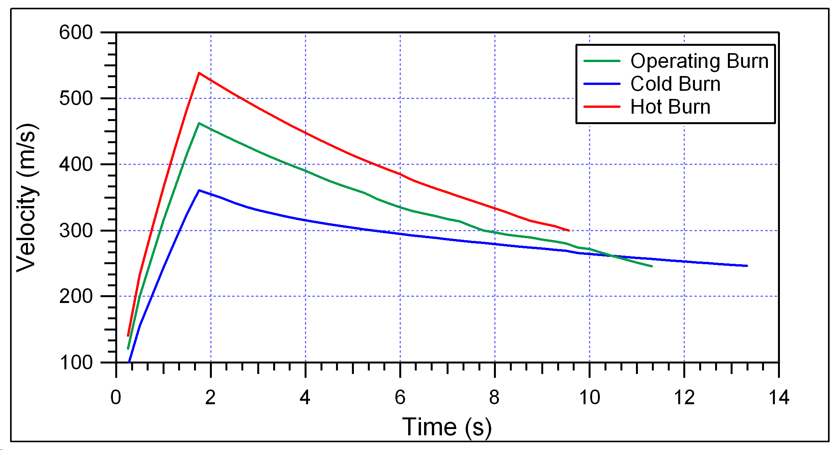
Figure 20: Ground Velocity with crosswind and platform error to wall in space
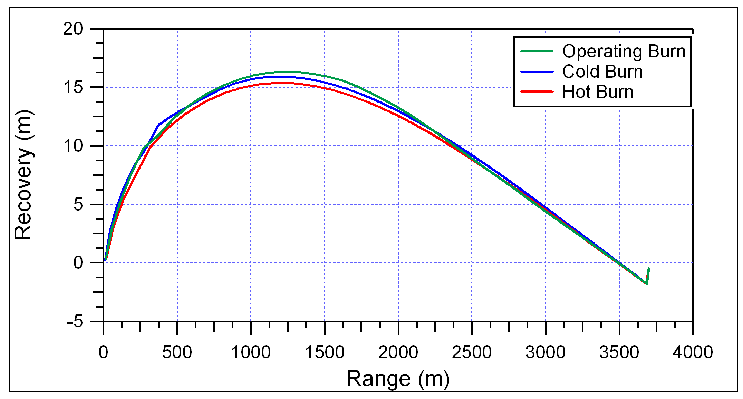
Figure 21: Crosswind and Platform Error Recovery for Ground Mission
The same analysis was completed for the helicopter mission, the only difference being the target is set at 7.7 km (25,262 ft) instead of 3.7 km (12,139 ft). The resulting graphs are presented in the same manner as above with the range shown in Figure 22, velocity in Figure 23, and Recovery in Figure 24. Figure 22 shows that the range to target criteria is met by the current design for the helicopter mission. Likewise, Figure 23 shows that the missile velocity meets the required 603 m/s (1978 ft/s) velocity at the wall in space with a maximum velocity of 173 m/s (567 ft/s) for the operational scenario. Like the ground mission, the missile slightly overcorrected its trajectory as seen in Figure 24 but remains well within the bounds for the wall in space requirements. By reviewing the performance of the missile, it is found that the current design is capable of delivering a M261 Warhead to the wall in space for each scenario.

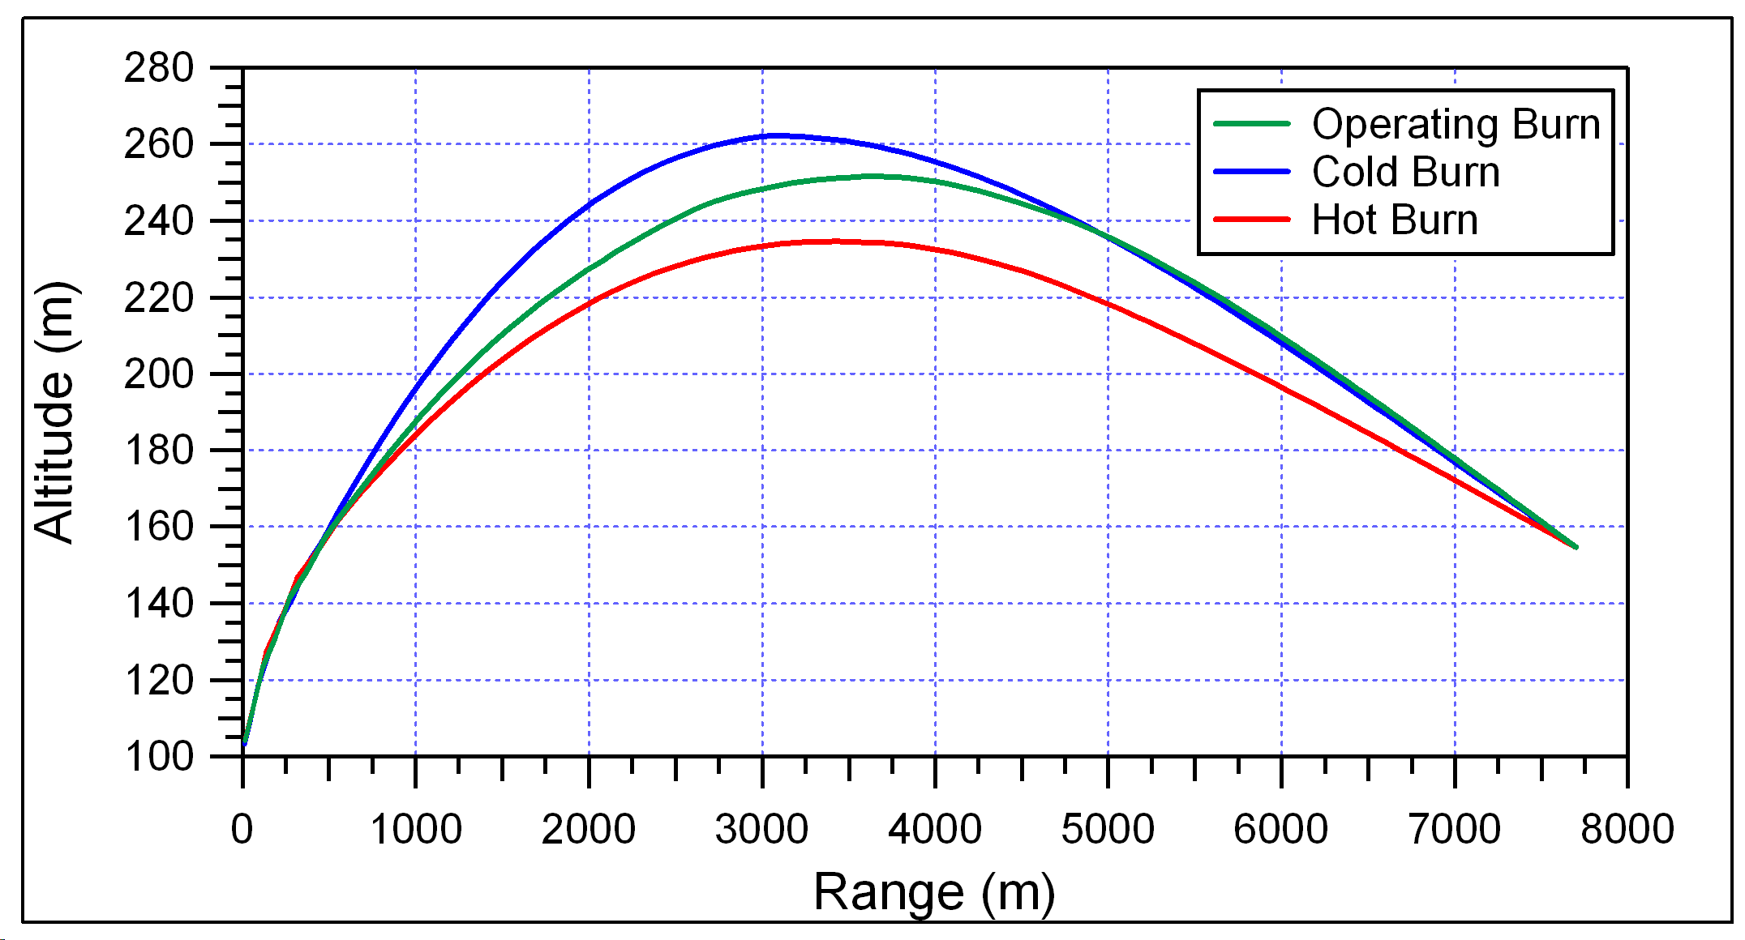
Figure 22: Helicopter Range to wall in space with crosswind and platform error
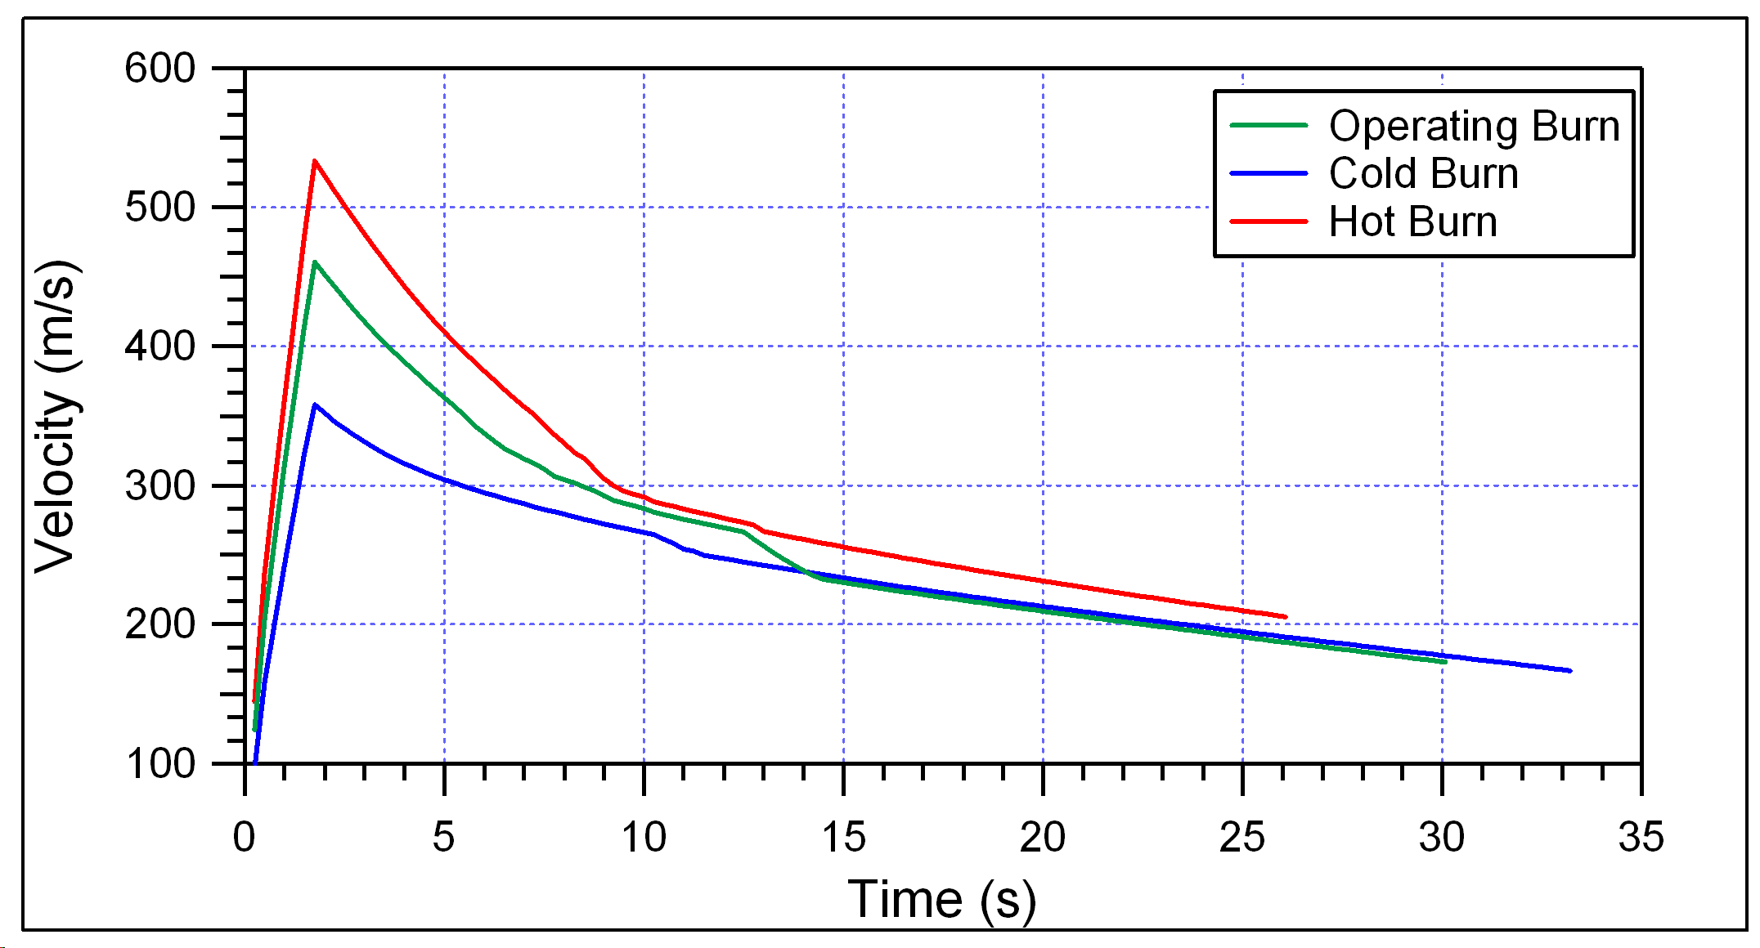
Figure 23: Helicopter Velocities to wall in space with crosswind and platform Error
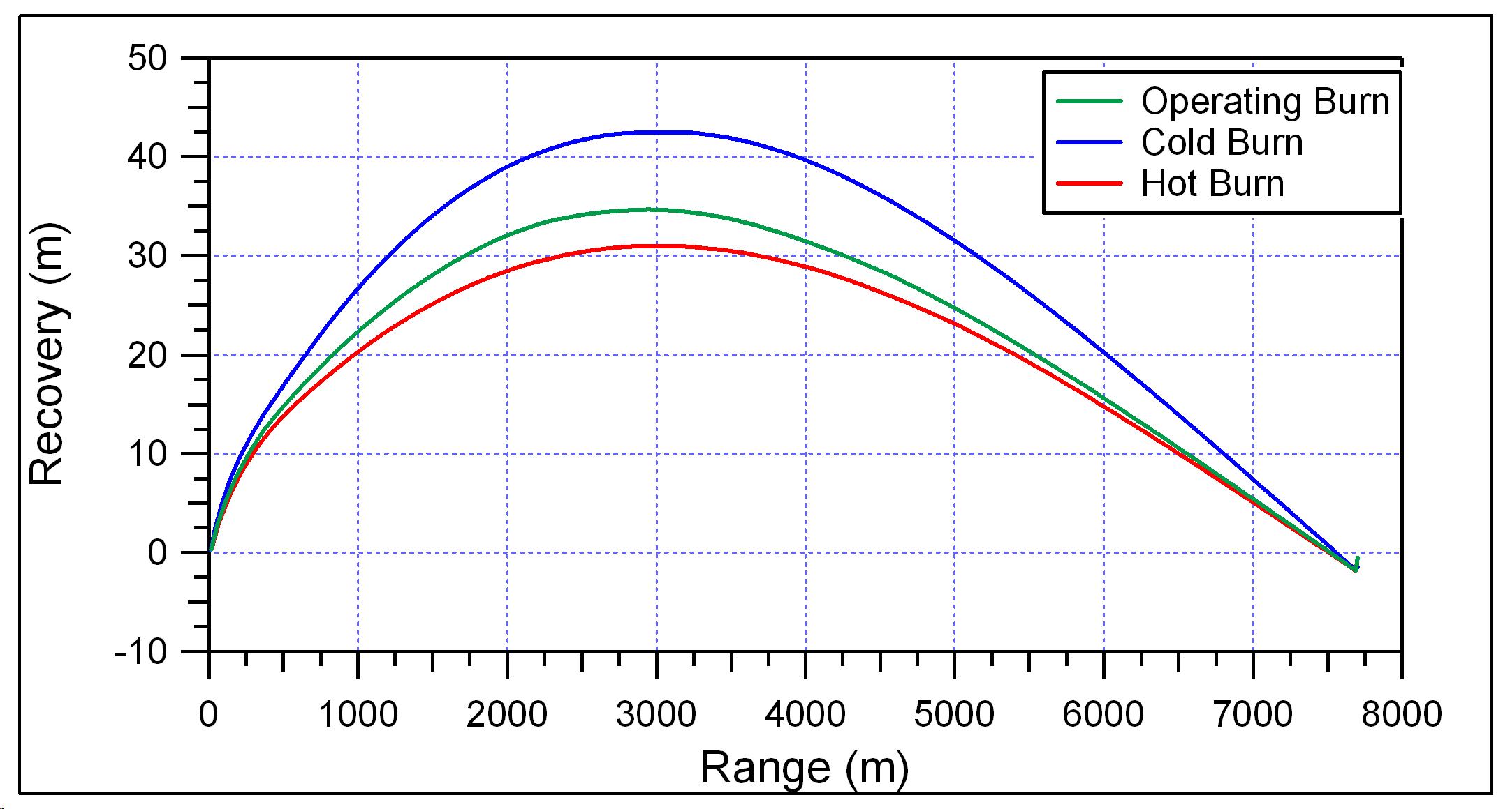
Figure 24: Crosswind and Platform Recovery Graph for Helicopter Mission

Maximum Lift/Drag and Maximum Range
To complete the analysis of the missile, two final trajectory runs were completed. These runs were the maximum lift versus drag and a maximum possible range with a proportional guidance system. These two analyses reveal what would happen if more weight was added to the missile and the maximum guided range for current design. Figure 25 and Figure 26 show the maximum lift verses drag ratio for the helicopter and ground missions respectively. While these graphs show the maximum range for increasing weights, Figure 27 and Figure 28 show the maximum guided missile range. These analyses were conducted by placing the wall in space at a range of 14 km (45,931 ft) from the launch point of the launch for both scenarios. This forces the guidance system to try to accommodate for such a large distance, which, in turn, shows the maximum distance attainable for this particular guided design.
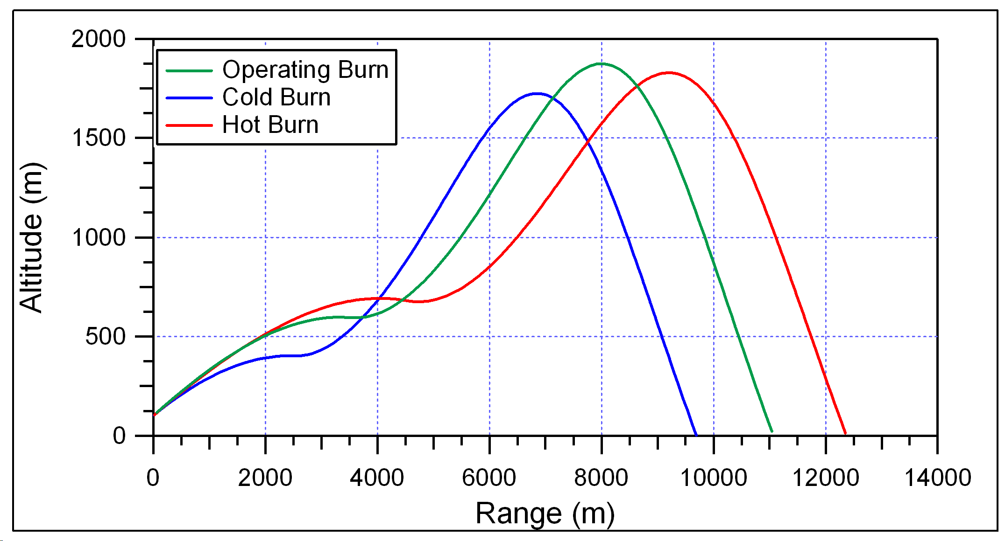
Figure 25: Maximum Lift/Drag Graph for Helicopter Mission
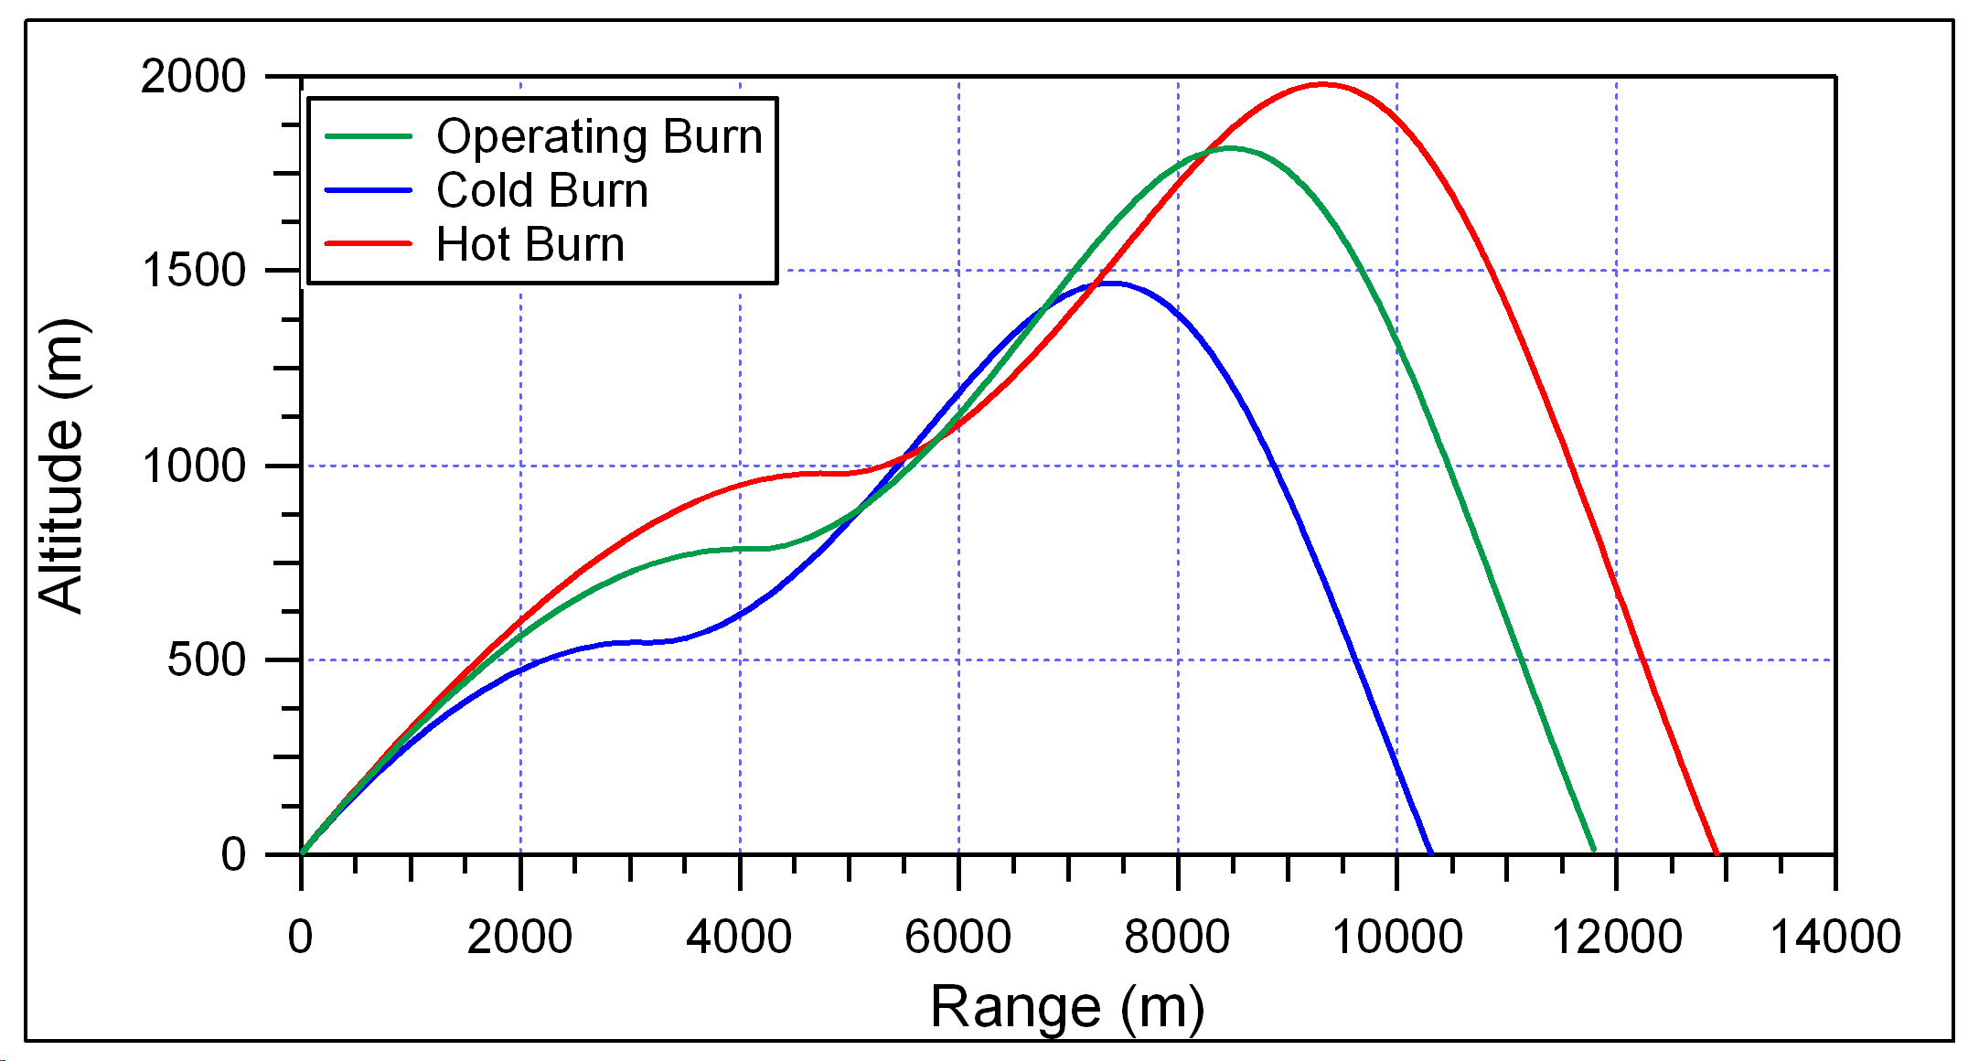
Figure 26: Maximum Lift/Drag Graph for Ground Mission
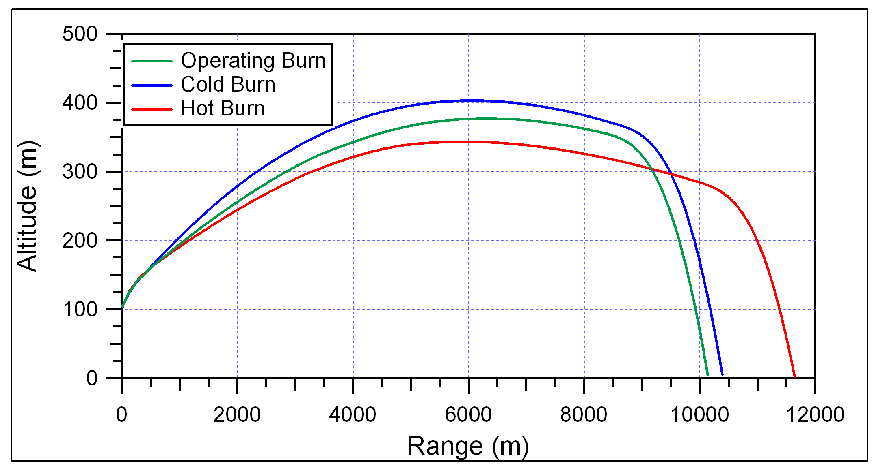
Figure 27: Maximum Achievable Helicopter Range
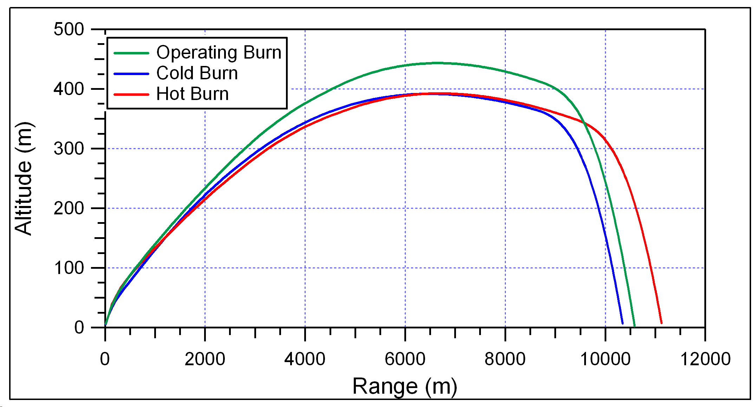
Figure 28: Maximum Achievable Ground Range

Final Conclusions
The current design meets all requirements set forth in the CDD. The maximum acceleration for any of the scenarios is 60g, which is less than the 79g requirement. The maximum velocity at the wall in space for any scenario is 300 m/s (984 ft/s) which is well below the 603 m/s requirement. The guided missile is able to overcome the platform error of 19 mils and the crosswinds of 15 knots for any of the launch conditions. The required ranges for both the helicopter mission and the ground mission are met for any scenario. Overall, this is a sound design from a trajectory standpoint.

Propulsion

Propellant Design

Methods and Assumptions
Excel spreadsheets written by J.M. Lyons of AMCOM Propulsion & Structures Directorate were used for first-order design computations. These programs provide a useful approximation of the propellant design. Propellant properties such as density, C*, isentropic coefficient and other pertinent information given in the propellant property table is entered into the appropriate cells and important resultant data such as pressures, thrusts, burn rates, and specific impulse is calculated. A star pattern grain design spreadsheet, DES-STAR, and a center perforated with slot(s) grain design spreadsheet, DES-CP, were used for the grain design for the ATM.

The thrust profiles calculated by the DES programs were then entered into a ballistic rocket program by the title of Launch. Launch is a purely ballistic motion program written for unguided projectiles (rockets). Launch is a useful tool for finding the velocity at launcher exit and maximum acceleration during flight. For the launcher exit velocity, the tower length was set to 1.67m (66in) and the velocity is output for that distance. See figures for Launch input settings and corresponding output screen.

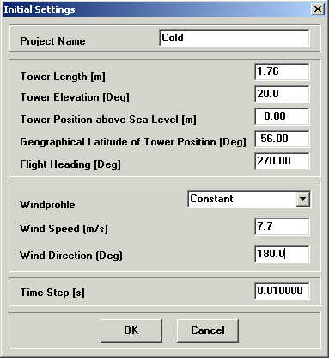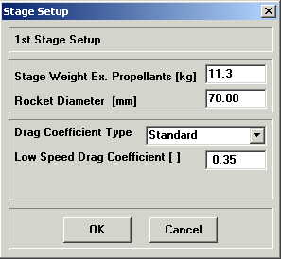

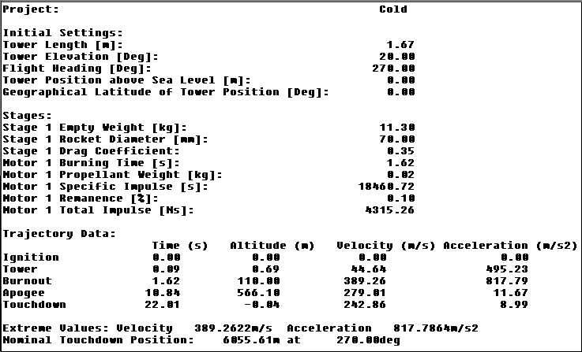

The maximum values of acceleration are erroneous because of an apparent glitch in the program when the thrust profile ends.

In order to find the range for both air- and ground-launch missions, AP02 aerodynamic/trajectory software was utilized. AP02 provides an extensive analysis of guided projectiles (missiles). If a propellant design does not meet requirements in either of the aforementioned programs then a new design will be created and then analyzed in an iterative process to find a suitable grain geometry and propellant.

Results [L. Hall]
The minimum smoke or min-smoke option was chosen for the final design in order to meet requirements stated in the CDD. The propellant is in the 1.1 HC as are all other min-smoke propellants due to the ingredients such as RDX and HMX that are common to min-smoke propellants. Generally, the HTPB propellants that contain smoke producing ingredients are in the 1.3 HC. The summarized properties of the selected propellant are in Table 4.

Propellant Properties at 75F unless otherwise noted
Parameter | Symbol | Value
Burn Rate | r | 1.35 cm/s (0.53 in/sec)
Burning Rate Exponent | n | 0.55
Burning Rate Coefficient | a_{t} | 0.012
Flame Temp |  | 2367 K (4260 R)
Isentropic Coefficient | γ | 1.2
Density | ρ | 1.58gm/cm³ (0.057 lb/in³)
Pressure-Temperature Sensitivity | π_{k} | 0.36 %/K (0.2 %/R)
Specific Impulse | I_{sp} | 215.5
Characteristic Velocity | C* | 1429 m/s (4688 fps)
Hazard Class | HC | 1.1
Table 4: Propellant Properties

The main obstacles to the grain design were to accelerate the ATM to 43m/s 141 (fps)in a distance of 1.67m without exceeding 79g’s in 150F temperature while propelling the ATM to 8km from a helicopter at 100m elevation in –50F temperature. It was assumed that if the grain met both requirements then the grain would meet all goals at all conditions.

The first propellant design was an 8-point star pattern that could have met all design requirements. Unfortunately the propellant was removed from the available selections for the ATM, as were others. The design would also have been difficult to manufacture because the clearances between the star tips would have made the casting mandrel difficult to machine and difficult to remove. The second design featured a 4-point star pattern and the slightly more energetic reduced smoke propellant (of the two new available), but did not meet launcher exit velocity and range requirements. This 4-point star also had a thick web that would lend itself to possible cracking in storage. A good propellant mechanical properties characterization and stress analysis by a leading research lab in this field could predict when this cracking would start. The third major design was changed from a star pattern to a center perforated (CP) with three slots. This grain met most requirements except for minimum air-launch range at cold temperatures.
The fourth major design used the minimum smoke propellant in a CP with six slots configuration. This grain caused the ATM to accelerate to approximately 141g’s, well beyond the 79g maximum limit specified in the CDD. All the DES spreadsheets can be found in Appendix F. The final design is a CP with eight slots using the min-smoke propellant. This next-to-final iteration of this design did not meet the maximum acceleration limit requirement at hot temperature or the minimum launcher exit velocity requirement at cold temperature. The solution to the problems was to set the fin length to 25.4cm (10in) and the CP length to 40.6cm (16in). The final design of the grain meets all of the design requirements at all conditions. The summary of the grain design is shown in Table 5.

Grain Specifications per the DES-CP output parameters
Parameter | Value (MKS)
Overall length | 68.05 cm (26.79 in)
Slot Length | 25.4 cm (10 in)
CP length | 40.6 cm (16 in)
Outside diameter | 6.35 cm (2.5 in)
CP diameter | 1.93 cm (0.76 in)
Slot Height | 1.7 cm (0.67 in)
Slot Tip Radius | 0.25 cm (0.1 in)
Slot Side Angle | 2 degrees
Web between slot tip and outer diameter | 0.5 cm (0.2 in)
Number of Slots | 8
Table 5: Final Grain Parameters
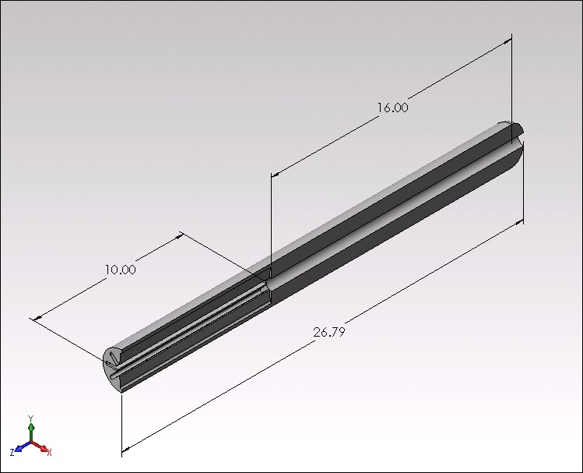
Figure 29: Grain Lengthwise Cross-Section
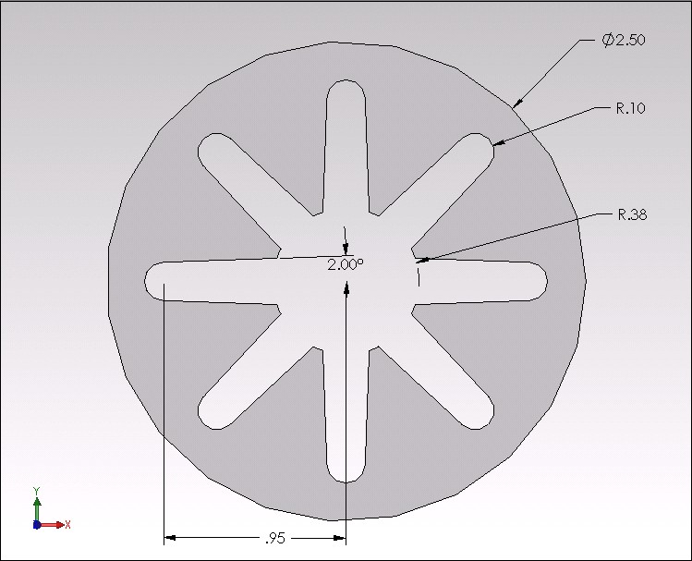
Figure 30: Grain Cross-Section at Slot Region
The effects of temperature on the properties of the propellant are shown in the Table 6 and effects on performance in Figures 31 and 32.

Parameter | Temperature
 | 227.6K (-50F) | 294.3K (75F) | 338.7K (150F)
Web time | 1.817 sec | 1.638 sec | 1.539 sec
Thrust | 2956.3 N (664.6 lb_{f}) | 3869.9 N (870.0 lb_{f}) | 4538.5 N (1020.3 lb_{f})
Pressure | 5.28 Mpa (767.1 Psia) | 6.79 Mpa (985.0 Psia) | 7.89 Mpa (1144.4 Psia)
C_{f} | 1.451 | 1.479 | 1.493
I_{t} | 5373 N-sec (1208 lb_{f}-sec) | 6339 N-sec (1425 lb_{f}-sec) | 6984 N-sec (1570 lb_{f}-sec)
I_{sp} | 182.63 sec | 215.50 sec | 237.47 sec
Table 6: Temperature Sensitivity Effects on Basic Propellant Grain Parameters
Figure 31: Thrust Versus Time with Temperature Effects
Figure 32: Pressure Versus Time
Figure 33: Burn Area Versus Web Distance

Structures

Guidance Module Casing
The guidance module serves two purposes, to provide structural rigidity and to protect the avionics components. The analysis of the guidance casing must be performed with regard to:
- Material of composition
- Material thickness
- Material length
- Buckling and bending stresses within the material

Appendix G.5 shows the mating between the M261 MPSM warhead and the guidance module casing. The guidance module casing is mated to the warhead using 2.400-6 Stub Acme Special Thread Blunt Start with a pitch diameter of 59.817 mm (2.355 in.). The mating portion of the case is 63.500 mm (2.500 in.) long. The casing thickness at the mating portion is 6.350 mm. (0.250 in), and the recessed portion at the front of the case is 6.350 mm (0.250 in.) long with a case thickness of 4.7625 mm (0.1875 in.). The casing outer diameter is 69.85 mm (2.75 in).

Figure 34 shows the overall and cross-section views of the case. The total case length is 568.96 mm (22.4 in.). Since the missile was required to stay at a length of 2024.38 mm (79.7 in.), any length loss from the design of the motor was added to the guidance case. It is for this reason that the guidance case is this length.

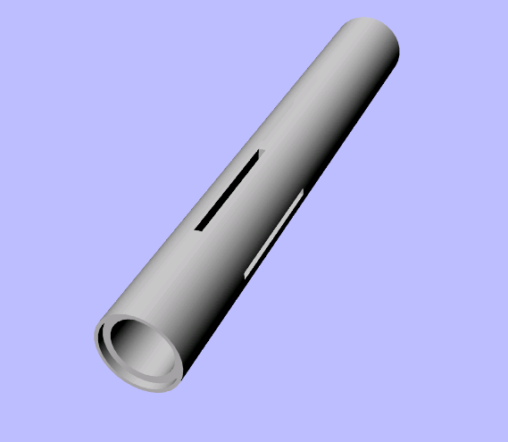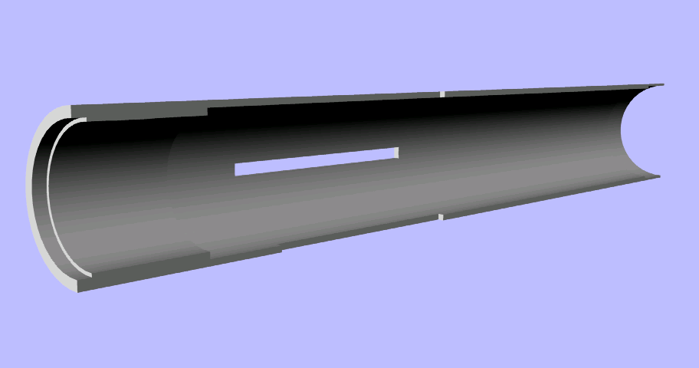
Figure 34: Guidance Case
To allow the canards to fold into the guidance case, four slots were added to the case measuring 120.65 mm (4.75 in.) in length and 6.350 mm (0.250 in.) wide. These slots were designed at these specifications to allow the canards to fold into and out of the case freely. The aft end of the case is threaded to allow the guidance module to mate with the propulsion module (see section 2.5.3). The threaded portion is 25.4 mm (1.000 in.) long, 2.500 Stub Acme Special Thread Blunt Start with a pitch diameter of 65.0875 mm (2.5625 in.). This thread type was chosen to ease manufacturing of the case since it is the same as the mating portion between the guidance module and the warhead. The rest of the guidance case between the two mating portions is 3.175 mm (0.125 in.) thick.

The case also includes holes through the case to account for the wiring from the M261 Launcher to the guidance system as well as the mounting of the guidance system. The hole for the launcher wiring is 3.175 mm (0.125 in.) in diameter and 84.296 mm (3.31875 in.) from the head of the guidance case. The holes for the mounting of the guidance system are specified according to the design of the guidance system mounts. A detailed drawing of the guidance case can be found in Appendix G.5.

Bending and Buckling Analysis
The guidance case was specified through bending and buckling of the guidance case due to aerodynamic loads. The analysis of the case was performed using aerodynamics information from APO2TM and the location of the centers of pressure and gravity. A Microsoft Excel file containing the input and output information is available (see Appendix B). The maximum bending moment within the guidance case is 1595.89 N-m. (14124.84 lbf-in). Using a case thickness of 3.18 mm (0.125 in.), the stress resulting from this moment is 133.76 Mpa (19.40 ksi). Using a factor of safety of 1.5, the stress in the case is 200.64 Mpa (29.1 ksi), well below the yield strength of the material (455.05 Mpa (66 ksi)).

Materials
The guidance case shall be made of the same material chosen by the spring 2003 team. The case shall be made of Aluminum Alclad Alloy 7075-T6. This is the strongest aluminum alloy currently available and the lightest metallic alloy used in these applications.

Composite materials were also considered for the guidance case. However, the holes for the wiring and connection points for the guidance system, as well as the slots needed for the canard fins would have created stress concentrations that would compromise the strength of the composite case.

Avionics / Guidance System
The ATM will incorporate the same design created by the spring 2003 team. This was done both to ensure that the aerodynamics of the missile stay the same as well as to use the pre-existing weights and centers of gravity for each component of the guidance system. Although there are some issues with this system (see Section 5.4), it was assumed that the system designed and its placement is correct. Appendix I contains the description of the guidance system provided by the spring 2003 team.

Propulsion Module Casing
The motor casing shall consist of graphite fibers in an epoxy matrix. The case shall be 1.6 mm (0.0625 in.) thick and 711.2 mm (28 in.) long. The outer diameter of the case shall be 69.9 mm (2.75 in). The specification of the motor case took the following considerations into account:

- Stresses resulting from internal motor pressure
- Materials
- Heat transfer resulting from internal motor chamber temperature

It should be noted that the motor case experiences stresses due to buckling and bending. However, the stresses due to the internal pressure are greater than what is experienced from an aerodynamic standpoint, so only the stresses due to internal pressure were used to calculate the necessary case thickness. Figure 35 shows the motor case, bulkhead and metal insert. Both the bulkhead and insert are used to mate the propulsion module with the guidance module and nozzle, respectively.

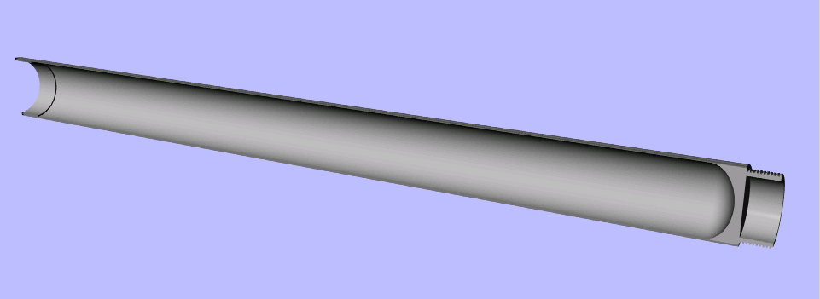
Figure 35: Motor Case
The concept chosen to mate the guidance and motor modules employs one coupler that acts as both the bulkhead for the motor as well as a connection point for the two module cases (see Figure 36). The aft end of the coupler is machined into the necessary dome shape of the propellant grain, an elliptical dome with a diameter of 66.675 mm (2.625 in.) and depth 22.1996 mm (0.874 in.). During the manufacture of the case, the composite will be wrapped over the coupler at the same time as the mandrel. This will ensure that the bulkhead remains fixed inside the motor case. The front of the coupler shall be threaded, allowing the two modules to mate. The threaded portion is 25.4 mm (1.000 in.) long, 2.500 Stub Acme Special Thread Blunt Start with a pitch diameter of 65.0875 mm (2.5625 in.). A detailed drawing of the motor bulkhead can be found in Appendix G.5. Other concepts were considered for the mating of the guidance and propulsion modules as well. A list and comparison of the various concepts considered can be found in Appendix G.6.

Figure 36: Motor Bulkhead
The concept chosen to mate the motor case with the nozzle employs a metal insert that acts as the connection point for the two modules. The two modules connect using a lock wire located 7.9375 mm (0.3125 in.) from the back of the insert. The insert is 25.4 mm (1 in.) long and has an outer diameter of 66.675 mm (2.625 in.) and an inner diameter of 63.5 mm (2.500 in.). A detailed drawing of the insert and picture of the mating between the two modules can be found in Appendix G.5.

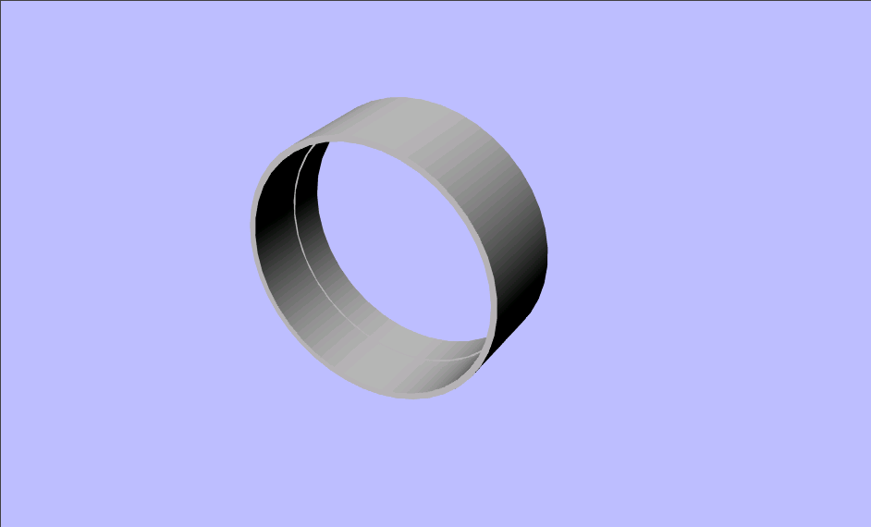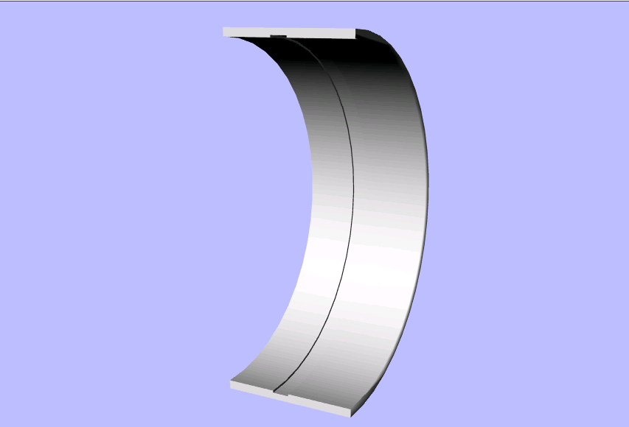
Figure 37: Motor Case Metal Insert

Materials
Three different materials were considered for the motor case:
- Stainless Steel 301 Full Hard. This is the material chosen by the spring 2003 team and served as a baseline design for the actual materials considered.
- Graphite Fibers in Epoxy Matrix. This composite material is much stronger than the metallic material considered with respect to both volume and density. However, thermal problems exist with this material due to its low melting point, resulting in an increase in the amount of insulation needed. Machining and drilling of graphite epoxy can be satisfactorily performed with tungsten-carbide tipped tools.
- Kevlar 49. This material consists of polyamide fibers, closely related to conventional nylons, but in which the flexible aliphatic chains are replaced by aromatic rings. Kevlar 49 is the form of this material used in engineering applications. The material has a greater tensile strength than graphite epoxy in the longitudinal direction, yet it has a lower compressive strength in both the longitudinal and transverse directions as well as a lower tensile strength in the transverse direction. The material does have a greater fracture toughness than graphite epoxy, but this strength of the material is also a weakness when it comes to manufacturing. Due to its inherent toughness, Kevlar 49 is very difficult to machine and, thus, specially designed tools are required. Because of the lower directional strength and the manufacturing difficulty of Kevlar 49, Graphite Epoxy was chosen in the end as the composite material for the motor case.

Stresses Resulting From Internal Motor Pressure [J. Schaeffel]
The motor casing experiences stresses due to the internal pressure of the rocket motor during operation. These stresses are known as hoop and longitudinal stresses. Hoop stress is the stress along the transverse axis of the pressure vessel, and is related to the internal pressure by
Equation 3: $σ_{\text{hoop}}=\frac{\text{pD}}{t}$,
Where p is the internal pressure, t is the casing thickness and D is the diameter of the tank. Since the case is thin-walled, it is not important which diameter is used (inside, mean or outer). Although the mean diameter will give a better result, by convention, the inner diameter is used for the value of D. The longitudinal stress is the stress in the longitudinal direction, and is related to the internal pressure by
Equation 4: $σ_{\text{longitudinal}}=\frac{\text{pD}}{2t}$,
Note that the longitudinal stress is half the hoop stress. This means that the case thickness must be determined using the hoop stress equation since the stress is greater in the transverse direction. The results of the stress analysis of the motor case can be found in Appendix G.2.

Additional Stress Considerations
It must also be remembered that composite materials have different strengths in different directions. Although the composite materials for the cases were analyzed using the ultimate strength of the material, the materials must be analyzed with respect to the way the fibers are laid. This requires a more detailed analysis to determine the exact behavior of the composite material. It was learned that design of composite structures is often based on a procedure known as a netting analysis, which assumes that the fibers are uniformly stresses in tension and provide all of the longitudinal stiffness while the matrix provides only the shear stiffness. It was known though that Kevlar 49 has both a lower compressive and tensile strength than graphite epoxy in the transverse direction. This was one of the major reasons that graphite epoxy was chosen over Kevlar 49 as the composite material.

Another factor in the strength of the material is the laying of the composite fibers. The fibers could be filament-wound around a mandrel. If the case is helically wound, the pattern will produce crossovers where the fibers overlap one another; this is a disadvantage in the case design because the local bending in the case at the points where the windings cross one another increases fiber stresses. It was decided instead to manufacture the case using the wrapping method, an alternative to filament winding for producing tubular components such as the motor case. Prepreg sheet, either warp sheet or cloth, is wrapped onto a removable mandrel and cured under pressure. The pattern will have fibers in both the hoop and longitudinal directions.

Another problem that may be experienced with the motor case is stress concentrations developed by either manufacturing errors or mishandling of the ATM. To minimize the effects of these circumstances, the case was thickened to more than what was required by the internal stress analysis

Thermal Analysis
To determine the thermal behavior of the motor case, a Finite-Difference thermal analysis was performed with a time step of 0.0025 seconds and a distance step of 1/20 of the material thickness. This analysis was performed to determine if the case could withstand the temperatures generated by the motor during its operation. The analysis was performed at the worst-case scenario characterized by the maximum operational temperature scenario. The equations and methods used in the thermal analysis can be found in Appendix G.4.

Nozzle

Nozzle Design
The nozzle deign produced by the spring 2003 team was reconfigured according to three different design aspects:

(1) Mating with the motor case. The original design required the nozzle to be welded to the motor case. This method is impossible, since the propellant inside the motor case would explode during the welding process. The concept chosen for mating the two modules involved using a lock wire to secure the nozzle to the motor case. The ring holding the fins at the front of the nozzle was thickened to 18.8214 mm (0.741 in.). This allowed the use of the groove for the current detent mechanism at the same dimensions as the original nozzle used on the Hydra-70 rockets while at the same time keeping the fins at their correct position. The head of the nozzle was increased in length to 23.8125 mm (0.9375 in.) and an outside diameter of 63.5 mm (2.5 in.). Two grooves were added to this extension. The first groove added was for an o-ring to provide a seal between the motor case and the nozzle for the purpose of protecting both the nozzle and case during motor operation as well as protecting the propellant during storage of the missile. The second groove was added to mate the nozzle to the motor case using the lock wire. The lock wire is of slightly larger diameter than the nozzle groove, and cut in one portion of the wire. This allows the wire to be contracted, and the spring-like ability of the wire allows it to regain its original shape when released. When assembling the two modules, the lock wire is pressed into the nozzle groove, and the entire nozzle assembly is slid into the motor case. When the lock wire meets the groove inside the motor case insert, the spring-like action of the wire forces the wire to expand into the metal insert groove, thus locking the two modules together. The only problem with this design is the fact that once the two modules have been joined, they cannot be separated. It was decided that since no maintenance is expected on this portion of the missile, separation of the nozzle and motor is not necessary after assembly. However, if the two modules do need to be separated, a hole could be added to the motor case and extended to the nozzle groove holding the lock wire. A punch could then be used to press the lock wire into the nozzle grove, allowing the nozzle to be removed from the motor case. This solution is not advised without the addition of reinforcement of the motor case, since the hole will form a stress concentration in the motor case.

(2) Nozzle throat design. The new design of the motor required a nozzle throat diameter of 22.098 mm (0.870 in.), an exit diameter of 57.15 mm (2.250 in.) and a nozzle half-angle of 15°. However, this could not be machined into the pre-existing nozzle due to the design of the fin portion of the nozzle. The thin portion of the nozzle was increased to 50.8 mm (2.000 in.) in diameter to give the necessary clearance for the required inside dimensions of the nozzle. A possible problem experienced due to the change in the diameter of the nozzle is the effects on the aerodynamic characteristics of the missile. However, due to the limitations of APO2TM, the design of the contact band and fin portion of the nozzle could not be defined in the program and an estimate of the nozzle was used by the spring 2003 team for the aerodynamic profile instead (see figure 38). It was assumed then that the change in the fin portion of the nozzle diameter would have no effect on the aerodynamic information inputted by the spring 2003 team into APO2TM. In fact, the change in design may actually conform closer to the estimate used than the original design.
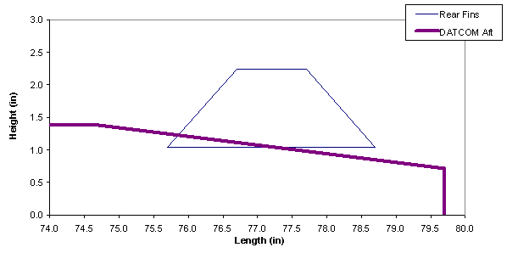
Figure 38: Nozzle Aerodynamic Profile Used in APO2TM
Another problem that could be experienced in the new design is the lowering of the fins into the nozzle. If the diameter chosen was too large, the fins could not be closed completely into the nozzle when loading the missile into the launcher. This would allow no leeway for the fins to move, thus opening the possibility that the fins could stick inside the launcher when the missile was fired. To make sure that the fins could close correctly, the fins were analyzed using the new nozzle diameter and the fin design chosen by the spring 2003 team and were found to be able to close with room to spare (see Figure 39).

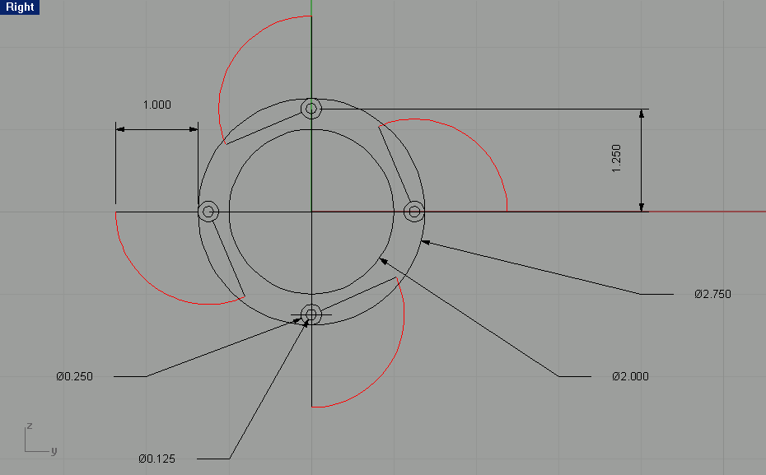
Figure 39: Fin Closure
(3) Locking the fins into the correct position when the missile is launched. To alleviate the difficult machining necessary in the original nozzle design, the fin locking mechanism was redesigned using a similar locking design employed in the current nozzles for Hydra-70 rockets. The aft end of the fin shaft is flush with the aft fin edge, and the lower portion is chamfered at a 45° angle. To make sure that the fin locks into the same position as specified by the spring 2003 team, the thickness of the nozzle ring used to lock the fins in place was thickened to 11.1125 mm (0.4375 in.). The ring is also chamfered at a 45° angle where the fin shaft meets the nozzle. When the fins are in the closed position, the aft edge of the fin is used to keep the fin from moving backwards into the nozzle ring. In the open, locked position, the fin slides backward and is held in place using the chamfered section of the nozzle. For a comparison of the original and improved nozzle design see Figure 40. Figure 41 shows a comparison of the overall changes between the fin design created by the spring 2003 team and the improved design. A detailed drawing of the nozzle can be found in Appendix G5.

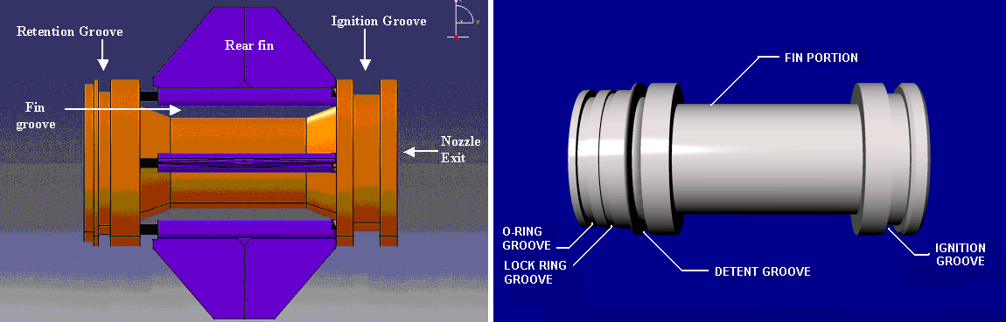
Figure 40: Original and Improved Nozzle Design

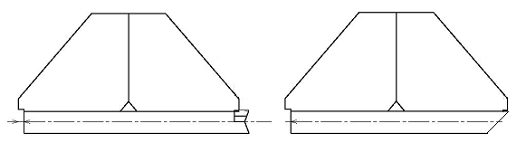
Figure 41: Original and Improved Fin Design
The casing of the nozzle shall be made of low carbon stainless steel, the same material chosen by the spring 2003 team. This was chosen instead of aluminum in order to add weight to the rear of the rocket, thus moving the center of gravity back from the canards for additional aerodynamic control.

Two different materials were selected for the o-ring, butyl and nitrile. Of these two, butyl was chosen as the material for the o-ring. A comparison of these two materials and their properties can be found in Appendix G.7. The nozzle shall use a graphite nozzle insert adhesively bonded to the nozzle shell to protect the throat of the nozzle from the exhaust heat of the motor. The adhesive will be used to retain the nozzle insert in the correct position as well as to alleviate the possibility of a gas path forming between the insert and the shell. The aft portion of the nozzle shell shall be stepped to keep the nozzle insert from blowing out during the motor operation. The rest of the inside of the motor portion of the nozzle shall be lined with EPDM. This will serve as an insulator for the rest of the nozzle during the motor operation. A moisture seal will be used on the exit of the nozzle to seal the propellant from the effects of the environment during storage of the missile. It was not known exactly which materials are typically used, but a possible material to be used for the moisture seal is known as PTFE (polytetrafluoroethylene). PTFE is inert to most chemicals and solvents with the exception of alkali methals. It also has a water absorption rate of 0.01% over a 24-hour period. A list of properties of PTFE can be found in Appendix G.7.

Fin Deployment
The missile uses four aluminum non-controllable tailfins that are able to fold around the casing of the nozzle and remain inside the 69.85 mm (2.75 in.) outer diameter of the missile while the missile is stored in the launcher. When the missile is launched the tailfins, which are spring-loaded, will move into the in-flight position. The fins rotate around steel rods anchored to the nozzle case. Once the tailfins have rotated perpendicular to the body of the missile they will slide aft on the rods they are mounted to and lock into place in the nozzle casing. The system will use the springs designed by the spring 2003 team. The designed springs are made of steel, with a 3 N/mm (17.130 lbf/in) spring constant and a 3 N-mm/degree (0.02655 lbf-in/degree) strength in rotation, which should be able to move the fins quickly and with adequate force to deploy. Drawings of the fin and spring can be found in Appendix G.5.

Weight / Center of Gravity Analysis
The weight and center of gravity analysis was essential to the trajectory and trim stability analyses of the ATM. Some values, such as the mass and center of gravity position of the warhead, were given in the CDD. Other weights were tabulated from the volume and densities of the materials of which parts are composed , hand calculations, computer simulations or online catalogs. A simple moment sum equation was used to determine the longitudinal position (from the nose) of the center of gravity of the entire ATM. For the results of the weight and center of gravity analysis, see Appendix G.1.

Manufacturing
The objective was to devise a feasible plan for the manufacturability of the redesigned ATM 2.75 missile, while maintaining a cost threshold of $15,000 or less. The redesigned missile can accommodate a M261 warhead, which is a warhead of extreme surplus in the U.S. Army. The warhead will not be mentioned in the manufacturing process because it does not have to be produced. The warhead is just simply threaded into the redesigned 2.75 at the U.S. Army’s desire. The first aspect of the manufacturing plan was to divide the missile into three major components, a propulsion, nozzle, and guidance system. The next step was to divide each major component into sub-components. Then detailed instructions were given on how to manufacture the sub-components and assemble them into the major components, then the major components into a finished product. There was an unavoidable problem that caused this approach to lack in detail and accuracy. The problem was that most information on manufacturing a missile is classified, which causes numerous problems that will be addressed in the following sections as they affect the accuracy of the manufacturing plan. The manufacturing process for each of the major components will be addressed in its own designated section. The plant location, missile cost and final assembly of the three major components will be addressed in separate sections.

Propulsion
The majority of the propulsion system is an in-house production part. The propulsion system can be divided into the follow sub-components: motor case, bulkhead, metal band, insulation/liner, and propellant. The following is a more detailed view into production and materials for the above sub-components.

Motor Case: The motor case is made of wrapped Graphite Epoxy. The Graphite Epoxy is wrapped around a collapsible mandrel in a hoop and longitudinal pattern until the desired thickness of 1.5875 mm (.0625 in.) is reached. A collapsible mandrel must be used because this particular motor case has a bulkhead at one end and at the other end a metal ring that must be attached to the case, so that the other modules may be linked to the motor case. The two attachments at either end would make the retrieval of a solid mandrel impossible without destroying the wrapped case. There is also a precaution that must be taken when using a Graphite Epoxy case. Graphite Epoxy is corrosive when in direct contact with aluminum alloys and steels. To avoid any corrosion due to direct contact with aluminum alloys and steels the contact area must be pre-coated with chromate-pigmented polysulphide rubber. Another way to prevent corrosion is to use titanium instead of aluminum alloys, but this would cause a change in the missiles center of gravity thus changing the aerodynamics.

Production equipment to use: wrapping and collapsible mandrel.

Bulkhead: The bulkhead is made from aircraft grade aluminum that is threaded and machined to the specified dimensions (see Appendix G.5). The bulkhead is threaded at on end so that the guidance system may be screwed onto the motor case. The outside area of the bulkhead is coated with chromate-pigmented polysulphide rubber to avoid a corrosive reaction with the motor case. The bulkhead is secured to the case by a military grade adhesive. The adhesive is applied to the bulkhead after the protective coating, and then the Graphite Epoxy is spun over the wet adhesive. The actual type of adhesive to use in missile applications is unknown due to clearance issues, but it was endorsed by Dr. Michael P.J. Benfield that such adhesives exist and are used in identical types of applications.

Production equipment to use: lathe, thread machine.
Metal Band: The metal band is made from aircraft grade aluminum that is machined to the specified dimensions (see Appendix G.5). The metal band has a grove cut .0625 in. (1.5875 mm) deep, so the lock wire can lock the nozzle to the motor case. The avoid corrosion with the motor case, the outside area of the metal band is coated with chromate-pigmented polysulphide rubber. The adhesive is applied to the metal band after the protective coating, and then the Graphite Epoxy is spun over the wet adhesive.

Production equipment to use: lathe

Insulation/liner: The insulation/liner is made of a substance called EPDM, which can also be used as a very effective insulation. The liner is evenly sprayed inside the case to a thickness of 1.5875 mm (.0625 in.). The case and liner are then temporarily baked, but not to full dryness. The liner must be allowed to somewhat adhere itself to the case walls. It must be noted that any gaps between the liner and case wall the case will catch fire during the motor burn. But, the liner must retain some wetness so that when the propellant is added they will adhere together when baked to full hardness.

Production equipment to use: A rotating spraying rod.

Propellant: The ingredients used to make propellant are considered classified material, so it was assumed that any type of propellant could be produced. The propellant’s ingredients are mix together in large mixers. The propellant is poured into the motor case when the liner is slightly wet, so that when baked the propellant will adhere to the liner. Placing a mandrel the shape of the design inside the motor case and pouring the propellant around the mandrel (see Figure 42) achieves the grain design of the propellant. The mandrel must also have a non-stick coating to insure that when the propellant is dried the mandrel will be able to be removed.

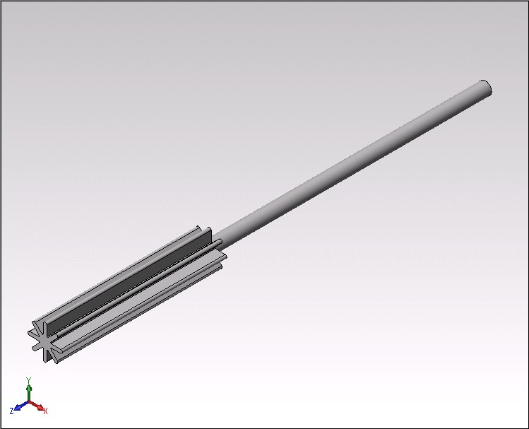
Figure 42: Propellant Mandrel
Production equipment to use: mixer, pouring device, propellant mandrel.

The following is step-by-step instructions to assemble the propulsion system:
- Coat the outside areas of the bulkhead and the metal band with a chromate-pigmented polysulphide rubber. Allow the coating to fully dry.
- Place the bulkhead and the metal band at opposite ends of the collapsible mandrel. The mandrel must a non-stick surface so that it may be removed when the Graphite Epoxy is dry.
- Apply a military-grade adhesive to the outer area of the bulkhead and the metal band. Begin wrapping the Graphite Epoxy sheets around the mandrel until the desired thickness is reached.
- Allow adhesive and Graphite Epoxy to dry for twenty-four hours.
- Remove the collapsible mandrel.
- Spray the entire inside area of the motor case, including the inside area of the bulkhead, and the metal band with .0625-inches (1.5875-mm) of EPDM.
- Temporarily bake the liner and case, but not to full dryness.
- While liner is damp insert the propellant mandrel and pour the propellant around the mandrel. Bake the propellant, liner, and case until full hardness.
- Remove the propellant mandrel.

Nozzle
It is assumed that the same company who provides the existing 2.75 nozzle can manufacture the redesigned nozzle (see Appendix G.5). It is more economical to have the nozzle produced by an outside contractor because of machinery and labor costs.

Guidance
The guidance system is bought from an outside supplier who manufactures top-self hardware to specified dimensions and material (see Appendix I). The guidance system case will be made of Aluminum instead of Graphite Epoxy to insure structural integrity. The guidance case will be pre-treated with chromate-pigmented polysulphide rubber before it is attached to the motor case.

Plant Location
It was determined that relocating or building a new plant in the existing location would be more costly than beneficial. The existing plant for production of the 2.75 will be modified to meet the new design requirements. The reasoning for that decision is based on the main asset for the 2.75, which is that it is a highly efficient weapon for its production cost. So, if the production cost for the 2.75 greatly increases or decreases the feasibility of its use, then a more efficient and devastating missile could be designed for approximately the same cost.

Missile Cost
The basis for the missile cost is strictly obtained by weight. The formula provided by Dr. Michael P.J. Benfield directly relates the weight of the missile to its cost. The equation used is as follows:
Equation 5: C = $6900 W_{L}^{0.64}
where W_{L} is the weight of the missile and C is the production cost of one missile. The cost was found to be $57,574.57. The single production cost then can referenced to a learning curve graph each estimates a single unit cost after mass production. In this case a single unit cost after the production of 10,000 units assuming a typical learning curve of 90% was found to be $14,393.64. It is also assumed that the large cost of early production is due to start-up costs that include upgrading plant facilities, labor, buying from outside suppliers, and operating costs.

Final Assembly
The following is a plan to assemble the major components to a finished missile:
- Apply Loctite to the threads on the bulkhead of the motor case.
- Before the adhesive dries screw the guidance system to the motor case.
- Insert the nozzle into the metal ring until the lock wire snaps into the lock wire groove.
- Add a moisture seal in the throat of the nozzle.
- Add another moisture seal at the rear of the nozzle.

Testing
Several tests are required to show that the design meets or exceeds the requirements of the CDD. These tests will include a hydroburst test, static tests, a ground mission, and an air mission. The following diagram is a test matrix showing the requirements of the CDD and the tests required to prove the design meets or exceeds those requirements.

Table 6: Test Matrix for the ATM
CDD Requirements | Hydroburst | Static Test | Launcher Compatibility Test | Ground Test | Air Test
Weapon ready (firing envelope) |  | X
Smoke Signature |  | X
Ejecta |  | X
Launcher Interfaces |  |  | X
Longitudinal Force |  | X
Temperature |  | X
Humidity |  | X
Thrust |  | X
Chamber Pressure |  | X
Burn Rates |  | X
Composite Case | X
Submunition Deployment |  |  |  | X | X
Max. Acceleration of ATM |  |  |  | X | X
Max. Velocity of ATM |  |  |  | X | X
Platform Error |  |  |  | X | X
Crosswind |  |  |  | X | X
Range |  |  |  | X | X
Min. exit Velocity from tube |  |  |  | X | X
Flight Fail Safe |  |  |  | X | X
Helicopter Mission |  |  |  |  | X
Ground Mission |  |  |  | X

A hydroburst test will be conducted on the composite case to ensure it can withstand the pressures of the propellant. Several static tests will be done to give the thrust, chamber pressure, and burn rates of the propellant, and to meet the following requirements from the CDD: weapon ready, longitudinal force, smoke signature, ejecta, temperature, and humidity. These tests will show the motor will perform as expected in all environmental conditions. A launcher compatibility test will be done to ensure the ATM is compatible with the M261 launcher interfaces. All electrical connections will be checked and the motor will be placed inside the tube to ensure proper clearances. A ground mission from a HMMWV of 4 km is required. The ground mission will also meet the following requirements from the CDD: submunition deployment, maximum acceleration of the ATM, maximum velocity of the ATM, platform error, crosswind, range, the minimum exit velocity of the tube, and flight fail safe. An air mission from an Apache of 8 km is required. The air mission will also meet the same CDD requirements as the ground mission, with the exception of the change in range of the mission. Refer to Appendix H for further information.

Platform Integration
The following concerns compatibility of the ATM with its surroundings, which include the launcher, the launcher interfaces, human limitations and the environment.

The compatibility with the launcher is addressed in two areas. First, the ATM must be physically compatible with the launcher adhering to limits such as size, weight and length. Second, the missile must be compatible with the launcher interfaces. The previous interfaces associated with the M261 launcher can be divided into two categories, mechanical and electrical. In order for the ATM to physically be compatible with the M261 launcher, the rocket had to meet size limits. These limits are a total length of 79.7 inches, a maximum diameter of 2.794 inches, and a maximum weight of 34.4 lbs. The ATM meets the physical limitations in order to properly integrate with the M261 launcher. For the ATM to meet compatibility issues with the launcher interfaces, the missile must be compatible with both electrical and mechanical interfaces. The mechanical interfaces include the detent retainer and ignition ring. The electrical interfaces are the ignition ring, the igniter, and the 1760 umbilical, which transmits data to the ATM. The ATM has a retention groove in order to interface with the detent retainer and an ignition ring in order to receive the firing signal. These mechanical interfaces are properly placed and incorporated into the aft of the ATM. The warhead is unchanged, so the umbilical connection shall be unchanged. The igniter that is currently being used on the MK66/Hydra 70 may be used with the ATM. The igniter is grounded to the case of the ATM and the positive lead is connected to the launch ring.

One of the limitations of the missile is that the motor shall not produce damaging ejecta that could cause damage to the launch platform, equipment, or adjacent aircraft. The TIGER motor uses propellant that produces no ejecta, and items used to ignite the propellant are currently used in the MK66 motor, therefore the TIGER will not produce any damaging ejecta. While it is impossible to determine the IM compliance of this propellant without actually testing it, the fact that it is a 1.3 HC indicates that it would mostly likely be compliant.

A restriction that is set by human performance limitations is that the ATM should be capable of being loaded in arctic gear. The ATM falls within weight limitations, and the aft fins can be fitted with the rear fin cover that is currently being used by the Hydra 70 system. The ATM is capable of being loaded and reloaded in a launcher with military issue arctic mittens, in addition to gloved hands removed from the arctic warming mittens.

It was also ensured that the ATM adhered to certain environmental conditions and that the ATM falls within all environmental condition limits. The environmental conditions include:

- The ATM shall be capable of being stored in -65ºF to 165ºF. The TIGER includes no components that will deteriorate in extreme temperature during storage.
- The ATM shall also be capable of operation in -50ºF to 150ºF. The TIGER’s propellant and avionics section is capable of operation within the set temperature limits, and will not degrade within the set limits.
- The ATM shall be capable of operation during or after exposure to a constant 100% humidity at 75ºF. The ATM’s components and guidance electronics are capable of operating at 100% humidity at 75º F and the components and guidance will not be affected at these conditions.
- There are no known issues with being able to fire the missile at any altitude between 61 m (200 ft) below MSL and 6,096 m (20,000 ft) above MSL.

The ATM shall be capable of being transported and stored within military standard fast packs. Since the ATM meets physical requirements, the ATM shall be capable of being stored within fast packs. Service life shall be a minimum of 10 years with a desired target goal of 25 years. The ATM propellant has a service life of at least ten years and the avionics section service life is determined by the battery, which has a service life of at least ten years as well. Therefore the ATM falls within limits set by the CDD for service life and storage requirements.

In conclusion, The ATM missile meets all requirements set by the CDD regarding platform integration.

Toft, H.O., AEROLAB: Rocket Drag and Stability Calculator, Version 1.2.1, Copyright 2001, http://inet.uni2.dk/~dark/.
Blake, W. B., “Missile DATCOM User’s Manual – 1997 Fortran 90 Revision”, AFRL-VA-WP-TR-1998-3009, February 1998.
Nielson Engineering and Research, Launch Vehicle eXpert System, Version 4.0S, Student Edition, July 2001.
Moore, F.G., and Hymer, T.C., “The 2002 Version of the Aeroprediction Code: Part II – User’s Guide”, NSWCDD/TR-02/34, May 2002.
Kreeger, Roberts, Auman, and Stumpe, “KRAS Configuration,” MAE 659 Team Assignment, UAH, Huntsville, AL, December 4, 2002.
Chin, S S., Missile Configuration Design, McGraw Hill, New York, 1961.
Launch : 2D Rocket Trajectory Calculation Code, version 2.01A, 1999
Hoskin, B.C. and A.A. Baker. 1985. “Composite Materials for Aircraft Structures”. New York, N.Y.
Hoskin, B.C. and A.A. Baker. 1985. “Composite Materials for Aircraft Structures”. New York, N.Y.
Hoskin, B.C. and A.A. Baker. 1985. “Composite Materials for Aircraft Structures”. New York, N.Y.
Hoskin, B.C. and A.A. Baker. 1985. “Composite Materials for Aircraft Structures”. New York, N.Y.
Hoskin, B.C. and A.A. Baker. 1985. “Composite Materials for Aircraft Structures”. New York, N.Y.
Hoskin, B.C. and A.A. Baker. 1985. “Composite Materials for Aircraft Structures”. New York, N.Y.
December 1990, Materials Selector 1991, Materials Engineering: The Magazine of Materials and Composites
December 1990, Materials Selector 1991, Materials Engineering: The Magazine of Materials and Composites
FibreGlast Website, www.fibreglast.com, 6 March 2003.
DeGarmo, E.P. et. al., Materials and Processes in Manufacturing, Eighth ed., John Wiley & Sons, New York, 1999
Rhinoceros: NURBS modeling for Windows. Version 3.0, 5-Mar-2003.
Interstate Electronics Website, www.iechome.com, 3 March 2003.
Hoskin, B.C. and A.A. Baker. 1985. “Composite Materials for Aircraft Structures”. New York, N.Y.
Hoskin, B.C. and A.A. Baker. 1985. “Composite Materials for Aircraft Structures”. New York, N.Y.
Hoskin, B.C. and A.A. Baker. 1985. “Composite Materials for Aircraft Structures”. New York, N.Y.

