Structures

Primary Material Selection

The materials chosen for the Cyclops were chosen for their 1) lightweight properties, 2) cost effectiveness, and 3) ability to withstand the extreme hot and cold temperatures of the lunar surface. The materials chosen for the lander structure are aluminum 6061 T6 and carbon fiber. Aluminum will be used for the main lander structure while carbon fiber will be used around the electronic components. It is important that the lander structure be lightweight while still having the strength required to maintain structural integrity. Aluminum 6061 T6 and carbon fiber are lightweight materials with specific gravities of 2.7 of 1.81 respectively. The aluminum and carbon fiber will both be able to handle the temperature range of 123K to 373K. Aluminum easily transfers heat and is able to maintain structural integrity in both hot and cold environments. Carbon fiber is an excellent thermal insulator and will handle the temperature range encountered on the lunar surface. Even though carbon fiber is a more expensive material than the aluminum, the carbon fiber can be used in areas that require higher thermal insulation. Another advantage of the materials used, the aluminum 6061 T6 and carbon fiber are both TRL 9. This provides historical data that shows that the materials used in the construction of the Cyclops are capable of remaining reliable for the mission duration.

2.1.2 Basic Structure Analysis

The Cyclops will be capable of surviving the maximum g-loads under which it will operate. These g-loads occur at launch and will maximize at 6 g’s during booster engine cutoff. The calculations used to verify survivability under this g-load can be found in Appendix G. The Cyclops uses a six wheel rocker bogey system for its mobility on the surface of the moon. Using this mobility system, the lander will have the capability to land on a twelve degree slope. This will be possible even under the worst-case landing scenario in which the Cyclops lands with its wheels perpendicular to the landing slope. The calculations showing the ability to land on a twelve degree slope are located in Appendix G.

    - Stress Analysis

Stress analysis was performed on each part of the rocker bogey system to determine the location and magnitude of the maximum stress. This analysis was performed using the Femap Express feature of Solid Edge V20. The results of this stress analysis are shown in the figures below.

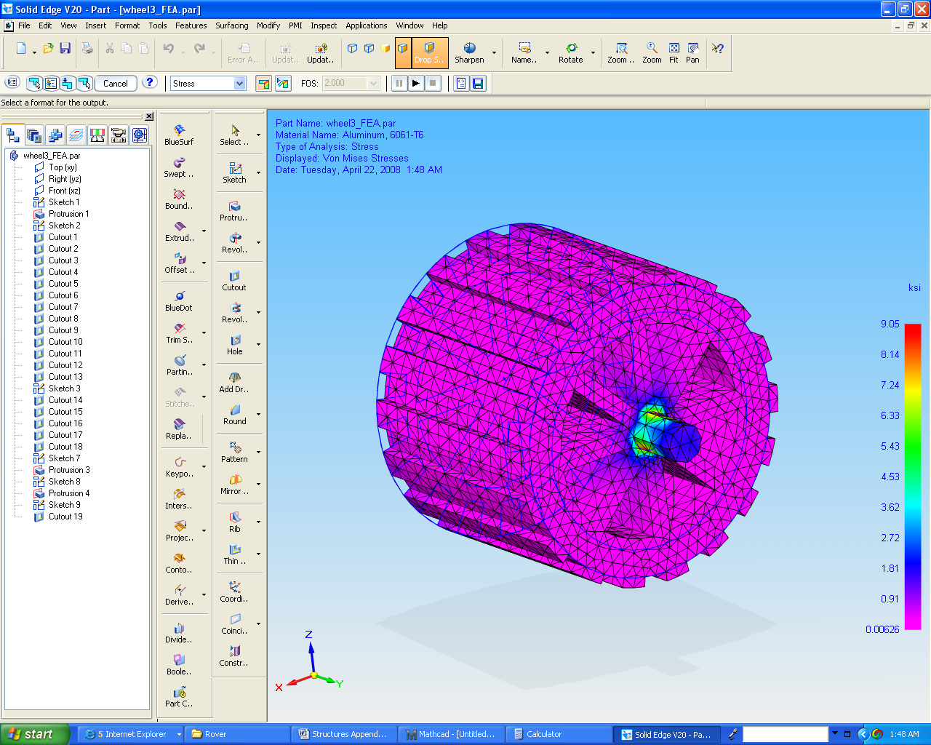

Figure X
Stress Analysis for Wheel

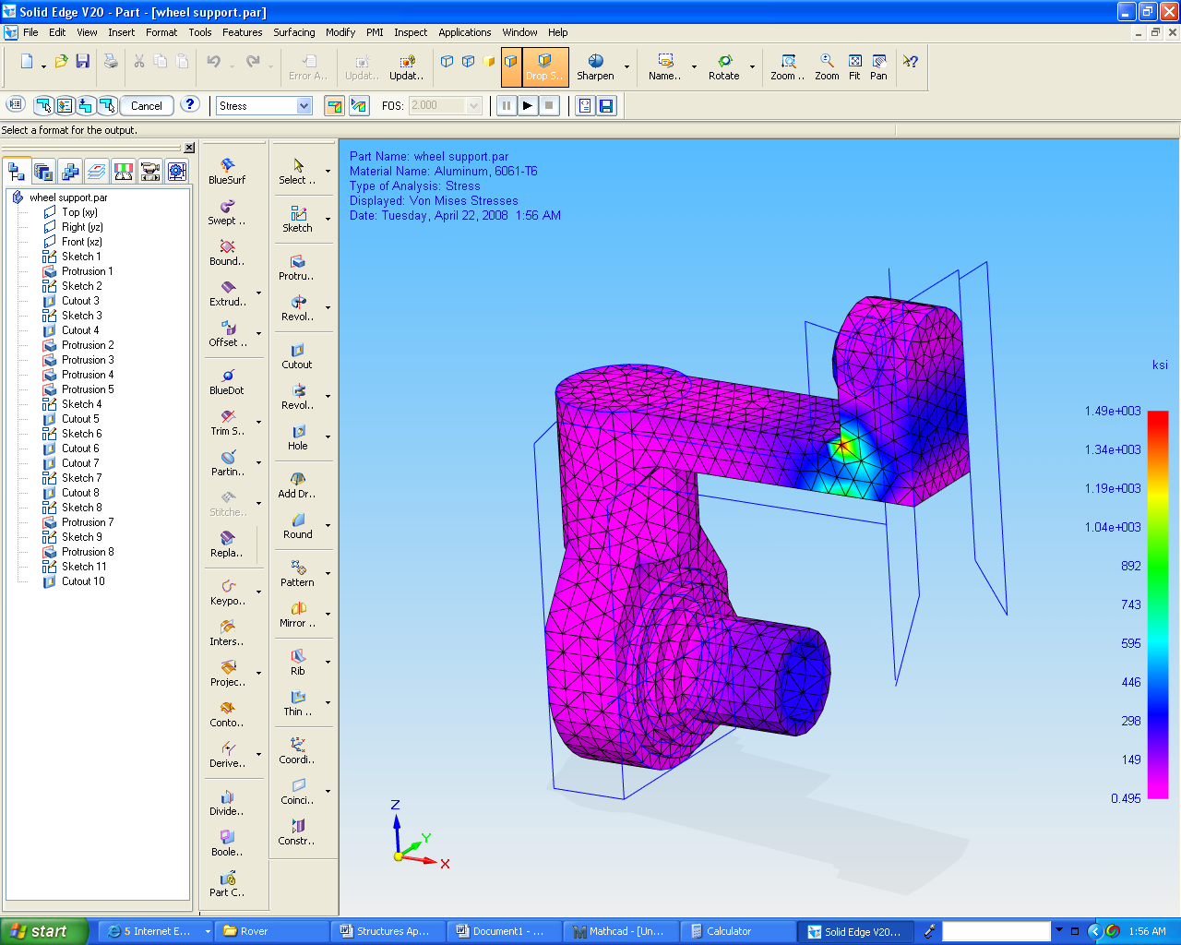

Figure X
Stress Analysis for Wheel Support

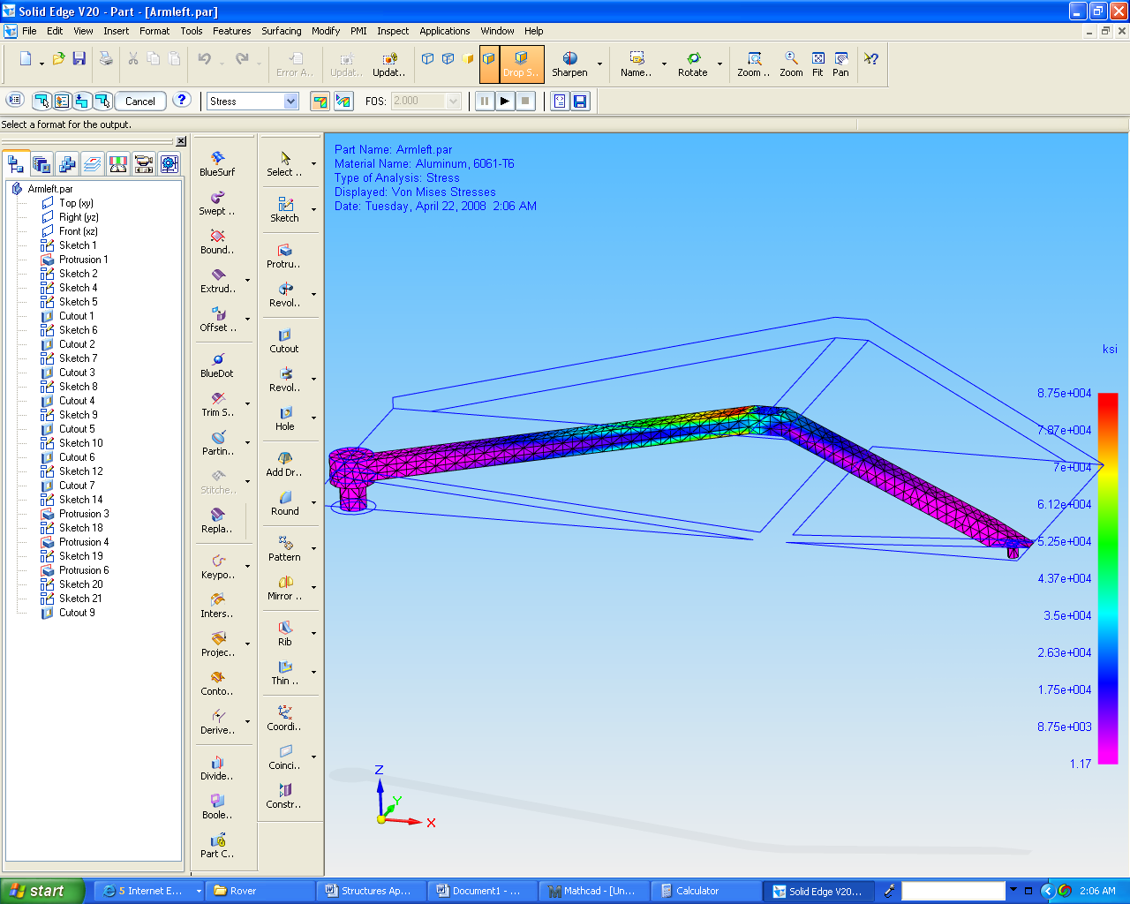

Figure X
Stress Analysis for Front Arm of Rocker Bogey

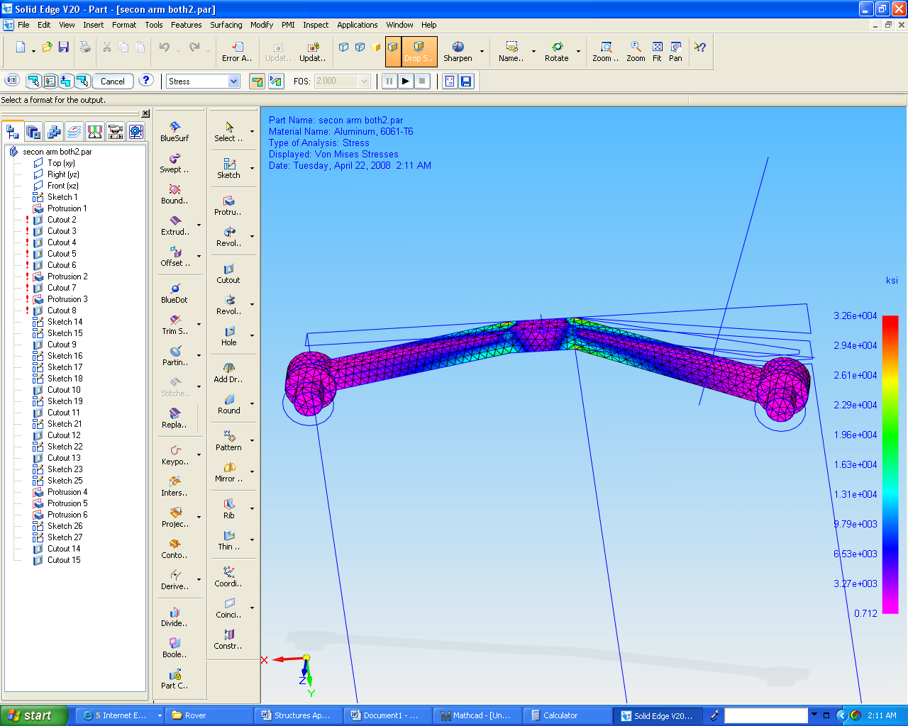

Figure X
Stress Analysis for Rear Arm of Rocker Bogey

