1.4 The Solution

1.4.1 Concept Overview

The concept proposed by team Frankenstein is one of reliability and mission success. The Cyclops is designed to be a fail proof multi-mission lander/rover that not only meets but exceeds the mission parameters of the LETS requirements. The Cyclops offers the ability to meet the mission requirements and exceed them. The Cyclops’s potential allows for possible malfunction during its mission but not total mission failure. During the first stage of the Cyclops’s mission, penetrators are deployed prior to landing. If any of the penetrators fail the Cyclops will have the ability to acquire any of the missing/needed samples due to its mobility and multi-mission ability. In closing, the Cyclops offers not only a high percentage in initial mission success, but reliability in redundancy for mission objectives.

1.4.2 Dimensional Properties

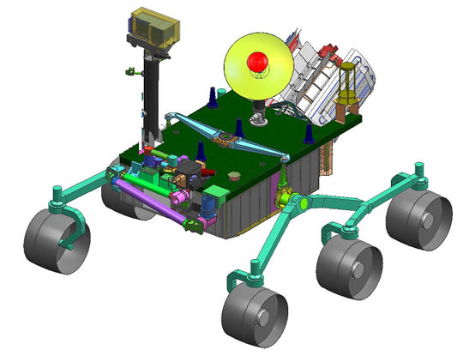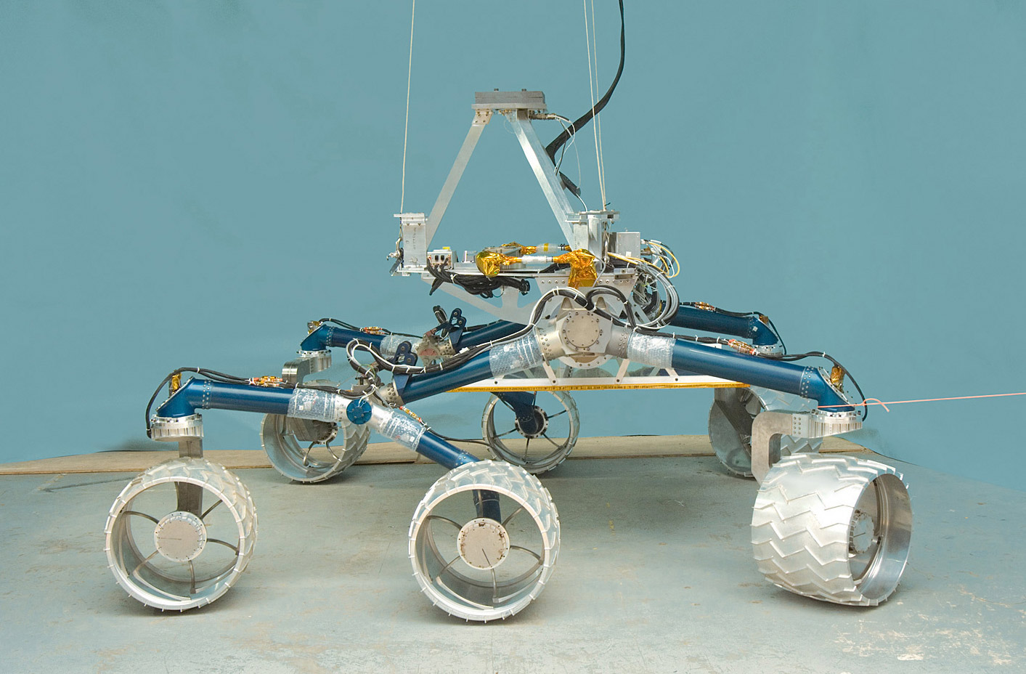
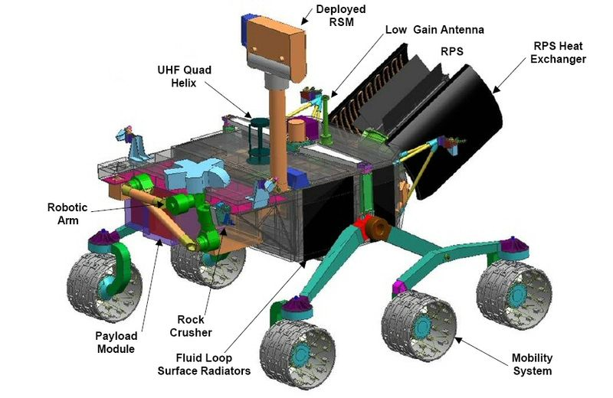

1.4.3 Operational Scenario

While in lunar orbit/descent the Cyclops will deploy fifteen penetrators from a launch ring positioned between the rover and the attitude control system. The penetrators once released, will utilize their kinetic energy in order to impact the lunar surface at targeted dark sites and relay data back to the Cyclops rover once the rover has landed. The attitude control system will then carry the Cyclops out of the dark region where it will land and separate from the attitude control system and the penetrator launch ring. Once landed, the Cyclops will rove to a suitable site in order to deploy our single site observation device with the attached sample return vehicle. The Cyclops will then begin its data acquisition from the dark site penetrators and acquiring lighted samples outside the dark region. If any of the launched penetrators fail to operate successfully, the Cyclops rover will then proceed to said dark sites and acquire the lunar samples itself. All data acquired will either be stored for direct transmission to earth or relayed through the LRO if necessary. The single site observation device that was deployed upon lunar landing of the Cyclops will acquire the lighting conditions, micrometeorite flux, and assess the electro static dust conditions. In addition to the recorded data, a sample return vehicle will be integrated with the single site observation device in order to return actual raw material to earth for further study.

1.4.4 The Performance

Final Concept Evaluation

CDD Requirement | Requirement | Assessment | Remark
Landed Mass | 932.8 kg | Exceeds
Survive Lunar Cruise | 28 days | Exceeds
Operational Period | 1 year | Exceeds
Sample Lunar Surface | 15 dark | Exceeds
Communication | Send and Receive (real time) | Exceeds
Landing Parameters | 12º slope Within 100 m. | Exceeds
Survive Launch of 3 G's | 3 G's | Exceeds
Technology Requirements | TRL9 | Meets
Power Requirements | Store Power in Dark Conditions | Exceeds
Thermal Conditions | Survive Tempeature Changes | Exceeds
Sample Return Vehicle | Sample Return (Goal) | Exceeds
Mobile | Roving/Real-Time Mobility | Exceeds

