Competition Sensitive Document Attached

Team 02F
IPT 2008 White Paper
The Attached Document is Competition Sensitive until May 2, 2008

If you find this document unattended put it in a secure place and notify

Dr. Robert A. Frederick, Jr.
IPT Project Director
Office: 256-824-7203
Cell: 256-503-4909
frederic@eng.uah.edu
Alternate Concepts White Paper

IPT 02F

The University of Alabama in Huntsville
Team Leader  Structures  Power  Systems Engineering  GN&C  Thermal  Payload / Communications  Operations | Matt Isbell, isbellm@email.uah.edu  Matthew Pinkston, mmjpink@hotmail.com  Robert Baltz, baltzr@email.uah.edu  Tyler Smith, smitht5@email.uah.edu  Kevin Dean, kwd0001@email.uah.edu  Joseph Woodall, joseph.woodall@charter.net  Thomas Talty, talty@uah.edu  Chris Brunton, bruntonc@email.uah.edu  Audra Ribordy, audra342@yahoo.com
Southern University
Mobility | Chase Nelson, cnelson0053@gmail.com  Eddie Miller, eddie.miller212@gmail.com
ESTACA
Sample Return | Kim Nguyen, kim.nguyen98@gmail.com  Vincent Tolomio, vincent.tolomio@gmail.com

Submitted By:

Team Frankenstein

February 21, 2008

Submitted To:
Dr. P.J. Benfield and Dr. Matthew Turner
Department of Mechanical and Aerospace Engineering
The University of Alabama in Huntsville
pj.benfield@uah.edu
matt.turner@uah.edu
Abstract
For the Spring 2008 IPT competition, Team Frankenstein will be competing in the design of a Lunar Exploration Transportation System, LETS. This system must have the ability to land on the moon at a polar location and also have the ability to move around while on the moon. For a single site, we must determine lighting conditions every two hours over the course of a year, determine micrometeorite flux, and assess electrostatic dust levitation and its correlation with lighting conditions. We must also achieve our mobility goals by collecting independent measurement of 15 samples in permanent dark and 5 samples in lighted terrain, determine the composition, geotechnical properties and volatile content of the regolith, and relay all information back to earth. For the second phase of this competition, Team Frankenstein has developed two alternatives to the given baseline design, the Viking. Each design consists of a lander and rover combination. The first is a land on wheels concept that encompasses the lander and rover into one vehicle. The second concept is a traditional lander that will deploy a rover on the lunar surface. Each design will be thoroughly assessed based on the specifications of the Concept Description Document (CDD). After each design is assessed and ranked, one design will be chosen and carried into the third phase.
Team Frankenstein’s first option is Cyclops. This design encompasses the land on wheels concept. Cyclops will land and travel on the lunar surface to accomplish our CDD requirements. The lander will have two MR-80 monopropellant liquid rocket engines, twelve MR-106 monopropellant thrusters, a hexagonal structure with six wheels, and penetrators. This option has been selected by Team Frankenstein to carry into the third phase of the project.
The second option is Medusa. This design has a lander which will deploy a rover on the surface to complete the CDD requirements. The lander will have two MR-80 monopropellant liquid rocket engines, twelve MR-106 monopropellant thrusters, a hexagonal structure with four landing legs, and penetrators.
The main reason for selecting Cyclops is because of the score of the evaluation matrix. This design is the best choice at this time to carry into the third phase of the project.

Technical Description

1.0 Overview of Phase 2
For Phase 2, the individual IPTs have worked independently to produce two alternative configurations to a baseline design. The deliverables for Phase 2 are a white paper and an oral presentation. The white paper compares the baseline concept, named the Viking Lander with two alternative concepts. This white paper summarizes a strategy for selecting alternative systems, qualitative and quantitative information to evaluate each idea, and a logical rationale for down selecting one concept from among the three presented.

1.1 Specification Summary
For this project to be a successful mission, there are certain requirements that must be achieved. For this mission, the lander and rover must be able to take and retrieve the CDD requirements and data from the moon’s surface and relay it back to Earth. The lander shall be able to achieve the worse case g-load and be able to land on a 12 degree slope. The lander will land at a polar location with the capability to land at other lunar locations. After reaching the moon, the lander has to be able to determine lighting conditions every two hours over the course of a year, determine micrometeorite flux, and assess electrostatic dust levitation and its correlation with lighting conditions for a single site. We must also achieve our mobility goals by collecting independent measurement of 15 samples in permanent dark and 5 samples in lighted terrain. From the collected samples, we must then determine the composition, geotechnical properties and volatile content of the regolith, and relay all information back to Earth by the end of our mission end (one year). The total landing mass cannot exceed 997.4kg for the chosen Atlas V-401 EPF shroud configuration. The system must be able to survive the polar and lunar environment for a year.

1.2 Team Frankenstein Approach to Phase 2
Upon completing Phase 1, the baseline review, Team Frankenstein began to function as a team. This is where each of the individuals became responsible for their own disciplines. The first step in Phase 2 was creating individual resumes for each team member and the Letter of Intent to create a common format for team operation. The two issues that caused the most concern were the harsh environment and mobility on the moon. The harsh environment presents an issue because of the little information known about the moon. Our requirements to achieve surface objectives in the permanently dark sites are also an issue due to the temperature ranging from +107 to -153 degrees Celsius. Mobility was non-existent on our baseline lander. The CDD for the LETS, however, does require mobility.
The group studied back over the baseline review presentation to attain detailed information about the customer’s specific requirements. From the customer’s requirements, each discipline began investigating the possible situations to meet the given CDD requirements. Once each team member envisioned several ideas, they were presented to the entire team. The team began revising these possibilities. Team Frankenstein began narrowing the alternatives to a of couple designs. From team collaboration two complete concepts were created. The team evaluated the concepts based on the weighted values for desired criteria and chose the highest score to be the winning concept.
Figure 1 shows the outline of the design process used for Phase 2. The CDD requirements were evaluated and given to the project manager. The manager then forwarded them on to the systems engineer and finally to the individual disciplines. After each discipline presented their own alternatives, a complete systems evaluation was completed and changes were made as necessary. This process was repeated until the final concepts were developed. Our results were then submitted to the project office for a final evaluation before being presented to the customer.
Results
System Simulation
CDD/Customer
Project Office
Systems Engineer
Thermal
Power
GN&C
Operations
Payloads
Structures
Mobility
Sample Return

Figure 1 – Outline of the Design Methodology

2.0 Description of Concepts
Team Frankenstein has narrowed its concepts of designing a lunar lander capable of navigating the moon to two different configurations. After research and application of engineering principles, the configurations were chosen based on the attributes of payload, propulsion, structure, electronics, communications, power, control system, and thermal system as well as how they affected each other. The first configuration was a single rover landing on wheels and the second configuration was a lander with a single rover. The Viking Lander was used as the baseline configuration for the project. Table 1 summarizes the final configurations of the baseline and the two alternative concepts.
Cyclops, the single rover landing on wheels, was the first concept based on its advantages of mass conservation and a reduced amount of ground support. Cyclops’ attributes will consist of the payload, propulsion, structure, electronics, communications, power, control system, and thermal system. The Cyclops will be able to shoot twenty penetrators on descent with fifteen in permanent dark and five in lighted terrain. With the Cyclops the time between sample data gathering and transmission will be minimal due to the fact that no rover will need to return data back to a stationary lander. The Cyclops will require less travel time and power in extreme cold than a single rover having to retrieve data and return it back to a stationary lander. Less weight will also be a key factor in the Cyclops concept because a rover will not be part of the payload which would be an increase in overall weight. Less maneuverability of the Cyclops may be compromised because of the extra features onboard.
Medusa, a lander with a single rover, was the second concept based on its advantage of proven off the shelf technology. Medusa’s attributes will consist of the payload, propulsion, structure, electronics, communications, power, control system, and thermal system. Medusa will be able to shoot twenty penetrators on descent with fifteen in permanent dark and five in lighted terrain. The rover that detaches from Medusa is capable of more maneuverability because of its size and weight. The lander being in a permanent position reduces the risk of failure to its subsystems. More travel time is required to the samples but a rover gives a better probability of mission completion and data return.

Table 1– BOOST Matrix for LETS

 |  | Baseline | Alternative Concepts
 |  | 02-BL | 02F-ALT1 | 03F-ALT2
CONFIGURATION | STATE | Viking | Cyclops | Medusa
CATEGORY
1. Payload | [Conposite Container] | Other | Composite Container | Composite Container
1. Payload | [Open Container] | Other | Composite Container | Composite Container
1. Payload | [Other] | Other | Composite Container | Composite Container
2. Propulsion | [MR-80B ] | RCS and TDS Engines | MR-80B | MR-80B
2. Propulsion | [RCS and TDS Engines] | RCS and TDS Engines | MR-80B | MR-80B
2. Propulsion | {Other} | RCS and TDS Engines | MR-80B | MR-80B
3. Structures | [Six Legs/Wheel] | Three Legs | Six Legs/Wheels | Four Legs
3. Structures | [Four Legs] | Three Legs | Six Legs/Wheels | Four Legs
3. Structures | [Three Legs] | Three Legs | Six Legs/Wheels | Four Legs
3. Structures | [Other] | Three Legs | Six Legs/Wheels | Four Legs
4. Thermal | [Multi-Layer Insulation] | Thermal Switches | Multi-Layer Insulation | Multi-Layer Insulation
4. Thermal | [Thermal Switches] | Thermal Switches | Multi-Layer Insulation | Multi-Layer Insulation
4. Thermal | [other] | Thermal Switches | Multi-Layer Insulation | Multi-Layer Insulation
5. Guidance | [GCSC] | GSCS | Autonomous | Autonomous
5. Guidance | [Autonomous] | GSCS | Autonomous | Autonomous
5. Guidance | [Other] | GSCS | Autonomous | Autonomous
6. Communications | [Telemetry] |  | Telemetry | Telemetry
6. Communications | [S-Band DCS] |  | Telemetry | Telemetry
6. Communications | [Other] | S-Band DCS | Telemetry | Telemetry
7. Control | [Radar Altimeter] | Radar Altimeter | Radar Altimeter | Radar Altimeter
7. Control | [Other] | Radar Altimeter | Radar Altimeter | Radar Altimeter
8. Power | [Batteries and RTG] | Batteries and RTG | Batteries and RTG | Batteries and RTG
8. Power | [Solar] | Batteries and RTG | Batteries and RTG | Batteries and RTG
8. Power | [Other] | Batteries and RTG | Batteries and RTG | Batteries and RTG

2.1 Baseline Concept: “Viking Lander 1” [02-BL]
The baseline project, Viking Lander, was a NASA program to put a lander on Mars. The objective of the Viking mission was to take direct measurements from the Martian surface and to enhance knowledge of the planet’s biological, chemical, and environmental existence. The Viking mission was separated into many phases: launch, cruise, orbital, separation, entry, and landing. The launch phase was when the Viking was first placed into orbit. During the cruise phase, the Viking orbiter provided all communications and navigation control. The orbital phase provided information for the Viking’s possible landing sites. The separation, entry, and landing phase occurred when the parachute was deployed, the aeroshell cap separated from the lander, and the legs of the lander were deployed.
The Viking Lander design consisted of structures and mechanisms, thermal control, communications, guidance and control, power, propulsion, pyrotechnics, telemetry and data handling, and science subsystems. The venting assembly, deployment mechanism for the high gain antenna, landing legs, the lander body structure, aero-decelerator made up of an aeroshell and parachute, as well as a bioshield made up the structures and mechanisms subsystems. The thermal control subsystem provided all components and structures with an acceptable temperature environment with the use of both passive and active techniques. The communication subsystem had the capability to support radio science experiments and receiving transmitted commands from Earth. The guidance and control subsystem interfaced with other lander subsystems and utilized the flight software to perform guidance, steering, control of the lander from separation to landing, command processing and sequencing for all mission phases, and computation of lander orientation. The power subsystem provided switching for various electrical loads, sensors for detecting unsafe operating conditions, and was a power source for the lander. The reaction control system and terminal descent system made up the monopropellant propulsion subsystem. The reaction control system consisted of four three-engine clusters and two fuel tanks to provide impulse energy for deorbit and altitude control through entry. Three engines, four roll engines, and two fuel tanks for controlling velocity on descent made up the terminal descent system. The pyrotechnics devices that made up the pyrotechnic subsystem controlled all functions on the lander by responding to the commands from the aerospace ground equipment, the Viking orbiter, or the guidance, control, and sequencing computer. The telemetry and data handling subsystem controlled, processed, and modulated all of the VLC data during the mission. The biology, gas chromatograph and mass spectrometer, lander camera system, meteorology, seismometer, surface sampler assembly, x-ray fluorescence spectrometer, and magnetic properties included the instruments that made up the science subsystem.
Even though the Viking mission was expensive, the data and information recovered from the Viking Lander furthered our interest in space and exploration. The Viking Lander was successful on many levels throughout the mission including the extended life and durability of the lander which created a baseline for other concepts.

2.2 Alternative 1 Concept: “Cyclops” [02F – ALT1]
Cyclops, the single rover landing on wheels, was the first design for the lunar exploration transportation system. This concept is based on its advantages of mass conservation and reduced amount of ground support needed. Some of the subsystems of the Cyclops include the payload, structure, electronics, communications, power, altitude control, thermal, and propulsion. With these systems the Cyclops will provide the flexibility to conduct systematic tasks at different locations on the lunar surface.
The payload of the Cyclops will need access to the lunar environment and will be connected on the bottom portion of the lander. It will house the propulsion subsystem, communication hardware, altitude control sensors and thrusters, computers, batteries, radar altimeter, penetrators, and thermal control parts. Six legs will be used to provide more maneuverability and stability for the structures portion of the Cyclops. The Cyclops will also be built to fit in the Atlas V-401 shroud configuration with a total landed mass of no more than 997.4 kg. The electronics and communications systems will be working together with the computers onboard to provide the Cyclops with telemetry to send back to Earth. The primary objective of the power subsystem is to provide power to all onboard systems which include the electronics, communications, computers, and the altitude control system. This will be achieved through the use of several lithium ion batteries as well as a radioisotope thermoelectric generator. The altitude control system will be designed for twelve MR-106 monopropellant thrusters. The thrusters will be used for stability of the Cyclops while in descent. The radar altimeter will also be part of the altitude control system which will measure the distance between the Cyclops and the ground below it. The thermal portion of the design will provide insulation to the Cyclops with temperatures ranging from 107 degrees Celsius to -153 degrees Celsius. The thermal subsystem on the Cyclops will also consist of a multi-layer insulation used to reduce dust build up and thermal radiation as well as prevent extremely cold temperature damage. The propulsion system will have two MR-80B monopropellant liquid rocket engines. The propulsion systems dry mass will be 64.6 kg of the total landed mass and shall be designed to accommodate 159.5 kg of hydrazine propellant as well as 2 kg of helium.
On the Cyclops’ descent to the moon, the penetrators will be spread across the surface of the moon in fifteen permanent dark and five lighted sites. These penetrators will be separated by a distance of at least 500 meters from each other. In descent the Cyclops will also provide guidance, navigation, and control beginning at five kilometers above the surface of the moon. The impact of the Cyclops on the surface of the moon will be dampened by the suspension of the six wheels. Once the motion of the Cyclops has ceased, a sample box will be dropped off to determine lighting conditions every two hours over the course of one year, assess electrostatic dust levitation, and determine micrometeorite flux. The Cyclops will then be able to begin its mission of collecting samples at each penetrator location.

2.3 Alternative 2 Concept: “Medusa” [02F – ALT2]
Medusa, a lander with a single rover, was the second design for the lunar exploration transportation system. This concept is based on its advantage of proven off the shelf technology. Some of the subsystems of Medusa include the payload, structure, electronics, communications, power, altitude control, thermal, and propulsion. With these systems Medusa will provide the flexibility to conduct systematic tasks at different locations on the lunar surface.
The payload of Medusa will need access to the lunar environment and will be connected on the bottom portion of the lander. It will house the propulsion subsystem, communication hardware, altitude control sensors and thrusters, computers, batteries, radar altimeter, penetrators, rover, and thermal control parts. Four legs will be used to provide stability on landing for the structures portion of Medusa. Medusa will also be built to fit in the Atlas V-401 shroud configuration with a total landed mass of no more than 997.4 kg. The electronics and communications systems will be working together with the computers onboard to provide Medusa with telemetry to send back to Earth from the rover’s findings. The primary objective of the power subsystem is to provide power to all onboard systems which include the electronics, communications, computers, and the altitude control system. This will be achieved through the use of several lithium ion batteries as well as a radioisotope thermoelectric generator. The altitude control system will be designed for twelve MR-106 monopropellant thrusters. The thrusters will be used for stability of Medusa while in descent. The radar altimeter will also be part of the altitude control system which will measure the distance between Medusa and the ground below it. The thermal portion of the design will provide insulation to Medusa as well as its rover with temperatures ranging from 107 degrees Celsius to -153 degrees Celsius. The thermal subsystem on Medusa and its rover will also consist of a multi-layer insulation used to reduce dust build up and thermal radiation as well as prevent extremely cold temperature damage. The propulsion system will have two MR-80B monopropellant liquid rocket engines. The propulsion systems dry mass will be 64.6 kg of the total landed mass and shall be designed to accommodate 159.5 kg of hydrazine propellant as well as 2 kg of helium.
On Medusa’s descent to the moon, the penetrators will be spread across the surface of the moon in fifteen permanent dark and five lighted sites. These penetrators will be separated by a distance of at least 500 meters from each other. In descent Medusa will also provide guidance, navigation, and control beginning at five kilometers above the surface of the moon. Once Medusa has landed on the surface of the moon, a rover will be unloaded to retrieve samples of the moon’s surface at each penetrator location. Medusa will remain stationary to determine lighting conditions every two hours over the course of one year, assess electrostatic dust levitation, analyze samples from rover, and determine micrometeorite flux.

3.0 Selection of Final Concept

The following categories were used in the final selection of the concept. They are as listed: weight, trip survival, operational limitations, scientific objectives, communications, landing site objectives, launch survival, technology readiness level, power, thermal, and mobility. The user defined objectives are ease of designing and ease of completing scientific objectives. The lander has a weight limit of 997.4kg. It must be adhered to and thus receives a weighting of three. The lander must also survive the trip to the moon. If the lander does not survive the trip to the moon, the mission does not get completed. Therefore, trip survival receives a weight of five. The lander must also operate and survive for one year. This is a basic operational limitation and receives a weighting of five. The lander has several scientific objectives. It must sample several lunar sites. This is the basis of the mission and therefore receives a weighting of five. The lander must also communicate the results of the tests back to Earth and receive commands from Mission Control. Therefore, the communication system receives a weighting of five. The lander must be able to land on a slope from zero to twelve degrees and within a hundred meters of a designated site. This is fairly critical to the mission objectives; therefore, it received a score of three. The payload must be able to survive the launch or else the mission will fail. Because of this, launch survival received a score of five. Technological Readiness Level (TRL) is not too critical to the mission because most of the components for this mission are easily TRL 9 compatible. Therefore, TRL9 received a score of two. Power is critical to mission survival and operational limitations; therefore, a score of five was given. Thermal systems will mainly be critical when the lander is in the dark, which occurs every fourteen days. Because of this, thermal received a score of two. Because mobility is one of the main parameters of this mission, it received a score of five. Ease of designing is a fairly critical and important parameter because of the time limitations of the project. It received a score of three. Ease of completing scientific objectives was also relatively important. Achieving success in the scientific objectives equates better information about the moon being transmitted back to Mission Control for future mission planning.
The two concepts that were considered were a lander with a single rover, and a lander that is mounted on wheels and acts as both a lander and a rover. Out of these two concepts, it was decided to develop a wheel mounted lander, because it is believed that a wheel mounted lander will operate more effectively and more efficiently. The wheel mounted lander will have a more flexible design allowing it to be used at various lunar locations. It is also believed that a wheel mounted lander will operate with more operational ease making it more likely that the mission objectives will be achieved. With the ease of design and ease of accomplishing the scientific objectives being key elements in the design, the wheel mounted lander is the design of choice.

4.0 Phase 3 Plan

4.1 Key Issues to Address
An issue that is to be considered is to use technology with a rating of TRL 9. That means that any newly developed concepts are discouraged from the design. This however, does not limit the use of new technology. Figures of Merit (FOM) will be used for deciding our concept designs. The FOM’s will be used in place of cost analysis. Keeping the mission low cost is definitely a priority, but the most important factor is functionality and reliability of the lander. Sufficient funding would most likely be based from and entrusted in knowledge of thorough research and design concepts.

4.2 Planned Tasks for ESTACA and Southern University
ESTACA is our partner from France that is involved with this project. ESTACA is responsible for the Sample Return Vehicle or SRV. Southern University from Baton Rouge, Louisiana is in charge of the Rover to be used in the lander. If a lander is not used, Southern University will help in concepts for a mobile lander or penetrators used.

4.3 Phase 3 Schedule
Each subsystem must develop a unique design that best fits the requirements for the chosen concept. There, however, will most likely be compromises on each design of the subsystem in yielding a beneficial product as far as the whole design goes. Pugh’s concepts and the House of Quality will most likely be implemented in deciding final designs. After all analysis is complete, a final design will be created. After all final decisions are made for the design, a final report will be written. Finally, a presentation will be made to the review board.

5.0 Illustrations

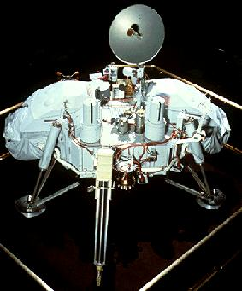

Figure 2 – Baseline: “Viking Lander” [02-BL]

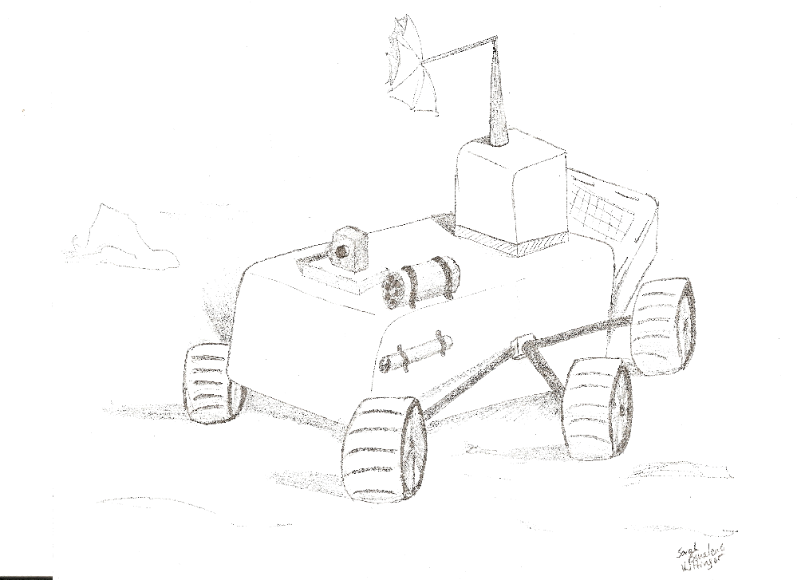

Figure 3 - Alternative 1 Concept : “Cyclops” [02F – ALT1]
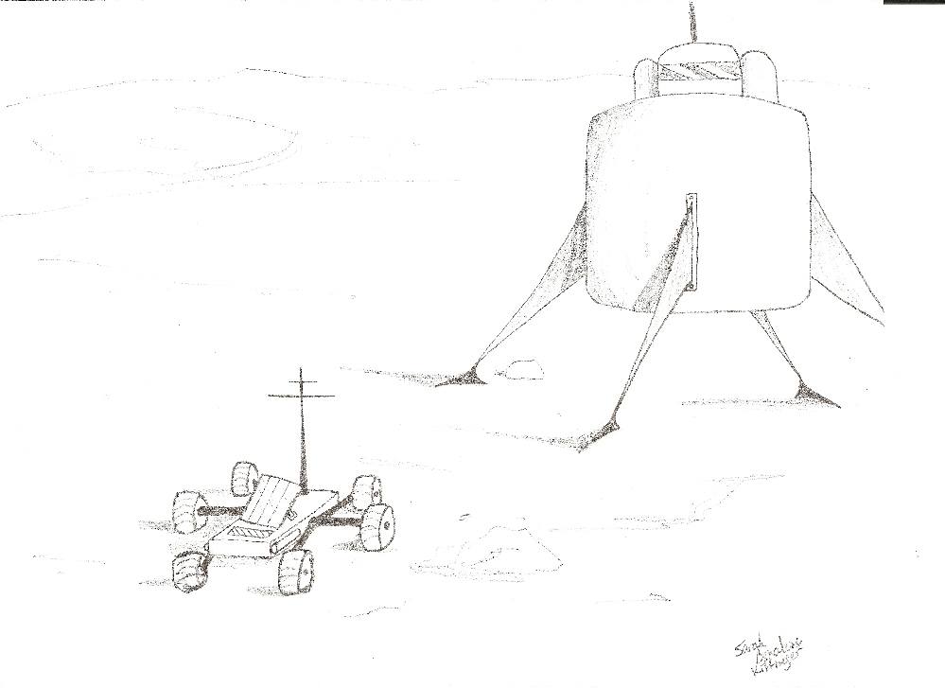
Figure 4 – Alternative 2 Concept: “Medusa” [02F – ALT2]

Table 2 – Engineering Summary

 |  | 02-BL | 02F-ALT1 | 02F-ALT2
NAME | Units | Viking | Cyclops | Medusa
GN&C | kg | 25 | 35.5 | 35.5
Structures | kg | 399 | 265 | 315
Power | kg | 60 | 45 | 45
Thermal | kg | 25 | 45 | 45
Payload | kg | 91 | 95 | 60
Sample Return | kg | N/A | 300 | 200
Mobility | kg | N/A | N/A | 232.3
Total | kg | 600 | 785.5 | 932.8
Table 3 - Concept Evaluation Matrix
Scoring Legend | NA  Not Analyzed  0 | Does Not Meet  0 | Partially Meets  5 | Meets  10

CDD Attribute | Score  Wt. | Baseline | Concept 1 | Concept 2 | CDD Requirement
CDD Attribute | Score  Wt. | Viking Lander | Cyclops | Medusa
Weight | 3 | 0 | 10 | 5 | Landed mass 932.8kg
Trip Survival | 5 | 10 | 10 | 10 | Survive Lunar Cruise up to 28 days
Operational Limitations | 5 | 10 | 10 | 10 | Operate for at least 1 yr
Scientific Objectives | 5 | 0 | 10 | 5 | Sample lunar surfaces
Communications | 5 | 5 | 5 | 5 | Send and Receive communication from Earth
Landing Site Objectives | 3 | 0 | 5 | 5 | Land on 12° slope, and within 100m of site
Launch Survival | 5 | 10 | 10 | 10 | Survive launch g loads (3g’s)
Technological Readiness Level 9 | 2 | 10 | 5 | 10 | Should be TRL 9
Power | 5 | 10 | NA  0 | NA  0 | Store power when in the dark
Thermal | 2 | 5 | NA  0 | NA  0 | Survive Temperature swings
Mobility | 5 | 0 | 10 | 10 | Must be mobile
USER SUPPLIED
Ease of Designing | 3 |  | 10 | 5 | User Selected
Ease of completing Scientific Objectives | 3 |  | 10 | 10 | User Selected
Total Score | 48 |  | 39 | 36.5

6.0 References

1) Holmberg, N.A., Faust, R.P., Holt, M.H., “Viking 75’ Spacecraft Design and Test Summery,” NASA Reference Publication, 1027, November, 1980.
2) Ingoldby, R.N., “Guidance and Control System Design of the Viking Planetary Lander,” AIAA Journal, Vol.1, No.3, 1978, pp.189-196.
3) Lawrence, G.F., Scofield, W.T., “Automated Lunar Landing Missions Using the Viking Spacecraft,” AIAA Paper, pp. 71-822, July 1971.
4) Bauer, D.E., Collicott, H.E., “Spacecraft Thermal Control, Design, and Operations,” AIAA Journal, Vol.1, No.3, 1982, pp. 311-345.

Some general comments from Matt:
Ok … you guys did a great job with the “what” but are really lacking on the “why”. Why did you make the combinations (or choices) that you made? That is, from your original big trade tree (from your white board), why did you decide that certain things should be cut off while you kept others? Present the entire tree, and then say, “well, this branch is a no-go because of this” and “that branch seems offers more capability because of blah.” (Not in those words – make it sound better – but you get my point.) In every section of the paper, ask yourself “Ok, why are we using this?” and then write it. It’s all about the “why.” Remember Hank – “I don’t care what your answer is, but I do care why/how you got it.”
Be concise. For example, the previous sentence. If you repeat something (subject, object, etc) in two or more sentences, try to combine them into a single thought/sentence … but don’t run-on.
Avoid repetitiveness … in your large Pugh’s paragraph, it’s repetitive after repetitive after repetitive. If you see something is going to be that way, use a list (numbered or bullets) or a table or something. Or, simply break it up to make it appear non-repetitive.
Watch your verb tenses. You switch around from past to present to future to past participle to future subjunctive – sometimes in the same paragraph. Part of the problem is that different people wrote different sections. However, you need to decide the tense of things. Are requirements past tense – the requirements “were” – or are they present tense – the requirements “are.” Furthermore, I realize that you “designed” or “calculated” things (past tense), but these “are” (present tense) your current designs. Just watch out, and try to be consistent.
Try to avoid colloquialisms when writing – generally, if a verb is two words (not including helping verbs), then there’s probably a better word. For example: “figure out” = “calculate” or “determine.” “Make sure” = “ensure” or “assure” or “guarantee” (be careful about using the word “guarantee”!).

