Competition Sensitive Document Attached

Team 01A
IPT 2006 White Paper
The Attached Document is Competition Sensitive until April 28, 2006

If you find this document unattended put it in a secure place and notify

Dr. Robert A. Frederick, Jr.
IPT Project Director
Office: 256-824-7203
Cell: 256-503-4909
frederic@eng.uah.edu
Alternate Concepts White Paper
IPT 01A

Team GAARD
Project Management | Payload | Prototyping | Trajectory
Jeremy Rimmer | Tyler Smith | Chorondalette Moore | Guillaume Delay
Systems Engineering | Propulsion/ACS | Brian Washington | Daniel Beatriz
Scott Butson | Michelle Christensen | Russel Kelly | Thermal/Structure
David Calvert |  |  | Nathan Holt
  Lee Trotman |  |  | Cameron Heck

Submitted By:
Gravity Assessment And Radiation Detection (GAARD)

February 16, 2006
Submitted To:
Dr. P.J. Benfield
Department of Mechanical and Aerospace Engineering
The University of Alabama in Huntsville
benfiem@uah.edu
Abstract
For this year’s IPT competition, team GAARD will be competing in the design of an orbiter and lunar lander system. This system must have the ability to land at the equator on the backside of the moon and at the Shackleton crater and record values for partial gravity and radiation, then relay this information back to earth. For the second phase of this competition, Team GAARD has developed three alternatives to the given Baseline Design, the Lunar Scout. Each design consists of one orbiter and two landers. One lander to land at the equator on the dark side of the moon, and another lander to land at the Shackleton crater. Each design will be thoroughly assessed based on the specifications of the Concept Description Document (CDD). After each design is assessed and ranked, one design will be chosen and carried on into the third phase.
Team GAARD’s first option is Alternative 1. This design has an orbiter in a 500 km circular orbit and the lander at the Shackleton crater will land on the rim of the crater. Both landers will have a hydrazine monoprop engine, and landing legs as the landing structure. This option has been selected by team GAARD to carry on into the third phase of the project.
The second option is Alternative 2. This design has an orbiter with a slightly elliptical orbit (1000 x 3000 km) and the lander at the Shackleton crater will also land on the rim of the crater. Both landers will also have a hydrazine monoprop engine, but will have landing spikes as the landing structure.
The third option is Alternative 3. This design has an orbiter with a more elliptical orbit (1000 x 11000 km) and the lander at the Shackleton crater is going to land inside the crater. Both landers will again have a hydrazine monoprop engine, but will have air bags as the landing structure.
The main reason for selecting Alternative 1 is because of the score of the evaluation matrix. This design is the best choice at this time to carry on to the third phase of the project.
Technical Description

Overview of Phase 2
For Phase 2, the individual IPTs have worked independently to produce three alternative configurations to the baseline. The deliverables for Phase 2 are a White Paper and a Poster Presentation. The White Paper compares the Baseline Concept, named the Lunar Scout [01-BL] with three alternative concepts. This White Paper summarizes a strategy for selecting alternative systems, qualitative and quantitative information to evaluate each idea, and a logical rationale for selecting one concept from among the four presented.

1.1 Specification Summary
For this project to be a successful mission, there are certain requirements that must be achieved. ¹ For this mission, both the landers and the orbiter must be able to communicate back to the earth. The landers shall achieve a soft (9g Earth) landing on the moon. One lander will land at the equator on the backside of the moon, and the other lander will land at the Shackleton crater. After reaching the moon, each lander has to be able to measure the partial gravity and radiation environments for at least thirty days. The mass of the orbiter and the landers cannot exceed the Trans Lunar Injection (TLI) mass of the chosen Delta-IV rocket. The system must be able to survive the TLI space environment for five days, and must be able to survive the lunar environment for at least thirty days.

1.2 Team GAARD Approach to Phase 2
Upon completing Phase 1, the Baseline Review, Team GAARD began to function as an official team. It was at this point that individuals became responsible for their disciplines. The first step in moving into Phase 2, the Alternative Concepts Review, was to evaluate what was learned in Phase 1. Looking back through the Baseline Review presentation, detailed information about the Customer’s specific requirements was obtained. From there each individual discipline began an investigation into the possible ways to meet the CDD requirements. Once the disciplines had conceived several alternatives, these were presented to the entire team. As a team, more possibilities were brainstormed. Team input narrowed the alternatives considerably, as it was necessary for the alternatives for each discipline to fit with those of the project as a whole. From this collaboration three complete concepts were created. The team evaluated the three concepts in relation to each other based on the weighted values for desired criteria, choosing the one with the highest score to be the winning concept.
Figure 1 shows the outline of the design process used for Phase 2. As stated earlier, the CDD/Customer requirements were first evaluated and passed down to the Project Manager, then to the Systems Engineers, and finally to the individual disciplines. Once the individual disciplines presented their own alternatives, a complete systems evaluation was performed and necessary changes to discipline specific areas were made. This iteration continued until the final concepts were developed. These results were then offered to the Project Office for final evaluation before they were given to the Customer.

Propulsion/
ACS
Thermal/
Structure
Payload
GN&C/Power/Telecom
Prototyping
Trajectory
CDD/Customer
Project Office
Systems Engineers
1
2
3
System Evaluation
Results
4
5

Figure 1 – Outline of the Design Methodology

2.0 Description of Concepts
After extensive research and application of engineering principles, the team has narrowed its concept to three different configurations. The configurations were chosen based on the attributes and how they affected each other. The three different configuration categories, orbiter, equatorial lander, and Shackleton crater lander, were chosen because each component has different requirements to meet. The attributes chosen for each configuration were driven mainly by the option to land one of the landers inside Shackleton crater or on its outer rim.
On the orbiter, the attributes were narrowed to the Lunar Orbit Injection (LOI) burn and type of orbit. The circular orbit for Alternative 1 was chosen as the best type of orbit for the orbiter because this particular configuration requires the crater lander to be on the outer rim of the crater. The circular orbit also requires the delta-v to be high, and implements two LOI burns.² Therefore, the bipropellant liquid motor is used. The highly elliptical orbit for Alternative 3 is determined by the crater lander being inside of the crater. This type of orbit allows for longer communication time between the lander and orbiter and increases the viewing angle between the lander and orbiter. The elliptical orbit requires a smaller delta-v and uses a solid rocket motor for the LOI burn.³ The orbiter is both solar and battery powered, since the orbiter will be able to utilize solar energy.⁴
The equatorial lander has the following attributes: payload, descent, landing, landing structures, Attitude Control System (ACS), power, and communication. The lander’s payload for all alternatives will consist of a radiometer and gravitometer. The ACS and landing propulsion systems use liquid monopropellant systems for all of the concepts. Alternative 3 also uses a monopropellant system for its descent. However, Alternatives 1 and 2 both use a solid propellant due to the higher delta-v encountered. The lander requires precise landing, therefore landing legs will be incorporated into its design. This lander will incorporate both batteries and solar energy for power. All alternatives for the equatorial lander will be using relayed X-band communication.
The Shackleton crater lander has the following attributes: payload, descent, landing, landing structures, ACS, power, and communication. This lander has the option of landing inside the crater or on the outer rim of the crater. This attribute will ultimately determine the type of power system onboard because solar power cannot be utilized inside the crater. The lander inside the crater will be powered solely with batteries. The landing legs and lawn dart landing structures are preferred for a more accurate landing; therefore, these two options are used for landing on the outer rim of the crater. The air bag structure will require less accuracy and will require a large landing area. Therefore it will be used for landing inside the crater. The ACS and landing propulsion systems use liquid monopropellants. Alternative 3 uses monopropellants for its descent propulsion system. However, Alternatives 1 and 2 use a solid propellant due to the higher delta-v encountered. Alternatives 1 and 2 will be using Direct to Earth (DTE) and relayed X-band communication and Alternative 3 will use only relayed communications because it is in the crater. The lander’s payload for all alternatives will consist of a radiometer and gravitometer.
Table 1 summarizes the final configurations of the three alternatives. It shows the different categories of configuration choices in the state column.
Table 1– BOOST Matrix for Robotic Lunar Lander

 |  | Baseline | Alternative Concepts
 |  | Lunar Scout | Tina | Spike | Bubbles
Configuration Category | State
1. Orbiter
i. LOI Burn | Solid Biprop Hybrid | NA | LOX/H2 Biprop | Hybrid | Solid
ii. Orbit | Circular Eliptical | NA | 500km circular | 1000 x 3000 km Slightly Eliptical | 1000 x 11000 km Highly Eliptical
2. Equatorial Lander
i. Descent | Solid Biprop Hybrid Monoprop | NA | Small Solid | Small Solid | Hydrazine Monoprop
ii. Landing | Monoprop Biprop | NA | Hydrazine Monoprop | Hydrazine Monoprop | Hydrazine Monoprop
iii. Landing Sructures | Airbags Lawn Dart Landing Legs Skycrane | NA | Landing Legs | Lawn Dart | Landing Legs
iv. ACS | Monoprop Cold Gas | NA | Hydrazine Monoprop | Hydrazine Monoprop | Hydrazine Monoprop
3. Shackelton Crater Lander
In the Crater | Yes No | NA | No | No | Yes
i. Descent | Solid Biprop Hybrid Monoprop | NA | Small Solid | Small Solid | Hydrazine Monoprop
ii. Landing | Monoprop Biprop | NA | Hydrazine Monoprop | Hydrazine Monoprop | Hydrazine Monoprop
iii. Landing Sructures | Airbags Lawn Dart Landing Legs Skycrane | NA | Landing Legs | Lawn Dart | Air Bags
iv. ACS | Monoprop Cold Gas | NA | Hydrazine Monoprop | Hydrazine Monoprop | Hydrazine Monoprop
v. Power | Solar Batteries RTG | NA | Solar and Batteries | Solar and Batteries | Batteries
vi. Comm | X-Band  S-Band DTE / Relay | NA | DTE and Relay/S-Band | DTE and Relay/X-Band | Relay/X-Band

2.1 Baseline Concept: “Lunar Scout: A Project Artemis Proposal” [01-BL]

The baseline project (as shown in Figure 2), Lunar Scout: A Project Artemis Proposal⁵, was a NASA program to put a lander on the moon in 1996 in order to provide low cost transportation of 200 kg payloads to survey the lunar surface and provide information as to the feasibility of developing a lunar outpost. The lander was projected to carry two payloads, a lunar telescope and possibly a robotic lunar rover. The payloads were to be used to demonstrate lunar mining to process hydrogen, nitrogen and helium from the moon's soil and to ultimately determine the feasibility of developing a lunar outpost for future manned missions.
The Lunar Scout was structured with a hexagonal shaped body, three lander legs, and six solar panels that surrounded the system. The lander housed a battery set, computer, communications system, star tracker, and a radar altimeter. The launch vehicle for the Lunar Scout was the Delta 7920 with a Thiokol Star 48A third stage solid rocket motor to send the spacecraft into its lunar trajectory. After burnout, the motor separated from the spacecraft. The Lunar Scout was battery powered on its trajectory to the moon and had communication back to earth using dipole antennas. When the spacecraft began its lunar orbit, the thrusters started a very slow spin rate to prevent overheating. When the lander reached an altitude of 200 km, a 4400 N bipropellant liquid thruster ignited to slow the spacecraft. A radar altimeter turned on to guide the spacecraft to the landing site. The main retro rocket slowed the lander to 10 m/s at an approximate altitude of 40 km above the moon. Using four 4.5 N hydrazine vertical thrusters and 1.5 N horizontal thrusters, the spacecraft performed a soft landing between +/- 60 degrees latitude on the lunar surface. Once on the ground, the lander shut off the radar and attitude control systems. After the debris from the impact has settled, the six solar panels deployed to begin recharging the batteries and to power up the payload. The feedhorn antenna then rotated to fix itself on the earth. The lander communicated with NASA’s Deep Space Network throughout the duration of the mission using the feedhorn antennas and two omni directional antennas. Once it moved, it stayed in that position for the spacecraft's lifetime. The payload was then activated to begin the lunar mission. Systems on the spacecraft shut down and were heated during the lunar night. The lander was designed to have a 2-year lifetime.

2.2 Alternative 1 Concept: “Tina” [01A-ALT1]

This concept for a robotic lunar lander consists of an orbiter and two landers. The orbiter will serve as a means of relaying data from the landers on the lunar surface back to Earth. The landers’ purpose is to take experimental readings of both radiation and specific gravity at two predetermined sites on the moon.
The orbiter will use a LOX/H₂ bipropellant rocket for its LOI burn. This will put the orbiter into a 500 km circular lunar orbit about the lunar poles. This particular orbit was chosen because it allows for similar requirements to be placed on both landers as far as the descent and landing maneuvers are concerned. The LOX/H₂ engine was chosen because of its high ISP, as well as, its ability to fire multiple times. The orbiter will remain in the orbit for the duration of the mission, which is to last for at least thirty days. The power requirements for the orbiter are substantial. In order to meet this demand, the orbiter will make use of 3.5m x 3.5m square solar panels, as well as 100Ah Li-Ion batteries, to power the mission. Another critical component of the orbiter is its ability to communicate to Earth. This is being accomplished by using Direct to Earth (DTE) S-Band links to ensure communication stability with Earth.
As stated previously, the landers will be touching down at two predetermined sites on the moon. One of these sites is on the equator of the “dark side” of the moon. This side of the moon is referred to as “dark” because it is never viewable from Earth. This equatorial lander will have a payload consisting of a radiometer and a system designed to measure the gravity at that particular site. Once the landers are separated from the orbiter, a small solid (Star 8) rocket booster will be used to exit the lunar orbit and begin its decent to the moon’s surface. A hydrazine monopropellant (MR 104C) rocket engine will be used to slow the landers’ descent to the lunar surface. Landing legs that extend from the body of the lander will act as the structure’s support. The lander will make use of solar panels and batteries to power the relayed S-band communications link and payload operations.
The second lander is slated to land at the rim of the Shackleton Crater which is located at the south pole of the moon. This lander will perform the same functions as the equatorial lander. It will carry the same payload and use the same descent and landing engines. The only difference between the crater lander and the equatorial lander is the ability to have DTE communications. Since this lander will be located at the South Pole, it will be able to send data directly to Earth instead of requiring a relay via the orbiter. This redundancy helps ensure the success of retrieving data from the lunar experiments.
This lunar lander design can be viewed in Figure 3 on page 14. The engine selection and specifications, along with power and guidance systems, are referenced from Table 2 on page 16.

2.3 Alternative 2 Concept: “Spike” [01A – ALT2 ]”
For the second concept, the configuration consists of an orbiter, an equatorial lander, and a Shackleton crater lander. The equatorial lander will be landing on the dark side of the moon on the equator and the Shackleton crater lander will be landing on the rim of the Shackleton crater on the South Pole. This concept is the second of three alternatives and differs from the Baseline Lunar Scout concept and the other two alternatives.
The first system considered is the lunar orbiter. The team has decided to use a hybrid propulsion system for the Lunar Orbit Injection (LOI) burn to get the orbiter and two landers into lunar orbit. The orbit will be slightly elliptical, approximately 1000 x 3000 km, so that the LOI burn can be done in one burn. The orbit period is about three hours which should give enough time per pass for communications. The orbit periapse is a little higher at 1000 km because it does not require the whole orbiter/lander assembly to get as low with a less efficient engine. This will allow the smaller landers to take out the extra delta-v. The orbiter will make use of batteries with a supplementation of solar energy for power and Direct to Earth (DTE) system and X-band frequency for communication. The power components will consist of 3.5 x 3.5 m solar panels with 200Ah Li-Ion batteries. This system is to endure the space environment for at least thirty days.
The next system considered is the equatorial lander. The payload will consist of a radiometer and a gravitometer. For the descent phase, the team has decided to use a small Solid-Star 5D propulsion system. After getting out of orbit and proceeding to the landing phase, the team has decided to use a RM-100T propulsion system to slow its descent. During its descent and landing the orbiter will make use of a MRE-5 monopropellant propulsion system to adjust its position. As the title “Spike” implies and referring to Figure 4 on page 15, the landing structure that the team has decided to use is the lawn dart design. The lander will make use of batteries with the supplementation of solar energy for power and use relayed X-band frequencies for communication.
The last system considered is the Shackleton crater lander. The first thing considered was to land in the crater or on the rim of the crater. For this concept, the team chose to land on the rim of the crater. This lander is identical to the equatorial lander in several aspects including the payload using a radiometer and gravitometer, descent using a small Solid-Star 5D propulsion system, landing structure using the lawn dart design, landing using a RM-100T monopropellant propulsion system, and ACS using a MRE-5 monopropellant propulsion system. Landing on the rim of the crater, the lander may have the possibility of being illuminated with sunlight for about 80% of the moon’s orbit. This will in turn allow the use of batteries for power, but also supplement solar energy, which can reduce the amount of batteries and possibly the cost of the mission. This lander will make use of the DTE and relay systems using X-band frequency for communication.

2.4 Alternative 3 Concept: “Bubbles” [01A – ALT3 ]
For the third concept, the configuration consists of an orbiter, an equatorial lander, and a Shackleton crater lander. The equatorial lander will be landing on the dark side of the moon on the equator and the Shackleton crater lander will be landing in the Shackleton crater on the South Pole. This concept is one of three alternatives and differs from the Baseline Lunar Scout concept and the other two alternatives.
The first system considered is the lunar orbiter. The team has decided to use a Solid-STAR 27 propulsion system for the Lunar Orbit Insertion (LOI) burn. It was decided to have a highly elliptical orbit, approximately 1000 x 11000 km, to pass over the two landers to receive data. A more elliptical orbit will allow for communication to the lander inside the crater. The periapse and apoapse chosen give an orbital period of about twelve hours to allow two passes per day with plenty of time for communication. The periapse is at 1000 km to help with the lower ISP of the solid rocket. This orbit can be achieved with one LOI burn. The power components will consist of batteries with a supplementation of solar energy and the communications used will be Direct to Earth (DTE) using X-band frequency. The power components will consist of 3.5 x 3.5 m solar panels and Li-Ion batteries. This system is to endure the space environment for at least thirty days.
The second system considered is the equatorial lander. The payload will consist of a radiometer and a gravitometer. To get the lander out of orbit and into the descent phase, the team has decided to use an OAM Hydrazine monopropellant propulsion system. After making a descent, the team decided to use a SE-8 propulsion system to land. To adjust the position of the lander, a MR-50L monopropellant ACS system will be used. The landing structure of choice is to use landing legs. This lander will make use of Lithium-Ion batteries with the supplementation of solar energy for power and use a relay system using X-band frequency for communication.
The last system considered is the Shackleton crater lander. The first thing considered was to land in the crater or on the rim of the crater. For this concept, the choice will be to land in the crater. This lander is identical to the equatorial lander in several aspects including the payload using a radiometer and gravitometer, descent using an OAM Hydrazine monopropellant propulsion system, landing using a SE-8 propulsion system, and an ACS system of a MR-50L monopropellant propulsion system. As the title “Bubbles” implies and referring to Figure 5 on page 15, the landing structure that the team has decided to use is the air bag design. Since the lander will be landing in the crater, providing this safe landing will reduce the risk of crashing. The lander in the crater will not be exposed to sunlight and therefore, must use only battery power. Because of this, the lander will require a relay through the orbiter to communicate with Earth using an X-band link.

3.0 Selection of Final Concept
During Phase II, three preliminary concepts were designed and assessed. All of the designs were based on the requirements found in the CDD, although the team took some of the requirements to be quite flexible. The three designs were evaluated and compared using a Pugh selection matrix. The metrics used for comparison were mass, cost, risk, technology readiness level, schedule attainment, and volume.
Each metric was weighted based on its importance to the mission and a value of 1,2, or 3 was assigned to each design based on how well it compared to the other designs in each metric category with 3 being assigned to the best concept. The concept scores were generated by multiplying the concept value by the metric’s weighted value. A total score was then used to determine the best overall concept. Mass, cost, and risk were given a value of 10 and were the most heavily weighted metrics. These metrics received the highest value because they were the strongest driving forces in the design process and most important to the customer. The concept with the lowest mass, cost and risk would receive the highest score for these metrics. Technology Readiness Level (TRL) and schedule attainment were assigned a value of 3 and volume was weighted with a value of 1. These metrics did not drive the spacecraft design as much as the first three but were still significant enough to be used in the concept comparison. Table 3 shows the Pugh selection matrix.
The main contributor to the differences in mass of the concepts was the propellant mass used for the LOI burn. The highly elliptical orbit of “Bubbles” required the least delta-v for orbit insertion. However, “Bubbles” uses a solid rocket motor, which has the lowest ISP of the three concepts. Even with a lower ISP the difference in delta-v makes “Bubbles” have the least mass. Both “Tina” and “Spike” will have very similar delta-v requirements and ISP values so the difference in mass should be negligible. For the cost metric, “Tina” received 30 points because it was the least expensive based on technology development and the lower demands on the power and thermal subsystems. “Bubbles” received 20 points because the solid rocket motor was less expensive but the power and thermal subsystems required to land in the crater were estimated at a much higher cost. “Spike” was only given 20 points based on the undeveloped hybrid rocket technology raising the cost of the mission. The risk metric was assessed by TRL, mission complexity, and exposure to extreme environments. The main contributor in this metric was the exposure to the extreme conditions inside the crater. These conditions make the mission very risky. Therefore, “Bubbles” was only given 10 points while “Tina” and “Spike” were each given 30 points.
Using the Pugh selection matrix, “Tina” had the most total points and is therefore the preferred concept. Phase III will be spent further developing this design.

4.0 Phase 3 Plan

4.1 Key Issues to Address
Some issues to be considered are as follows: only pre-existing technology is to be used. That means that any newly developed concepts are to be excluded from the design. Both the availability of funding and how it is to be used are to be addressed. Keeping the mission low cost is definitely a priority, but the most important thing is reliability, that the mission is successful. Therefore, funding for the project is very important! Funding from the government can sometimes be inconsistent, but in general it can be considered reliable when it comes to these types of projects, since it is a plan to help return humans to the moon. It is very important that all research and development be thorough and exact in order to yield an efficient but most importantly, a successful mission. Sufficient funding would most likely be based from and entrusted in knowledge of thorough research.

4.2 Planned Tasks for ESTACA and Southern University
ESTACA is our partner from France that is involved with this project. They will be responsible for orbital simulation, projection, and calculations. They will be involved throughout the project. Southern University from Baton Rouge, Louisiana will be helping us with CAD drawings. They will do a drawing of the baseline design for the poster and then in Phase III they will produce drawings of the final design

4.3 Phase 3 Schedule
Each subsystem must find their individual best solution to the design. However, there will most likely be compromises from each subsystem in yielding a beneficial product as far as the whole design goes. What is the best for each individual subsystem may make the mission unfeasible for other subsystems. Such techniques as using the Pugh’s concepts and the House of Quality will most likely be implemented. After all analysis is complete all resolutions have been settled a final design will be created. After all final decisions are made for the design, a final report will be written. Finally, a presentation will be made to the board.

5.0 Illustrations

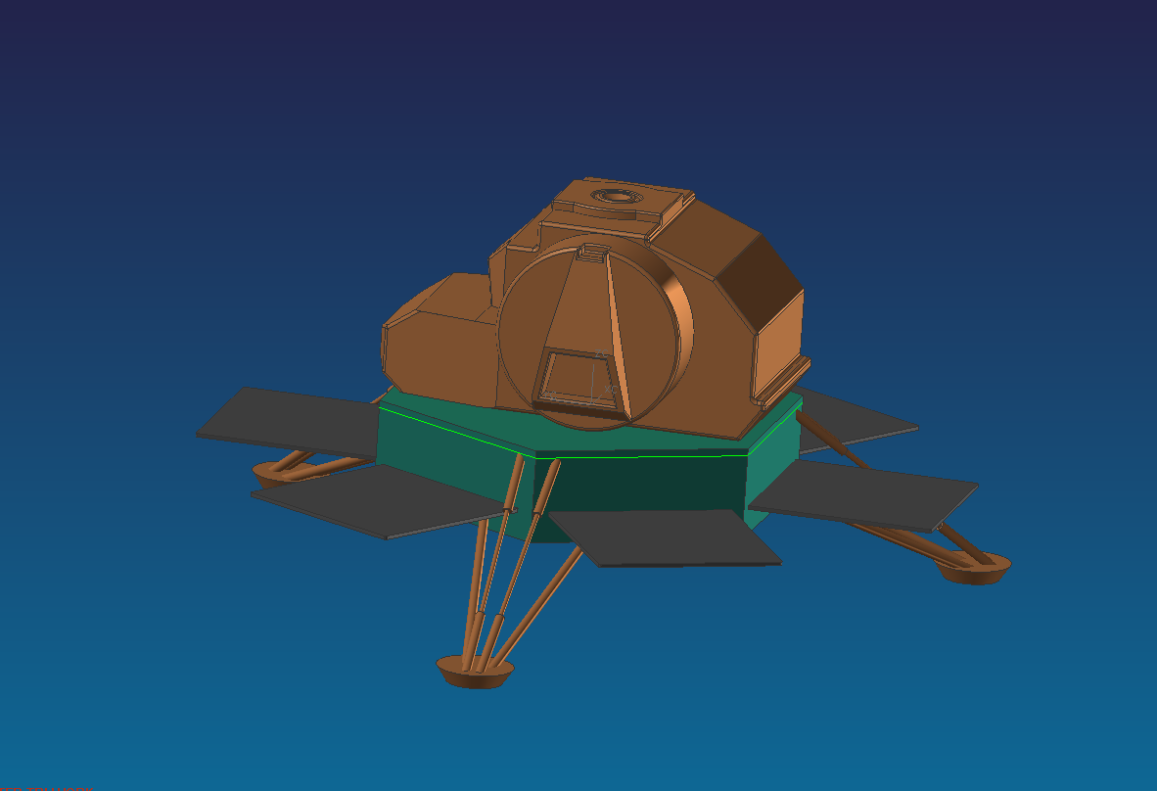

Figure 2 – Baseline: “Lunar Scout: A Project Artemis Proposal” [01-BL]

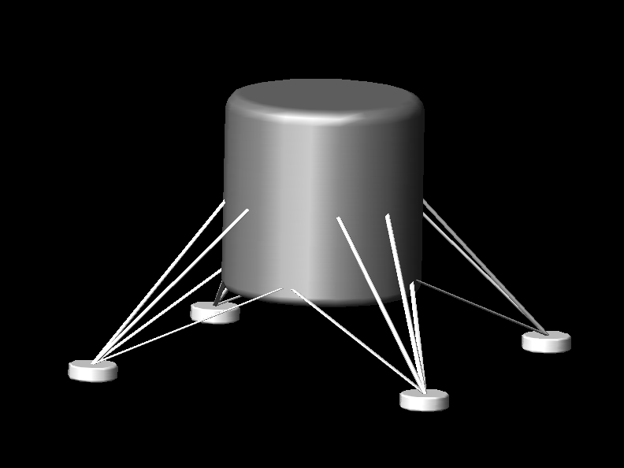

Figure 3 – :Alternative 1 Concept : “Tina” [01A – ALT1]

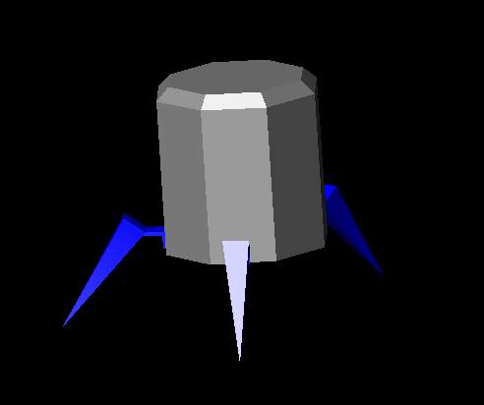
Figure 4 – Alternative 2 Concept: “Spike” [01A – ALT2]
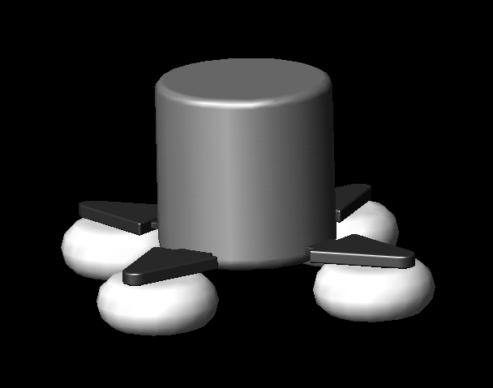
Figure 5 – Alternative 3 Concept : “Bubbles” [01A – ALT3]
Table 2 – Engineering Summary

 |  | Baseline | Alternative Concepts
 |  | Lunar Scout | Alt. 1 | Alt. 2 | Alt. 3
Configuration Category | Units
1. Payload
i. Spectrometer |  |  | USB-4000 | USB-4000 | USB-4000
dimensions | mm | NA | (89.1x63.3x34.4) | (89.1x63.3x34.4) | (89.1x63.3x34.4)
mass | g | NA | 190 | 190 | 190
ii. Calibration Std.
dimensions | mm | NA | (150x135x319) | (150x135x319) | (150x135x319)
mass | kg | NA | 6 | 6 | 6
iii. Calibration Source
dimensions | mm | NA | (125.7x70x25.8) | (125.7x70x25.8) | (125.7x70x25.8)
2. Propulsion
i. LOI Burn |  | NA | Biprop- RL10A3⁶ | Hybrid | Solid- STAR 27 ⁷
Average Thrust | lbf | NA | 16500 | Custom | 6010(vac)
ISP | s | NA | 444 | Custom | 290.8
ii. Descent |  | NA | Small Solid-Star 8⁸ | Small Solid-Star 5D⁸ | Monoprop-OAM(Hydrazine)⁹
Average Thrust | lbf | NA | 1681 | 1251 | 198
ISP | s | NA | 272 | 256 | 222
iii. Landing |  | NA | RS-21¹⁰ | RM-100T¹⁰ | SE-8¹⁰
Average Thrust | lbf | NA | 300 | 100 | 93
ISP | s |  | 294 | 296 | 274
iv. ACS |  | NA | Monoprop-MR 104C⁶ | Monoprop-MRE-5⁶ | Monoprop-MR 50L⁶
Average Thrust | lbf | NA | 129 | 4 | 5
ISP | s | NA | 239 | 226 | 225
3. C&DH |  | NA
i. IMU |  | NA | IMU - Litton LN200 | IMU - Litton LN200 | IMU - Litton LN200
Mass | g | NA | 700 | 700 | 700
Dimensions | cm | NA | 8.9 x 8.35 x 8.35 | 8.9 x 8.35 x 8.35 | 8.9 x 8.35 x 8.35
ii. Processor |  | NA | RAD 750 Processor | RAD 750 Processor | RAD 750 Processor
Mass | g | NA | 549 | 549 | 549
Dimensions | mm | NA | 100 x 160 x 10 | 101 x 160 x 10 | 102 x 160 x 10
iii. Power |  | NA
Solar Panel |  | NA | Solar Panel | Solar Panel | Solar Panel
Mass | g | NA | 31000 | 31000 | 31000
Dimensions | mm | NA | 3500x3500 | 3500x3500 | 3500x3500
Battery |  | NA | 100Ah Li-Ion | 200Ah Li-Ion | Li-Ion
Mass | g | NA | 24000 | 22000 | 24000
Dimensions | mm | NA | 230 x 63 x 145 (x 8 cells) | 295 x 71 x 182 (x 4 cells) | 230 x 63 x 145

Table 3 – Concept Evaluation Matrix

 | Alternative 1 | Alternative 2 | Alternative 3
Mass(10) | 20 | 20 | 30
Cost(10) | 30 | 20 | 20
Risk(10) | 30 | 30 | 10
TRL(3) | 9 | 3 | 9
Schedule(3) | 9 | 9 | 9
Volume(1) | 1 | 3 | 2
Total Score | 99 | 85 | 80

6.0 References

¹Benfield, P., and Kirchmyer, H, “Concept Description Document,” University of Alabama in Huntsville, Huntsville, AL, 1996.

²Brown, C.D., Elements of Spacecraft Design, AIAA Education Series, Reston, VA, 2002.

³Adams, R., Personal Interview, 6 February 2006.

⁴Bate, Roger R., Mueller, Donald D., White, Jerry E., “Fundamentals of Astrodynamics” Dover Publications, Inc. New York. 1971. pp. 321-355.

⁵McLaurin, Matthew, “Lunar Scout NASA-CR-192076”, 1996.

⁶Griffin, M.D., and French, J.R., Space Vehicle Design, 2nd ed., AIAA Education Series, Reston, VA, 2004.

⁷Sutton, G., and Biblarz, O., Rocket Propulsion Elements, 7th ed., Wiley-Interscience, New York, 2001.

⁸Alliant Tech Systems Inc., “Retro/Separation Motors,” ATK[online], URL: http://www.atk.com [cited 10 February 2006].

⁹Wade, M., Encyclopedia Astronautica [online], URL: http://www.astronautix.com [cited 10 February 2006].

¹⁰Boeing, Liquid Propellant Rocket Propulsion Systems, Rocketdyne Propulsion and Power.

¹¹Roddy, Dennis., Satellite Communications, 3rd ed., McGraw-Hill, New York, 2001.

¹²Fortescue, Peter., Spacecraft Systems Engineering, 3rd ed., John-Wiley & Sons, San Francisco, 2003.
Appendix A – Instructor Directed Reporting Items

From: tylersmith03@aol.com [mailto:tylersmith03@aol.com]
To: cicely.Brodie@oceanoptics.com
Subject: Radiation Measuring Devices

Hi Tyler,

Thanks for your call today. I am attaching quote 9958412 for a low light level spectrometer for use on the dark side of the moon. It will cover 200-850nm with ~7.5nm resolution, and is appropriate for seeing light that is as dim as could be seen with the bare eye in a darkened room. The calibration lamp I had previously quoted will be too bright to calibrate this lamp (the lamp will saturate the detector), but I’m sure you could find some other way to calibrate it.
Regards,

Cicely

Cicely Brodie, M.Sc.
Applications Sales Scientist
Ocean Optics Inc.
830 Douglas Ave.
Dunedin, FL 34698

www.oceanoptics.com
(727) 733-2447 - ph
(727) 733-3962 - fax
cicelyb@oceanoptics.com

The information transmitted is intended only for the person or entity to which it is addressed and may contain confidential and/or privileged material. If you are not the addressee, any disclosure, reproduction, copying, distribution, or other dissemination or use of this communication is strictly prohibited. If you have received this transmission in error please notify the sender immediately and then delete this e-mail.

From: tylersmith03@aol.com [mailto:tylersmith03@aol.com]
Sent: Friday, February 03, 2006 4:12 PM
To: cicely.Brodie@oceanoptics.com
Subject: Re: Radiation Measuring Devices

Cicely,
I thought I would let you know that our mission objectives have slightly changed, but I'm afraid it will affect the spectrometers that we will need (maybe, maybe not). Our lunar locations have changed: one will be placed on the far side of the moon which receives no sunlight whatsoever. The other location is in a crater on the south pole of the moon. The crater is deep enough to block all light. So, instead of extreme levels of light, we are experiecing very little. I know from conversations that we discussed that the spectrometers ( USB-4000 and the HR-4000 ) were designed for intense light and their were other spectrometers designed for low-light situations. The electrical and computer engineers were very excited about the USB connection be the power supply. I hope to talk to you soon. Again, thanks for your help.
Tyler
-----Original Message-----
From: Cicely Brodie <cicely.Brodie@oceanoptics.com>
To: TylerSmith03@aol.com
Sent: Fri, 3 Feb 2006 11:23:44 -0500
Subject: RE: Radiation Measuring Devices

Hi Tyler,
Thanks for the contact info. I am attaching quote 9958310 for the irradiance system we discussed. The USB4000-UV/VIS will measure from 200-850nm with ~1.5nm resolution, and needs to be run by a computer via USB cable (through which it also draws its power). SpectraSuite is our user interface software for irradiance, but we also have software drivers for LabView, Visual Basic, C++, etc.
USB4000-UV/VIS http://www.oceanoptics.com/products/usb4000uvvis.asp
SpectraSuite http://www.oceanoptics.com/products/spectrasuite.asp

The fiber is a 25cm length, but we can do any length you require. The cosine corrector on the end will give you a 180 degree field of view, weighted by the cosine of the angle of incidence (the fiber a 25 degree full angle field of view). The DH2000-CAL calibration lamp will allow you to calibrate with or without the cosine corrector, and should be recalibrated after every 50 hours of use.
QP400-025-SR http://www.oceanoptics.com/products/premgradesol.asp
CC-3-UV http://www.oceanoptics.com/products/irradianceprobes.asp
DH2000-CAL http://www.oceanoptics.com/products/dh2000cal.asp

I’d also recommend a mercury argon calibration lamp for wavelength recalibration, and our annual service package. The ASP will extend your warranty by a year for only $250, and allows you to send the spectrometer back anytime in that two year period for a full checkup and wavelength recalibration. The recalibration fee is usually $250, so you are really getting the extended warranty for free!
HG-1 http://www.oceanoptics.com/products/hg1.asp
ASP http://www.oceanoptics.com/products/annualservicepackage.asp

All I will need to place the order is a credit card (Visa, Mastercard, or Amex) or a purchase order, as well as your preferred method of shipment (UPS- ground, ORANGE- 3rd bus day, BLUE-2nd bus day, REDSAVER- next bus day by 5:00pm, or RED- next bus day by 10:00pm). These are stock items, and should ship within a week.

Please let me know if you have any questions, or if I can do anything else to help you. A copy of our catalog is on its way.

Regards,

Cicely

Cicely Brodie, M.Sc.
Applications Sales Scientist
Ocean Optics Inc.
830 Douglas Ave.
Dunedin, FL 34698

www.oceanoptics.com
(727) 733-2447 - ph
(727) 733-3962 - fax
cicelyb@oceanoptics.com

The information transmitted is intended only for the person or entity to which it is addressed and may contain confidential and/or privileged material. If you are not the addressee, any disclosure, reproduction, copying, distribution, or other dissemination or use of this communication is strictly prohibited. If you have received this transmission in error please notify the sender immediately and then delete this e-mail.

From: TylerSmith03@aol.com [mailto:TylerSmith03@aol.com]
Sent: Thursday, February 02, 2006 11:23 AM
To: Cicely.Brodie@oceanoptics.com
Subject: Radiation Measuring Devices

Cicely,

Thank you for your kindness and your willingness to assist me with this project. Again, what I am looking for is three different devices that would be most suitable for this mission in your opinion. Basically, I need the following information about each of these three devices:
- Weight
- Temperature Range
- Power Consumption
- Cost
- Dimensions
- Abilities
Again, thank you for your assistance and I look forward to talking with you in the future.

Tyler Smith

