Thermal System

For the thermal design and control for the Frankenstein Rover assumptions will be made. The thermal systems used on the rover are TRL 9 therefore functionality is assumed. Using standard RTG estimates, it will output 2250 watts of heat at a constant rate once activated. This heat will then be utilized to ensure temperature-sensitive components are maintained at their needed temperatures. One problem to overcome will be all the extra heat generated.
The heat output is transferred to a pipe filled with ammonia, run by a pump. The pump has a max power drawl of 5 watts. Ammonia is used for the temperature ranges that it can operate under. The RTG and heat pipes are assumed to be at 300 Kelvin, this is assumed to be the ideal temperature for the whole system. Using Heat transfer techniques, the area around the rover is considered to be a black body. Due to the inherent design of an RTG the looped pipe system will lie below the base structure used to store all instruments. Conduction will be used to transfer the heat along the structure The top of the lander will be covered with an MLI, this will protect the system from solar radiation.

The instrumentation and onboard computer all must be maintained from 258 Kelvin to 303 Kelvin. Therefore an assumed ideal temperature of 300 Kelvin will be used. Two types of heat switches are used to control the temperature. The heat switches are placed on either side of the main compartment and when the temperature inside the compartment rises above the recommended operating temperature for that component the heat switch conduct heat to the radiator which transfers the heat to the atmosphere lowering the temperature inside of the compartment. The switches will have a peak power draw of 50 Watts. The top of the lander is also lined with multi-layer insulation (MLI) to ensure the heat switches control heat loss. The number of layers selected was thirteen, this was chosen due to the performance drop off of adding additional layers. The overall spacecraft will not use the estimated amount of MLI, the large amount was used for initial mass estimations, this leaves a margin for any extra MLI needed. There is enough MLI to cover the entire space craft where applicable. This design creates multiple factors s of redundancy, and after testing, it may be determined that there is not a need for so much redundancy.

Thermal Appendix

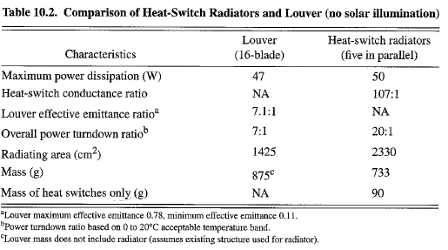
Table: A comparison of the Louver and Heat Switch Radiators

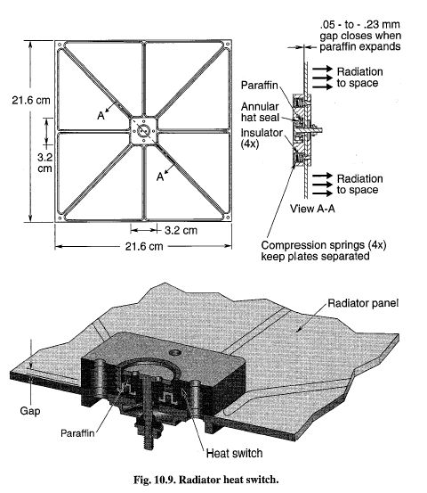
Fig : Radiator Heat Switch used based on the provided dimensions
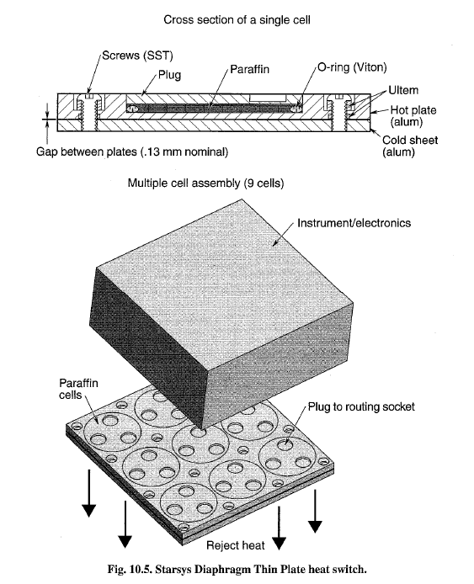
Fig: Heat Switch to be used to control Temperature in the rover

