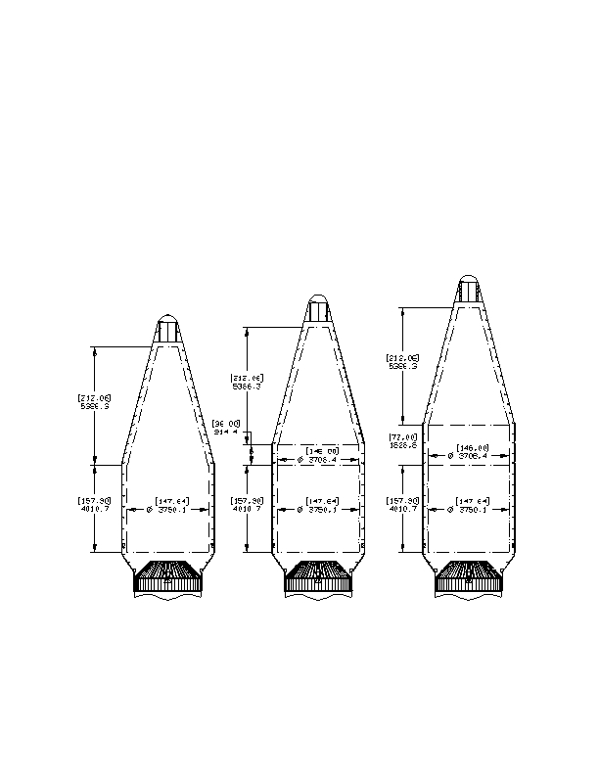Atlas Launch System Mission Planner's Guide
Revision 10a, January 2007
CLSB-0409-1109
The static payload envelope defines the usable volume for a spacecraft. This envelope represents the
maximum allowable spacecraft static dimensions (including manufacturing tolerances) relative to the
spacecraft and payload adapter interface. For clearances between the spacecraft and PLF, primary
clearance concerns are for dynamic deflections of the spacecraft and PLF and the resulting relative loss of
clearance between these components. For clearances between the spacecraft and PLA, primary envelope
concerns are for access to the mating components and payload separation system for integration and
installation operations, motion of the payload separation system during its operation, and movement of the
spacecraft and launch vehicle after separation of the spacecraft. For all areas of the static payload envelope,
clearance layouts and analyses are performed for each spacecraft configuration, and if necessary, critical
clearance locations are measured during spacecraft and launch vehicle integration operations to ensure a
positive clearance is maintained. Overall views of static payload envelopes for Atlas V 400 series launch
vehicle configurations are shown in Figure 4.1.1-3 and for Atlas V 500 series launch vehicle configurations
are shown in Figure 4.1.1-4. Detailed descriptions are included in Appendix D.
Figure 4.1.1-3: Atlas V 4-m Static Payload Envelope
Dimensions: mm [in]
4-m LPF
4-m EPF
4-m XEPF

AMPG10a_F040101_03a
Cleared for Public Release Through OFOISR
Page 4-4

