Stress Analysis of one leg of Daedulus

Mesh
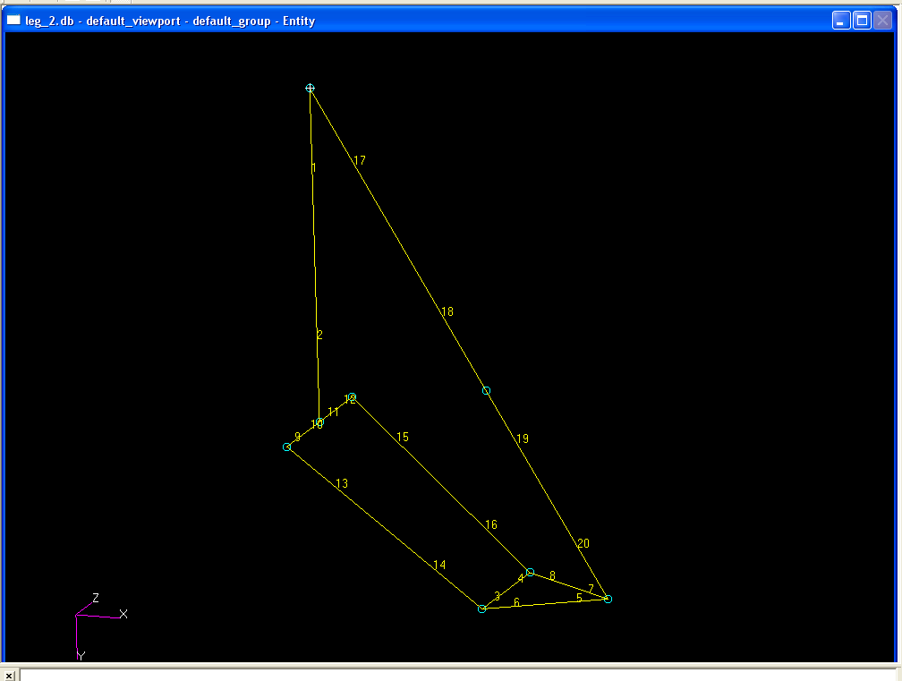
Figure 1

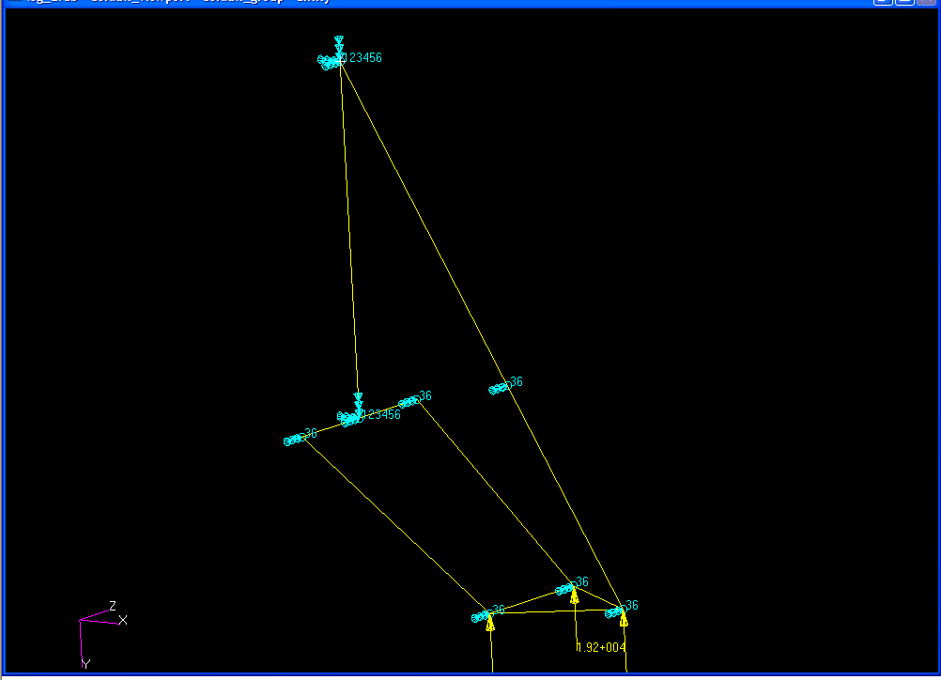

Figure 2

Figure 2 shows the loads and constraints. It was assumed that the landing load was distributed equally on the foot. The T portion of the leg was fixed in all directions and all other joints were fixed in the Z direction.

MAX STRESS: 5.77*10^9 Pa
MIN STRESS: -5.38*10^10 Pa
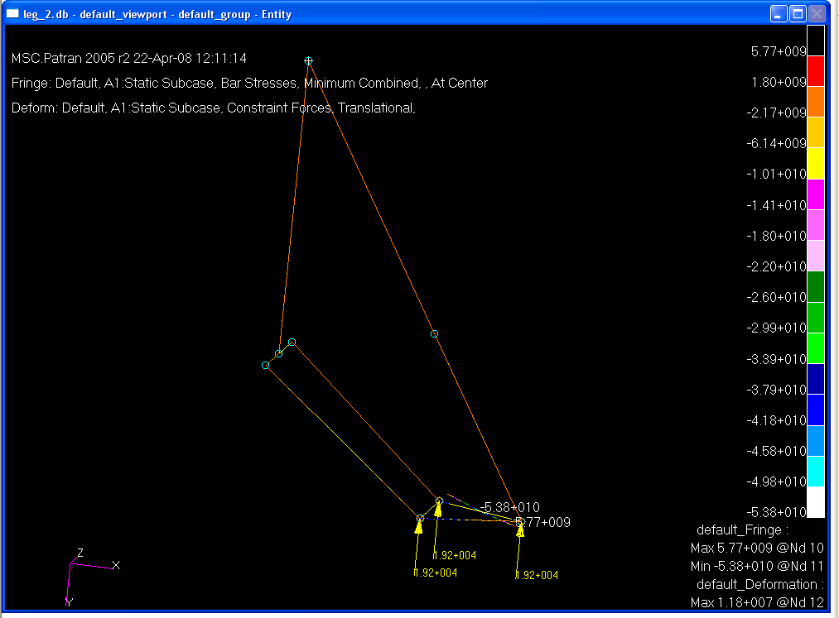
Figure 3

Figure 3 shows that we are within the limits of our design and materials. It also shows the structure will have a small factor of safety. This is a simplified representation where the foot was modeled as three bars in triangular orientation which in reality the assembly would be as shown in Figure 4. The real life assembly would be stronger and therefore give a higher factor of safety.

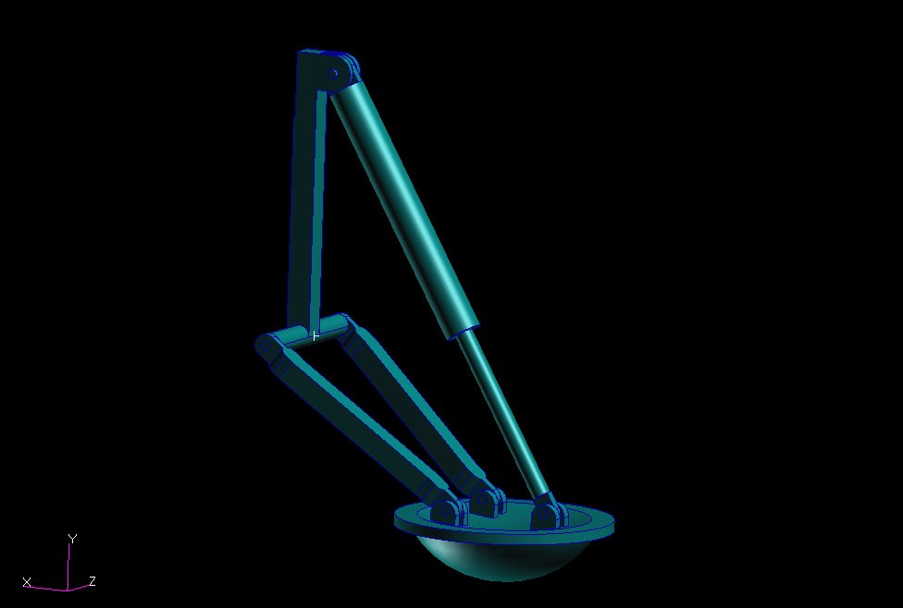
Figure 4

Max Deflection: 1.66*10^14 m
Min Deflection: 0 m

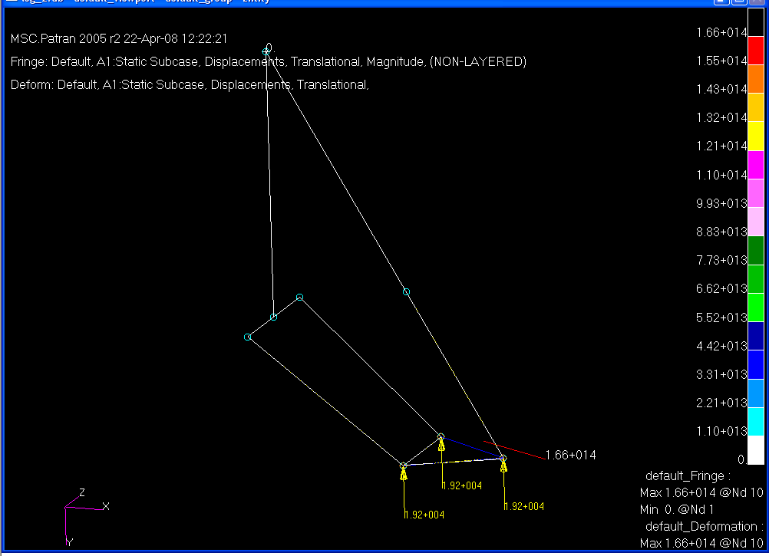
Figure 5

Figure 5 shows that the foot will utilize the shock in the leg assembly that can be seen in Figure 4.

