2.7.1 Methods and Assumptions
The structural package for the Daedalus is a square design based on a four-legged configuration presented at the Viking science instrument team’s meeting in 1968. The lander mounts to the Atlas V-401 payload adapter and is equipped with the electrical interfaces necessary to power the lander during flight. The lander body structure is square in shape with the 4 corners housing the landing legs. The exterior sides between the legs will support the Helium and Hydrazine tanks. The enclosed volume of the lander body is approximately 120,000 cubic inches. The square structure allows room for the main propulsion motors, penetrators and solar cells on the exterior. The batteries and other instrumentation are located inside the structure for thermal protection. The structure, with thermal protections in place, shields sensitive systems from exposure to the harsh environment of the Moon. The entire package fits inside the Atlas V-401 EPF shroud configuration.

The 4 landing legs provide stability for the structure upon landing on the uneven lunar terrain. The landing legs of the Daedalus are modeled directly after the legs of the Viking Landers. The legs consist of a main strut that is stowed during flight inside a larger cylinder that houses the crush pads. The strut is spring loaded and upon ejection of the vehicle extends and locks into place. The legs are also equipped with a round plate-like foot pad that is pinned to the end of the main strut. This foot pad provides a stable and level base for the lander and spreads out the impact to the lunar surface. The landing legs are equipped with shock absorbers in the form of honeycomb crush pads. These are of the same design as the Viking Mars landers and prevent the lander from incurring damage from a hard landing. The term “hard” in this case refers to terminating propulsion 5 meters above the lunar surface and dropping to the final landing site. The landing legs are also equipped with 2 a frame braces that plastically deform upon impact and help to absorb shock of the landing.

2.7.2 Results and Discussions
The structure of the Daedalus is constructed mainly of 6061-T6 Aluminum alloy and some small components requiring increased strength are constructed of 6AL-4V Titanium alloy. Refer to Table 8 in Appendix G. The structure was analyzed by finite element analysis (FEA) using CosmosWorks FEA package in the SolidWorks modeling program. The structure was also analyzed using approximate hand calculations. The structure was analyzed for 2 different phases of the mission.

The first phase of the mission analyzed was the launch phase. The structure is designed to withstand approximately 5.5 g’s, with a maximum of 7.15 g’s, during flight. This acceleration applies a force of approximately 54000 Newtons to the lander The chassis of the lander is constructed one-inch 6061-T6 Aluminum square tubing with a .25-inch-thick wall. Finite element analysis was setup by restraining the four edges of the chassis and applying the 54000 Newton force to the payload adapter ring on the chassis assembly (See Figure 5 & 6 of Appendix G). The results of the analysis show the chassis can withstand the G-loads from takeoff with a factor of safety of 1.3. (See Figure 7 of Appendix G)
The second phase of the mission analyzed was the landing sequence. The velocity upon impact is expected to be 4 meters per second and the impact of the landing is assumed to occur over a period of 5 milliseconds. The resulting impact force upon landing is calculated to be approximately 82000 Newtons or 82 earth G’s yet the crush pads are assumed to damp 90% of the shock so a force of 8200 Newtons may be felt on a single leg if the lander lands on an incline. The leg assembly of the lander is constructed of 6061-T6 Aluminum and consists of a 12-inch-diameter foot, 1-inch-diameter solid rod, two 1.25x1.25x.25inch square tubes for the strut, and a t-brace made from 2x2x.25 in square tubing. To insure the lander could withstand the impact of the entire lander on one leg, the final FEA was performed on the leg assembly and the chassis. FEA was setup on the leg assembly by restraining the back edge of the t-brace on the leg assembly and applying the 8200 Newton force to the foot (See Figure 8 & 9 of Appendix G). The results of the analysis show the leg assembly can withstand the loads from landing on one leg with a factor of safety of 1.15. (See Figure 10 of Appendix G) FEA was setup on the chassis by restraining the payload adapter ring and applying the 8200 Newton force to the member where the legs will attach (See Figure11 & 12 of Appendix G). The results of the analysis show the chassis can withstand the loads from landing on one leg with a factor of safety of 1.15. (See Figure 13 of Appendix G)

- Structures

Table 1: Material Properties For Materials Used in the Daedalus
Material | Density (kg/m^3) | Young's Modulus (Gpa) | Yield Strength (Mpa) | Thermal Expansion (m\m*K)
6061-T6 Aluminum | 2800 | 68 | 276 | 23.6
6AL-4V Titanium | 4400 | 110 | 825 | 9

Material properties obtained from www.matweb.com

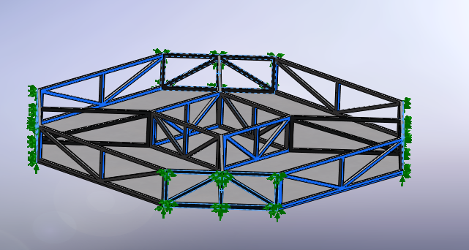

Figure 5: Restraints on the chassis

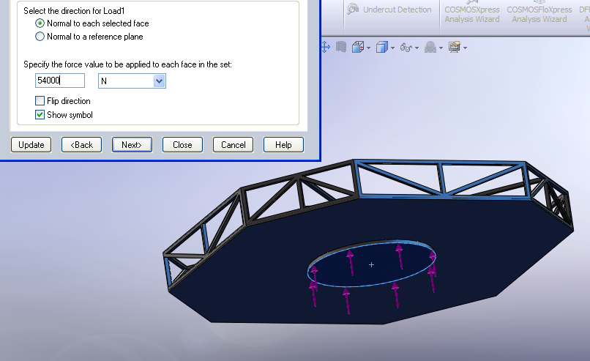

Figure 6: Loads applied to the chassis

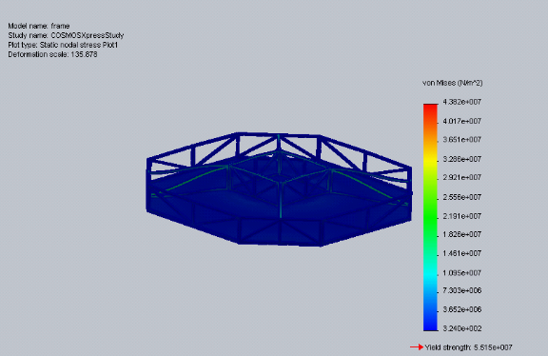

Figure 7: Results from chassis analysis
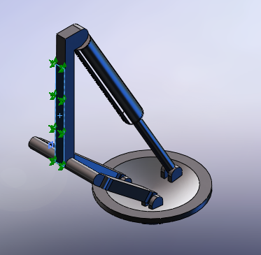

Figure 8: Restraints for the leg assembly

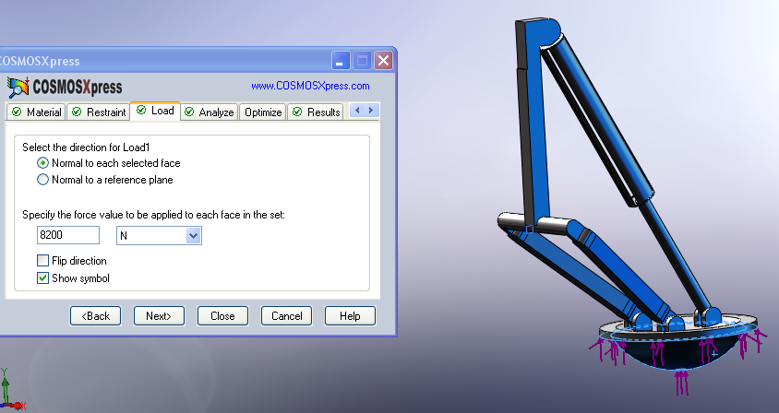

Figure 9: Loads on the leg assembly

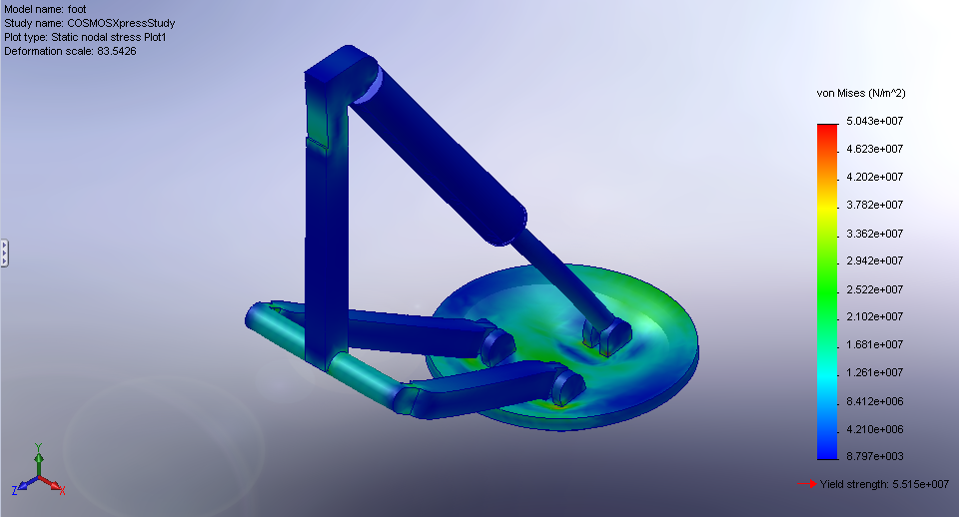

Figure 10: Results from the leg assembly

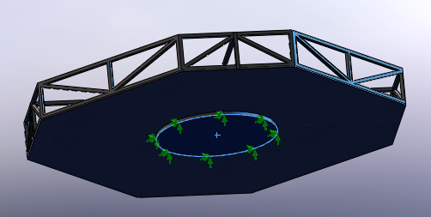

Figure 11: Restraints on the chassis
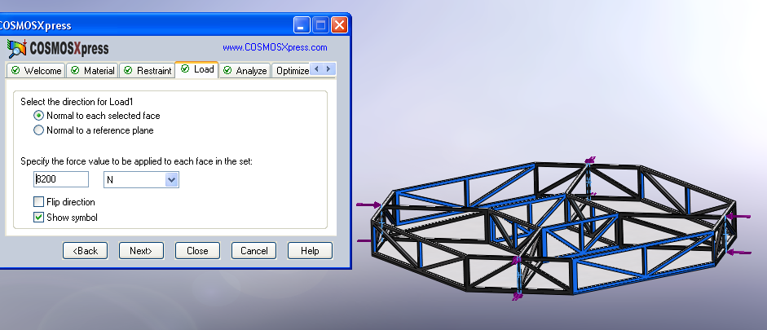

Figure 12: Loads on the chassis

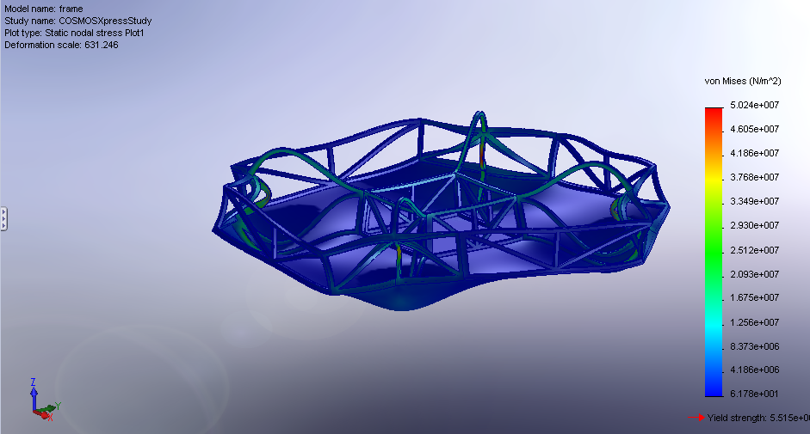

Figure 13: Results from chassis analysis

