2.4 Power
2.4.1 Methods and Assumptions

The main goal throughout the design of the power system is to survive a one year mission on the moon. This is just one of the critical requirements that affected the design of the power system. Another driving factor of the design is to land at a polar location. Due to the polar location, 14 days of light and 14 days of darkness is assumed. However, certain landing locations on the southern pole may allow for the Daedalus to receive 70% sunlight per month. The Daedalus is to be launched no later than September 30, 2012, therefore time is critical for acquiring all components.

There were many considerations reviewed for generating power. The first option assumed was solar cells with batteries. This would utilize the available source of light to generate power and charge batteries during the daylight, while the batteries would be active during the dark periods. Many batteries were reviewed and Lithium batteries were considered to be the most appropriate due to the high specific energy and storage capacity. Lithium-Sulfur Dioxide batteries and Lithium-Ion batteries were the two choices for the power system. However, Lithium-Sulfur Dioxide batteries were eliminated due to the voltage drop after initial power surge. The voltage drops well below operating voltage for a period of time, such as seconds or minutes.

Another option of power considered was nuclear power. A Radioisotope Thermoelectric Generator (RTG) and a Stirling Radioisotope Generator (SRG) were reviewed. Both of the nuclear power options were eliminated. The SRG has a low Test Readiness Level (TRL) compared to the RTG. Therefore, it was eliminated. Cost for the Daedalus is to be as minimal as possible. RTGs come at a very high cost. Another reason for elimination is due to the assumption that time and availability would be an issue. The acquirement of nuclear power may affect the launch date previously mentioned.

The final option of power was solar cells in combination with fuel cells. Regenerative fuel cells and Hydrogen fuel cells were the two reviewed choices. The fuel cells are very effective, yet they contain a large amount of mass. And, since the Daedalus would be testing samples, the fuel cells were eliminated due to the by-product of water. This water may have an adverse effect on the sample testing.

The power that needs to be obtained to maintain all systems running off of power is 700 Watts. This budget is derived from the initial power budget table that can be found in Table X. The estimated mass of the power system is 158.6 kilograms. This budget is derived from the initial mass budget that can be found in Table Y.

2.4.2 Results and Discussion

All of the methods and assumptions have contributed to the power combination of solar arrays and Lithium-Ion batteries. The solar power system allows Daedalus to power itself during light periods and recharge the Lithium-Ion batteries for use in the dark periods. The maximum output power of this arrangement is 902 Watts. This is over the initial power budget. LunaTech designed the power system to generate excess power to charge the batteries, make up any lost power in case of damaged parts, and/or to extend the mission past its required lifetime. The total mass of the solar cells, Lithium-Ion batteries, and support system is 182.3 kilograms. This is over the initial power budget. The mass is based upon calculations that can be found in Appendix D. The design of this system is based upon the Venus Express spacecraft which launched in 2005.

Since there is the available light source from the sun, the Daedalus design utilized solar cells. The total solar array area for the Daedalus is 5.98 square meters. This is due to the reason that there are 2 and 1/5 panels. The extra 1/5 panel is to provide the extra amount of energy generation needed for this design. The panels are covered with Optical Surface Reflectors (OSRs) to minimize the effect of extreme temperatures. Each panel is 1.78 meters in length and 0.8 meters in width. Each panel weighs 20.25 kilograms with an output power of 410 Watts. The total power acquired from these panels is 902 Watts with a total weight of 44.55 kilograms.

It is important for the design to include batteries that have a high specific energy and a long cycle life. The Daedalus will run off of batteries during the dark periods that occur on the lunar surface as well as during an eclipse. The design will use Sony 18650HC Lithium-Ion batteries. Lithium-Ion batteries were chosen due to the notion that they have a high specific energy, high output power to weight ratio, and the availability for space applications. The specific energy is 114.6 W-hr/kg. Each battery has an energy rate of 9 Ampere-hours. The batteries have a charge time of 12 hours.

The number of batteries needed to provide adequate power to the Daedalus is 15. This results in a total calculated mass of 70.4 kilograms and a total volume of 2.2 cubic feet. The mass of batteries were estimated upon how much each subsystem would be running during the dark periods. The dark period consists of 14 days, which is 336 hours. The systems that will be running 10% of the time are power and thermal. The batteries have an operating temperature of -10 degrees Celsius to 40 degrees Celsius. When generating, these batteries generate a lot of heat, therefore the thermal system does not have to be on 100% of the time. Payload, communication, and guidance, navigation, and control will only be running 1% of the time during the dark periods. This results in a total energy-rate output of 7.64 kW-hrs. Review Appendix D for calculations.

With the solar cells and Lithium-Ion batteries, a power management and control is needed due to the reason that the solar cells will be operating during sunlight and the batteries will be operating in the darkness. The batteries must be fully charged from the solar cells once daylight has ended. The average charge time of the batteries is 12 hours. The mass of the power control unit is 18 kilograms, while the regulator/converter unit is 40.6 kilograms, and the mass of the wiring is 2% of the estimated dry mass which is 19 kilograms. This comes to an overall mass of the power support system to be 67.3 kilograms. Refer to Appendix D for calculations. The way the system operates is based upon the subsystem set up that can be shown in Figure A.

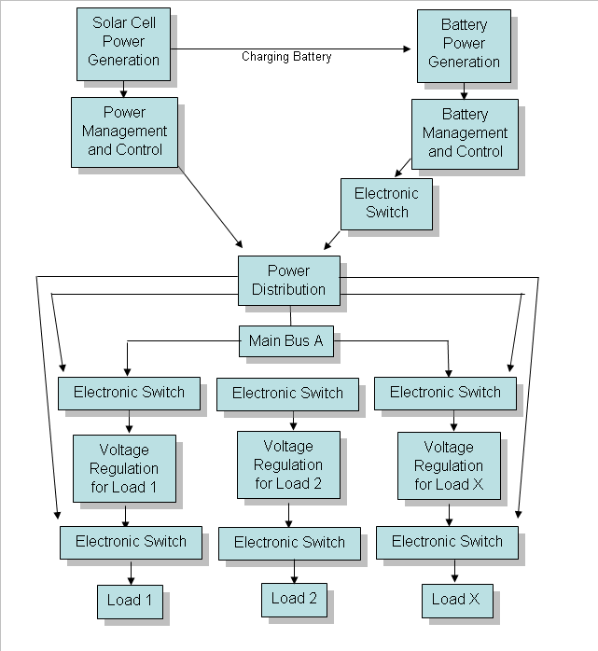

Figure A. Power System Management

