Payload

To achieve the scientific goals of our mission our team has decided to use Lunar Penetrators Exploration System (for our multiple site goals) and science instrument packages on Daedalus. Daedalus will have three science packages for a single site, utilized over a period of 1 year. A minimal volatile composition and geotechnical properties package with a mass of 3 kg, an enhanced volatile species and elemental composition with a mass of 5 kg, and an enhanced geologic characterization with a mass of 5 kg. These packages supported by a drill mechanism, arm and scoop, and witness plates will successfully determine:
- Lighting conditions every 2 hours over the course of one year
- Micrometeorite flux
- Electrostatic dust levitation and its correlation with lighting conditions
Below is the list of payload instrumentation including with mass and power requirements.

Daedalus Payload | Mass kg | Power W
Stereo imaging system or Radar or Lidar | 0.8 | 6
Mast for stereo imaging system | 3.5 | 9.5
Drill and drill deployment mechanism | 20 | 30
Arm | 13 | 43
Scoop | 0.5 | 0
Mass Spectrometer | 19 | 75
Geotechnical Experiments - cone penetrometer | 1.5 | 0
Geotech - bearing plate | 1 | 0
Geotech - shear vane | 0.5 | 0
Magnets | 0.5 | 0
XRD/XRF | 2 | 10
Total | 62.3 | 173.5
Estimated |  | 168

The penetrators will be dispersed in the Shackleton Crater amid the mostly dark regolith surface. By using tested instrumentation from the Deep Space 2 penetrators (TRL 6) and LUNAR-A penetrators (Space Qualified), LunaTech was able to parallel new projects such as Lunar EX and MoonLite. The design concept incorporates LUNAR-A’s architecture of a ballistic missile shape, but cutting off the propulsion system.

Penetrator Requirements
Impact Deceleration | Up to 10000g
Impact Angle (between impact velocity vector and tangent to surface) | ~90 degrees (not critical)
Attack Angle (between penetrator long axis and impact velocity vector) | ~<8 degrees (critical)
Penetration Depth into Regolith | 1-2m
Mission Duration | 1.2 year

In this way mass is conserved to allow for 22 penetrators with a mass of 14kg each. They will have a diameter of 14cm and a length of 75cm. Without an atmosphere to perform
Aerobraking (DS-2), the lunar probes will have to be ejected from the carrier spacecraft with very little lateral velocity, at the appropriate height so that free fall will give the penetrators the proper impact velocity. The penetrators will be spring loaded into chambers located on the bottom of Daedalus. At 5km above the lunar surface 22 penetrators will be released.

GEOMETRY
Deployement
Penetrators | n | alpha | beta | r (m) | theta
2 | 1 | 180.00 | 0.00 | 0.00 | 0.00
4 | 2 | 90.00 | 45.00 | 250.00 | 2.05
6 | 3 | 60.00 | 60.00 | 500.00 | 4.09
8 | 4 | 45.00 | 67.50 | 750.00 | 6.12
10 | 5 | 36.00 | 72.00 | 1000.00 | 8.13
12 | 6 | 30.00 | 75.00 | 1250.00 | 10.12
14 | 7 | 25.71 | 77.14 | 1500.00 | 12.09
16 | 8 | 22.50 | 78.75 | 1750.00 | 14.04
18 | 9 | 20.00 | 80.00 | 2000.00 | 15.95
20 | 10 | 18.00 | 81.00 | 2250.00 | 17.82
22 | 11 | 16.36 | 81.82 | 2500.00 | 19.65

There is a geometrically sized ring that the chambers will be aligned to. Each chamber is angled at 19.65 degrees from the center y-axis. This will insure that all 16 penetrators will be a minimum of 500m from each other and allowing the smallest angle of attack. Using GN&C capabilities Daedalous will be centered (5km above surface) 1091.67m – 1637.5m from the ridge of Shackleton Crater. This insures that 16 penetrators (set #1) will land in the shadow area of the crater and 6 (set #2) will land outside the rim in the sunlight area. For all the penetrators, the same impact velocity is needed to reach our goal of a depth into the lunar surface of 1-2m. The same sized springs will be used for the two sets but there will be a difference in depth that they penetrate into the lunar surface (set #1 falling 7km and set#2 falling 5km). Steel springs will provide an initial velocity of 315m/s leaving Daedalous. The 6 that land in the sunlight will only fall 5km not 7km. There impact velocity will then be 340.37m/s and burrow to a depth of 1.402m. With these initial velocities on the other 16 penetrators an impact velocity of 368.17m/s and a depth of 1.53m can be acquired.

Equations Used:

Penetrator Impact Velocity

Penetrator Depth

G-Force

At this speed the penetrators will have to withstand a G-force of ~4500 (Appendix Chart . A vast amount of resources has been devoted to testing survival conditions of the instrumentation at such speeds. These types of “missiles” are common within the defense sector and a (limited) range of components are available off-the-shelf that will survive impacts of >50,000g. Each penetrator will include micro-seismometers, a geochemistry package, a water/volatiles detector, a heat flow experiment, and accelerometers and tilt sensors. These packages support:
- Lunar Seismology
  - A network of micro-seismometers could detect the presence and measure the size of a lunar iron core; determine crustal and basal fill thickness; the deep structure of lunar mantle; the origin and location of the enigmatic shallow moonquakes. These would benefit understanding of Moon’s residual magnetism; origin of Earth-Moon system; and evolution of planetary magnetic fields.
- Lunar Thermal Gradients
  - Passive thermometers would be capable of determining heat flow from the Lunar interior and information on inhomogeneity of crustal heat producing elements (U,K,Th). This is relevant to understanding the Moon’s early history. Lunar Water and other Volatiles Sensing Water sensors capable of detecting the presence, extent, and concentration of water and other volatiles (organic), would provide information on Lunar evolution and future Lunar resources. If possible, an isotope discrimination capability could also provide information on the origin of the water. Such information could also be relevant to astrobiology including the highly controversial panspermic theory of the origin of life on Earth.
- Geochemical Analysis
  - Provide ground truth for remote sensing XFA and multi-spectral imaging.
- Far Side
  - As there has not yet been a far side landing, and there is evidence that the near and far sides of the Moon may be quite different internally, this could determine differences in regolith, lunar interior structure and composition.

The LPES will be designed to operate for 1-1.2 years below the lunar surface. This has very significant consequences for total energy requirement. It is not proposed to have a detached aft body surface element (unlike DS-2) and therefore all power must be generated internally. Moreover, the temperature on the lunar surface is estimated to be <50K which is dramatically different then Mars where the DS-2 is designed for. The instruments are powered by Li-SOCL2 (super lithium) batteries with an expected lifetime of one year. The batteries (with a power density ~430 Wh/kg) will power the electronics that will in turn provide heat to keep the instruments warm. A 400 MHz UHF hybrid telemetry system will be used for communication between the penetrators and the orbiter. The penetrator antennae will be 1 to 3 meters below the surface, but lunar regolith is relatively transparent to radio waves. The data transfer rate from the penetrators to the orbiter will be 2 kbit/s and will occur one hour each day when the orbiter is in position overhead. The LPES will be constructed out of Carbon fiber reinforced plastic, with an Ogive nose. Shock protection will be provided by high rigid epoxy-resin and glass micro-spheres.
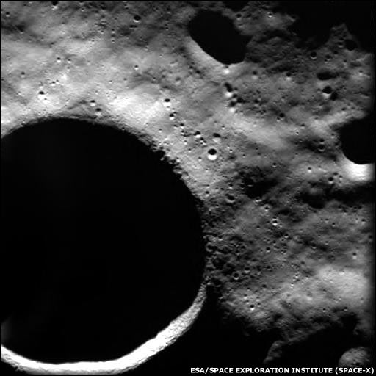
Shackleton Crater
Penetrator Landings
Not to Scale
Payload Appendix

Table 1

Chart 1

Chart 2

