Structural Package

The structural package for the Daedelas is a square design based on a four-legged configuration presented at the Viking science instrument team’s meeting in 1968 (1). The lander mounts to the ______________ payload adapter for the Atlas IV Centaur and is equipped with the electrical interfaces necessary to power the lander during flight. The lander body structure is square in shape with the four corners housing the landing legs. The exterior sides between the legs will be support the Helium and Hydrazine tanks. The enclosed volume of the lander body is approximately 120,000 in^3. The square structure allows room for the main propulsion motors, penetrators, batteries and other instrumentation and payload inside the structure. The structure, with thermal protections in place, shields sensitive systems from exposure to the harsh environment of the Moon. Ramps mounted on top of the structure allow the deployment of the rover and double as surface area for solar cells. The entire package fits inside the _____________shroud for the Atlas IV Centaur.

The four landing legs provide stability for the structure upon landing on the uneven lunar terrain. The landing legs of the Daedelas are modeled directly after the legs of the Viking Landers. The legs consist of a main strut that is stowed during flight inside a larger cylinder that houses the crush pads. The strut is spring loaded and upon ejection of the vehicle extends and locks into place. The legs are also equipped with a round plate-like foot pad that is pinned to the end of the main strut. This foot pad provides a stable and level base for the lander and spreads out the impact to the lunar surface. The landing legs are equipped with shock absorbers in the form of honeycomb crush pads. These are of the same design as the Viking landers and prevent the lander from incurring damage from a hard landing. The term “hard” in this case refers to terminating propulsion 5 meters above the lunar surface and dropping to the final landing site. The landing legs are also equipped with two braces that plastically deform upon impact and help to absorb shock of the landing.

The structure of the Daedelas is constructed mainly of 6061-T6 Aluminum alloy, and some small components requiring increased strength are constructed of 6AL-4V Titanium alloy (Material properties shown in Figure 1 of Appendix A). The structure was analyzed by finite element analysis (FEA) using CosmosWorks FEA package in the SolidWorks modeling program. The structure was also analyzed using approximate hand calculations. The structure was analyzed for two different phases of the mission.

The first phase of the mission analyzed was the launch phase. The structure is designed to withstand approximately 5.5 g’s during flight. This acceleration applies a force of approximately 4448N onto each vertical and horizontal member of the lander, since there is an equal number of each member. This calculation is shown in Figure 2 of Appendix A. Analysis was performed on both a horizontal and a vertical member of the structure. The vertical member is constructed of 6061-T6 Aluminum and consists of a .25-inch-thick tee extrusion that is 12 inches long. The finite element analysis was performed on the vertical member and the results are shown in Figure 3 of Appendix A. This analysis displays a factor of safety of 8.8. The vertical member was checked for column buckling and yielding of the material using equations shown in Figure 4 of Appendix A. These calculations display a minimum factor of safety of 12.4. Similar analyses were performed on a horizontal member of the lander. The horizontal member is also constructed of 6061-T6 Aluminum and consists of a .25-inch-thick angle extrusion that is 12 inches long. This length is the approximate distance between vertical members. The FEA results are shown in Figure 5 of Appendix A and displayed a factor of safety of 1.3. The hand calculations shown in Figure 6 of Appendix A display a factor of safety of 24.9.

The second phase of the mission analyzed was the landing sequence. The velocity upon impact is expected to be 4 m/s and the impact of the landing is assumed to occur over a period of 5 ms. The resulting impact force upon landing is calculated to be 797,600 N (Figure 7 of Appendix A). The landing leg strut analyzed is constructed of 6061-T6 Aluminum and consists of a 12-inch-long, 1.2-inch-diameter solid rod. From calculations shown in Figure 7 of Appendix A, the each landing leg has to withstand an impact force of 230,200N. It is assumed that the crush pads absorb 90% of this force. The FEA was performed on a 1-inch-diameter solid rod using the remaining 10% of the impact force applied to the strut at a 60 degree angle. However, this force would be shared by the four legs. Thus the FS of 3.1 for the landing legs shown in Figure 8 of Appendix A is actually 12.4. The landing legs were checked for column buckling and yielding as well. These calculations are shown in Figure 9 of Appendix A and display a factor of safety of 1.13.

(1) On Mars Exploration of the Red Planet 1958-1978, Edward Clinton Ezell and Linda Neuman Ezell, published 1984 by the Scientific and Technical Information Branch of the National Aeronautics and Space Administration, page 218

Appendix A

Figure 1: Material Properties For Materials Used in the Daedelas

Material | Density (kg/m^3) | Young's Modulus (Gpa) | Yield Strength (Mpa) | Thermal Expansion (μm\m*K)
6061-T6 Aluminum | 2800 | 68 | 276 | 23.6
6AL-4V Titanium | 4400 | 110 | 825 | 9

Material properties obtained from www.matweb.com

Figure 2: Force Applied To The Lander During Launch Phase

Figure 3: Design Check of Vertical Member Using Von Mises Stress Criterion
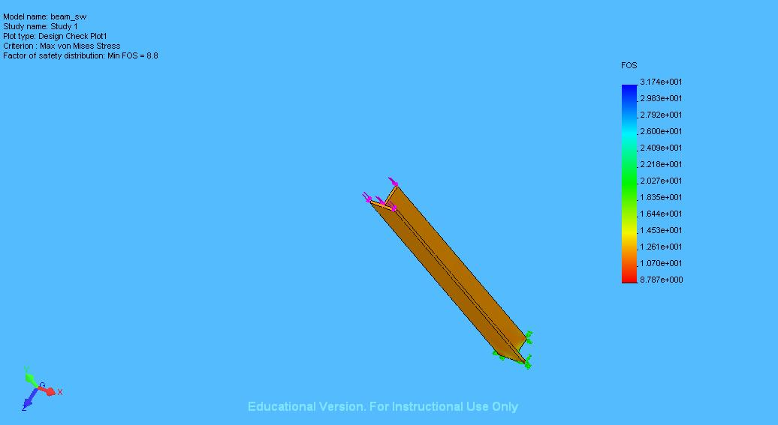

Figure 4: Hand Calculations For Vertical Member of The Daedelas During Launch

Young's Modulus
Effective Length
Radius of Gyration
Critical stress for column buckling
Cross-sectional Area of the vertical beam
Applied Force
Compressive Stress
Factor of Safety
Maximum Stress Allowed
Actual Stress Applied
Yield Stress for 6061-T6

Figure 5: Design Check of Horizontal Member Using Von Mises Stress Criterion

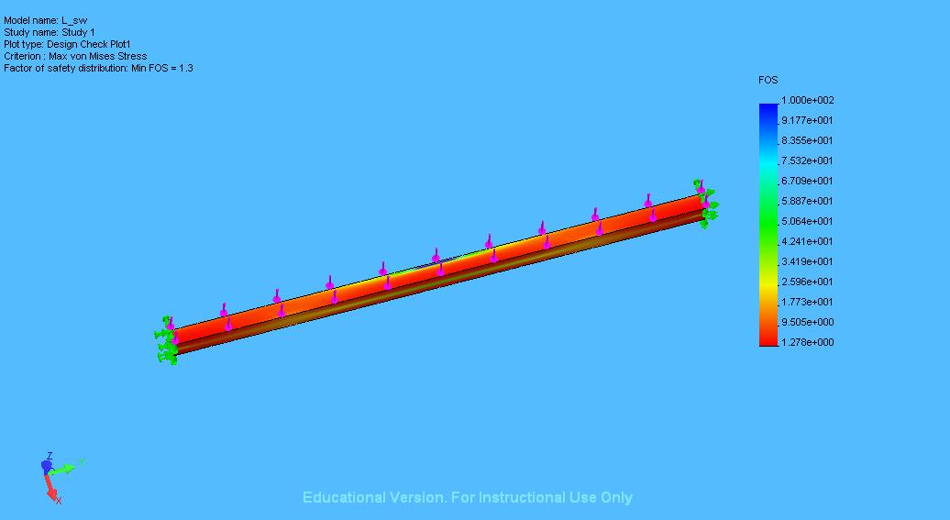

Figure 6: Hand Calculations For Horizontal Member of the Daedelas During Launch

Young's Modulus
Effective Length
Radius of Gyration
Cross-sectional Area of the horizontal beam
Applied Force
Compressive Stress
Actual Stress Applied
Factor of Safety
Yield Stress for 6061-T6
Maximum Stress Allowed

Figure 7: Force Applied To The Lander During Landing Phase

Figure 8: Design Check of Landing Leg Strut Using Von Mises Stress Criterion

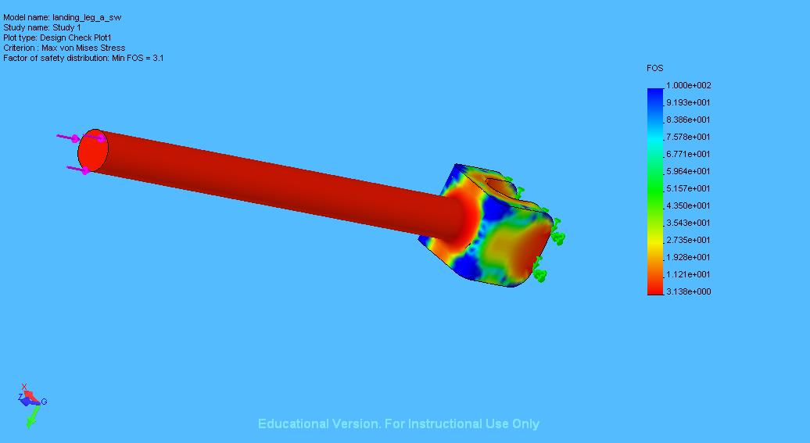

Figure 4: Hand Calculations For Landing Leg Strut of The Daedelas Upon Landing

Young's Modulus
Effective Length
Radius of Gyration
Critical stress for column buckling
Cross-sectional Area of the Landing Leg Strut
Applied Force
Compressive Stress
Factor of Safety
Maximum Stress Allowed
Actual Stress Applied
Yield Stress for 6061-T6

