Final Proposal:
Lunar Exploration Transportation System
(LETS)

IPT 2008


Submitted By:

April 22, 2008

Submitted To:
Dr. P.J. Benfield and Dr. Matthew Turner
Department of Mechanical and Aerospace Engineering
The University of Alabama in Huntsville
pj.benfield@uah.edu
matt.turner@uah.edu

Contributors

Project Office | Nicholas Case
Systems Engineering | Morris Morell
Guidance, Navigation & Control | Travis Morris
Thermal Systems | Greg Barnett
Power Systems | Adam Garnick
Power Systems | Katherine Tyler
Payload | John Grose
Structures | Tommy Stewart
Communications | Adam Fanning
Concept of Operations | Julius Richardson
Technical Editor | Eric Brown

Participating Agencies
The University of Alabama in Huntsville | National Aeronautics Space Administration
Southern University | Ecole Superieure des Techniques Aeronautiques et de Construction (ESTACA)






Executive Summary

English
The need for National Aeronautics and Space Administration (NASA) to return back to the Moon has created a desire for robotic missions to preempt the arrival of manned missions. The Lunar Precursor Robotic Program was created to develop a series of robotic spacecraft to provide valuable information to assist NASA in returning to the Moon, develop a lunar outpost, and travel to Mars. Daedalus is a concept for the proposed Lunar Exploration Transportation System to be developed for NASA. Daedalus uses off-the-shelf components and existing technology to provide NASA with a robust, inexpensive, and long-lasting design with the capability of visiting several lunar locations. The Daedalus structure is based on the Viking Mars Lander design with an additional landing leg for increased stability. The power system uses a combination of solar cell and lithium-ion batteries. The guidance, navigation, and control system uses off-the-shelf components previously developed for several planetary landers, as well as technology developed for cruise missile use. Lunar penetrators are used to achieve most of the scientific goals for the mission. The penetrators are based on the LUNAR-A penetrator design developed for a defunct lunar mission, which was spent 10 years in development. The Daedalus system is easily modified and capable of meeting the launch requirements of the mission.

French
Le besoin de la NASA de retourner de nouveau à la lune a créé un besoin des missions robotiques d'acquérir l'arrivée des missions homme. Le programme robotique de précurseur lunaire a été créé pour développer une série de vaisseau spatial robotique pour fournir des informations valables à la NASA d'aide pour retourner à la lune, pour développer un avant-poste lunaire, et pour voyager à Mars. Daedalus est concept pour que le système lunaire proposé de transport d'exploration soit développé pour la NASA. Daedalus emploie les composants disponibles immédiatement et la technologie existante pour fournir à la NASA une conception robuste, peu coûteuse, et durable avec les possibilités de visiter plusieurs endroits lunaires. La structure de Daedalus est basée outre de la conception de Viking Mars Lander avec une addition débarquant la jambe pour la stabilité accrue. Le système d'alimentation emploie une combinaison des batteries de pile solaire et de lithium-ion. Les conseils, la navigation, et le système de commande emploient les composants disponibles immédiatement développés pour plusieurs landers planétaires, comme la technologie développée pour l'usage de missile de croisière. Des pénétrateurs lunaires sont employés pour réaliser la plupart des buts scientifiques pour la mission. Les pénétrateurs que basé sur la conception Lunaire-Un de pénétrateur a développés pour une mission lunaire ancienne. Le système de Daedalus est facilement modifié, et capable de répondre aux exigences de lancement de la mission.

LETS Compliance List

Specification | CDD Location | Proposal Location
Atlas V-401 EPF shroud configuration with a total landed mass of 997.4 kg | 2.1
64.6 kg of the total landed mass is devoted to the propulsion system dry mass | 2.1.1
Propellant shall be housed in two spherical propellant tanks, each 0.55 m in diameter | 2.1.2
Helium shall be housed in 2 spherical tanks, each 0.4 m in diameter | 2.1.2
Two (2) MR-80B monopropellant liquid rocket engines | 2.1.3
Twelve (12) MR-106 monopropellant thrusters | 2.1.4
First mission to be at a polar location | 2.2
Capability to land at other lunar locations | 2.3
Launch to the Moon NLT September 30, 2012 | 2.5
Capability to move on the surface | 2.6
Survive for one year on the surface of the Moon | 2.7
Meet both the Science Mission Directorate (SMD) and the Exploration Systems Mission Directorate (ESMD) objectives | 2.9
Landing at a slope of 12 degrees (slope between highest elevated leg of landing gear and lowest elevated leg) | 2.11
G-loads during lunar landing not to exceed the worst case design loads for any other phase of the mission (launch to terminal descent) | 2.12

Table of Contents
List of Figures vi
List of Tables vii
Acronyms and Symbols viii
IPT Final Report: Feasibility of Lunar Exploration Transportation System 1
1.0 Daedalus 1
1.1 Overview 1
1.2 The Need 2
1.3 The Requirements 2
1.3.1 Customer Requirements 2
1.3.2 Concept Design Constraints 2
1.3.3 Figures of Merit (FOM) 3
1.3.4 Surface Objectives 3
1.4 The Solution 3
1.4.1 Concept Overview 3
1.4.2 Dimensional Properties 5
1.4.3 Operations Scenarios 6
1.5 The Performance 6
1.6 The Implementation 7
2.0 Technical Description of Methods Used 7
2.1 Overview 7
2.2 Project Office 7
2.3 Systems Engineering 8
2.4 Power 11
2.4.1 Methods and Assumptions 11
2.4.2 Results and Discussions 11
2.5 Guidance, Navigation, and Control 13
2.5.1 Methods and Assumptions 13
2.5.2 Results and Discussions 14
2.5.3 Operations 15
2.6 Thermal 15
2.6.1 Methods and Assumptions 15
2.6.2 Results and Discussions 16
2.7 Structures 18
2.7.1 Methods and Assumptions 18
2.7.2 Results and Discussions 18
2.8 Payload 19
2.8.2 Autonomous Robotic Rover 19
2.8.3 Sample Return Vehicle (SRV) 19
2.8.3.1 Methods and Assumptions 19
2.9 Communication 21
2.9.1 Methods and Assumptions 21
2.9.2 Results and Discussion 22
2.9.3 Operations 23
2.9.4 Data Handling and Storage 24
2.10 Concept of Operations 24
2.10.1 Overview 24
2.10.2 LRO Concept of Operations 25
2.10.3 LPES Concept of Operations 25
2.10.4 Lander Concept of Operations 25
2.11 Systems Interactions 27
3.0 Implementation Issues 28
3.1 Schedule 28
3.2 Hardware 28
4.0 Company Capabilities 28
4.1 Company Overview 28
4.2 Personnel Description 29
5.0 Summary and Conclusions 30
6.0 Recommendations 31
Appendix A - Concept Description Document 33
Appendix B - Project Office 36
Appendix C - Systems Engineering 38
Appendix D - Power 39
Appendix E - Guidance, Navigation, and Control 43
Appendix F - Thermal 46
Appendix G - Structures 48
Appendix H - Payload 56
Appendix I - Communications 56
Appendix J - Concept of Operations 68
Appendix K - Level II Requirements 68
References: 68

List of Figures

Figure 1: Atlas V-401 Payload Fairing Options 6
Figure 2: Information Flow Chart 10
Figure 3: Power System Management 13
Figure 4: Daedalus Sample Return Vehicle 20
Figure 5: High Gain Antenna Design Plot 23
Figure 6: Daedalus Concept of Operations 27
Figure 7: Design Check of Vertical Member Using Von Mises Stress Criterion 49
Figure 8: Design Check of Horizontal Member using Von Mises Stress Criterion 50
Figure 9: Design Check of Landing Leg Strut Using Von Mises Stress Criterion 51
Figure 10-High Rate Transmitter 62
Figure 11: High Rate Transmitter 63
Figure 12: MER UHF System Specifications 64

List of Tables

Table 1: Final Concept Evaluation 6
Table 2: Engineering Summary 8
Table 3: Thermal Control System Components 16
Table 6: Initial Mass Estimates for Daedalus 36
Table 7: Initial Power Estimates for Daedalus 37
Table 8: Material Properties For Materials Used in the Daedalus 48
Table 9: Daedalus UHF Communication Components 61
Table 10: Mass and Power for Ka System 65
Table 11: Mass and Power for UHF System 65
Table 12: Total Mass and Power for Communications System 65

Acronyms and Symbols

Term | Definition
ACS |  | Attitude Control System
CDD |  | Concept Description Document
DSMAC |  | Digital Scene Matching Area Correlation
ESMD |  | Exploration Systems Mission Directorate
FEA |  | Finite Element Analysis
LETS |  | Lunar Exploration Transportation System
LiDAR |  | Light Detection and Ranging
LPES |  | Lunar Penetrator Exploration System
LRO |  | Lunar Reconnaissance Orbiter
LROC |  | Long Range Optical Cameras
MEMS IMU |  | Micro Electro Mechanical Sensor Inertial Measurement Unit
MER |  | Mars Exploration Rovers
MLI |  | Multi Layer Insulation
NASA |  | National Aeronautics and Space Administration
OSR |  | Optical Surface Reflectors
RHU |  | Radioisotope Heater Units
RTG |  | Radioisotope Thermoelectric Generator
SMD |  | Science Mission Directorate
SRG |  | Stirling Radioisotope Generator
SRV |  | Sample Return Vehicle
UHF |  | Ultra High Frequency
VCHP |  | Variable Conductance Heat Pipes
VRHU |  | Variable Radioisotope Heater Units
Kbps |  | Kilobits per second
Mbps |  | Megabits per second
MB |  | Megabytes

Can you add GN&C to this list?
IPT Final Report: Feasibility of Lunar Exploration Transportation System

1.0 Daedalus

1.1 Overview
Team LunaTech has created a vision for lunar exploration using the Daedalus system. The team conducted research on the evolution of robotic missions on Mars. The overall consensus is that a simple lander with science is sent to a prospective sight to collect data. Based on the research and data collected from the single lander, a lander with a mobility concept is sent to collect more science with greater detail and range that before. Next, multiple rovers are sent to maximize the data return and provide even more data than previous missions. Finally, a lander on wheels concept is sent to combine the mobility and lander into one function. Team LunaTech believes this expanding process is a good starting point for lunar exploration. It has been over 30 years since humans have had any measurable presence on the moon. Essentially NASA and the world is starting from the beginning to build an extensive exploration architecture in a very limited timeframe.

Using the Mars exploration road map, and discussing the current mission objectives with several lunar experts, the team has come to conclusion that the most effective method of exploring the Moon is to start with a basic lander that will achieve all of the mission requirements, but leave room for more in-depth analysis to be done using future missions. This is the reasoning for the design of Daedalus. The Daedalus Vision is to use the design to continuously build upon the data collected for each mission. This will require Daedalus to be modified to achieve specific goals for different missions. Team LunaTech has designed this capability into Daedalus.

For Daedalus 1, the mission is designed to visit Shackleton Crater in the Lunar South Pole and is the mission outlined in this report. The Daedalus lander will utilize a Lunar Penetrator Exploration System (LPES) to explore both permanently dark and lighted regions to check for signs of H₂O and H_{2.} Also, the lander will conduct research that benefits both science and exploration programs for future missions. The LPES is based on the proven and extensively tested LUNAR-A penetrator. All of the data collected using the LPES and the Daedalus lander should provide great detail of Lunar South Pole. The data collected could then be used to procure more funding to send another Daedalus mission back to the South Pole with increased payload capability. Daedalus 2 would utilize a robotic rover capable of visiting each of the sites studied by the LPES on Daedalus 1 and study them in greater detail. The rover could visit these sites of interest and conduct in-situ analysis. The robotic rover has been designed by Southern University and will be available to integrate into the Daedalus system. Also, a Sample Return Vehicle (SRV) has been developed by ESTACA and could return a 1 kilogram sample back to Earth. The robotic rover could collect an interesting sample from one of the sites characterized by LPES and deliver it back to Earth. This type of data return capability could only be rivaled by the future human missions. The robotic rover and the SRV designs will be discussed in detail in this report.

Team LunaTech firmly believes that following the roadmap created in exploring Mars is the best and most cost effective way to approach this difficult task. Starting with a basic, yet powerful lander; building on the good design practices and valuable data will allow the Daedalus concept to evolve with each lunar mission and provide a low-cost solution for the Lunar Precursor Robotic Program. This is the Vision of Daedalus, and the mission of Team LunaTech.

1.2 The Need
The national Vision for Space Exploration calls for a permanent human presence on the Moon. Lunar Exploration Transportation System (LETS) is one of several missions designed to help sustain a permanent lunar base. The presence of water-ice is of particular interest and will be a key factor in establishing a permanent lunar base because, if found in extractable quantities, water-ice provides potable water, breathable oxygen, fuel cell reactants, and rocket propellants. Water is also an excellent working fluid and stores easily at room temperature. Hence, the availability of water is critical to sustaining a human presence on the Moon.
Besides water-ice, Daedalus will also directly measure the type, form, and distribution of subsurface volatiles. Lunar scientists believe that the characteristics of Shackleton crater allow for the volatiles to remain inside the crater. It is estimated that Shackleton crater is 80% in shadow, an important factor because the Sun would not have evaporated volatiles close to the lunar surface.
Daedalus will also be used to conduct site analysis for future human missions. The customer requires that Daedalus measure the lighting conditions at the landing site every 2 hours. Also, micrometeoroid flux is valuable data required by the customer. This data would allow NASA to fully characterize the environment of the landing site and apply that to possible use in the human exploration program.

The Requirements

1.3.1 Customer Requirements
The following requirements were given by the customer as Level 1 Requirements. The LETS shall be designed to survive one year on the surface of the Moon and have a landed mass of 1450 kilograms with a margin of 100 kilograms. It LETS shall be designed for the first mission to be at a polar location with the capability to land at other lunar locations as well as move across the surface of the Moon. This is a requirement just in case there is a location of interest other than the mission sites that needs to be evaluated. The LETS will launch to the Moon no later than September 30th of 2012. The design should minimize cost as much as possible.

The LETS shall survive the proposed concept of operations. It shall be able to meet the Exploration Systems Mission Directorate (ESMD) and the Science Mission Directorate (SMD) objectives. The LETS shall land at ± 100 meters 3 sigma of the predicted location and shall be capable of landing at a slope of 12 degrees. This is important so that the weight of the lander does not topple over due to the lunar terrain of the crater. The g-loads experienced during the lunar landing shall not exceed the worst case design loads for any other phase of the mission.

1.3.2 Concept Design Constraints
The following constraints are placed on the LETS design. The first is to be designed to interace with the Atlas V-431 Launch Vehicle per the Atlas Launch System Mission Planner's Guide, Rev 10a, January 2007, CLSB-0409-1109. The LETS systems shall also be designed to operate for one year, to survive the lunar environment at polar regions and equatorial regions, and survive the lunar cruise environment for up to 28 days. The design shall utilize off-the-shelf technology at a technology readiness level of 9. This will ensure the usability of the technology in the mission.

1.3.3 Figures of Merit (FOM)
The following will be used to asses the LETS design concept. Some FOMs are the percentage of mass allocated to payload and power systems. There are also the ratios of objectives (SMD to ESMD) validation and the ratio of off-the-shelf to new development, which could minimize the cost of the design. One other FOM is getting the data into stakeholders hands versus the capability of the mission. Another important FOM is how many of the surface objectives were accomplished, such as single site goals, lighting conditions, micrometeorite flux, electrostatic dust levitation, mobility goals, and instrument package baselines.

1.3.4 Surface Objectives
These surface objectives mentioned above were provided by the customer. Each single site goal will evaluate the geologic context, which in turn will provide information about the lunar environment. The lighting conditions will also be assessed every 2 hours for one year as well as the electrostatic dust levitation that correlates with it. This will help determine if the electrostatic dust levitates due to the sunlight. Micrometeorite flux will also be determined.

Another surface objective deals with the mobility goals of the mission. The mission is to evaluate 20 sites, 15 in the permanent dark regions and 5 in the lighted regions. Each site is to be separated by at least 500 meters from each other. Each site takes 1 whole Earth day to acquire the minimal data and generates 300 megabytes of data. This data includes the composition, geotechnical properties and volatile content of the regolith. For a value added mission, geologic context information can be collected for all or a selected site. Another value added mission can be to determine the vertical variation in volatile content at one or more sites.

The instrument package baselines are as follows. The package shall be a minimal volatile composition and geotechnical properties package, suitable for a penetrometer, surface-only, or down-bore package, with a weight of 3 kg. For the enhanced volatile species and elemental composition (e.g. GC-MS), add 5 kg. For the enhanced geologic characterization (multispectral imager + remote sensing instrument such as Mini-TES or Raman), add 5 kg.

1.4 The Solution

1.4.1 Concept Overview
The Daedalus concept is a high system performance, meets the basic requirements, and addresses the most possible mission complications. Daedalus was chosen from two concepts described and compared in the white paper. This design uses many off-the-shelf technologies that are currently used on several Mars landers and orbiters. The individual designs of each subsystem combine to create high system performance for the lander.

The Daedalus thermal control subsystem is a semi-passive system that incorporates variable radioisotope heater units (RHU), variable conductance heat pipes (VCHP), an aluminum cold plate/mounting plate, multi-layered insulation (MLI) blankets, thermal switches, solid-state controlled heaters, and other passive techniques. The thermal control subsystem is designed to control the environment inside the vehicle such that it remains at approximately 20 degrees Celsius. The various components of the thermal control system function individually but are integrated together to achieve sufficient heat transfer to and from the controlled environment when appropriate. The temperature of the internal compartment of the vehicle is dependent upon the operating temperature range of the lithium-ion batteries. This thermal control subsystem is designed to provide enough heat to the internal compartment of the spacecraft during the 14 day dark (cold) periods and dissipate a sufficient amount of heat during the 14 day light (hot) periods.

The Daedalus power system is to be comprised of solar cells, lithium-ion batteries, and a power management system. The system has been designed to operate at a 14 day cycle, with 14 days of light and 14 days of dark. The solar cells will be the main power source during the lighted periods. This is due to the available supply of sunlight energy. Not only will the solar cells power the Daedalus, but they will also charge the lithium-ion batteries. At the end of the lighted periods, the batteries will be fully charged and ready for operation. During the dark periods, the power management system will then switch the main power source to the lithium-ion batteries. Each subsystem has been divided into amounts of time of operation during the dark. The thermal, power, and communications subsystems were in operation the most during the dark periods. All other systems were dormant. The subsystems that were on were only in operation for the minimal amount of time to send data, heat the thermal compartment, and provide power when needed.

The Daedalus Guidance, Navigation, and Control (GN&C) system will be responsible for the vehicle’s terminal descent landing sequence beginning at 5 kilometers altitude. It will guide the vehicle to 2 predetermined penetrator launch locations on its way down, and then sit the vehicle down softly and safely on the lunar surface. Sensors for the system include several inertia measurement units (IMUs), two Light Direction and Ranging (LiDAR) sensors, and two Digital Scene Matching Area Correlation (DSMAC) long range digital cameras. The system will use existing cruise missile technology to provide extremely high accuracy. Hazard avoidance will also be incorporated into the design. Controls will consist of two Aerojet main engines and 16 smaller Aerojet engines that make up the Attitude Control System (ACS). The main engines will be responsible for controlling the descent rate to 5 kilometers in 3 minutes, while the ACS will keep the vehicle in a horizontal state and provide the vehicle with a large horizontal movement after the first penetrator launch. The whole system will provide a completely autonomous landing sequence, requiring no human control. All paths, checkpoints, and landing zones will be determined before launch from Earth, and will be based on accurate data from the Lunar Reconnaissance Orbiter (LRO) that will be in orbit at the time of the mission.

The Daedalus communications system was based on the communications architecture for the Mars Exploration Rovers (MER). The simple design and redundancy lent itself well to the design of the Daedalus communications architecture. Use of the LRO as a communications satellite removed a major obstacle in the ability to transmit data from the lunar South Pole. Daedalus uses a Ka-bad transmitter combined with a directional high gain antenna to transmit directly to the orbiting LRO. The transmission rate of data from Daedalus to LRO is assumed to be 100 Megabits per second. This is based on the design of the MER Ka-band system and the assumed transmit capability of the LRO. Daedalus will receive data from mission control via an Ultra High Frequency (UHF) receiver connected to a low gain antenna. The UHF system is also based on the MER architecture. The transmission rate of data to Daedalus is believed to be 8 kilobits per second. The Daedalus communications architecture provides a dual-redundant system to effectively transmit all the necessary data back to the customer.

The Daedalus structural design is divided into the landing frame and the components compartment. The frame is the primary load-bearing structure for the lander during launch and landing loading. This requires the design to be strong and have flexible material to handle several environments and loading conditions. To address this, the frame is constructed using 6061-T6 Aluminum because of its light-weight and rigid properties. Also, some components were constructed out of aircraft-grade Titanium. This was to increase the strength in critical load-bearing areas. The use of titanium was kept to a minimum in an effort to minimize cost across the design. The design allows Daedalus to withstand g-forces up to 7.1 g’s, well above the expected maximum g-load of 5.1 g’s.

CONCEPT OF OPERATIONS

1.4.2 Dimensional Properties
During the design, the requirement of fitting inside the Atlas V-401 shroud was always considered. To begin the design, LunaTech reviewed the Atlas Mission Planner’s Guide. The Concept Description Document (CDD) required the use of the Atlas V-401 4-m EPF shroud supplied in Appendix A. The team designed around these restrictions and ensured that Daedalus would integrate correctly with the payload fairing and other Atlas systems. The Atlas V-401 4-m EPF shroud allows for housing of an object 3.75 meters wide by 4.01 meters tall in the cylindrical section with the largest diameter. Additional volume is also available to accommodate the Daedalus lander into the payload fairing. The base volume for Daedalus is X and the vertical volume is X.

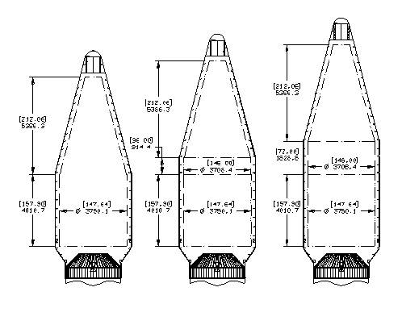
Figure 1: Atlas V-401 Payload Fairing Options

1.4.3 Operations Scenarios

1.5 The Performance

Table 1: Final Concept Evaluation
Figure of Merit | Goal | Design
Number of surface objectives accomplished | 15 samples in permanent dark and 5 samples in lighted terrain
Percentage of mass allocated to payload | Higher is better | 40 % of Dry Mass
Ratio of objectives (SMD to ESMD) validation | 2 to 1
Efficiency of getting data in stakeholders hands vs. capability of mission | Higher is better
Percentage of mass allocated to power system | Lower is better | 17% of Dry Mass
Ratio of off-the-shelf hardware to new development hardware | Higher is better

1.6 The Implementation
To accomplish all goals set forth by the requirements mentioned previously, Daedalus uses several systems. The communications and thermal systems have few problems due to the many parts available for theses applications. The structures, power, and mobility, however are more specific and are geared more toward the mission alone. The structure is made of high strength aluminum and requires custom machining and fabrication specific to the mission. The penetrator launchers are also unique to Daedalus and require the testing of the system and components prior to launch. To meet the mobility requirements for the mission, Daedalus will use penetrators to collect 22 samples. The penetrators are preloaded with springs on the under side of the lander and will be deployed upon descent. Because the Daedalus will land in a lighted region, the lander utilizes the use of solar panels and batteries for its power requirements. During the light periods, the solar cells will be in operation. During the dark periods, the Daedalus will shut down all but necessary systems such as communications and thermal, and resume full operation when light is available.

2.0 Technical Description of Methods Used

2.1 Overview

2.2 Project Office
The project office was in charge of developing an approach plan for each phase for the team. The approach plan included creating a schedule of all deadlines and items needed for the entire project life. Also, the project office developed the initial power and mass budgets for the entire system. This allowed the subsystem leads to effectively develop their designs. The project office also served as a liaison between the team and the customer. This helped ensure that the design was meeting all of the expectations of the customer.
Deadlines are set to allow a margin of at least 2 days before a review must be presented to the customer and the review panel in order to have all of the editing finished. Generally, there are several deadlines set to ensure there is more than 2 days in order to submit the best possible finished product. The deadlines are also set to allow editing time before drafts are submitted for review to ensure that steady progress is made throughout the planned period and the project office can take a more hands off role and reduce the amount of micro-managing taking place.
Each subsystem was given very high standards for the design. For this project, each subsystem’s success depends on the success of the others. This required extreme dedication and team communication for this system to work properly. Emphasis on this was discussed daily by the project office to ensure that the team would not grow complacent in any area of the design. The team made it a priority early that LunaTech would produce a quality product that would be developed as designed by the customer. The project office also works closely with the systems engineer to set expectations based on what the systems engineer observed in the area of team communication and subsystem compatibility.
The team leader developed agendas before each meeting to be accomplished during the meeting. Issues concerning upcoming deadlines were handled first, and design issues followed. This allowed for the team to stay on task and work any critical design problems without the worry of missing a deadline. This also allowed the limited meeting time to be used more effectively. Each member was emailed the agenda prior to the meeting. This allowed them to prepare for any briefings or issues that needed to be worked during the meeting. Team work days were also created to allow the entire team to meet and work on any issues needing to be complete.

Systems Engineering
Table 2: Engineering Summary
Parameter | Unit | Notes
Overall Vehicle
Mission duration | 1 year
Total mass
Number of sites visited | 24 | Achieved with LPES
Single site goal mass
Payload Subsystem
Total mass | 373.1 kg
SMD mass
ESMD mass
Payload percentage of total mass | 40 %
Power Subsystem
Type (solar, battery, RTG) | Solar cells with lithium-ion batteries
Total mass | 169.98 kilograms
Total power required | 937.1 watts
Number of solar arrays | 3 panels
Solar array mass/solar array | 46.29 kilograms
Solar array area/solar array | 6.16 square meters
Number of batteries | 15
Battery mass/battery | 70.4 kilograms
Structure Subsystem
Total mass | 170 kg
Maximum “g” load | 7.15
Thermal Subsystem
Operating temperature range | 20 ۫ C | Inside Thermally Controlled Environment
Non-operating temperature range | Below -10 ۫ C and above  + 40 ۫ C | Nominal Operating Temperature of Li-Ion Batteries
Total mass | 34.90 kg
Passive/Active system | Semi-passive
GN&C Subsystem
Total mass | 4.3 kg
Accuracy | Estimate +-10m
Power required | 70 Watts
Communication Subsystem
Total mass | 17 kg
Type (UHF, S-band, X-band) | Ka-band Transmitter  UHF Receiver
Bandwidth | Ka-band 32 GHz  UHF 401.5 MHz
Power required | 53/44.2 Watts
Storage capacity | 50 Gigabytes
Mobility Subsystem
Type
Maximum velocity
Total mass
Power required

The systems engineering position was in charge of planning for the entire project. This included creating an initial mass and power budget for each subsystem, including margin into the design for overruns, and ensuring that each subsystem stayed on task.
Each subsystem budget was developed with margin included. The mass margins were designed to have extra mass available to distribute among different subsystems as necessary. The maximum mass is set forth in the CDD. The mass margins were set using the American Institute of Aeronautics AIAA recommended weight contingencies for spacecraft. The contingencies were made understanding that the contingencies were for spacecraft. The mass margin was left at 10% of the total mass. This was lowered because of inherent margins in the initial mass and power equations. The total usable mass was initially set at 932.6 kilograms for each of the subsystems. Refer to Table 6 and Table 7 for the actual mass and power budgets for Daedalus.
The power requirements were approximated at 700 watts at any single time during operations. A similar method of creating a margin was used for setting up the power supply. These preliminary numbers were used to guide the designers. Each subsystem was allotted a power value, because the lander would not require all systems running concurrently. The power system was a larger variable than the mass systems because the power requirements were based on the operations of the lander.
Figure 2: Information Flow Chart

2.4 Power

2.4.1 Methods and Assumptions
The main goal throughout the design of the power system is for the Daedalus to survive a one year mission on the Moon. This is just one of the critical requirements that affected the design of the power system. Another driving factor of the design is to land at a polar location. Due to the polar location, 14 days of light and 14 days of darkness are assumed. However, certain landing locations on the southern pole may allow for the Daedalus to receive 70% sunlight per month. The power system was designed to assume the 14 day cycle for a worst case scenario. The Daedalus is to be launched no later than September 30, 2012; therefore, time is critical for acquiring all components.

There were many consideration reviewed for generating power, such as solar cells with batteries, nuclear power, and fuel cells. The first option considered was solar cells with batteries. This would utilize the available source of light to generate power and charge batteries during the daylight. Yet, during the dark periods only the batteries would be active. Many batteries were reviewed and in general, lithium batteries were considered to be the most appropriate due to the high specific energy and storage capacity. Lithium-sulfur dioxide batteries and lithium-ion batteries were the two choices for the power system. The lithium-sulfur dioxide batteries were eliminated due to the voltage drop, ranging from seconds to minutes, after the initial power surge.

Another option of power considered was nuclear power. A Radioisotope Thermoelectric Generator (RTG) and a Stirling Radioisotope Generator (SRG) were examined. Both of the nuclear power options were eliminated. The SRG has a low Technology Readiness Level (TRL) compared to the RTG. Therefore, it was eliminated. Cost for the Daedalus is to be as minimal as possible. RTGs come at a very high cost due to the nuclear power. Another reason for elimination is due to the assumption that time and availability would be an issue. The acquirement of nuclear power may affect the launch date previously mentioned.

The final option of power was solar cells in combination with fuel cells. Regenerative fuel cells and hydrogen fuel cells were the two choices considered. The fuel cells are effective, yet they contain a large amount of mass. And, since the Daedalus would be testing samples, the fuel cells were eliminated due to the by-product of water. This water may have an adverse effect on the sample testing.

2.4.2 Results and Discussions
All of the methods and assumptions have contributed to the power combination of solar arrays and lithium-ion batteries. The solar power system allows Daedalus to power itself during light periods and recharge the lithium-ion batteries for use in the dark periods. The maximum output power of this arrangement is 937.1 watts. The minimum amount of power that needs to be obtained to maintain all systems running is 700 watts. This budget is derived from the initial power budget table that can be found in Table 7 in Appendix B. LunaTech designed the power system to generate excess power to charge the batteries, make up any lost power in case of damaged parts, and/or extend the mission past its required lifetime.
The total mass of the solar cells, lithium-ion batteries, and support system is 169.98 kilograms. The estimated mass of the power system is 158.6 kilograms. This budget is derived from the initial mass budget created by the project office and can be found in Table 6 in Appendix B. The design of this system is based upon the Venus Express spacecraft which launched in 2005.

Since there is the available light source from the Sun, the Daedalus design utilizes solar cells. There are 3 solar panels and the total solar array area for the Daedalus is 6.16 square meters. The third panel is smaller than the other two and is 0.287 square meters. It provides the extra amount of power generation needed for this design. The panels are covered with Optical Surface Reflectors (OSRs) to minimize the effect of extreme temperatures. Each whole panel is 1.78 meters in length and 0.8 meters in width. Each whole panel weighs 20.25 kilograms with an output power of 410 watts. The total power acquired from these panels is 937.1 watts with a total weight of 46.29 kilograms.

It is important for the design to include batteries that have a high specific energy and a long cycle life. The Daedalus will run off of batteries during the dark periods that occur on the lunar surface. The design will use Sony 18650HC lithium-ion batteries. Lithium-ion batteries were chosen because they have a high specific energy, high output power to weight ratio, and the availability for space applications. The specific energy is 114.6 W-hr/kg. Each battery has an energy rate of 9 Ampere-hours.

The number of batteries needed to provide adequate power to the Daedalus is 15. This results in a total calculated mass of 70.4 kilograms and a total volume of 2.2 cubic feet. The mass of batteries was estimated upon how much each subsystem would be in operation during the dark periods. The dark period consists of 14 days, which is 336 hours. The systems that will be running 10% of the time are power and thermal. The rest of the time, the systems will be down. The batteries have an operating temperature of -10 degrees Celsius to 40 degrees Celsius. When in operation, these batteries generate a lot of heat in the thermal compartment; therefore the thermal system does not have to be on all of the time. The thermal system will discuss this more in detail in the next section. Payload, communication, and guidance, navigation, and control will only be running 1.25% of the time during the dark periods. This results in a total energy-rate output of 7.6 kW-hrs. Review Appendix D for calculations.

With the solar cells and Lithium-Ion batteries, a power management and control unit is needed in order to properly condition and manage the power generated from solar cells and batteries. The batteries must be fully charged from the solar cells once daylight has ended. The average charge time of the batteries is 12 hours. The mass of the power control unit is 16.4 kilograms, while the regulator/converter unit is 22.55 kilograms, and the mass of the wiring is 1% of the estimated dry mass which is 9.5 kilograms. This comes to an overall mass of the power support system along with a 10% margin for unexpected additions to be 53.3 kilograms. Refer to Appendix D for calculations. A flow diagram of the entire power system is shown in Figure 3.

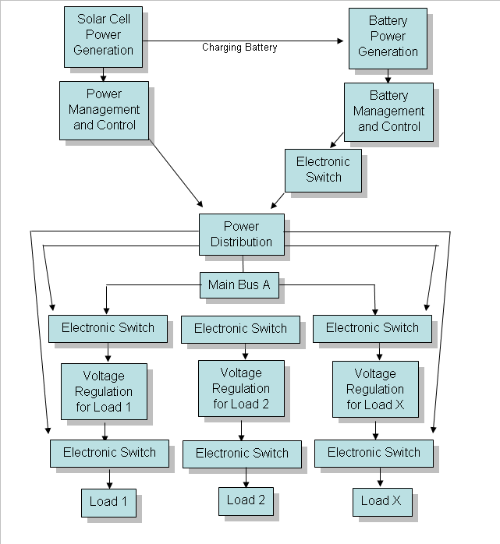
Figure 3: Power System Management

2.5 Guidance, Navigation, and Control (GN&C)

2.5.1 Methods and Assumptions
The first step in designing the GN&C system was to identify the requirements associated with its design and performance. The main pertaining customer requirement involving the GN&C system is the ability to land with a precision of ± 100 meters 3 sigma of the predicted location.

Multiple assumptions had to be made when designing the GN&C system. Since the customer designated the mission to begin at terminal descent at an altitude of 5 kilometers above the lunar surface, the team assumed that at 5 kilometers is when the design begins. At this point, no initial horizontal corrections will be necessary to put Daedalus on its intended course. Also at this point, the assumption is that there is zero velocity relative to the Moon. Afterwards, the vehicle will descend to the lunar surface at a rate of 5 kilometers in 3 minutes. During the descent, there is an assumption that the distance the Moon rotates under the Daedalus is negligible. Once the requirement and assumptions were established, the actual system design began.

2.5.2 Results and Discussions
The GN&C system for the Daedalus concept will be responsible for the terminal landing sequence of the vehicle, which starts at 5 km above the lunar surface. It will be responsible for properly positioning the vehicle along the right descent path and releasing the penetrators at the correct location above the Shackleton Crater, so that all penetrators land in their intended locations, as well as land the vehicle safely on the surface. The Daedalus GN&C system is will be divided into three categories: sensors, guidance computer, and controls.

The sensors will provide critical information on the current state of the vehicle to the guidance computer. Two Honeywell HG1930 Micro Electro Mechanical Sensor Inertial Measurement Unit’s (MEMS IMU) will contain 3-axis strap-down-rate gyros to measure vehicle body attitude rates with respect to the inertial frame and 3-axis accelerometers to measure vehicle body accelerations with respect to the inertial frame. Two IMUs will be used for redundancy and for the case of a failure. The IMUs will be responsible for controlling the vehicle attitude only; it will not be used for navigational purposes.

Two Ball Aerospace Flash 3D Light Detection and Ranging (LiDAR) systems will measure altitude, relative velocity, and useful surface terrain information such as surface slope and hazard detection. This sensor will help the vehicle avoid potential hazards such as rocks or holes, as well as give it the ability to pitch the vehicle to the same slope as the landing surface, providing equal forces on all four vehicle legs during touchdown. Because of their importance, two will be used for redundancy and in case of failure.

Two Long Range Optical Cameras (LROC) will be used to provide the vehicle with Digital Scene Matching Area Correlation (DSMAC) technology. DSMAC will compare a stored image that will be obtained from the LRO prior to launch, to actual images that the LROCs will obtain while descending. This will tell the vehicle exactly where it is in a latitude-longitude sense at any time. This technology has been used and proven for many years on Tomahawk cruise missiles, and is said to provide enough accuracy to hit a window on the side of a building from 500 miles away. DSMAC will provide Daedalus with the ability to launch the penetrators from a precise location, as well as a landing precision that far exceeds the 100 meter requirement. The LROCs will also provide the single site light level readings during the mission on the surface. Two DSMAC cameras will be utilized to help overcome any boresite issues, as well as help if one cameras field of view gets obstructed by dust or by the lander itself in a high pitch maneuver.

The guidance computer will be responsible for processing the signals obtained from all the guidance sensors and outputting the correct command signals to the main engines and Attitude Control System (ACS) to guide the vehicle safely and efficiently to the intended landing spot on the lunar surface. A BAE Systems RAD6000 CompactPCI Single Board Computer with RAD750 Microprocessor will be used to achieve this task. The computer will be responsible for controlling penetrator and rover deployment as well as smaller tasks after landing such as solar cell and antenna deployment.

The controls for landing will consist of 2 Aerojet MR-80 main engines, and 16 Aerojet MR-108 engines that make up the Attitude Control System (ACS). The main engines will be responsible for controlling the vehicles relative velocity and acceleration to ensure a soft landing speed, and will rely mostly on the altitude and velocity readings of the LiDAR. The ACS will control the vehicles yaw, pitch, and roll, and will power the large horizontal movement after the penetrators are launched at 3 km altitude. Both the main engines and ACS are provided to us by the Aerojet Company.

The Daedalus GN&C system will provide the vehicle with a completely autonomous landing and penetrator firing sequence. All inputs will be chosen before the mission and programmed into the computer. These inputs will be based mostly on LRO data and mission planning.

2.5.3 Operations
At 5 km, all GN&C sensors, controls, and computer power up from a dormant state. The LiDAR immediately begins taking altitude and descent velocity readings and feeding them to the computer, which in turn initiates the main engines to give the control descent rate. The IMU’s also immediately power up to observe the vehicles attitude so that the ACS can keep the vehicle in a horizontal state. The LROCs will also begin taking pictures of the lunar surface below and calculating the latitude and longitude of the vehicle continuously. If any adjustments need to be made, the computer will send the appropriate signals to the ACS to position the vehicle back on track. All these operations run continuously as Daedalus travels thru its penetrator and landing sequence explained in the Concept of Operations section. When the vehicle reaches 100 meters above the lunar surface, the LiDAR begins scanning the surface for hazards near the landing site. If such a hazard exists, the computer will use the ACS to adjust the landing site to a safe location. If no such hazards exist, the LiDAR will determine the slope of the landing site, and the computer will begin pitching the vehicle to match the landing surface. When the LiDAR detects the vehicle being 5 meters above the surface, the computer shuts down the main engines and ACS.

2.6 Thermal

2.6.1 Methods and Assumptions
The thermal control subsystem employed in the Daedalus Lander is intended to provide a stable thermal environment in which mission critical equipment and components are maintained at acceptable operating temperatures. The thermal control subsystem supplies a means of dissipating unwanted heat during the sustained hot period and a method of generating and retaining internal heat during the sustained cold period. Both passive and active systems are employed and thus the thermal control subsystem design is referred to as a semi-passive approach. There were numerous assumptions that were made in order to assist in producing a realistic and achievable analysis. The heat transfer from the vehicle was assumed to be steady state due to the fact that the worst-case cold and worst-case hot conditions occurred over periods that were fourteen days in length. The transfer modes were also assumed to be one-dimensional since flow was generally into or out of the vehicle. Instead of analyzing the system through a range of temperatures, all analysis was performed assuming a temperature inside the lander of 20 degrees Celsius. The operating temperature is acceptable for all of the critical components and eliminates calculating the power requirement through a range of internal temperatures. The space surroundings and the lunar surface are assumed to operate as blackbodies in order to simplify radiation analysis.

The ambient temperature ranges for the worst-case cold and worst-case hot conditions were assumed to be -173 degrees Celsius and 100 degrees Celsius, respectively. Conductive losses were assumed to occur inside the thermally controlled environment of the spacecraft due to structural supports that may protrude outside of the controlled environment. These conductive losses are greatly dependent upon the amount of cross-sectional area that they are conducting through. It was assumed that there would be 8 cylindrical rods of 0.25 inch radius that could possibly be providing a thermally conductive path and facilitating conduction heat losses. The effective emmitance was calculated to be

The values for the multiplier factors were obtained from the tables provided in the aforementioned resource (“Spacecraft Thermal Control Handbook”, page 169). This calculated effective emittance was used for the radiation transfer that was assumed to occur between the vehicle surface and the surroundings. An energy balance was performed on the insulated vehicle surface in order to determine the heater power that would be required to maintain 20 degrees Celsius inside the spacecraft during the worst-case cold condition. The calculated mass of the components that comprise the thermal control subsystem is shown below:
Table 3: Thermal Control System Components
Component | Quantity | Estimated Mass [kg] | Units | Total Mass [kg] | Volume [m³]
Multi-Layered Insulation | 28 | 0.73 | kg/m^2 | 20.44 | N/A
Variable RHU Packages | 10 | 0.39 | kg/m | 3.90 | 5 RHUs
RHUs | 50 | 0.042 | kg | 2.10 | 26mm dia x 32mm long
Solid-State Controllers | 2 | 0.03 | kg | 0.06 | 16.5 x 21.6 x 24.1mm
Heaters | 1 | 2.00 | kg/m^2 | 2.00 | N/A
Radiator | 0.57 | 3.30 | kg/m^2 | 1.88 | 0.57 m^2 on top
Paint (White & Black) | 8.5 | 0.24 | kg/m^2 | 2.04 | N/A
Thermal Switch | 5 | 0.10 | kg | 0.50 | 38.1mm dia x 25.4mm height
VC Heat Pipes | 6 | 0.33 | kg/m | 1.98 | 1.27cm dia
Total Mass |  |  |  | 34.90

2.6.2 Results and Discussions
Passive measures are employed extensively on the spacecraft due to their relatively low complexity, cost, and implementation. Multi-layered insulation blankets are utilized for the entire exterior of the vehicle. The insulation is a fifteen-layer insulation blanket with a beta cloth outer-cover material. The beta cloth was chosen due to its mechanical strength properties. The interior-layer material is aluminized kapton. The separator-layer material is Dacron netting and inner-cover material is a kapton laminate. Various thermal control coatings are also used in the subsystem. The outer surface of the radiator is a white paint to minimize absorbed solar energy and all internal surfaces are painted black to facilitate high emittance.

A high conductance aluminum mounting plate will be located inside the thermally controlled compartment of the lander. This “cold plate” will be used to mount sensitive electronic equipment and the high thermal conductivity aluminum will help to dissipate the heat generated by the operation of these components. The cold plate will be the same length and width of the thermally controlled compartment and will be ¼ inch’ thick. Component placement on this plate will also facilitate proper heat dispersion. Components that run simultaneously will be purposely separated while components that run at high temperatures will be centrally located on the plate to maximize heat dissipation. The thermally controlled compartment will be encased with multi-layered insulation blankets and will consume a large amount of the available volume on the interior of the spacecraft.

Thermal switches will be used on the interior of the vehicle to provide thermal conductive paths where necessary. Thermal switches will be used to take advantage of the lithium-ion batteries that will be running during the fourteen day dark (cold) periods. The lithium-ion batteries generate a lot of thermal energy that can be used to heat internal components and other essential equipment. The thermal switches will provide a conductive path to internal components and their mounting structures that will assist in keeping them at a safe operating temperature and thereby reducing the duty cycle of electric heaters.

Variable conductance heat pipes will be used to dissipate heat to the external radiator located on the top of the vehicle. The heat pipes will be essential in order to dissipate the heat that is generated by the variable radioisotope heater units (VRHUs) and the waste heat from inside the spacecraft during the fourteen day hot period. The VRHUs generate a constant thermal wattage that must be dissipated to the radiator during this period. The variable conductance heat pipes used will be 1.27 centimeters in diameter and will utilize a working fluid of ammonia. The heat pipes will have a simple groove wick design. The groove wick is susceptible to gravitational affects; however, they should be negligible due to the weak gravitational field on the lunar surface.

Radioisotope Heater Units (RHU) will be used inside of variable RHU containers. The containers allow the heat to be applied to the desired source only when it is desired by means of a bimetallic actuator. When the temperature is below the desired range the variable RHU container will allow for the heat to be transferred to the location. When the temperature reaches the high point of the desired range, the container will rotate again; this places a thermal insulation blanket between the RHUs and the controlled location. During the fourteen day light period, this heat provided by the RHUs must be transferred out of the spacecraft. This waste heat will be removed by the heat pipes to an external, surface radiator. The RHUs will provide the needed heat during the fourteen day dark periods. Fifty RHUs will be utilized in order to provide approximately fifty watts to the controlled environment. These fifty RHUs will be located inside ten variable RHU containers that hold five RHUs each.

Structures

2.7.1 Methods and Assumptions
The structural package for the Daedalus is a square design based on a four-legged configuration presented at the Viking science instrument team’s meeting in 1968. The lander mounts to the Atlas V-401 payload adapter and is equipped with the electrical interfaces necessary to power the lander during flight. The lander body structure is square in shape with the 4 corners housing the landing legs. The exterior sides between the legs will support the Helium and Hydrazine tanks. The enclosed volume of the lander body is approximately 120,000 cubic inches. The square structure allows room for the main propulsion motors, penetrators, batteries and other instrumentation and payload inside the structure. The structure, with thermal protections in place, shields sensitive systems from exposure to the harsh environment of the Moon. Ramps mounted on top of the structure allow the deployment of the rover and double as surface area for solar cells. The entire package fits inside the Atlas V-401 EPF shroud configuration.

The 4 landing legs provide stability for the structure upon landing on the uneven lunar terrain. The landing legs of the Daedalus are modeled directly after the legs of the Viking Landers. The legs consist of a main strut that is stowed during flight inside a larger cylinder that houses the crush pads. The strut is spring loaded and upon ejection of the vehicle extends and locks into place. The legs are also equipped with a round plate-like foot pad that is pinned to the end of the main strut. This foot pad provides a stable and level base for the lander and spreads out the impact to the lunar surface. The landing legs are equipped with shock absorbers in the form of honeycomb crush pads. These are of the same design as the Viking Mars landers and prevent the lander from incurring damage from a hard landing. The term “hard” in this case refers to terminating propulsion 5 meters above the lunar surface and dropping to the final landing site. The landing legs are also equipped with 2 braces that plastically deform upon impact and help to absorb shock of the landing.

2.7.2 Results and Discussions
The structure of the Daedalus is constructed mainly of 6061-T6 Aluminum alloy and some small components requiring increased strength are constructed of 6AL-4V Titanium alloy. Refer to Table 8 in Appendix G. The structure was analyzed by finite element analysis (FEA) using CosmosWorks FEA package in the SolidWorks modeling program. The structure was also analyzed using approximate hand calculations. The structure was analyzed for 2 different phases of the mission.

The first phase of the mission analyzed was the launch phase. The structure is designed to withstand approximately 5.5 g’s, with a maximum of 7.15 g’s, during flight. This acceleration applies a force of approximately 4448 Newtons onto each vertical and horizontal member of the lander, since there is an equal number of each member. This calculation is shown in Appendix G. Analysis was performed on both a horizontal and a vertical member of the structure. The vertical member is constructed of 6061-T6 Aluminum and consists of a .25-inch-thick tee extrusion that is 12 inches long. The finite element analysis was performed on the vertical member and the results are shown in Figure 5 of Appendix G. This analysis displays a factor of safety of 8.8. The vertical member was checked for column buckling and yielding of the material using equations as shown in Appendix G. These calculations display a minimum factor of safety of 12.4. Similar analyses were performed on a horizontal member of the lander. The horizontal member is also constructed of 6061-T6 Aluminum and consists of a .25-inch-thick angle extrusion that is 12 inches long. This length is the approximate distance between vertical members. The Finite Element Analysis (FEA) results are shown in Figure 6 of Appendix G and displayed a factor of safety of 1.3. The hand calculations as shown in Appendix G display a factor of safety of 24.9.

The second phase of the mission analyzed was the landing sequence. The velocity upon impact is expected to be 4 meters per second and the impact of the landing is assumed to occur over a period of 5 milliseconds. The resulting impact force upon landing is calculated to be 797,600 Newtons as shown in Appendix G. The landing leg strut analyzed is constructed of 6061-T6 Aluminum and consists of a 12-inch-long, 1.2-inch-diameter solid rod. From calculations shown in Appendix G, each landing leg has to withstand an impact force of 230,200 Newtons. It is assumed that the crush pads absorb 90% of this force. The FEA was performed on a 1-inch-diameter solid rod using the remaining 10% of the impact force applied to the strut at a 60 degree angle, which is shown in Figure 7 in Appendix G. However, this force would be shared by the 4 legs. Thus the factor of safety of 3.1 for the landing legs shown in Appendix G is actually 12.4. The landing legs were checked for column buckling and yielding as well. These calculations are shown Appendix G and display a factor of safety of 1.13.

2.8 Payload

2.8.2 Autonomous Robotic Rover

2.8.3 Sample Return Vehicle (SRV)
The SRV was designed by ESTACA in Paris, France. ESTACA was tasked with designing a vehicle that will bring the regolith samples safely back to Earth. For the mission to succeed, there were many constraints to consider. These are gathered in three main categories: performance, environments, and interfaces. This required the SRV to have a propulsion system able to escape the Moon velocity and an optimized trajectory in order to minimize the fuel quantity and then the fuel mass. This fuel economy will allow the SRV to deliver 1 kilogram of lunar regolith back to Earth. Next, the SRV must withstand the environment conditions anywhere in space, on the lunar surface, or on Earth as well as in any situation like launch, landing, or atmospheric reentry. The SRV shall be designed to keep the regolith samples viable; the team has to provide means to sustain samples in lunar condition. Finally, during the entire mission, the SRV has to be designed in relation to the Daedalus and the rover in order to fit in the Atlas V-401 shroud.

2.8.3.1 Methods and Assumptions
The performance category consists of trajectory and the propulsion system. The trajectory is vital in order to develop the project. The distance the module covers influences the fuel consumption. As the SRV is going to pass from one orbit to another, the engine has to provide an impulsion that will depend on the change in velocity required

The SRV will use four different orbits to go back to Earth. First, is the lift-off phase. This depends on the propellants and the engine chosen. At the end of the lift-off, the SRV will go on a circular orbit for several reasons. First, the injection point is not known. Since all the points have the same characteristics, the same altitude will be reached wherever the lift-off zone is. Due to unexpected circumstances, then the SRV can make multiple rounds to wait for the injection into the other orbit. Orbital
maneuvers are also possible like orbit inclination which is not possible with an elliptical orbit.
From the circular orbit, we want to leave the gravitation field of the moon. We have
two possibilities to do so. We can opt for either an elliptical orbit or a hyperbolic one. We
first tried our calculations with an ellipsis. However, the Microsoft Excel solver was
converging on a hyperbole. Therefore, we chose a hyperbolic trajectory.
Then, we would like the SRV to do the main course trajectory thanks to an ellipsis
that will lead us to the Earth’s atmosphere. Finally, the SRV will turn around the Earth on
another circular orbit to wait until the time of the landing.

The propulsion system will be a bi-propellant system of Nitrogen Tetraoxide (NTO) and Monomethyl Hydrazine (MMH). The structure will consist of
Figure 4: Daedalus Sample Return Vehicle

2.9 Communication

2.9.1 Methods and Assumptions
The first step in this process was to identify any requirements that would drive the communications design. There were only two constraints given by the customer. The lunar science experiments will generate a minimum of 300 MB of data. Also, the Lunar Reconnaissance Orbiter (LRO) would be available for use as a relay satellite.

The project office developed the mass and power budgets for the communications subsystem to facilitate the design. The power allotted for the subsystem was 119 watts, and the mass allotted was 56 kilograms. These values were based on historical percentages given by AIAA standards. The team also made an assumption of 100 Mbps for the data transmission rate. This assumption was based on the believed transmission capability of LRO discussed in the NASA Ground Network of the LRO paper. [NASA LRO Paper]. The power and mass budgets forced the team to choose lightweight, high-performance components. The data rate assumption led the team to choose a high-gain radio frequency transmission method. This was chosen over laser optical methods because of the narrow beamwidth of the optical system compared to the radio system. [Lunar Base Handbook] Several high-rate frequencies were explored for the design. X-band was determined to be the most widely used high-rate frequency in space exploration, and it had a wide variety of compatible components for use on the lander. However, NASA has recently begun implementing the use of Ka-band in new spacecraft designs. X-band and other frequencies have been widely used by countless spacecraft, and the frequency pipeline has reached full capacity. This has forced NASA to use other frequencies to transmit data. The higher frequency of Ka-band allows for more data to be transmitted while using less power. For this reason, Ka-band was chosen as the main transmission frequency for the Daedalus design. NASA has allocated the 25.25-32 gigahertz range for the Ka-band to be used in space-to-space return link communications.

The team chose to make the communications design more robust, by combining a secondary UHF system with the primary Ka-band system. The Ka-band transmitter is connected to the high gain antenna, and a gimbal system is used for maneuvering. The team chose to use the UHF system for data uplink from Earth. This was chosen based on the comparison of the amount of data transmitted from Earth to the amount of data transmitted back. The UHF system will also function as a redundant system in case the Ka-band system fails. This will limit the amount of data transmitted, but it will still allow for communication to the lander. The UHF system is based off of the system currently used on the Mars Exploration Rovers (MER).

The next phase of the design was to calculate the view time of LRO for data transmission. LRO will have several orbits throughout its mission life. This orbit variation will also cause the LRO view time to vary. For the design, the team chose to assume the orbit will be a circular orbit at an altitude of 50 kilometer. This was because the majority of time LRO will be in this orbit. Unfortunately, this orbit will provide the least amount of time for visibility. The time-of-flight for LRO for the polar landing location was determined to be 5 minutes, with a period of 113 minutes.

Next, the team determined the data rates needed for each link. For this mission there are several different communications links. The lander-to-LRO link will use Ka-band and will have a data rate of 100 Mbps. The LRO to Earth link will also use Ka-band and will have a data rate of 100 Mbps. The lander to LRO link will also use UHF and will have a data rate of 8 Kbps. The penetrator-to-LRO link will use UHF and will have a data rate of 8 Kbps. The team has assumed that there will be minimal affect of lunar dust on the transmission rates of the penetrators.

Next, the team designed the links for the Ka-band system. Several factors had to be considered for the design to work properly. The communication system must overcome losses of signal strength. These losses accumulate as the signal moves from each component to the next. However, because of the distance of transmission, the most significant loss comes from propagation losses. These losses are estimated using Equation 1. The other losses are atmospheric and feeder, however, these losses were neglected for the Daedalus design. [Lunar Base Handbook].

$L_{P}=\text{20}\text{log}(λ/4πd)$ (Equation 1)

The team designed the antenna for the Ka-band system. This would give the team the ability to overcome any losses by using signal amplification, transmission antenna gain, and receiver antenna gain. The receiver antenna gain is based on the design of the LRO; therefore the team chose to design only the transmission antenna gain. In doing research, the team determined that the simplest antenna design is an omni-directional aerial antenna. This design delivers signal with zero gain added. The ability for the antenna to direct its signal and concentrate it into a smaller area essentially amplifies the signal for the receiver. The smaller the aiming area will result in a higher gain, but it will require a precise aiming capability for the transmitting antenna. The team chose to use a parabolic reflector for the high gain antenna. This was chosen over the dipole and horn reflector because of its high gain and simple formulas for analysis. The team chose a parabolic reflector with an efficiency of 0.79 and a diameter of 0.28 meters. This was based off of the MER high gain antenna design.

$φ_{3\text{dB}}=λ/d\sqrt{\text{pa}}$ (Equation 2)

$G_{0}=\text{10}\text{log}(\text{pa}({πd}/λ)^{2})$ (Equation 3)

2.9.2 Results and Discussion
The team calculated propagation losses using Equation 1 and found the maximum propagation loss for the system would be 185.5 decibels. The team assumed the line losses to be 10 decibels, providing a total loss of 195.54 decibels. This leads to the transmitter antenna gain. Because the gain and beamwidth are inversely affected by the diameter of the antenna, as shown in Equation 2 and Equation 3, the design was made to maximize both and was finalized at 0.28 meters. With this diameter, the peak gain is equal to 36.4 decibels. The half-power beamwidth is 2.16 degrees to each side. The effective gain in relation to the angle of error is in Figure 3. This gives a beam with a diameter of 3.77 kilometers at LRO minimum distance. The team also researched high gain antenna gimbals to allow for directional pointing. The team based the Daedalus design on the design of the Mars Exploration Rover High Gain Antenna Gimbal. This gimbal is a two-axis gimbal produced for NASA by Ball Aerospace and Technologies Corp. It can control the position of the antenna with a precision of 0.5 degrees. It has a mechanical step size of 0.2 degrees. Reference Equation 1. The antenna used on the Mars Exploration Rover is also of a comparable size to the antenna specified above for our design. A gimbal of similar design is the choice for the rover. With the above step size, the gimbal would have to move, on average, once every 52 seconds as it follows the satellite. The tracking of the satellite and aiming of the antenna will require future analysis. For this project, the team allocated space and power for the controller. A plot of the gain pattern is shown in Figure 3. The plot shows that the antenna can have an error of 2 degrees in either direction and still be able to stay connected. This is well within the limits of the antenna gimbal.
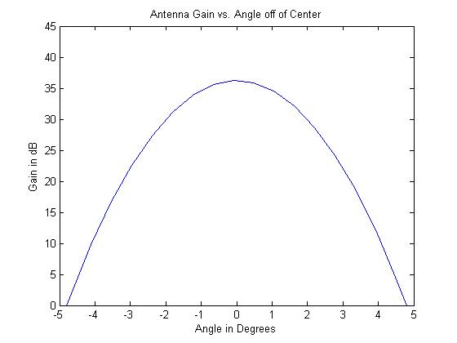
Figure 5: High Gain Antenna Design Plot

2.9.3 Operations
The operations planning of the communications system is mostly based on the relay satellite availability. The lander will only be able to communicate for 5 minutes every 113 minutes. During the periods when it does not have satellite coverage, Daedalus will store scientific data on its space-rated hard drive. It will also have to store any other data until the relay is available again. The view time for the lunar penetrators will vary depending on landing location. However, the penetrators should have the capability to store scientific data for upload once

2.9.4 Data Handling and Storage
Daedalus will have an available communication link for 5 minutes for every 113 minutes. While LRO is not in view of Daedalus, the data will be stored on the lander for transmission when LRO is visible. The team has determined that Daedalus could potentially transmit 3600 MB of data every time LRO is visible. Additionally, control and other operational memory will have to be stored to operate Daedalus for the entire mission. The data bus will employ a distributed architecture that will allow it to use multiple central processors. For this design, all software is resident in the non-volatile memory. During various mission phases the software components which are executing may be different than those executing during other mission phases. This provides a high level of redundancy. The central processors may be used to perform “data processing” functions for the sensor front-ends or the actuator back-ends, as required. However, using this design requires more complex testing, because the system can reconfigure itself as software modules are allocated to processing resources. The computer system will use a BAE Systems RAD6000 flight computer. This was chosen based on the wide use in planetary spacecraft, and radiation hardening. The plan is to use non-volatile flash memory for the lander’s data storage needs. The designers have concluded that approximately 50 gigabytes of memory should be sufficient to handle the needs of the lander and have allocated 30 gigabytes of this memory for storage of images and other scientific data. The remaining 15 gigabytes will be used for operational needs and 5 gigabytes of data will be used for emergency storage. This will be a redundant system storing operation memory in two locations in case of data corruption. Daedalus will use BAE Systems C-Ram radiation hardened memory for the non-volatile flash memory. These are available in 512K x 8 packages. Non-volatile gives Daedalus the ability to keep the stored data even if power is lost to the computer system. This provides a level of security for the design.

2.10 Concept of Operations

2.10.1 Overview
The concept of operations for the Daedalus lander will depend on the interactions of three main components: the Lunar Reconnaissance Orbiter (LRO), the Lunar Penetrator Exploration System (LPES), and Daedalus. These require the interactions of all subsystems on Daedalus to work effectively to achieve the goals for the mission. The LRO concept of operations will be essential to receiving and transmitting all data to and from Daedalus and LPES, as well as provide key images of the landing sites for both the penetrators and the lander. The LPES concept of operations will consist of deployment, landing, and data collection. The lander concept of operations will consist of descent, penetrator deployment, landing, and the 1 year science mission. Using this overview, a more detailed concept of operations package was developed for the Daedalus mission.

2.10.2 Lunar Reconnaissance Orbiter (LRO) Concept of Operations
The LRO is an essential key to the success of the entire mission. Images collected from the LRO will be stored in the DSMAC system for correlation, and for the positioning of the penetrator launch and Daedalus landing locations. LRO will serve as a communications satellite for the mission. LRO will collect the data for both the lander and LPES, and transmit it back to mission control. The orbit for LRO gives the lander and penetrators 5 minutes of transmission time for every 113 minutes, or about 1 hour per day. This view time will vary for the lander and penetrators based on their locations. The maximum assumed data transmission rate for LRO is 100 Mbps, therefore the maximum assumed data rate for Daedalus is assumed to be 100 Mbps. The CDD suggested a maximum of 300 MB of data will be generated per site. This equates to 7500 MB of total data generated from the 23 sites for the entire mission. The communications system for Daedalus allows it transmit 3600 MB of data every time LRO is visible. This exceeds the requirement of transmitting 300 MB of data for the entire mission to mission control. The LPES uses a UHF system to transmit data to the LRO. The maximum data transmission rate for each penetrator is assumed to be 8 kbps. The communications system allows each penetrator to transmit 0.286 MB of data every time LRO is visible. This may require some data be stored in the penetrator memory for uploading to LRO when it is available.

2.10.3 Lunar Penetrator Exploration System (LPES) Concept of Operations
Daedalus will carry 22 penetrators for the mission. These penetrators will be based on LUNAR-A design and each penetrator will be housed in the penetrator launch system. This system will utilize a spring-loaded system with shear bolts to release the pre-tensioned springs to eject the penetrators away from the lander. Each penetrator will be positioned in tubing that is angled at the correct orientation to achieve the required 500 meter distance per sample site. There will be two extra penetrators one for each environment to increase the success rate of the system. At 5 kilometer above Shackleton crater, Daedalus will launch 16 penetrators with an impact velocity 255 meters per second. These penetrators will impact the permanently dark lunar surface and begin collecting data. Once Daedalus has reached the 3 kilometer mark, 6 penetrators will launch from Daedalus with an impact velocity of 255 m/s. Once all of the penetrators land they will begin collecting and streaming data. The team has assumed that LRO will be visible for an entire viewing period when all of the penetrators have landed. This will ensure that the maximum amount of data can be transmitted back to mission control. The penetrators utilize a UHF transceiver to send data at 8 kbps. Each penetrator will generate 300 MB of data for the life of the mission, and can transmit 0.286 MB of data every time LRO is visible. The penetrators have the capability of storing data for periods when LRO is not visible. The life of each penetrator is estimated to be a year.

2.10.4 Lander Concept of Operations
The lander concept of operations is broken in to two phases. The first phase is the descent, LPES deployment, and landing phase and the second phase is the surface mission. The first phase will take place above the lunar surface and will mostly consist of GN&C and LPES Deployment. Once Daedalus is 5 kilometers from the lunar surface and approximately 2.5 kilometers from the rim of the Shackleton Crater, the GN&C system will take over control of the lander. This includes the LiDAR, DSMAC, IMU, flight computer, MPS, and ACS. DSMAC will ensure proper location above permanently dark region of interest. At this time, at the 5 kilometer mark, 16 penetrators will launch into the permanently dark region of the crater. This will satisfy the customer requirement of 15 samples in the permanently dark region. Daedalus will then use the MPS and ACS to transverse over to the designated landing site while descending from the 5 kilometer mark down to 3 kilometer. During this time the DSMAC will continue imaging the lunar surface to correlate the stored landing location image to ensure that the lander is in the designated range. At the 3 kilometer mark, 6 penetrators will deploy for the lighted region of lunar surface. This will satisfy the requirement of 5 samples in the lighted region. There are two extra penetrators to account for any issues during launch and landing. The launch mechanism for the LPES will utilize a spring-loaded system with shear bolts to release the pre-tensioned springs. Each penetrator will be positioned in tubing that is angled at the correct orientation to achieve the required 500 meter distance per sample site.

During the descent period, the LiDAR will scan the landing site to avoid any unforeseen obstacles. The LiDAR will also be responsible for calculating the angle of the lunar surface and adjust Daedalus accordingly to ensure that safe landing is achieved. The DSMAC system will ensure that Daedalus will land at the correct location. Once the lander has been positioned 5 meters above the target, the computer will send a signal to the MPS to shut down. This will create the hard landing designed to reduce lunar dust disturbance from the thrusters. The entire landing sequence will take approximately 3 minutes from 5 kilometers to landing. This completes the landing phase of the mission. The GN&C system is shut down, and power is diverted to other subsystems. A detailed illustration of the Daedalus landing sequence is shown in figure 6.

The next phase begins once Daedalus has landed on the lunar surface. After Daedalus has landed and time has been allotted for dust settlement, the 3 solar panels will unfurl and position for optimal sunlight exposure. This will start power generation for Daedalus and begin recharging the 15 lithium-ion batteries. For the lunar night, the power system will provide power to accommodate all communication, payload and power systems efforts for about 3 hours and 21 minutes per lunar night. This is based on a 1% duty cycle for the lunar night power system. The thermal system will operate on a power cycle. The thermal system will work to expel most of the heat generated during the lunar day, and conserve heat generated during the lunar night. For the lunar night, the thermal system will need to be on 10 percent of the time to maintain the optimal temperature for component survival. Once sufficient power has been converted, the scientific research for Daedalus will begin. The observations will consist of measuring micrometeorite flux, determining lighting conditions every two hours, and assessing electrostatic dust levitation with the correlation to lighting conditions. The lighting conditions will be measured every 2 hours per scientific requirement, and will use the efficiencies of the solar cells and the camera system to verify the data.

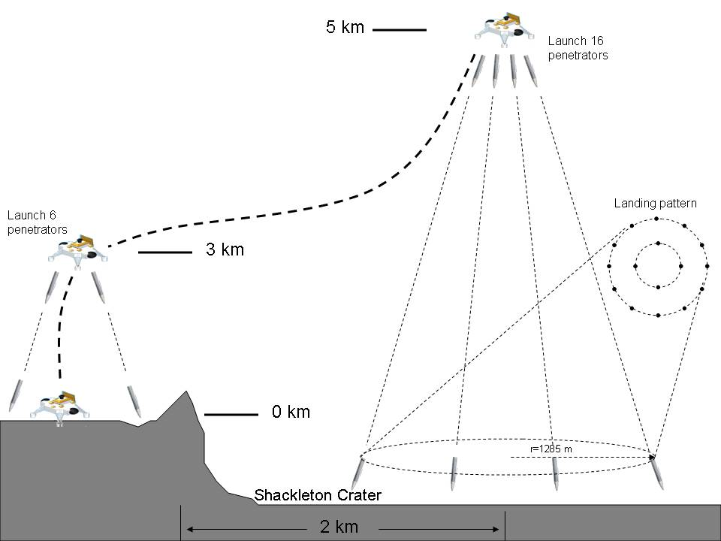
Figure 6: Daedalus Concept of Operations

2.11 Systems Interactions

The subsystems of Daedalus interact several ways. The team designed the lander to minimize the interactions between the different subsystems. This was done to simplify the design, and increase the flexibility of Daedalus. The idea to minimize the design, along with using OTS hardware was created to overcome the short time table for creating the design.

The design took advantage of the low size restrictions to increase the size of the rover and reduces the interaction of many of the systems, by allowing plenty of room for each of the subsystems. The structure of the rover is similar to an automobile. It has a long frame and a wide body. The frame allows for plenty of room on top for the subsystems to be placed. This reduced the size requirements on the individual subsystems and allowed for a greater level of freedom for the individual designers to design the system without having to spend large amounts of time working out exact dimensions early on. As a result, the designers could work out their parts without concern that the subsystems would physically contrast with each other. This change did require a trade of mass to increase the size of the rover, but considering time constraints, it was decided to be the best method.
The power system provided the most subsystem interactions for the Daedalus concept. Nearly all subsystems require power to operate effectively. The commands for providing power to parts of the spacecraft are carried out by the power distribution center. One interaction is that the batteries required a specific thermal environment to be maintained for maximum operations. While generating, the batteries also introduced a great amount of heat into the system. This had to be mitigated through the thermal system.
The communication system also has several issues with interference. The antenna must be able to point at the satellite in order to transmit to Earth and must also be on the top of the lander.
These are the interactions address by the system design. Many things were done to reduce the level of negative interaction of the different subsystems and take advantage of some of the systems interactions.

3.0 Implementation Issues

3.1 Schedule
Insert GANTT Chart!

3.2 Hardware
Nearly all of the Daedalus lander utilizes OTS technology that is at TRL 9. This will minimize the need for additional hardware development. The LUNAR-A penetrators that are used for the Daedalus LPES will require additional development and testing. (TALK About what is needed to get LPES TRL 9)

Company Capabilities

4.1 Company Overview
LunaTech consists of a diverse group of young engineers with various backgrounds in nationality, discipline and education joined together to produce superior designs for our customers. Two of the members have a permanent location outside of Paris, France at ESTACA and specialize in fluid dynamics and structures. The American members specialize in mechanical, electrical, industrial, and aerospace engineering. LunaTech also has the pleasure, good fortune, and opportunity to call upon many field professionals that include, but are not limited to, mentors and professionals in their fields and disciplines.

LunaTech has utilized many tactics for staying in contact with the members of the group. Bi-weekly, face-to-face meetings are held for the local members. During these meetings, disciplines report on progress, problems, and new information for the team to consider and work on together. These meetings are crucial to maintain a group that functions together and complies with their system requirements. Communication between the group as a whole takes place daily by way of e-mail, teleconferencing, team bulletin boards, and a group site that allows the members to post files and alert other members of changes or improvements.

Throughout Phase 1 and parts of Phase 2 and 3, individual disciplines within each group worked together with mentors and each other for direction. This allowed for LunaTech members to become proficient in their discipline in an accelerated time frame, which in turn was a benefit to the group and the design process. The team leader worked with the team leaders of the competing companies to question the customer and become comfortable with all of the requirements. Assistance from the team members based in France was crucial during all phases of production. They provided the team with drawings and analysis that initially proved the incompetence of the Baseline Design. Through the final phases, they provided assistance with analysis on the selected design. Throughout the final weeks of the last phase, each discipline stayed in constant contact with their mentors in order to guarantee quick turnaround on any questions and issues. Through hard work, dedication, and perseverance, LunaTech was able to generate a working design quickly and completely.

4.2 Personnel Description
Listed below are the primary members of LunaTech. Beneath each of their names and titles are highlights to the assistance that they brought to the team, and the contributions that they made.

- Mr. Nicholas Case– LunaTech Team Leader
Mr. Case was in charge of coordinating weekly meetings for LunaTech. Also, he was instrumental in the overall vision for the project, and assigning various task for each subsystem.

- Mr. Morris Morell – LunaTech Systems Engineer
Mr. Morell was in charge of ensuring that Daedalus was compliant with the requirements and recommendations of the customer. He was also instrumental in integrating all components for Daedalus. He was also helpful in designing the structural system for Daedalus and creating a 3-D CAD model of Daedalus.

- Mr. Travis Morris – LunaTech Guidance, Navigation, and Control Engineer
Mr. Morris was a valuable asset to LunaTech for this project. He developed the entire GN&C subsystem for Daedalus. Mr. Morris used unconventional ideas to create a very unique and robust GN&C design. Mr. Morris was a major reason that the Daedalus concept was a success.

- Mr. Greg Barnett – LunaTech Thermal Engineer
Mr. Barnett expressed great interest in the thermal system design for LETS from the start of the program. His work ethic and love for thermal design proved invaluable for this project. Without his in depth design, Daedalus would not be able to meet the objectives given by the customer.

- Mrs. Katherine Tyler – LunaTech Power Systems Engineer
Mrs. Tyler was part of the power systems team. Without the dedication of this team, LunaTech would be in a struggle to ensure that the design would meet the requirements of the customer. Mrs. Tyler was also instrumental in the design of the team presentations, and the team display, which won first place in the IPT 2008 Open House competition.

- Mr. Adam Garnick – LunaTech Power Systems Engineer
Mr. Garnick was also part of the power systems team. Mr. Garnick brought a lot of energy to the team, and gave tremendous effort to completing the design. Mr. Garnick’s technical expertise in power systems, allowed Daedalus to survive for the entire mission length.

- Mr. John Grose – LunaTech Payload Systems Engineer
Mr. Grose was in charge of designing the lunar penetrator concept for Daedalus. Mr. Grose brought his hard work ethic and spacecraft design to the team and was very instrumental in creating a great product for the customer. Mr. Grose was also instrumental in creating the winning team display for IPT 2008 Open House.

- Mr. Adam Fanning – LunaTech Communications Engineer
Mr. Fanning was in charge of designing the communications architecture for Daedalus. His work ethic and mellow attitude allowed him to create a great design and was very helpful in brainstorming sessions.

- Mr. Thomas Stewart – LunaTech Structural Engineer
Mr. Stewart was in charge of the structural design of Daedalus. His hard work ethic and design capabilities were instrumental in producing a robust and flexible structural design.

- Mr. Julius Richardson – LunaTech Concept of Operations Specialist
Mr. Richardson was in charge of developing the operations schedule for the entire length of the mission. Julius was also in charge of developing requirements for the rover design. Without his help, achieving the scientific goals of the mission would not be possible.

- Mr. McArthur Whitmore – LunaTech Mobility Specialist
Mr. Whitmore was in charge of developing the robotic rover for the Daedalus concept. He was instrumental in relaying information between LunaTech and Southern University.

- Mr. Robert Danso – LunaTech Mobility Specialist
Mr. Danso was in charge of developing the robotic rover for this concept. He was a valuable addition to our team.

- Mr. Sebastien Bouvet – LunaTech Sample Return Vehicle Specialist
Mr. Bouvet was in charge of developing the Sample Return Vehicle for the Daedalus concept. The SRV added great scientific flexibility to the overall design.

- Ms. Julie Monszajin– LunaTech Sample Return Vehicle Specialist
Ms. Monszajin was in charge of developing the Sample Return Vehicle for the Daedalus concept. The SRV added great scientific flexibility to the overall design

Summary and Conclusions
The Daedalus lander was designed to achieve the mission goals envisioned by the customer. Starting with the initial trade studies of each subsystem, the team designed the lander with the requirements in mind. The lander draws from the experience developed over the years and utilizes several systems currently used on other landers and spacecraft.

The Daedalus system was broken down into individual subsystems for more in depth analysis. The structures subsystem was analyzed to support the scientific payload and to withstand the forces experience during launch and landing. Careful consideration was given to selection of materials. This was to ensure the lander’s survivability in all of its extreme environments. A 3-D model was developed of the Daedalus structure and analyzed using Nastran and Patran. This provided detailed anaylsis of the entire structure and ensured that the design would withstand the rigors of the lunar mission. Future work could include: more detailed models of the structure, and full simulation of the Daedalus model to increase the accuracy of current calculations.
The Daedalus thermal control system utilizes a semi-passive system to allow Daedalus to survive the lunar environment. The use of the semi-passive system reduces the amount of risk in the lander operations and system failure. The system utilizes MLI blankets, VRHUs, heat pipes, paints, and heat switches to ensure that the Daedalus components maintain an optimal working temperature. This design is widely used on several landers and spacecraft, and nearly all components are OTS and TRL 9 components.
The Daedalus power system was the most critical subsystem for the design. It utilizes the power system designed for the Venus Express and Mars Express orbiters. The power production will be done from X solar panels to produce the power needed to conduct all the required science during the lunar day and store power in the space-rated lithium-ion batteries. During the lunar night, these batteries will provide the power needed to run the essential systems for survival. These include: thermal control, minimum scientific research, and communications. These systems will operate on specific duty cycles to minimize the impact on the power allowances.
The Daedalus communications system is based on the Mars Exploration Rover design. The system consists of a Ka and UHF band transceiver. This provides Daedalus with a redundant system of two antennas and two transceivers. The Ka-band system is used to uplink data to LRO for transmission back to mission control. The UHF system is used to download transmissions and data sent from mission control. The UHF system can also be used as a transmitter if the Ka-band system fails. This ensures that data will reach the customer throughout the life mission. Nick: Need to say specifically how the lander communicates and how the penetrators communicate.
The Daedalus guidance, navigation, and control system provides a completely autonomous landing sequence for the vehicle. All starting points, checkpoints, penetrator launch points, and landing points are all determined before launch, and are based on accurate LRO pictures and mapping. The system will utilize IMUs for attitude control and horizontal maneuvers, LiDARs for altitude control and hazard avoidance, and two DSMAC systems to provide precise latitude-longitude location. These sensors all feed signals into a guidance computer and processor, which then determines the correct signals to send to the main propulsion engines, as well as the ACS. The overall system provides the high accuracy that is critical to successfully completing the mission.
The Daedalus scientific payload….

6.0 Recommendations
Power:

Thermal:

Guidance, Navigation, and Control:

- Research and development is currently being done on incorporating a DSMAC system into space vehicles, actual numerical accuracy has yet to be determined.
- Bore site errors may be an issue with the DSMAC system
- More research on specific navigation computer model is needed

Communication:

- Additional Analysis of satellite tracking system
- A dedicated communications satellite on a molyina orbit for maximum communication time.

Structures:

Payload:

Concept of Operations:

- Concept Description Document

- Scope. This document outlines the specifications for the Lunar Exploration Transportation System (LETS). The LETS project is to develop a lunar lander mission for NASA that provides the flexibility to conduct different scientific investigations and technology validation tasks at different areas on the Moon’s surface. For this study only one lander is envisioned. The mobility of the lander system is subject to trade. For the purposes of this project, the mission begins with terminal descent. The project goal is to design the transportation system to accomplish the scientific and technology objectives, not the science and technology itself.

- Customer Requirements. The following requirements were given by the customer as Level 1 Requirements.

  - The LETS shall use an Atlas V-401 EPF shroud configuration with a total landed mass of 997.4 kg.
    - The LETS shall be designed so that 64.6 kg of the total landed mass is devoted to the propulsion system dry mass. Table 1 details this mass allocation to the propulsion subsystems.
    - The LETS propulsion system shall be designed to accommodate 159.5 kg of hydrazine (N2H4) propellant and 2.0 kg of helium. The propellant shall be housed in two spherical propellant tanks, each 0.55 m in diameter. The helium shall be housed in 2 spherical tanks, each 0.4 m in diameter.
    - The LETS propulsion system shall be designed for two (2) MR-80B monopropellant liquid rocket engines.
    - The LETS attitude control system shall be designed for twelve (12) MR-106 monopropellant thrusters.
  - The LETS shall be designed for its first mission to be at a polar location.
  - The LETS shall be designed with the capability to land at other lunar locations.
  - The LETS shall minimize cost across the design.
  - The LETS shall launch to the Moon NLT September 30, 2012.
  - The LETS shall have the capability to move on the surface.
  - The LETS shall be designed to survive for one year on the surface of the Moon.
  - The LETS shall survive the proposed concept of operations.
  - The LETS shall be capable of meeting both the Science Mission Directorate (SMD) and the Exploration Systems Mission Directorate (ESMD) objectives.
  - The LETS shall land to a precision of ± 100m 3 sigma of the predicted location.
    - The LETS shall provided guidance, navigation, and control for the terminal descent phase, beginning at 5 km above the surface of the Moon.
    - The LETS shall not be responsible for hazard avoidance.
  - The LETS shall be capable of landing at a slope of 12 degrees (slope between highest elevated leg of landing gear and lowest elevated leg).
  - The LETS shall be designed for g-loads during lunar landing not to exceed the worst case design loads for any other phase of the mission (launch to terminal descent).
    - The LETS shall be designed to withstand g-loads with respect to stiffness only.
    - The LETS design shall not be concerned with frequency responses or frequency loads.

- Concept Design Constraints. The following constraints are placed on the LETS design.

  - The LETS shall be designed to interface with the Atlas V-401 EPF shroud configuration launch vehicle per the Atlas Launch System Mission Planner's Guide, Rev 10a, January 2007, and CLSB-0409-1109.
  - The LETS shall be designed to survive the lunar cruise environment for up to 28 days per NASA Technical Memorandum 82478, Space and Planetary Environment Criteria Guidelines for Use in Space Vehicle Development, Volume 1. Including but not limited to the following environment obstacles
    - Radiation
    - Thermal
    - Micrometeoroids
  - The LETS shall be designed to survive the lunar surface environment at both the polar and equatorial regions.
    - This includes temperatures ranging from 107 Celsius to -223 Celsius
    - Including conditions stated in section 3.2
  - The LETS shall maximize the use of off-the-shelf technology. Off-the-shelf technology shall have a technology readiness level of 9.
    - Readiness of level 9 states it is an actual “Flight Proven” system through successful mission operations.
  - The LETS shall be designed to accomplish the maximum surface objectives outlined below.

- Figures of Merit. The following Figures of Merit (FOM) will be used to evaluate the LETS design concepts.

  - Number of surface objectives accomplished (as outlined below)
  - Percentage of mass allocated to payload
  - Ratio of objectives (SMD to ESMD) validation (2 to 1 being the goal)
  - Efficiency of getting data in stakeholders hands vs. capability of mission
  - Percentage of mass allocated to power system
  - Ratio of off-the-shelf hardware to new development hardware

- Surface Objectives. The following surface objectives were provided by the customer.

  - Single site goals - Geologic context
    - Determine lighting conditions every 2 hours over the course of one year
    - Determine micrometeorite flux
    - Assess electrostatic dust levitation and its correlation with lighting conditions
  - Mobility goals
    - Independent measurement of 15 samples in permanent dark and 5 samples in lighted terrain
    - Each sampling site must be separated by at least 500 m from every other site
    - Minimum: determine the composition, geotechnical properties and volatile content of the regolith
    - Value added: collect geologic context information for all or selected sites
    - Value added: determine the vertical variation in volatile content at one or more sites
    - Assume each sample site takes 1 Earth day to acquire minimal data and generates 300 MB of data
  - Instrument package baselines
    - Minimal volatile composition and geotechnical properties package, suitable for a penetrometer, surface-only, or down-bore package: 3 kg
    - Enhanced volatile species and elemental composition (e.g. GC-MS): add 5 kg
    - Enhanced geologic characterization (multispectral imager + remote sensing instrument such as Mini-TES or Raman): add 5 kg

Table 1. Propulsion Dry Subsystem Mass

Subsystem | Number | Mass/Unit (kg) | Total Mass (kg)
Propellant Tank | 2 | 5.1 | 10.2
Helium Tank | 2 | 5.2 | 10.4
Helium | 2 | 1.0 | 2.0
Main Engine | 2 | 7.9 | 15.8
ACS Thruster | 12 | 0.5 | 6.0
Components | 1 | 14.1 | 14.1
Contingency | 1 | 6.1 | 6.1

- Project Office

Table 4: Initial Mass Estimates for Daedalus
Given Mass Values from CDD
System | Mass (kg) | % of Total Mass
Total Landed Mass | 997.4 | 100.00
Propulsion Dry Mass | 64.6 | 6.48
Propellant Mass | 159.5 | 15.99
Helium | 2 | 0.20
Sample Return Vehicle | 250 | 25.07
Lander Dry Mass | 932.8 | 93.52
Initial Mass Budget Derived from Historical Percentages
Element of Weight Budget | Est.% of Lander Dry Mass | Est. Mass Based on Col. (1) (kg)
Payload | 40 | 373.1
Structures and Mechanisms | 15 | 139.9
Thermal | 5 | 37.3
Power | 17 | 158.6
GN&C | 2 | 18.7
Communication | 2 | 18.7
Propulsion (dry) | 7.7 | 64.6
Margin (kg) | 11 | 102.6
Total Lander Dry Mass | 100 | 913.4

Table 5: Initial Power Estimates for Daedalus
Given Mass and Power Values for Payload Units
Unit | Mass (kg) | Power (W)
Stereo Imaging System (SIS) | 0.8 | 6
Mast (SIS) | 3.5 | 9.5
Drill and Drill Deployment | 20 | 30
Arm | 13 | 43
Scoop | 0.7 | 0
Penetrator | 1 | 0
Mass Spectrometer | 19 | 75
XRD/XRF | 2 | 10
Total | 60 | 173.5
Initial Power Budget Based on Payload Power Requirements
System | Est. % of Lander Power | Est. Power Based on Col. (1) (W)
Total Budget | 100 | 700
Payload | 24 | 168
Structures and Mechanisms | 1 | 7
Thermal | 25 | 175
Power | 5 | 35
GN&C | 18 | 126
Communication | 17 | 119
Margin | 10 | 70
Total | 100 | 700
- Systems Engineering

- Power

- Guidance, Navigation, and Control
6U CompactPCI single-board computer
6U availability: Available now
Supports variable-memory configurations

SRAM: 16 MBytes standard with options to 48 Mbytes and ECC
Device sparing
SUROM: 64 KBytes + ECC
EEPROM for engineering (256 KBytes)
PROM for flight units (64 KBytes)
EEPROM: 4 MBytes + ECC

6U specifications

Form factor
CompactPCI 6U (233 mm x 160 mm)
Weight: 1000 to 1220 grams, varies with memory
Memory
16-48 MBytes RHSRAM,4 MBytes EEPROM
Radiation-hardness
Total dose: >100 Krad (Si)
SEU: 1.9 E-4 errors/card-day (90% W. C. GEO)
varies with orbit
Latchup: Immune
Performance
>260 Dhrystone 2.1 MIPS @ 132 MHz
4.3 SPECint95 4.6 SPECfp95 at 132 MHz
Power supply
5V ± 10% and 3.3V ± 5%
(2.5V generated via onboard regulator)
Power dissipation
11-14W
Rail temp range
-28°C to +70°C
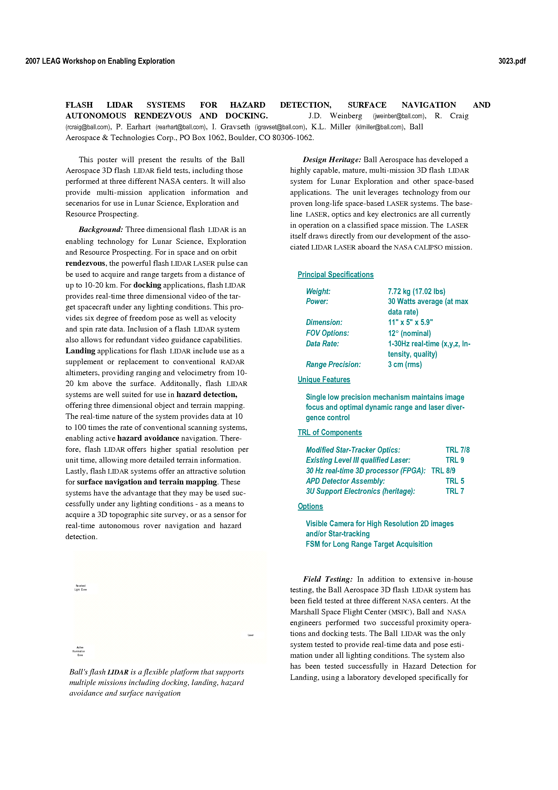
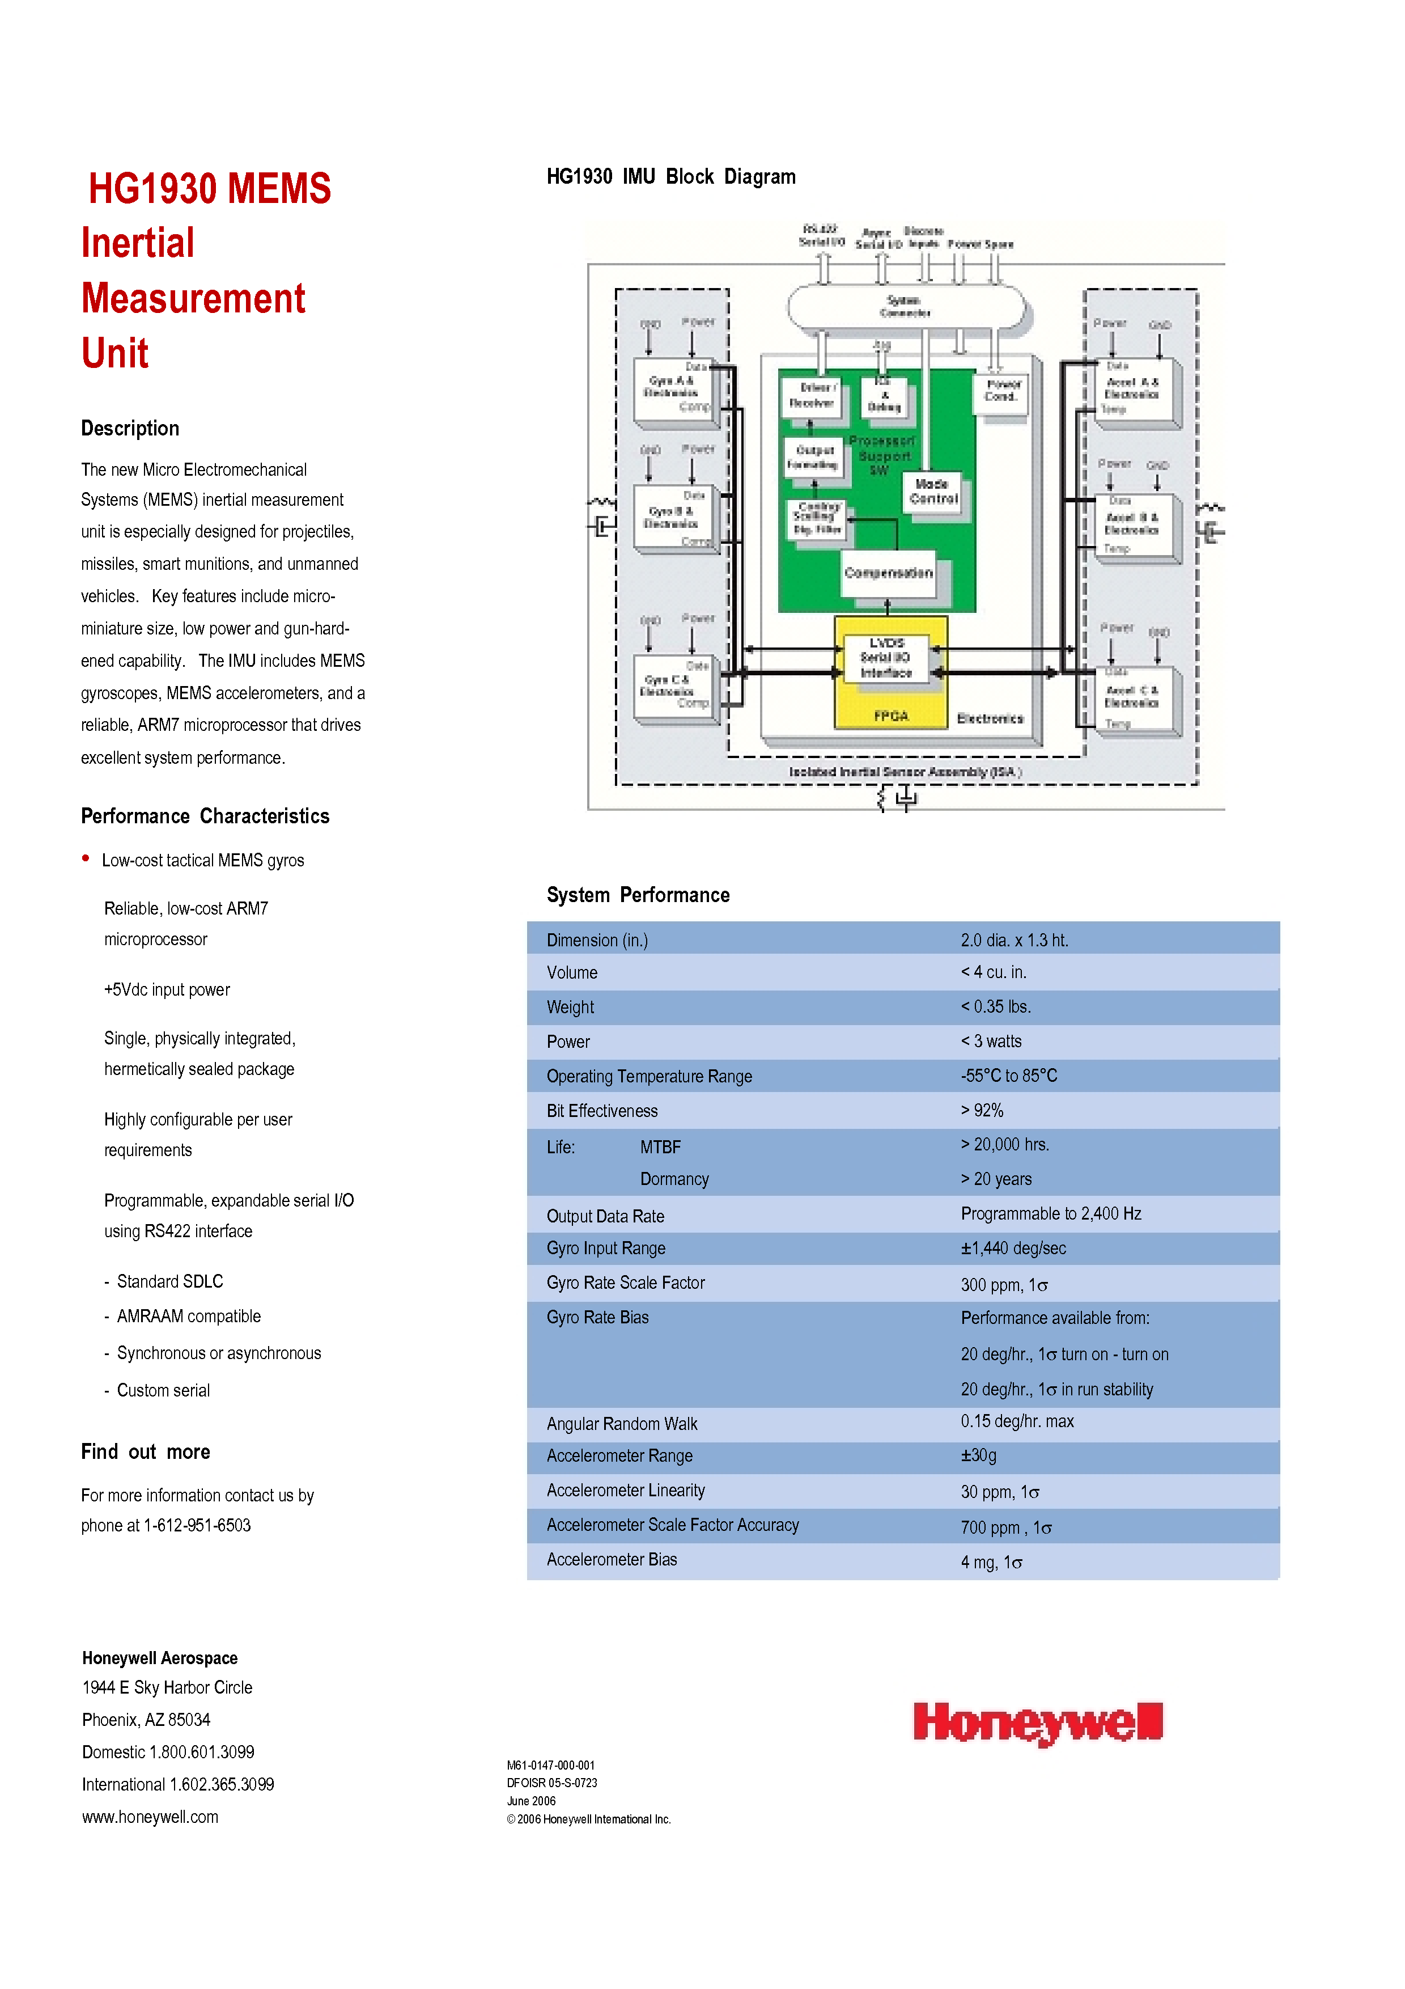
- Thermal

- Structures

Table 6: Material Properties For Materials Used in the Daedalus
Material | Density (kg/m^3) | Young's Modulus (Gpa) | Yield Strength (Mpa) | Thermal Expansion (m\m*K)
6061-T6 Aluminum | 2800 | 68 | 276 | 23.6
6AL-4V Titanium | 4400 | 110 | 825 | 9

Material properties obtained from www.matweb.com

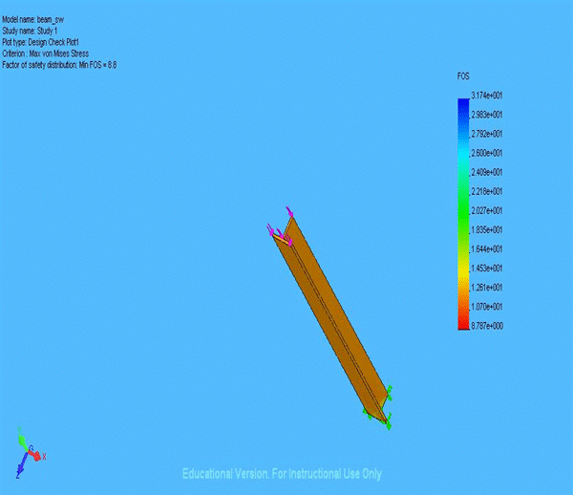
Figure 7: Design Check of Vertical Member Using Von Mises Stress Criterion

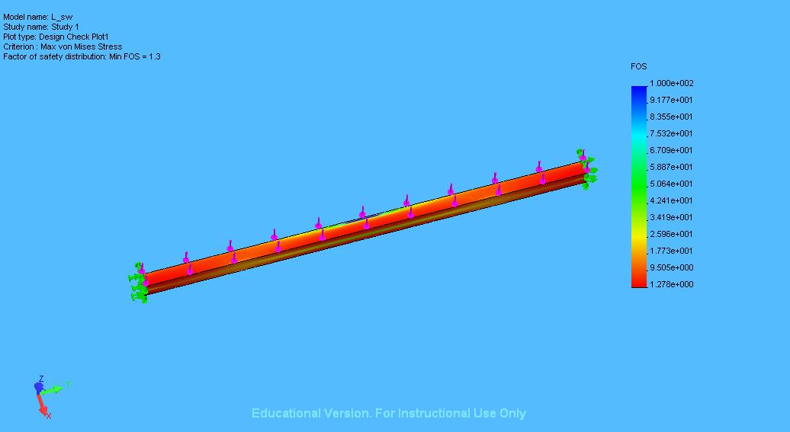
Figure 8: Design Check of Horizontal Member using Von Mises Stress Criterion

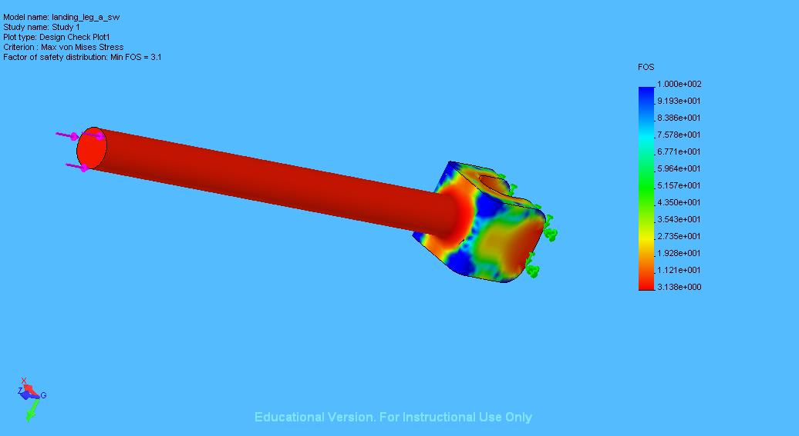
Figure 9: Design Check of Landing Leg Strut Using Von Mises Stress Criterion

- Payload

- Communications

****************************************************************************************************************************************************
Daedalus Antenna Program
****************************************************************************************************************************************************

*****
Input
*****

function DaedalusAntenna

pa = .79; % Antenna efficiency
d= .28; % Antenna diameter (m)
l=.012; % Wavelength (m)
Go=pa*(((pi*d)/l)^2) % Maximum Antenna Gain
p=l/(d*sqrt(pa)) % 3dB or half-power beamwidth (radians)
Gt=10*log10(Go) % Maximum Gain in dB
P=-pi:.01:pi; % 180 degree range of angles
G=Go.*exp(-2.76*(P/p).^2); % Antenna Gain across range of angles
%orAntenna Pattern
D=P*180/pi; % angle range converted to degrees
Gt0=10*log10(G); % Antenna Gain in dB vs. degrees

plot(D,Gt0); % Plot of Antenna Pattern
xlim([-5 5]);
ylim([0 45]);

*******
Output
*******

>> DaedalusAntenna

Go =

4.2450e+003

p =

0.0482

Gt =

36.2788

Table 7: Daedalus UHF Communication Components
Figure 10-High Rate Transmitter

Figure 11: High Rate Transmitter

Figure 12: MER UHF System Specifications

Table 8: Mass and Power for Ka System
Ka-band System | Input Power Watts | RF Power Out Watts | Mass  kg | Quantity | Total Mass  kg | Dimensions  in cm
Ka transmitter | 47 max  1.2 stand-by | 2 | 2.3 | 1 | 2.3 | 20.3x16.8 x8.1
HGA | 5 |  | 1.5 | 1 | 1.5 | 33x10x 10
HGAG | 2 |  | 4.5 | 1 | 4.5 | 20x15x45
Tracking | 1 |  | 1.0 | 1 | 1.0
Controller | 2 |  | 2.5 | 1 | 2.5 | 20x15x10
Coax | 1 |  | 1.0 | 2 | 2.0

Table 9: Mass and Power for UHF System
UHF System | Input Power Watts | RF Power Out Watts | Mass  kg | Quantity | Total Mass  kg | Dimensions  in cm
Transceiver | 6 rec.  43 rec./tra | 12 | 1.9 | 1 | 1.9 | 5.1x6.8x 3.7
Diplexer | Included |  | 0.4 | 1 | 0.4 | 2.9x3.7x 1.3
CTS | Included |  | 0.1 | 1 | 0.1 | 5.3x3.0x 4.0
RUHF | Included |  | 0.1 | 1 | 0.1 | 16.9x1.9 x1.9
DUHF | Included |  | 0.1 | 1 | 0.1 | 20x15x10
Coax | Included |  | 0.6 | 1 | 0.6

Table 10: Total Mass and Power for Communications System
System | Power  Watts | Mass  kg
Ka-band system | 47/1.2 | 13.8
UHF System | 43/6 | 3.2
System Total | 53/44.2 | 17

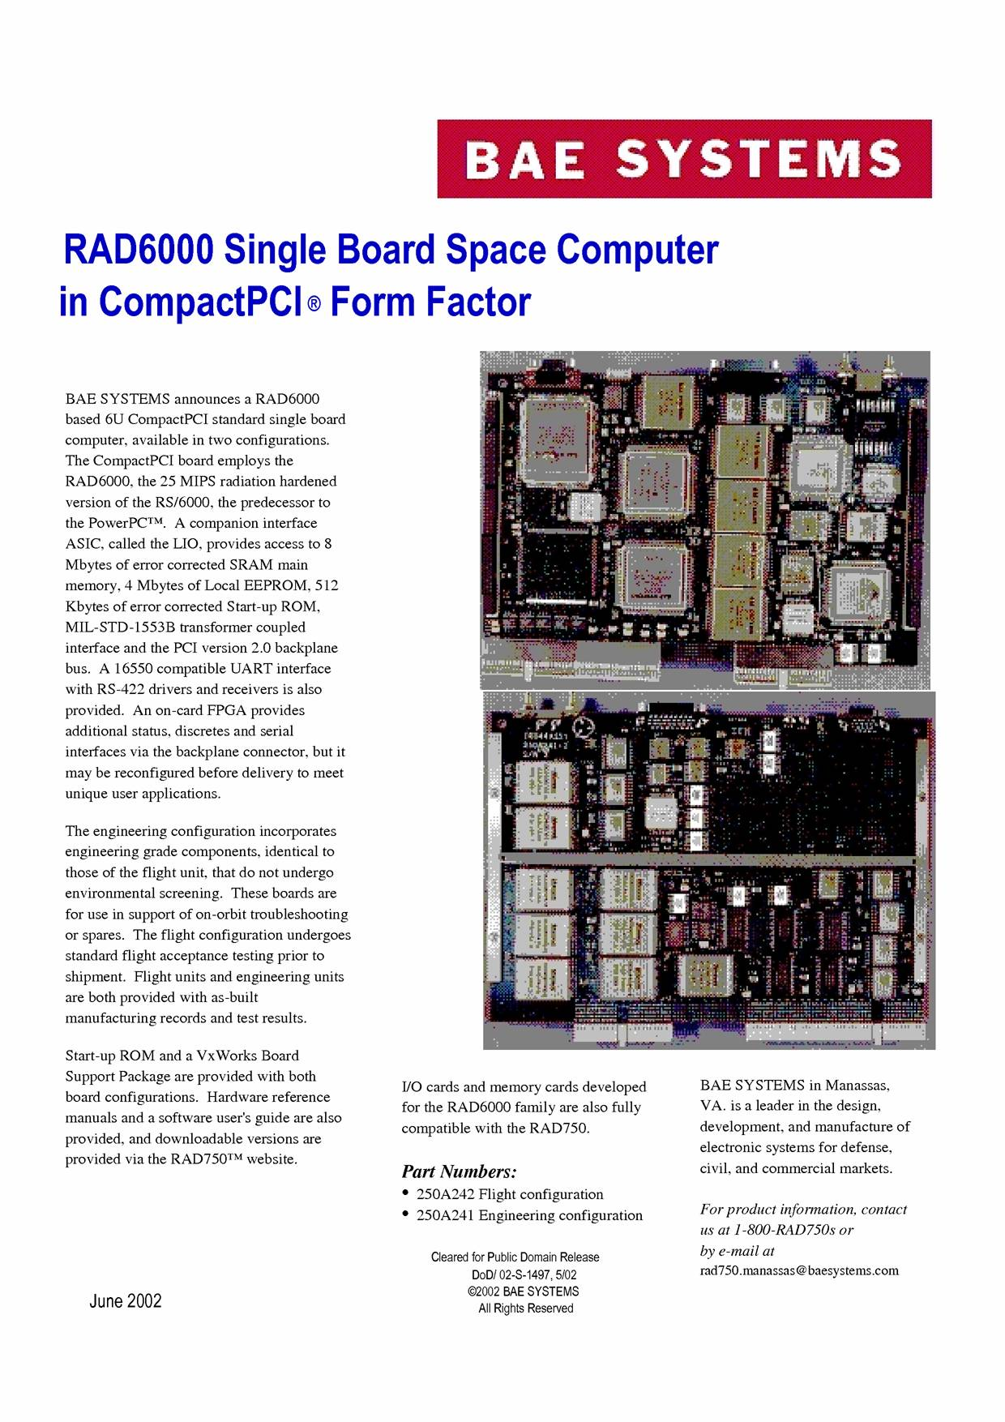
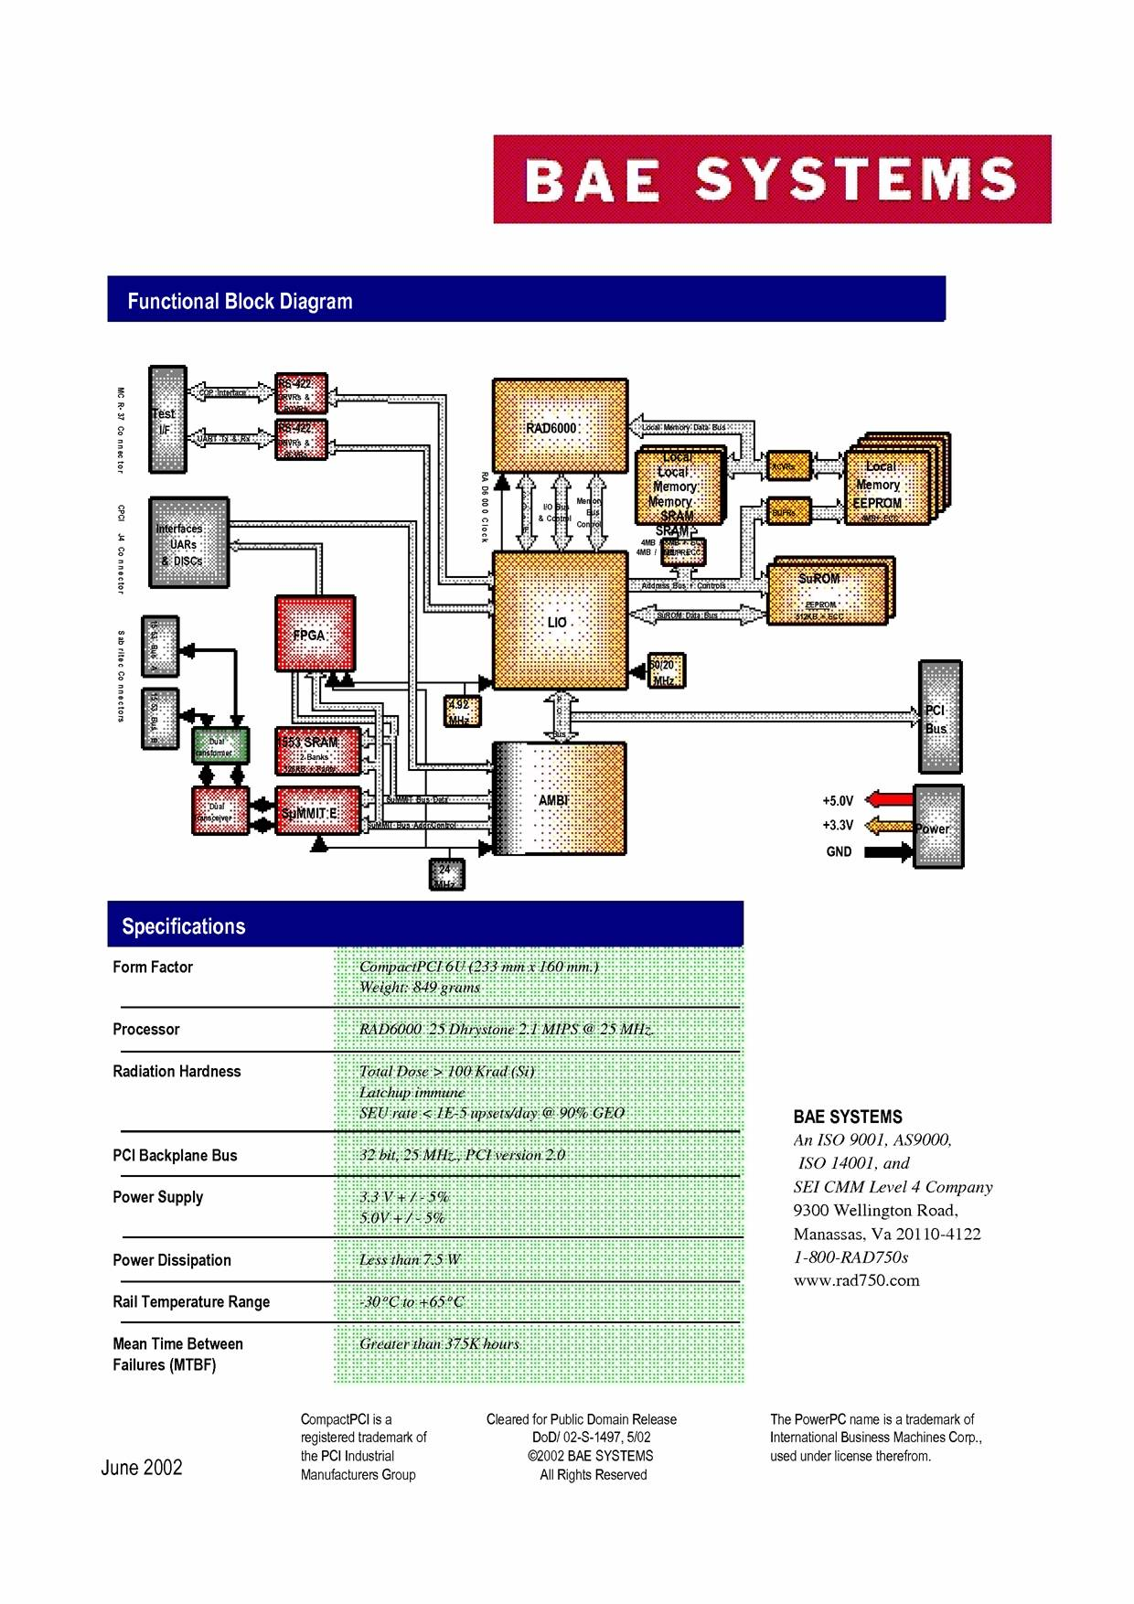
- Concept of Operations

- Level II Requirements

Power:

Thermal:

Guidance, Navigation, and Control:

- The vehicle will have the capability to detect and avoid potential hazards in the landing site.
- A lunar latitude/longitude position shall be known at all times during descent
- Position relative to Shackleton Crater shall be known at all times
- Altitude shall be known at all times during descent
- Attitude shall be known at all times during descent
- Velocity relative to the lunar surface shall be known at all times during descent

Communication:

Structures:

Payload:

Concept of Operations:

References:

On Mars Exploration of the Red Planet 1958-1978, Edward Clinton Ezell and Linda Neuman Ezell, published 1984 by the Scientific and Technical Information Branch of the National Aeronautics and Space Administration, page 218

Brown, C. 2002. Elements of Spacecraft Design. Reston, Virginia: AIAA. Ch. 7 and 10.

Gilmore, D. G. Ed. 2002. Spacecraft Thermal Control Handbook. 2nd Edition volume 1. El Segundo: The Aerospace Press.

Eckart, P., “The Lunar Base Handbook,” An Introduction to Lunar Base Design, Development, and Operations, McGraw-Hill, St Louis, 1999,Chpt 14.

Wertz, J., Space Mission Analysis and Design. Hawthorne, California: Space Technology Library.

