The Daedalus Vision

Team LunaTech has created a vision for lunar exploration using the Daedalus system. The team conducted research on the evolution of robotic missions on Mars. The overall consensus is that a simple lander with science is sent to a prospective sight to collect data. Based on the research and data collected from the single lander, a lander with a mobility concept is sent to collect more science with greater detail and range that before. Next, multiple rovers are sent to maximize the data return and provide even more data than previous missions. Finally, a lander on wheels concept is sent to combine the mobility and lander into one function. Team LunaTech believes this expanding process is a good starting point for lunar exploration. It has been over 30 years since humans have had any measurable presence on the moon. Essentially NASA and the world is starting from the beginning to build an extensive exploration architecture in a very limited timeframe.

Using the Mars exploration road map, and discussing the current mission objectives with several lunar experts, the team has come to conclusion that the most effective method of exploring the Moon is to start with a basic lander that will achieve all of the mission requirements, but leave room for more in-depth analysis to be done using future missions. This is the reasoning for the design of Daedalus. The Daedalus Vision is to use the design to continuously build upon the data collected for each mission. This will require Daedalus to be modified to achieve specific goals for different missions. Team LunaTech has designed this capability into Daedalus.

For Daedalus 1, the mission is designed to visit Shackleton Crater in the Lunar South Pole and is the mission outlined in this report. The Daedalus lander will utilize a Lunar Penetrator Exploration System (LPES) to explore both permanently dark and lighted regions to check for signs of H₂O and H_{2.} Also, the lander will conduct research that benefits both science and exploration programs for future missions. The LPES is based on the proven and extensively tested LUNAR-A penetrator. All of the data collected using the LPES and the Daedalus lander should provide great detail of Lunar South Pole. The data collected could then be used to procure more funding to send another Daedalus mission back to the South Pole with increased payload capability. Daedalus 2 would utilize a robotic rover capable of visiting each of the sites studied by the LPES on Daedalus 1 and study them in greater detail. The rover could visit these sites of interest and conduct in-situ analysis. The robotic rover has been designed by Southern University and will be available to integrate into the Daedalus system. Also, a Sample Return Vehicle (SRV) has been developed by ESTACA and could return a 1 kilogram sample back to Earth. The robotic rover could collect an interesting sample from one of the sites characterized by LPES and deliver it back to Earth. This type of data return capability could only be rivaled by the future human missions. The robotic rover and the SRV designs will be discussed in detail in this report.

Team LunaTech firmly believes that following the roadmap created in exploring Mars is the best and most cost effective way to approach this difficult task. Starting with a basic, yet powerful lander; building on the good design practices and valuable data will allow the Daedalus concept to evolve with each lunar mission and provide a low-cost solution for the Lunar Precursor Robotic Program. This is the Vision of Daedalus, and the mission of Team LunaTech.

Daedalus Concept of Operations:

2.10.1 Overview
The concept of operations for the Daedalus lander will depend on the interactions of three main components: the LRO, LPES, and Daedalus. These require the interactions of all subsystems on Daedalus to work effectively to achieve the goals for the mission. The LRO conops will be essential to receiving and transmitting all data to and from Daedalus and LPES, as well as provide key images of the landing sites for both the penetrators and the lander. The LPES conops will consist of deployment, landing, and data collection. The lander conops will consist of descent, penetrator deployment, landing, and the 1 year science mission. Using this overview, a more detailed concept of operations package was developed for the Daedalus mission.

2.10.2 LRO Concept of Operations
The LRO is an essential key to the success of the entire mission. Images collected from the LRO will be stored in the DSMAC system for correlation, and for the positioning of the penetrator launch and Daedalus landing locations. LRO will serve as a communications satellite for the mission. LRO will collect the data for both the lander and LPES, and transmit it back to mission control. The orbit for LRO gives the lander and penetrators 5 minutes of transmission time for every 113 minutes, or about 1 hour per day. This view time will vary for the lander and penetrators based on their locations. The maximum assumed data transmission rate for LRO is 100 Mbps, therefore the maximum assumed data rate for Daedalus is assumed to be 100 Mbps. The CDD suggested a maximum of 300 MB of data will be generated per site. This equates to 7500 MB of total data generated from the 23 sites for the entire mission. The communications system for Daedalus allows it transmit 3600 MB of data every time LRO is visible. This exceeds the requirement of transmitting 300 MB of data for the entire mission to mission control. The LPES uses a UHF system to transmit data to the LRO. The maximum data transmission rate for each penetrator is assumed to be 8 kbps. The communications system allows each penetrator to transmit 0.286 MB of data every time LRO is visible. This may require some data be stored in the penetrator memory for uploading to LRO when it is available.

2.10.3 LPES Concept of Operations
Daedalus will carry 22 penetrators for the mission. These penetrators will be based on LUNAR-A design and each penetrator will be housed in the penetrator launch system. This system will utilize a spring-loaded system with shear bolts to release the pre-tensioned springs to eject the penetrators away from the lander. Each penetrator will be positioned in tubing that is angled at the correct orientation to achieve the required 500 meter distance per sample site. There will be two extra penetrators one for each environment to increase the success rate of the system. At 5 kilometer above Shackleton crater, Daedalus will launch 16 penetrators with an impact velocity 255 meters per second. These penetrators will impact the permanently dark lunar surface and begin collecting data. Once Daedalus has reached the 3 kilometer mark, 6 penetrators will launch from Daedalus with an impact velocity of 255 m/s. Once all of the penetrators land they will begin collecting and streaming data. The team has assumed that LRO will be visible for an entire viewing period when all of the penetrators have landed. This will ensure that the maximum amount of data can be transmitted back to mission control. The penetrators utilize a UHF transceiver to send data at 8 kbps. Each penetrator will generate 300 MB of data for the life of the mission, and can transmit 0.286 MB of data every time LRO is visible. The penetrators have the capability of storing data for periods when LRO is not visible. The life of each penetrator is estimated to be a year.

2.10.4 Lander Concept of Operations
The lander conops is broken in to two phases. The first phase is the descent, LPES deployment, and landing phase and the second phase is the surface mission. The first phase will take place above the lunar surface and will mostly consist of GN&C and LPES Deployment. Once Daedalus is 5 kilometers from the lunar surface and approximately 2.5 kilometers from the rim of the Shackleton Crater, the GN&C system will take over control of the lander. This includes the LiDAR, DSMAC, IMU, flight computer, MPS, and ACS. DSMAC will ensure proper location above permanently dark region of interest. At this time, at the 5 kilometer mark, 16 penetrators will launch into the permanently dark region of the crater. This will satisfy the customer requirement of 15 samples in the permanently dark region. Daedalus will then use the MPS and ACS to transverse over to the designated landing site while descending from the 5 kilometer mark down to 3 kilometer. During this time the DSMAC will continue imaging the lunar surface to correlate the stored landing location image to ensure that the lander is in the designated range. At the 3 kilometer mark, 6 penetrators will deploy for the lighted region of lunar surface. This will satisfy the requirement of 5 samples in the lighted region. There are two extra penetrators to account for any issues during launch and landing. The launch mechanism for the LPES will utilize a spring-loaded system with shear bolts to release the pre-tensioned springs. Each penetrator will be positioned in tubing that is angled at the correct orientation to achieve the required 500 meter distance per sample site.

During the descent period, the LiDAR will scan the landing site to avoid any unforeseen obstacles. The LiDAR will also be responsible for calculating the angle of the lunar surface and adjust Daedalus accordingly to ensure that safe landing is achieved. The DSMAC system will ensure that Daedalus will land at the correct location. Once the lander has been positioned 5 meters above the target, the computer will send a signal to the MPS to shut down. This will create the hard landing designed to reduce lunar dust disturbance from the thrusters. The entire landing sequence will take approximately 3 minutes from 5 kilometers to landing. This completes the landing phase of the mission. The GN&C system is shut down, and power is diverted to other subsystems.

The next phase begins once Daedalus has landed on the lunar surface. After Daedalus has landed and time has been allotted for dust settlement, the 3 solar panels will unfurl and position for optimal sunlight exposure. This will start power generation for Daedalus and begin recharging the 15 lithium-ion batteries. For the lunar night, the power system will provide power to accommodate all communication, payload and power systems efforts for about 3 hours and 21 minutes per lunar night. This is based on a 1% duty cycle for the lunar night power system. The thermal system will operate on a power cycle. The thermal system will work to expel most of the heat generated during the lunar day, and conserve heat generated during the lunar night. For the lunar night, the thermal system will need to be on 10 percent of the time to maintain the optimal temperature for component survival. Once sufficient power has been converted, the scientific research for Daedalus will begin. The observations will consist of measuring micrometeorite flux, determining lighting conditions every two hours, and assessing electrostatic dust levitation with the correlation to lighting conditions. The lighting conditions will be measured every 2 hours per scientific requirement, and will use the efficiencies of the solar cells and the camera system to verify the data.

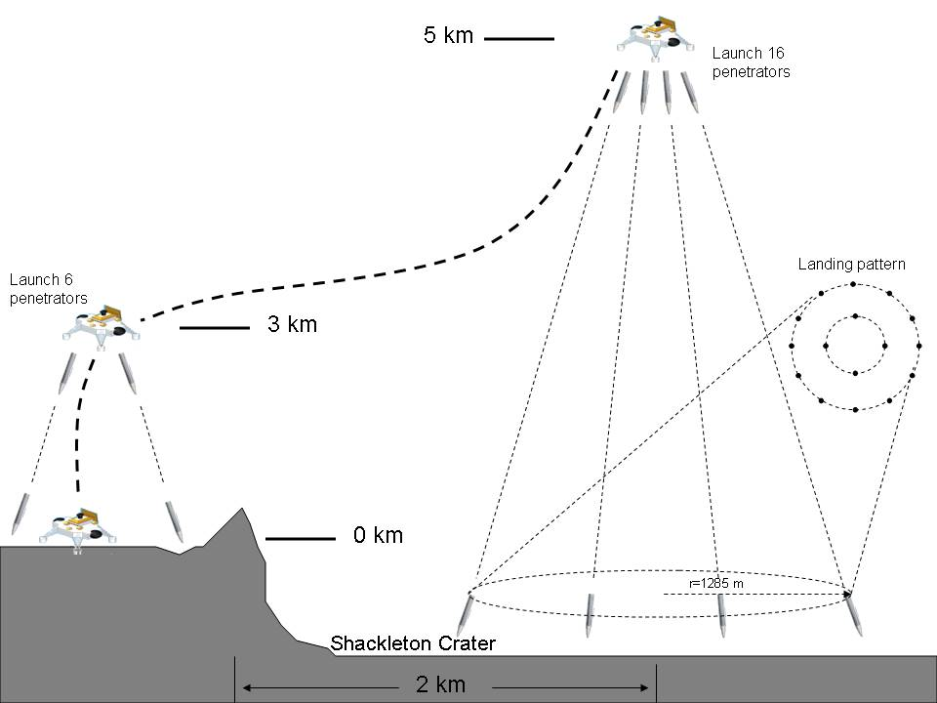
Figure 1: Daedalus Concept of Operations

