Operations – Brett Guin

The operations subsystem of the LETS is a broad area that encompasses all aspects of the mission. It is the responsibility of this subsystem to ensure that the various other components of the concept can work together in an efficient and effective manner in order to complete the objectives outlined in the Concept Description Document (CDD) for the mission.
The operations component of the Lander on Wheels proposed by Team Eclipse must pay special attention to minimizing single point failure and maximizing scientific payload. Several challenges are associated with these goals such as efficient data storage and careful planning to ensure power for the duration of the mission. These challenges and goals were approached initially by developing a Concept of Operations (ConOps) (Appendix J), which allows a general structure and timeline to be given to the mission. Over the course of the project this ConOps was adjusted to fit the constraints created by the other subsystems.
One of the primary constraints for the mission is power. The LOW has eight days of battery life, which is utilized when the rover travels into dark areas. The LOW also requires fourteen days to replenish the on-board batteries. These factors play a large role in determining the ConOps and the mission timeline.
The course of the mission is through an area along the rim of Shackleton crater and can be seen in Figure 1 below. This region is ideal since there is a well-lit area next to a dark area that makes the travel between charging sites and sample sites as easy as possible. The Shackleton crater site is saved until the end of the mission since it is the most difficult and riskiest to reach. The time designated for travel into the crater is also around three times longer than the travel time between the other sites. This is due to the low lighting conditions even during lunar daytime and the potentially hazardous nature of the terrain. During lunar daytime the LOW will only receive 20-30% of the normal sunlight, which will translate into less available power and slower travel. The schedule outlined in the ConOps is conservative, especially for the Shackleton Crater site, with more time than may be necessary designated for travel. The ConOps is based on a rover speed of five meters per hour, which is slower than the LOW is capable of going but serves the purpose of minimizing the potential for single point failure. At this speed it will take the LOW about 4.2 days to travel between sites. The ConOps allows 5 days in order to minimize the potential for failure. During some portions of the mission where 2 dark sites will be visited in a row the ConOps schedules extra travel time to allow the LOW to return to the light for recharging between sites. This travel speed still leaves extra time at the end of the mission so the conservative scheduling is not an issue to completing the necessary objectives. This extra time could also be used to maximize payload by visiting additional sites.
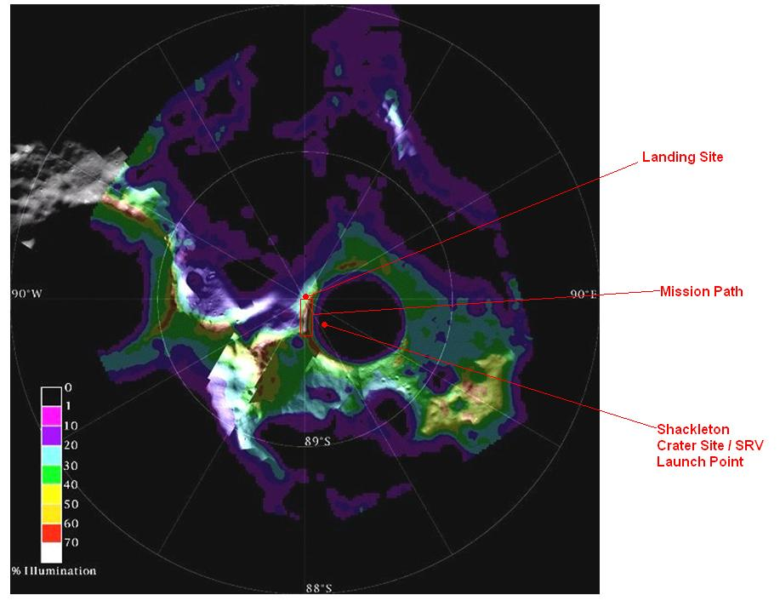
Figure 1. Lunar South Pole Region with Lander on Wheels Mission Course

The mission can be subdivided into three phases for the purposes of the operations subsystem: landing, exploration, and departure. Each of these phases requires the other subsystems to be coordinated in order to assure mission success. The landing phase requires the Guidance Navigation and Control (GN&C) component to land the LOW within the 300-meter designated landing area. The LOW rover is then removed from the propulsion system via a lowered ramp. This action requires the cooperation of several subsystems including structures, power, GN&C, and thermal. After sending a signal to Earth confirming system readiness, the mission continues to the next phase.
The second operations phase covers exploration of the lunar surface. The schedule and course for this phase is largely driven by the power subsystem since the LOW can only spend eight days in the dark before requiring fourteen days of sunlight to recharge. These timeframes play a large role in the ConOps construction seen in Appendix J. The CDD states that the mission must visit five lit sites and fifteen dark sites including one dark site in the Shackleton Crater. The ConOps outlines the approach taken to ensure that all of these sites are visited within the given timeframe of one year. Figure 1 above also illustrates the path taken by the Lander on Wheels to meet these requirements.
The main challenge in the exploration phase of the mission is remaining efficient while keeping the rover charged for its dark site exploration. It is important to monitor remaining battery charge and ensure that the rover has enough power to reach the light for recharging. Initially, the rover will have fourteen days of sunlight. This is taken advantage of by first exploring lit sites. As the moon becomes dark the rover will switch to battery power and travel into the dark sites. In addition to the power subsystem, structures, GN&C, thermal, and payload will also play roles in this phase of the mission. Data transfer, in particular, is also important during this phase of the mission since any occasion when the Lunar Reconnaissance Orbiter (LRO) passes overhead should be utilized to send information back to Earth. The data needs to be sent often in order to keep the rover’s data storage from becoming full and to ensure acquired data is not lost should there be a mission failure. The time required for the each site’s data to be send is 5.5 days. This is accounted for in the ConOps seen in Appendix J.
The third and final operations phase is the return phase. During this portion of the mission the Sample Return Vehicle (SRV) will be loaded with all of the samples taken during the exploration phase. The SRV is then sent from the rover to rendezvous with the LRO in orbit around the moon. At that point, the mission is concluded. The return phase is the most critical part since the samples must be returned to Earth in order to be of any value. This phase of the mission requires to cooperation of structures, GN&C, power, thermal, and payload subsystems.
The operations component of the mission supports the main goals of Team Eclipse. The scientific payload is maximized since the schedule allows time for extra sites as well as outlining the simplest method to reach the required sites. The potential for failure is minimized by the conservative nature of the schedule. This allows the LOW to travel at a safe pace and take extra care to avoid hazards.

