Operations – Brett Guin

The operations subsystem of the LETS is a broad area that encompasses all aspects of the mission. It is the responsibility of this subsystem to ensure that the various other components of the concept can work together in an efficient and effective manner in order to complete the objectives outlined in the Concept Description Document (CDD) for the mission.
The operations component of the Lander on Wheels proposed by Team Eclipse must pay special attention to minimizing single point failure and maximizing scientific payload. Several challenges are associated with these goals such as efficient data storage and careful planning to ensure power for the duration of the mission. These challenges and goals were approached initially by developing a Concept of Operations (ConOps) (Table ??), which allowed a general structure and timeline to be given to the mission. Over the course of the project this ConOps was adjusted to fit the constraints created by the other subsystems. The power subsystem, for example, caused changes to be made to the mission timeline since the fuel cell must be replenished using solar power after a certain number of days.
The mission can be subdivided into three phases for the purposes of the operations subsystem: landing, exploration, and departure. Each of these phases requires the other subsystems to be coordinated in order to assure mission success. The landing phase requires the Guidance Navigation and Control (GN&C) component to land the Lander on Wheels within the 300 meter designated landing area. The Lander on Wheels rover is then removed from the propulsion system via a lowered ramp. This action requires the cooperation of several subsystems including structures, power, GN&C, and thermal. After sending a signal to Earth confirming system readiness, the mission continues to the next phase.
The second operations phase covers exploration of the lunar surface. The schedule and course for this phase is largely driven by the power subsystem since the Lander on Wheels can only spend ten days in the dark before requiring sunlight to recharge. The CDD states that the mission must visit five lit sites and fifteen dark sites including one dark site in the Shackleton Crater. The ConOps outlines the approach taken to ensure that all of these sites are visited within the given timeframe of one year. Figure 1 below also illustrates the path taken by the Lander on Wheels to meet these requirements.
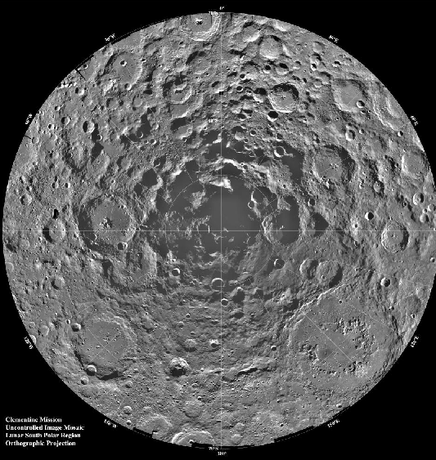<This will have the mission path drawn on it
Figure 1. Lunar South Pole Region with Lander on Wheels Mission Course
The course of the mission is through an area along the rim of Shackleton crater. This region is ideal since there is a well-lit area next to a dark area that makes the travel between charging sites and sample sites as easy as is possible. The Shackleton crater site is saved until the end of the mission since it is the most difficult and riskiest to reach. The time designated for travel into the crater is also longer than the travel time between the other sites. This is due to the low lighting conditions even during lunar daytime and the potentially hazardous nature of the terrain. The schedule outlined on the ConOps is conservative with more time than may be necessary designated for travel. The ConOps is based on a rover speed of three meters per hour, which is much slower than the Lander on Wheels is capable of going. This speed still leaves extra time at the end of the mission so the conservative scheduling is not an issue to completing the necessary objectives.
The main challenge in this phase is remaining efficient while keeping the rover charged for its dark site exploration. Initially, the rover will have 14 days of sunlight. This is taken advantage of by first exploring lit sites. As the moon becomes dark the rover will switch to battery power and travel into the dark sites. In addition to the power subsystem, structures, GN&C, thermal, and payload will also play roles in this phase of the mission. Data transfer, in particular, is also important during this phase of the mission since any occasion when the Lunar Reconnaissance Orbiter (LRO) passes overhead should be utilized to send information back to Earth. [Info about data capacity and transfer goes here]. The data needs to be sent often in order to keep the rover’s data storage from becoming full.
The third and final operations phase is the return phase. During this portion of the mission the Sample Return Vehicle (SRV) will be loaded with all of the samples taken during the exploration phase. The SRV is then sent from the rover to rendezvous with the LRO in orbit around the moon. At that point, the mission is concluded. The return phase is the most critical part since the samples must be returned to Earth in order to be of any value. This phase of the mission requires to cooperation of structures, GN&C, power, thermal, and payload subsystems.
The operations component of the mission supports the main goals of Team Eclipse. The payload is maximized since the schedule allows plenty of time for extra sites as well as outlining the simplest method to reach the required sites. The potential for failure is minimized by the conservative nature of the schedule. This allows the Lander on Wheels to travel at a safe pace and take extra care to avoid hazards.

Communications

The Lander on Wheels will utilize a communications subsystem similar to that of the Viking Lander. This system consists of Ultra High Frequency Relay Communications Equipment (UHF RCE) used to transmit data to the LRO. The Viking also had a S-band transmitter, however this is a redundant system and is not necessarily needed. The UHF RCE operates at around 381 MHz. The system transmits 1 x 10⁷ bits of data daily with an error of less than .003%. The maximum amount of power that the antenna for this system will use is 30 W.

