Payload Subsystem

Based on current design of the rover, the allotted spatial area for the payload is 2 meters long by 1 meter wide. This is subject to change, but the current placement of the payload is based on this layout. There is unused space for potentially more equipment if needed. The Payload includes scientific equipment for experimentation and also the SRV, which will return samples to earth.

The box for the SRV is positioned at the rear of the rover, centered at the longitudinal axis. The majority of the scientific equipment is placed towards the front of the rover. At 200 kg, the SRV acts to balance the combined masses of the lighter equipment placed in the forward position.

An arm and a scoop are placed on the top of the rover to collect regolith from the lunar surface. The arm may also be used for operating other equipment. Also on the top of the rover is a mast that will hold a stereo imaging system to take 360˚ pictures. Cameras on the mast will include those as used on MER.

Geotechnical experiments include cone penetrometers, an experimental vane, and a bearing plate to measure lunar soil properties, which can be used to compare soil at the south pole to that previous landing sites. The Gas Chromatograph Mass Spectrometer (GCMS) is used to determine volatile compounds and their composition (such as water, carbon dioxide, hydrogen, etc.). This instrument will use more power and time [and therefore Whr] than the other instruments. A neutron spectrometer is used to determine the flux and energies of neutrons to determine H content of regolith, while magnets placed on the front of the rover determine gauss and magnetic susceptibility. XRD/ XRF may be used with the arm, and will determine the mineralogy and chemistry of the regolith.

A drill is also used to collect regolith and can be used to extract regolith samples to a maximum depth of 2 m. On the underside of the payload there is mounted a belly cam for imaging to aid drilling.

The power system is placed in the center of the payload.

(General layout of the payload is on the figures, next page)

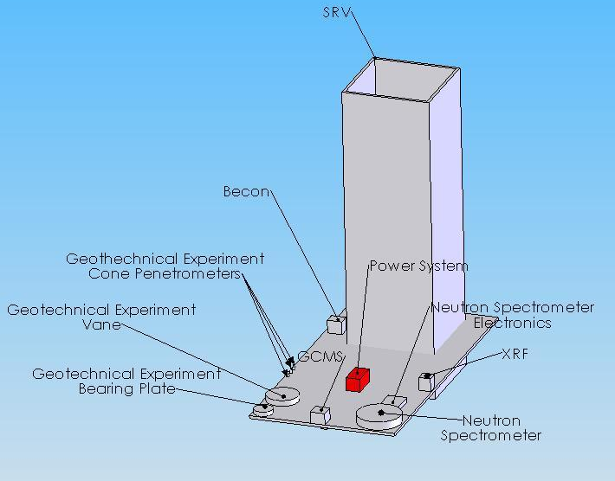

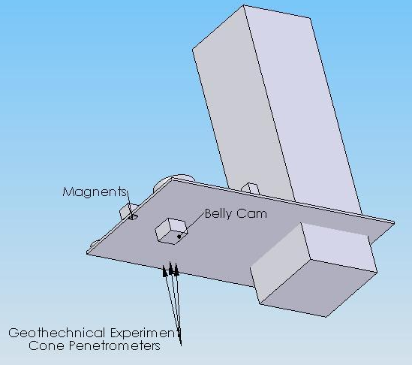
Bottom view

Drill not shown.
Top view

Arm/ scoop not shown.
Stereo imaging system/ mast not shown.

