The original configuration, from the Whit Paper, was in a vertical orientation. After detailed examination of payload, power systems, and a final design of the sample return vehicle including launch box, it was determined that the rover can be orientated in a horizontal orientation. The original vertical orientation was chosen to maximize the usable volume of the Atlas shroud. However, the total volume needed to house all of the above stated systems is much less than anticipated. By choosing a horizontal rover, the structural requirements and methodology of extrication the rover from the landing platform was greatly simplified.

The structural requirements for the landing platform and the rover are as follows. All must withstand a maximum of 5 g’s of acceleration during launch. It is assumed that an adaptor will be designed to attach the landing platform to the shroud of the Atlas launch vehicle that will be able to support the total mass of the lander on wheels. This total mass is estimated to be 976 kg. In addition to launch, the landing platform must be able to survive the semi-hard landing that will occur it hits the moon’s surface. It is assumed that the propulsion system will cut off when the lander is at an altitude of approximately five meters. With the gravitational acceleration on the moon’s surface (1.64m/s²) being approximately one sixth that of gravity on earth’s surface (9.81m/s²), and assuming that when the propulsion system cuts off, the velocity of the lander is approximately zero, the velocity that the lander will hit the surface of the moon will be approximately 8.2 meters per second. This impact velocity is significant enough that honey comb crush pads, similar to that of the baseline Viking Lander will be utilized. By utilizing crush pads on the bottom of the lander’s feet and within the main body of the lander legs, it is assumed that ninety percent of the impact force will be absorbed within them.

The original design concept, for the lander on wheels, utilized titanium (Ti-6Al-4V) exclusively for all structural components. However, due to the size and volume requirements of the lander legs, Aluminum 6061-T6 was utilized in the main member. This material is significantly lighter than titanium, and still gives a large enough factor of safety in the design. The factor of safety in the design of the lander legs was determined utilizing the Finite Element Analysis (FEA) package COSMOS. The minimum factor of safety is 2.8 using maximum von mises stress criterion. Below, are two images of the FEA performed on the lander leg. The first image is the complete leg (top view) and the second is of the aluminum main leg member.

Top View
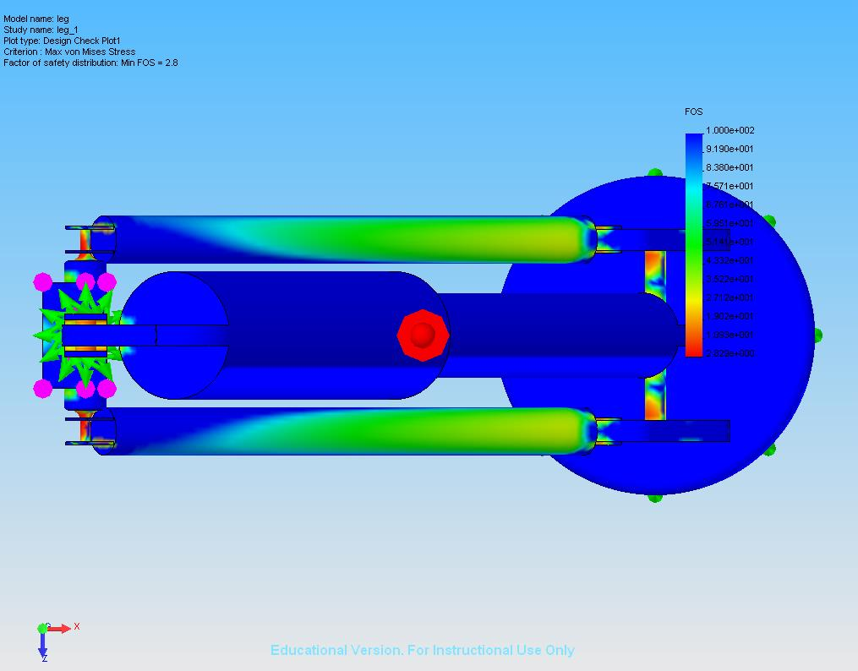

Aluminum Main Leg Member
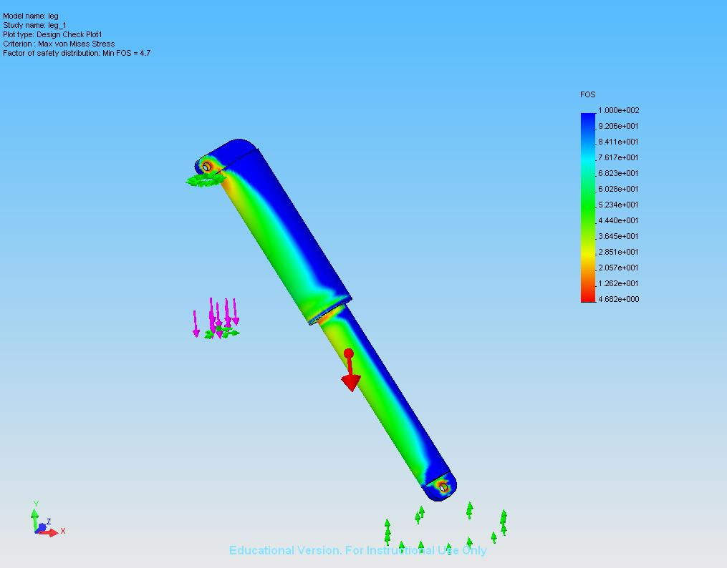
The lander platform is a four leg design that when once on the lunar surface will be discarded by the rover. The rover will simply roll off of the platform leaving it behind. To assist in the extrication of the rover from the platform, the lander platform will utilize a small ramp that will be located in the front of the rover. The ramp will be deployed using two small explosive bolts, that when detonated, will cause the ramp to fall. In the event that the ramp does not successfully deploy when the bolts are detonated, most likely due to landing on an incline, the robotic arm of the rover will push the ramp over.

The main structural component of the rover is the body. The body will be constructed of the same titanium that was utilized in the design of the landing legs. The rover body design is a rectangular box with dimensions of 1 meter by 2 meters by approximately .5 meters. The body is designed such that it encapsulates all equipment that must be thermally protected and contains access ports to all scientific equipment that must receive regolith samples from the robotic arm. In addition, the main body is designed to adapt to the six wheel rocker bogie system that Southern University is designing for Mobility and the sample return vehicle (SRV) that ESTACA in designing.

