Payload Subsystem

Based on the design of the rover, the allotted spatial area for the payload will be 2 meters long by 1 meter wide. The Payload will have a mass of 124 kg for equipment + 200 kg for the SRV= 324 kg. This high mass allotment is intended to maximize the scientific equipment, satisfying the minimum scientific experimental requirements as well as including extra equipment for more experimentation. The original payload design used only about 60 kg, but due to availability for greater mass and volume, a more instrumentation was in the design added to maximize experimentation.

The Sample Return Vehicle (SRV) will be used to return samples to the earth. (See Figures A and B). A launcher for the SRV is positioned at the rear of the LOW, centered at the longitudinal axis. (See Figures C and E).

A photoemission spectrometer and photoelectric cells will be included in order to measure emitted electrons and determine lighting conditions. An emission spectrometer with witness plate will determine regolith composition from micrometeorite impact flashes. A langmuir probe and a particle counter will be used to assess levitation dusts. The LOW will place and leave this equipment on the surface of the moon the first site in order to satisfy the single site goals. Also at the first site, the mast for the imaging system will be deployed on the LOW, and it will remain deployed for the duration of the mission.

An arm and a scoop will be placed on the right side of the LOW to collect regolith from the lunar surface. The arm may also be used for operating other equipment (See Appendix (#?) ). Note that a second arm will be included, but only one is shown in the figures. There will also also a drill in order to collect regolith from up to 2 m below the surface. Also on the top of the LOW is a mast that will hold a stereo imaging system to take 360˚ pictures. Cameras on the mast will include those as used on MER (See Figure E).

Geotechnical experiments will include cone penetrometers, an experimental vane, and a bearing plate to measure lunar soil properties, which can be used to compare soil at the south pole to that previous landing sites. The Gas Chromatograph Mass Spectrometer (GCMS) will be used to determine volatile compounds and their composition (such as water, carbon dioxide, hydrogen, etc.). This instrument will use more power than the other instruments; so the GCMS’s power requirement is the deciding factor for maximum power allotment. A neutron spectrometer will be used to determine the flux and energies of neutrons to determine H content of regolith, while magnets placed on the front of the LOW will determine and magnetic susceptibility. XRD/ XRF will be used with an arm, and will determine the mineralogy and chemistry of the regolith. This satisfies the requirements for the instrument package baseline.

Other equipment that will be included in the payload are as here described. A tunable diode laser will be included to determine the presence of water in regolith. An electron paramagnetic resonance spectroscope (EPRS) will determine the radioactivity of dust on the moon. An IR bolometer will be included determine surface temperatures. UV imaging will view the lunar surface and the interior of any crater that the LOW may encounter. Helium-3 sensors will allow the LOW to detect the presence of any Helium-3. An alpha particle (AP) spectrometer will determine the presence of alpha particles from gasses below the surface. A gamma ray spectrometer will detect thorium and uranium. A beacon will be used to as a reference for navigation.

See Figure C for the layout of the payload within the LOW. Positioning for power is also included. See Figure D for a simplified drawing of the underside of the payload with the magnets and belly cam.

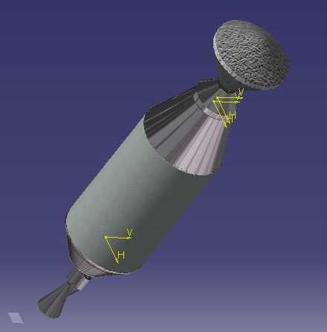
Figure A
SRV View 1
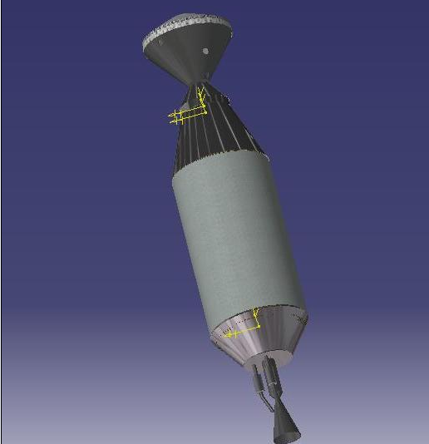
Figure B
SRV View 2
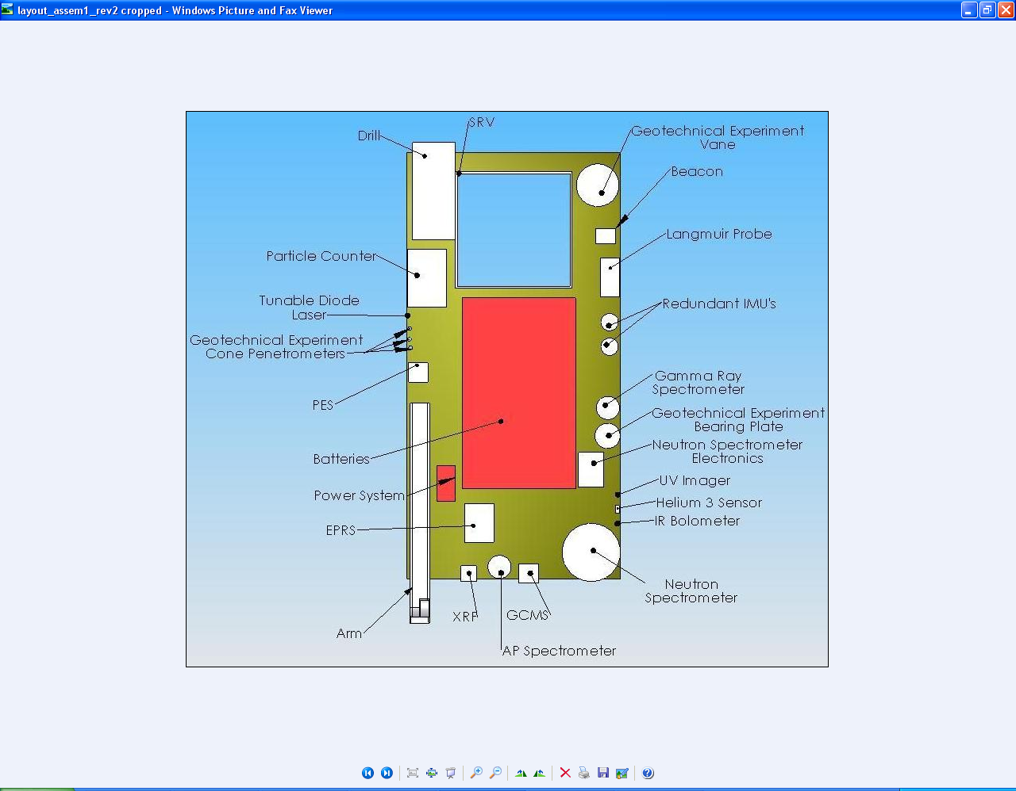
Figure C
Bottom view

Drill not shown.
Top View of Payload Without Cover
(Second Arm not Pictured)
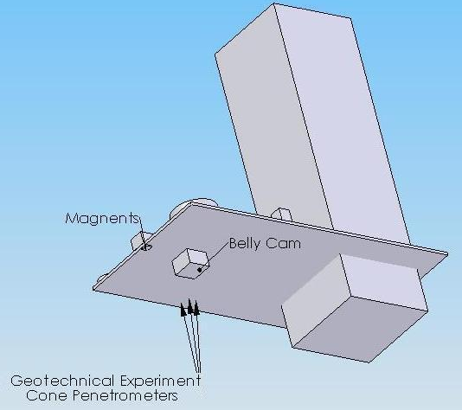
Figure D
Bottom View of Payload Without Cover
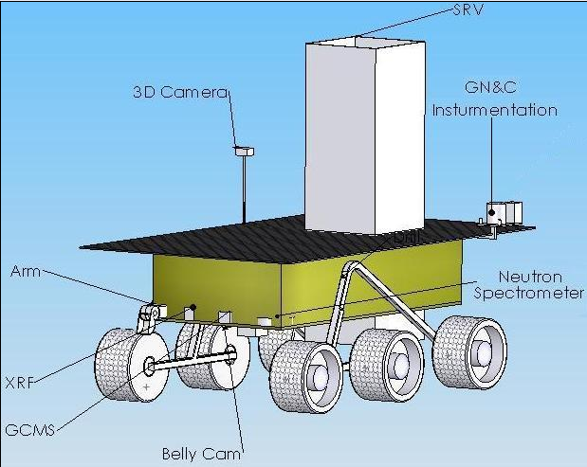
Figure E
LOW Completed

