Payload Subsystem

Based on the design of the rover, the allotted spatial area for the payload is 2 meters long by 1 meter wide. Payload has an allotted mass of 120 kg for equipment + 200 kg for the SRV= 320 kg. This high mass allotment is intended to maximize the scientific equipment, satisfying the CDD requirements as well as including extra equipment for more experimentation. The original payload design used only 60 kg, but a redesign filled the remaining 60 kg.

The box for the SRV is positioned at the rear of the rover, centered at the longitudinal axis. The majority of the scientific equipment is placed towards the front of the rover. At 200 kg, the SRV acts to balance the combined masses of the lighter equipment placed in the forward position.

A photoemission spectrometer and photoelectric cells are included in order to measure emitted electrons and determine lighting conditions. And emission spectrometer with witness plate determines regolith composition from micrometeorite impact flashes. A langmuir probe and a particle counter are used to assess dust levitation. The rover places this equipment on the surface of the moon the first site in order to satisfy the single site goals (CDD 5.1). Also at the first site, the mast for the imaging system is deployed on the rover, and it will remain deployed for the duration of the mission.

An arm and a scoop are placed on the top of the rover to collect regolith from the lunar surface. The arm may also be used for operating other equipment. There is also a drill in order to collect regolith from up to 2 m below the surface. Also on the top of the rover is a mast that will hold a stereo imaging system to take 360˚ pictures. Cameras on the mast will include those as used on MER.

Geotechnical experiments include cone penetrometers, an experimental vane, and a bearing plate to measure lunar soil properties, which can be used to compare soil at the south pole to that previous landing sites. The Gas Chromatograph Mass Spectrometer (GCMS) is used to determine volatile compounds and their composition (such as water, carbon dioxide, hydrogen, etc.). This instrument will use more power and time [and therefore Whr] than the other instruments. A neutron spectrometer is used to determine the flux and energies of neutrons to determine H content of regolith, while magnets placed on the front of the rover determine gauss and magnetic susceptibility. XRD/ XRF may be used with the arm, and will determine the mineralogy and chemistry of the regolith. This satisfies the requirements for the instrument package baseline (CDD 5.3).

The payload also includes the following equipment: diode laser, EPRS (Electron Paramagnetic Resonance Spectroscopy), IR bolometer, UV imaging, emission spectrometer, He-3 sensors, alpha particle spectrometer, gamma ray spectrometer, and a beacon for navigation if necessary.

(Detailed instrument list on Excel file)
(General layout of the payload is on the figures, following page)
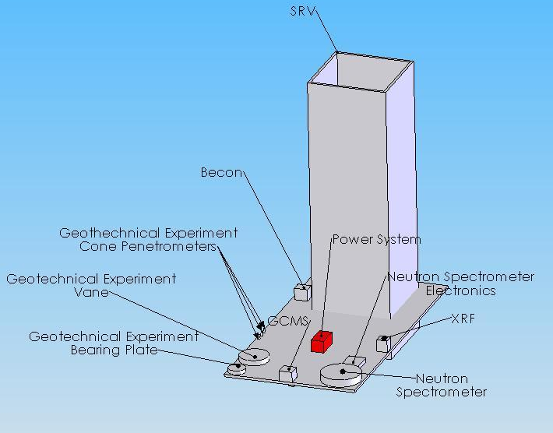

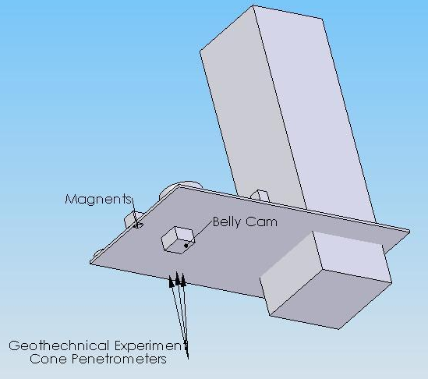
Bottom view

Drill not shown.
Top view

Arm/ scoop not shown.
Stereo imaging system/ mast not shown.

